Campaign for ETSU Discussion Document – [Donor Name(s)]

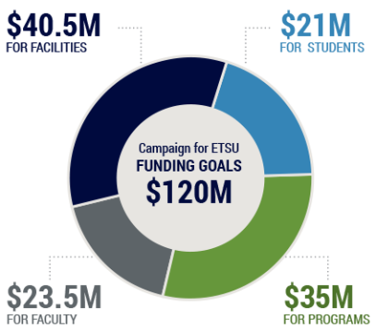
For over 108 years, the stories of ETSU students, faculty, staff, alumni, and donors have been woven together to tell a much bigger story – the story of an institution improving the quality of life for the people of the Appalachian Highlands. Today, like never before, ETSU is poised to leave a lasting impact. With your help, we have the opportunity to transform the lives of our students and change the landscape of higher education.

The Campaign for ETSU, officially launched in April 2019 and set to culminate in June 2022, sets an ambitious goal of $21M for Student Support, providing funds to recruit and retain deserving students by offering competitive scholarships, study abroad opportunities, graduate student stipends, and participation at prestigious academic conferences.

[First name(s)], your commitment and ongoing leadership with the ETSU Foundation [or other examples] has guided us to some pretty amazing results. With your help and continued support, we look forward to the future and to accomplishing even more. The opportunity described below is intended to be the start of this conversation, resulting in a program tailored to you and to the change you’d like to bring to ETSU.

Your campaign pledge of $XX,XXX payable over five years, will create the [fund name and/or description]. This first-of-its-kind initiative will improve access to higher education for ETSU students of all disciplines, who have financial need. These scholarships will help students who may not qualify for strict merit-based criteria, but nonetheless have great potential. Your efforts will be multiplied as we marshal the efforts of many other Buccaneers (staff and donors alike). We will promote the challenge, asking ETSU donors across the globe to endow new scholarships ($25,000 minimum) in their respective areas. Each new endowment will then be matched dollar-for-dollar by you, in $100,000 challenge blocks. Doing this in increments will help to create a sense of urgency among donors and inspire friendly competition among our staff.

Your investment in the Campaign for ETSU will not simply help us meet a campaign goal; it will truly provide resources necessary to enable our students to achieve a lifetime of hopes, dreams, and aspirations. These investments carry forth as our students graduate, empowered to improve their communities and the world.

Thank you and Go Bucs!

Use the photos/language below, depending on the area(s) in which the donor is interested.

Student Support – see verbiage and photo on first page.

Faculty Support – The Campaign for ETSU, officially launched in April 2019 and set to culminate in June 2022, sets an ambitious goal of $23.5M for Faculty Support, providing funds for opportunities such as distinguished professorships and chairs as well as new endowments. Faculty are the lifeblood of ETSU.

Facility Support – The Campaign for ETSU, officially launched in April 2019 and set to culminate in June 2022, sets an ambitious goal of $40.5M for Facility Support, providing critical matching funds required by the state for future building and renovation projects, breathing new life into our campus home. Facilities help transform the experience of our students, impacting everything from where they learn to where they sleep.

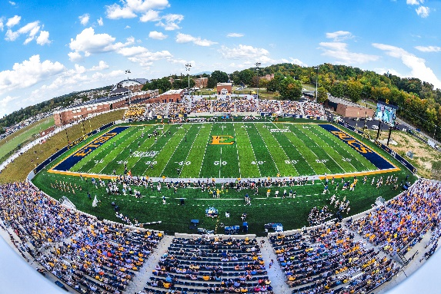

Program Support – The Campaign for ETSU, officially launched in April 2019 and set to culminate in June 2022, sets an ambitious goal of $35M for Program Support, providing exciting new academic programs that will attract students and ultimately transform their lives. Deans and campus leaders are closely following emerging market demands in order to position ETSU students to meet the needs of tomorrow’s employers.
