Honors in Biology, East Tennessee State University

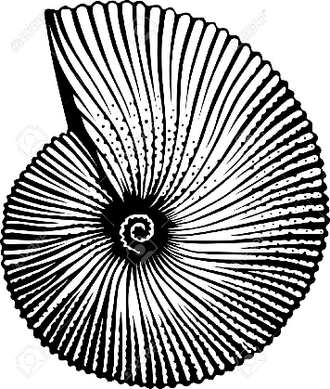
The Honors-in-Discipline (HiD) program in the Department of Biological Sciences will provide YOU with an enhanced program of study for your major in biology (standard, concentration, and biochemistry tracks). The Biology Faculty promise you a challenging and stimulating college experience. The Biology HiD program emphasizes student learning through experience, research and scholarship. Honors students become part of our scholarly community, encouraged to participate in scientific dialogue with peers and faculty. You will gain the knowledge and skills needed to complete a formal research project that you select from the vast array of on-going research disciplines in biology. We seek highly motivated students willing to work with us in learning and discovery.

THE BIOLOGY HONORS PROGRAM OF STUDY

Freshmen Year, Honors
- BIOL 1888, Honors Launch (1 credit). This course is, effectively, a full year course---you will take it both fall and spring semesters. The course is specifically designed to jump-start the college experience for our honors scholars. Learn the “ins & outs” of the university and the department; study techniques; meet your colleagues and your faculty; learn about journal clubs, seminars, science organizations, and ongoing research in the department.
Sophomore Year, Honors
- BIOL 4300 Honors Seminar (2 credits) will introduce biology honors students to professional oral presentations given by scientists from other institutions, as well as ETSU faculty and graduate students. Students will attend weekly seminars (1 hour), be invited to special events, and will meet four times a semester to critique and discuss presentation styles, “pitfalls” and tactics for success.
- BIOL 2992 Research Orientation (2 credits). This course is designed to assist students in understanding experimental design and data analysis, as well as selecting a research mentor, defining a research project, and completing a research prospectus.
Junior Year, Honors
- In both fall and spring semesters, Biology Honors students will select an upper division course to enroll as honors-enriched (BIOL 3XXX-088 or 4XXX-088). In consult with the course professor, Honors students will arrange special enrichment activities for their honors credit. Examples of honors enrichments include class presentations on a special topic or research effort; service-learning assignments; special data analyses or reports; and other creative experiences.
- In Fall or Spring, biology honors students will enroll in Research in Biology (BIOL 4910-088) or Independent Studies (BIOL 4900-088) with their faculty mentor to begin their formal research.
Senior Year, Honors
- BIOL 4018 Honors Thesis in Biological Sciences (3-6 credits): Biology Honors students will typically enroll both fall and spring semesters. These credits enable another semester of research and then a semester to write the thesis and prepare a presentation. Note that a minimum of a B grade is required for award of Honors in Biology (on transcripts and diploma) at graduation.
- BIOL 4300 Honors Seminar in Biological Sciences: As a capstone experience, Biology Honors students will enroll in Honors Seminar (see sophomore year, above) their last semester. Seniors will help mentor our sophomores. Honors student may present their thesis at this department seminar or other symposia or conferences.

ETSU Biology Honors students will find diverse opportunities to interact with colleagues and other scientists. With assistance from the Honors College, funds are available for research grants and travel to attend professional scientific conferences.

COME JOIN OUR JOURNEY OF DISCOVERY!

