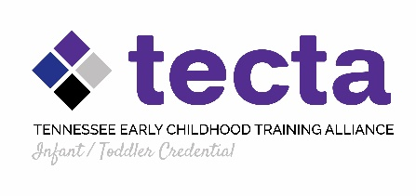
Tennessee Early Childhood Training Alliance (TECTA)
Infant/ Toddler Credential
Overview and Syllabus

Instructor: Sara Mietzner
E-mail: mietzner@etsu.edu
Phone: 423-439-7855

About the Infant/ Toddler Credential
The Infant/ Toddler Credential provides knowledge and training that supports improving the quality of infant/ toddler care. The Credential includes 3 “live” modules and 5 online components. Each participant will create a portfolio during the course of the Credential process. Credential work will incorporate various methods of assessment which include: written essays/ reflections, classroom observations, journal reflections, access to relevant websites and research-based materials, and communication with local TECTA Specialists and CCR&R IT Quality Coaches.
Candidates who successfully complete the Credential work, including pre and post assessments, and portfolio review, will be awarded the Tennessee Early Childhood Infant/ Toddler Credential. The Academy process equals 18 DHS professional development training hours.

IT Credential Online work
Online learning requires certain skills, behavior, study habits, computer equipment, and discipline in order to be successful. Therefore, candidates enrolled in online courses through TSU Online are encouraged to complete our TSU eLearn Student Orientation. To access the Orientation, log into eLearn, then click on the TSU eLearn Student Orientation link found in your My Courses area.

If a candidate has a question about an assignment or needs something clarified, they are encouraged to ask questions through email or through the eLearn messaging platform. If the question is of a confidential or urgent nature, they can email or call the instructor directly at mietzner@etsu.edu.

The Credential consists of 3 ‘live’ modules and 5 online class sessions. Live modules are 60-90 minutes in length and online work is self-paced. Although online work is self-paced, students are encouraged to stay within the time frame of the course and not work ahead. Early portfolio submissions will not be accepted.

Online Academy Guidelines
- Access eLearn directly at the web address: http://elearn.tnstate.edu.
- When you are on the eLearn login page, you will need to type in your username and password in order to access your course. If you need assistance with your username or password, please contact Sara Mietzner at mietzner@etsu.edu.
- The Credential ‘live’ sessions take place online one evening approximately every 6-8 weeks. See the schedule below for the dates.
- Students MUST have regular and frequent access to the Internet to participate in discussions during the online sessions.
- Students must utilize Microsoft Word for all assignments.
- All electronic communications will be conducted via eLearn and all additional reading materials will be accessible via this system.
- All discussions should occur in the eLearn platform.
- Students must access course resources to receive professional training hours. Online content will be monitored and students will be contacted if needed.
- Discussion and reflection of the resources, articles, and websites are the essence of the Credential process and are required for success.
- It is the student’s responsibility to check the eLearn course page for all assignments and online sessions scheduled.

Professional Portfolio
The TECTA Infant/ Toddler Credential Professional Portfolio reflects quality measurements of early childhood care and teaching in alignment with National Association for the Education of Young Children (NAEYC). It provides the Candidate an important reflective experience after reviewing online resources, reading research articles, watching research-based videos, and working on improving goals and objectives with support of community partners. The Professional Portfolio also provides an outlet for articulating candidate’s view of their work and in caring for our youngest learners and their families. Listed below are the objectives for each session.
The Professional Portfolio includes 5 Modules:

Module 1- Professionalism:
Candidates will reflect on their personal classroom practices and philosophy; learn about the role of mindfulness as an educator and within the classroom; and examine their professional development plan.
Module 2- Relationships:
Candidates will describe their competence in building relationships with children and families; create a relationship-based case study; collect a supportive letter of recommendation from a family; and resolve an ethical dilemma related to building and maintaining relationships with a family.
Module 3- Child Development:
Candidates will deepen their understanding of brain development; identify developmental changes during the period between infancy and toddlerhood; reflect on classroom community; and recognize the importance of infant mental health.
Module 4- Environment & Curriculum:
Candidates will examine the role of reflective curriculum in scaffolding learning; document and outline changes to classroom based on coaching and feedback; research tools that assist with challenging behaviors; and summarize the importance of routines and daily rhythms.
Module 5- Assessment & Evaluation:
Candidates will describe the role of documentation and assessment; assess appropriate lesson plans; outline community resources; and examine conference-planning forms and the relationship to goal-setting and individualized expectations.

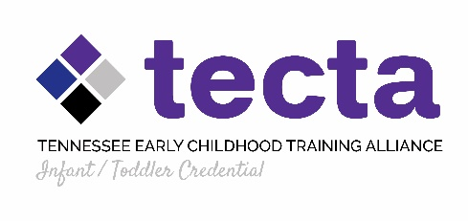

Course schedule outline

Date | Topic | Assignment
Credential start date:  March 2 | Live Module 1: Professionalism and Infant/ Toddler Care | “live” online ‘meeting’
 | Online Module 1: Professionalism
March 30 | Live Module 2: Relationships and Child Development | “live” online ‘meeting’
 | Online Module 2: Relationships
 | Online Module 3: Child Development
May 4 | Live Module 3: Environment, Curriculum & Assessment | “live” online ‘meeting’
 | Online Module 4: Environment and Curriculum
 | Online Module 5: Assessment and Evaluation
June 1-4  Dec. 10 | Submission of all Credential materials (if pre-requisites are completed)  Submission of all Credential materials (including all pre-requisites)

**IT Credential awarded after Candidate portfolio peer reviewed by TECTA review team; Credential certificates will be awarded in July.

