Interactive Notebook Content & Supplemental Resources
By Laura Stanton
**All work is original, no sources/citations needed**

Explain Phase in Notes (Concept map):

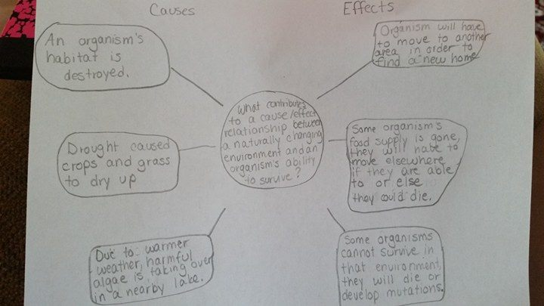

Elaborate Phase:
Activity Instructions for Students:
You will need:
- Pencil
- Piece of paper
- Scenarios (teacher will give you a piece of paper with a given situation)

- Think of 3 organisms that have the ability to survive in changing environments and write a sentence about each.
- Be sure to use your vocabulary words (Environment, organism, cause & effect, and relationship) to use a complete sentence about what you learned.
- Form into groups of 4 and one person in each group will be given a piece of paper out of a bag that the teacher will have.
- Within your group, read what is on the piece of paper and talk about how you would answer the question on the paper. Before sharing your group’s solution, you will need to include the previously learned vocabulary words (environment, organism, cause & effect, and relationship) in their response.
- Share your ideas with the other groups in a discussion.
- Next, everyone will create and fill in a table of some possible cause/effects and impacts on the organism’s survival.

3rd Grade Level CER summary chart with prompts (students using vocabulary words):

Claim  (Write a sentence stating what causes an organism to change/adapt.) | Evidence  (Provide evidence from the scenarios as to how organisms have to change in order to adapt to the naturally changing environment.) | Reasoning  (Explain how your evidence supports your claim.)
Animal adaptations depend on what happens naturally in the environment such as weather or their habitat. | In the eagle story, they had to adapt and find a safe place where they could raise their young. | When the environment does not change, organisms do not either.

Student CER notebook version with writing prompts and sample student responses:

Claim: (Write a sentence stating what causes an organism to change/adapt.)
Animal adaptations depend on what happens naturally in the environment such as weather or their habitat.

Evidence: (Provide evidence from the scenarios as to how organisms have to change in order to adapt to the naturally changing environment.)
In the eagle story, they had to adapt and find a safe place where they could raise their young.

Reasoning: (Explain how your evidence supports your claim. Provide an example of an organism you have seen that has had to adapt in order to survive.)
When it gets colder outside, humming birds move south where it’s warmer outside during the winter months because they would not survive in a cold climate in the winter time.

Possible Causes/Effects of Scenarios:
Cause/change in the environment | Effect/impact on the organism’s ability to survive
*Frog Scenario-There is a drought. | The frog is unable to survive in a dry climate. If it does not find a new pond or creek, it might die.
*Eagle looking for nest- People trying to cut down trees in order to build more houses. | Eagles are unable to find a place to build a nest. They will then not be able have offspring and increase the overall eagle population
*Plant scenario- Global warming has been a problem. | If the temperature increases any more, the plant will not be able to survive and it will no longer be a source of food for different animals.
*Eagle/bird park scenario- Clearing of forests and eagle habitats | Adding this park will help the population of eagles because they will have a safe environment where they can raise their young and future offspring.
*Honey bee scenario-Drastic drop in honey bee population. | Helping honey bees survive will in turn help our food producing trees and other plants to produce our food.
*Lake scenario-Large fish are thriving because small fish are abundant. | With an increased amount of food, the large fish will have an increased population.
*Plant in the garden scenario-Pulling weeds helps the plant survive. | Pulling weeds will help the plant survive because it does not have as much competition and will in turn have a better chance of survival.
*Worm scenario-Rain causes the earthworms to come to the surface. | With the earthworms coming to the surface, the birds will have an easier time finding food for themselves or their young.

Documentation of a student example:
