Phases
of
Matter

Standard: Describe the properties of solids, liquids, and gases and identify that matter is made up of particles to be seen.

Matter Notes

__________: Anything that has mass and takes up space.

What is something you believe is matter? ________________________

1.____________ 2. _____________ 3._______________ are matter.

________: has fixed, closely packed arrangement of particles which results in a definite shape and volume.

________: Has a definite volume but no shape of its own.

________: Does not have a definite shape nor a definite volume.

________: The smallest piece that makes up matter that is invisible to the naked eye.

Solid particles are closely packed and do not move around much.

Liquid _________ packed together but can move around. That’s why they can take form of its container.

Gas is invisible. That means you can't see it. The particles are so far apart they are invisible, but they are still there! Think about oxygen. You can't see it, but you know it's there because you breath it.

6th grade "matter" review. (n.d.). Retrieved March 14, 2017, from https://quizlet.com/3330026/6th-grade-matter-review-flash-cards/

Elaborate

What’s the Matter Experiment

Instructions: Place the ice in the pan. Then place the pan on the hot plate and turn the heat level to 5.

Record the temperature before the ice has melted and after the ice has melted. Be sure to record the time it takes for the ice to melt to water. Record the data in the table for each attempt. Explain the particle alignment for solids in the table.

Record the temperature before and after the water has evaporated. Be sure to record the time it takes for the water to evaporate into a gas. Record the data in the table. Explain the particle alignment for liquids.

Explain the particle alignment for gases in the table.

Below the table draw a picture of what each phase of the ice looks like.

States of Matter. (n.d.). Retrieved March 22, 2017, from http://www.cpalms.org/Public/PreviewResourceLesson/Preview/128993

Chart
Type of Matter | Temperature | Time to phase Change | Picture of Particle alignment | Explain Particle alignment
Solid | Attempt 1:  Attempt 2: | Attempt 1:  Attempt 2:
Liquid | Attempt 1:  Attempt 2: | Attempt 1:  Attempt 2:
Gases | Attempt 1:  Attempt 2:

Citation: Self created chart

CER

Claim: (Write a sentence explaining a change of state in matter and how it affects the properties of the matter.)

Evidence: (Describe how the changes in states of matter took place.)

Reasoning: (Explain how your evidence supports your claim. Describe how the particle alignment changed and how you observed this transformation)

Citation: Self created CER

Target CER Answers

Claim: (Write a sentence explaining a change of state in matter and how it affects the properties of the matter.)
A change in matter can take place when the matter is heated up. This causes the matter to take on the properties of new state of matter it is transforming into.

Evidence: (Describe how the changes in states of matter took place.)
The ice warmed up and turned into water then the water started to boil and turn into steam. During the experiment, we took the average time and temperature for the change to take place.

Reasoning: (Explain how your evidence supports your claim. Describe how the particle alignment changed and how you observed this transformation) The particle alignment changed because I saw the states of matter change from solid, liquid, to gases. As the particles were warmed up by the heat they began to separate and this is when I saw the matter change state.

Draw a picture of the particle alignments

Picture of Particle Alignments

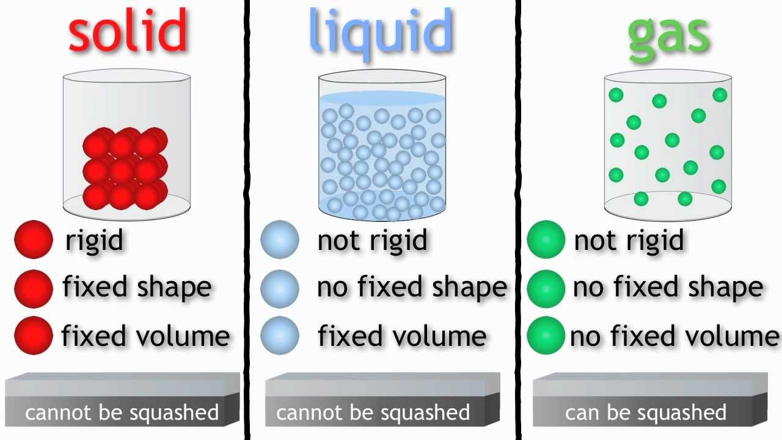

Citation: 1.1 understand the arrangement, movement and energy of the particles in each of the three states of matter: solid, liquid and gas. (n.d.). Retrieved April 25, 2017, from http://igcse-chemistry-edexcel.blogspot.com/2015/12/11-understand-arrangement-movement-and.html#!/2015/12/11-understand-arrangement-movement-and.html

