Waves

Waves

Overarching Question: What is a wave?
Overarching Question: What is a wave?

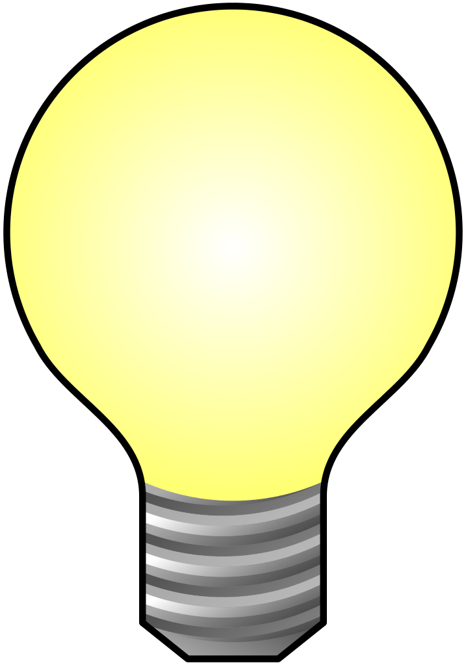
What creates a wave?
What are three main patterns of a wave?
How does direction change a wave?
What creates a wave?
What are three main patterns of a wave?
How does direction change a wave?
Are interactive notebooks effective?
How are interactive notebooks organized?
How are interactive notebooks assessed?

Line of Evidence – What is a Wave?
Direction is any of the ways a wave can travel. If a wave moves perpendicular, it is a transverse wave. If a wave moves in the same direction, it is longitudinal.

Line of Evidence – Straw Waves
A disturbance travels through space and matter to create a wave. When we tapped and twisted the straw wave model, a wave formed.

Line of Evidence – Making Waves
Three main patterns of a wave are amplitude, wavelength, and direction. Amplitude is the measure of displacement of the wave. Wavelength is the distance between two corresponding points on a wave. Direction is the way a wave travels. We could see these patterns when we made a wave.

Big Aha Thesis Statement
A wave is a disturbance that travels through space and matter and transfers energy. Waves have properties such as amplitude, wavelength, and direction. These properties can change the way a wave looks and what type of wave it is.

Line of Evidence – What is a Wave?
Direction is any of the ways a wave can travel. If a wave moves perpendicular, it is a transverse wave. If a wave moves in the same direction, it is longitudinal.

Line of Evidence – Straw Waves
A disturbance travels through space and matter to create a wave. When we tapped and twisted the straw wave model, a wave formed.

Line of Evidence – Making Waves
Three main patterns of a wave are amplitude, wavelength, and direction. Amplitude is the measure of displacement of the wave. Wavelength is the distance between two corresponding points on a wave. Direction is the way a wave travels. We can see these patterns when we make a wave.

Big Aha Thesis Statement
A wave is a disturbance that travels through space and matter and transfers energy. Waves have properties such as amplitude, wavelength, and direction. These properties can change the way a wave looks and what type of wave it is.

Engage: What We Know about Waves

Directions:
- Fill out the Knowledge (K) and the Wonder (W) column of the KWL chart with what you already know and what you want to know.
- Go to BrainPOP.com.
  - Select “Science.”
  - Select “Energy.”
  - Select “Waves.”
  - Watch the “Waves” movie.
- While you watch the movie, write down any information that is new to you in the Learned (L) column of your KWL chart.

Citations:
Brain POP. (2017). Waves. In Brain POP. Retrieved from https://www.brainpop.com/science/energy/waves/?panel=login&refer=/science/energy/waves/transcript/
West Virginia Department of Education (WVDE). (2017). Examples of Formative Assessments. In West Virginia Department of Education. Retrieved from http://wvde.state.wv.us/strategybank/GraphicOrganizers.html.

Engage: What We Know about Waves

Directions:
- Fill out the Knowledge (K) and the Wonder (W) column of the KWL chart with what you already know and what you want to know.
- Go to BrainPOP.com.
  - Select “Science.”
  - Select “Energy.”
  - Select “Waves.”
  - Watch the “Waves” movie.
- While you watch the movie, write down any information that is new to you in the Learned (L) column of your KWL chart.

Citations:
Brain POP. (2017). Waves. In Brain POP. Retrieved from https://www.brainpop.com/science/energy/waves/?panel=login&refer=/science/energy/waves/transcript/
West Virginia Department of Education (WVDE). (2017). Examples of Formative Assessments. In West Virginia Department of Education. Retrieved from http://wvde.state.wv.us/strategybank/GraphicOrganizers.html.

What I KNOW | What I WANT to Know | What I LEARNED

What I KNOW | What I WANT to Know | What I LEARNED

Explore: Straw Wave Model
Directions:
- Fill out the “Watching Waves” Observation Chart as you do the activity.
- Look at the straw wave model.
- What do you think will happen when the wave is tapped or moved?

- Find a partner and take turns tapping the straw wave model.
- Now, hold the straw model loosely and tap it. Do you see anything different?
- Now, hold the straw model tightly and tap it. What changed from when you held the straw model loosely?
- Take turns twisting the straw model. What do you see start to form?
- Fill out the Learned (L) column of your Waves KWL chart.

Citations:
Cleaver, S. (2017). Hands-On is Minds-On. In Scholastic. Retrieved from http://www.scholastic.com/browse/article.jsp?id=3751901.
Gupta, A. (Narrator). (2011). Straw Waves [Online video]. YouTube. Retrieved from https://www.youtube.com/watch?v=IlF8sdHTqaU&feature=share.

Explore: Straw Wave Model
Directions:
- Fill out the “Watching Waves” Observation Chart as you do the activity.
- Look at the straw wave model.
- What do you think will happen when the wave is tapped or moved?

- Find a partner and take turns tapping the straw wave model.
- Now, hold the straw model loosely and tap it. Do you see anything different?
- Now, hold the straw model tightly and tap it. What changed from when you held the straw model loosely?
- Take turns twisting the straw model. What do you see start to form?
- Fill out the Learned (L) column of your Waves KWL chart.

Citations:
Cleaver, S. (2017). Hands-On is Minds-On. In Scholastic. Retrieved from http://www.scholastic.com/browse/article.jsp?id=3751901.
Gupta, A. (Narrator). (2011). Straw Waves [Online video]. YouTube. Retrieved from https://www.youtube.com/watch?v=IlF8sdHTqaU&feature=share.

“Watching Waves” Observations
Specific Observation | Description
What the “wave” looks like without any variable affecting it
What happens when the straw model is tapped
What happens when the wave is tapped while the straw model is held loosely
What happens when the wave is tapped while the straw model is held tightly
What happens when the wave is twisted

“Watching Waves” Observations
Specific Observation | Description
What the “wave” looks like without any variable affecting it
What happens when the straw model is tapped
What happens when the wave is tapped while the straw model is held loosely
What happens when the wave is tapped while the straw model is held tightly
What happens when the wave is twisted

“Watching Waves” Observations (Answer Key)
Specific Observation | Description
What the “wave” looks like without any variable affecting it | The straw wave model was flat without any variable. The wave did not have any movement.
What happens when the straw model is tapped | When the wave is tapped, you can see the vibrations move through the model. The wave travels down the straw model on one side and reflects on the other side. This indicates direction. The amplitude and wavelength are difficult to identify when tapping the model because it moves so quickly.
What happens when the wave is tapped while the straw model is held loosely | When the string is held loosely, the wave travels the same as it did before but much slower. We could still see the direction of the vibrations travelling down the model.
What happens when the wave is tapped while the straw model is held tightly | When the string is held tightly, the wave travels the same as it did before but much faster. We could still see the direction of the vibrations travelling down the model.
What happens when the wave is twisted | When the straw model is twisted, it creates a helix-shaped wave. You can see the troughs, crests, wavelength, frequency, and amplitude. We can find and measure the wavelength of the wave. We noticed that the wavelength gets shorter when we twist the wave model more. The amplitude gets larger when we twist the wave model more. It is the height of the wave from the black tape to the top of the wave.

“Watching Waves” Observations (Answer Key)
Specific Observation | Description
What the “wave” looks like without any variable affecting it | The straw wave model was flat without any variable. The wave did not have any movement.
What happens when the straw model is tapped | When the wave is tapped, you can see the vibrations move through the model. The wave travels down the straw model on one side and reflects on the other side. This indicates direction. The amplitude and wavelength are difficult to identify when tapping the model because it moves so quickly.
What happens when the wave is tapped while the straw model is held loosely | When the string is held loosely, the wave travels the same as it did before but much slower. We could still see the direction of the vibrations travelling down the model.
What happens when the wave is tapped while the straw model is held tightly | When the string is held tightly, the wave travels the same as it did before but much faster. We could still see the direction of the vibrations travelling down the model.
What happens when the wave is twisted | When the straw model is twisted, it creates a helix-shaped wave. You can see the troughs, crests, wavelength, frequency, and amplitude. We can find and measure the wavelength of the wave. We noticed that the wavelength gets shorter when we twist the wave model more. The amplitude gets larger when we twist the wave model more. It is the height of the wave from the black tape to the top of the wave.

Straw Waves Model CER
Claim (Write a sentence stating how amplitude, wavelength, and direction are connected.)

Evidence (Provide scientific data to support your claim. The evidence should include how these properties relate to a wave.)

Reasoning (Explain why your evidence supports your claim. Describe what each property is and how they are connected to waves.)

Straw Waves Model CER
Claim (Write a sentence stating how amplitude, wavelength, and direction are connected.)

Evidence (Provide scientific data to support your claim. The evidence should include how these properties relate to a wave.)

Reasoning (Explain why your evidence supports your claim. Describe what each property is and how they are connected to waves.)

Straw Waves Model CER (Answer Key)
Claim (Write a sentence stating how amplitude, wavelength, and direction are connected.)
Amplitude, wavelength, and direction are connected because they are each a property of a wave.

Evidence (Provide scientific data to support your claim. The evidence should include how these properties relate to a wave.)
While we worked with the straw wave model, we were able to see amplitude, wavelength, and direction in the same wave. When we tapped on the wave model, we could see the vibrations travel down the wave, indicating direction. When we twisted the wave model, we could see the amplitude and could find the wavelength in the helix-shaped wave.

Reasoning (Explain why your evidence supports your claim. Describe what each property is and how they are connected to waves.)
Waves have properties such as amplitude, wavelength, and direction. Amplitude is the measure of displacement of the wave from its rest point. Wavelength is the distance between two corresponding points on back-to-wave cycles. Direction is any way that the wave can travel. Using a wave model, we could see that each of these properties are present in a wave.
Straw Waves Model CER (Answer Key)
Claim (Write a sentence stating how amplitude, wavelength, and direction are connected.)
Amplitude, wavelength, and direction are connected because they are each a property of a wave.

Evidence (Provide scientific data to support your claim. The evidence should include how these properties relate to a wave.)
While we worked with the straw wave model, we were able to see amplitude, wavelength, and direction in the same wave. When we tapped on the wave model, we could see the vibrations travel down the wave, indicating direction. When we twisted the wave model, we could see the amplitude and could find the wavelength in the helix-shaped wave.

Reasoning (Explain why your evidence supports your claim. Describe what each property is and how they are connected to waves.)
Waves have properties such as amplitude, wavelength, and direction. Amplitude is the measure of displacement of the wave from its rest point. Wavelength is the distance between two corresponding points on back-to-wave cycles. Direction is any way that the wave can travel. Using a wave model, we could see that each of these properties are present in a wave.
Explain: What is a Wave?

A wave is a disturbance that ____________ through space and matter and transfers energy.
There are several types of waves such as mechanical waves, sound waves, and electromagnetic waves.
Patterns of a wave include: _______________________________________
____________ is any of the ways a wave can travel.
The direction of a wave determines whether it is ________ or ___________.
Transverse waves move ________________ to the direction of the wave.
Longitudinal waves move in the _______ direction as the wave.
A wave looks like:
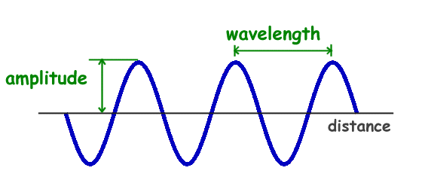
The amplitude of a wave is the measure of the _____________ of the wave from its ______________.
The wavelength is the distance between two corresponding points, or points in _______ locations, on back-to-bak cylces of a wave.

Citaions:
Technological Solutions, Inc. (2017). Physics for Kids: Properties of Waves. In Ducksters Education Site. Retrieved from http://www.ducksters.com/science/physics/properties_of_waves.php
Technological Solutions, Inc. (2017). Physics for Kids: Waves. In Ducksters Education Site. Retrieved from http://www.ducksters.com/science/physics/waves.php
Explain: What is a Wave?

A wave is a disturbance that ____________ through space and matter and transfers energy.
There are several types of waves such as mechanical waves, sound waves, and electromagnetic waves.
Patterns of a wave include: _______________________________________
____________ is any of the ways a wave can travel.
The direction of a wave determines whether it is ________ or ___________.
Transverse waves move ________________ to the direction of the wave.
Longitudinal waves move in the _______ direction as the wave.
A wave looks like:
The amplitude of a wave is the measure of the _____________ of the wave from its ______________.
The wavelength is the distance between two corresponding points, or points in _______ locations, on back-to-bak cylces of a wave.

Citaions:
Technological Solutions, Inc. (2017). Physics for Kids: Properties of Waves. In Ducksters Education Site. Retrieved from http://www.ducksters.com/science/physics/properties_of_waves.php
Technological Solutions, Inc. (2017). Physics for Kids: Waves. In Ducksters Education Site. Retrieved from http://www.ducksters.com/science/physics/waves.php
Explain: What is a Wave? (Answer Key)

A wave is a disturbance that travels through space and matter and transfers energy.
There are several types of waves such as mechanical waves, sound waves, and electromagnetic waves.
Patterns of a wave include: direction, amplitude, and wavelength.
Direction is any of the ways a wave can travel.
The direction of a wave determines whether it is transverse or longitudinal.
Transverse waves move perpendicular to the direction of the wave.
Longitudinal waves move in the same direction as the wave.
wavelength
A wave looks like:
amplitude
amplitude
The amplitude of a wave is the measure of the displacement of the wave from its rest point.
The wavelength is the distance between two corresponding points, or points in similar locations, on back-to-bak cylces of a wave.

Citaions:
Technological Solutions, Inc. (2017). Physics for Kids: Properties of Waves. In Ducksters Education Site. Retrieved from http://www.ducksters.com/science/physics/properties_of_waves.php
Technological Solutions, Inc. (2017). Physics for Kids: Waves. In Ducksters Education Site. Retrieved from http://www.ducksters.com/science/physics/waves.php
Explain: What is a Wave? (Answer Key)

A wave is a disturbance that travels through space and matter and transfers energy.
There are several types of waves such as mechanical waves, sound waves, and electromagnetic waves.
Patterns of a wave include: direction, amplitude, and wavelength.
Direction is any of the ways a wave can travel.
The direction of a wave determines whether it is transverse or longitudinal.
Transverse waves move perpendicular to the direction of the wave.
Longitudinal waves move in the same direction as the wave.
wavelength
A wave looks like:
The amplitude of a wave is the measure of the displacement of the wave from its rest point.
The wavelength is the distance between two corresponding points, or points in similar locations, on back-to-bak cylces of a wave.

Citaions:
Technological Solutions, Inc. (2017). Physics for Kids: Properties of Waves. In Ducksters Education Site. Retrieved from http://www.ducksters.com/science/physics/properties_of_waves.php
Technological Solutions, Inc. (2017). Physics for Kids: Waves. In Ducksters Education Site. Retrieved from http://www.ducksters.com/science/physics/waves.php
Elaborate: Making Waves
Directions:
- Form a circle with a small group (5-6) of friends, right shoulders pointed toward the center.
- Think of a way that you and your friends can create a wave with your bodies. Write it here:

- Try your idea and see if it makes a wave.
- Keep trying ways to move your arms until it resembles a wave.
- Look for the amplitude, wavelength, and direction in your wave.
- What kind of wave did you make? Transverse or longitudinal?

- Try to make the type of wave you have not made yet.
- How are transverse and longitudinal waves different from each other?

- Write down what you learned in the Learned (L) column of your KWL chart.

Citations
Adapted from: Burkholder, F., Watrous, A., & Yowell, J. (2006). Hands-on Activity: Make Some Waves. In Teach Engineering: curriculum for k-12 teachers. Retrieved from https://www.teachengineering.org/activities/view/cub_soundandlight_lesson1_activity1
Elaborate: Making Waves
Directions:
- Form a circle with a small group (5-6) of friends, right shoulders pointed toward the center.
- Think of a way that you and your friends can create a wave with your bodies. Write it here:

- Try your idea and see if it makes a wave.
- Keep trying ways to move your arms until it resembles a wave.
- Look for the amplitude, wavelength, and direction in your wave.
- What kind of wave did you make? Transverse or longitudinal?

- Try to make the type of wave you have not made yet.
- How are transverse and longitudinal waves different from each other?

- Write down what you learned in the Learned (L) column of your KWL chart.

Citations
Adapted from: Burkholder, F., Watrous, A., & Yowell, J. (2006). Hands-on Activity: Make Some Waves. In Teach Engineering: curriculum for k-12 teachers. Retrieved from https://www.teachengineering.org/activities/view/cub_soundandlight_lesson1_activity1

(Image/Example) | (Definition)

(Image/Example) | (Definition)
Evaluation
- Taylor wants to measure the height or the displacement of a wave from its rest point. What is he looking for?
- Crest
- Amplitude
- Trough
- Wavelength

- A scientist in a sound lab is measuring the distance between two consecutive crests. What is she measuring?
- Crest
- Amplitude
- Trough
- Wavelength

- Draw a wave and label its amplitude and wavelength.

- True or False: Displacement is any of the ways a wave can travel.

- List three patterns of a wave.
__________________________________
__________________________________
__________________________________

- Which of the following is not a type of wave?
  - Mechanical
  - Sound
  - Chemistry
  - Electromagnetic

Evaluation
- Taylor wants to measure the height or the displacement of a wave from its rest point. What is he looking for?
- Crest
- Amplitude
- Trough
- Wavelength

- A scientist in a sound lab is measuring the distance between two consecutive crests. What is she measuring?
- Crest
- Amplitude
- Trough
- Wavelength

- Draw a wave and label its amplitude and wavelength.

- True or False: Displacement is any of the ways a wave can travel.

- List three patterns of a wave.
__________________________________
__________________________________
__________________________________

- Which of the following is not a type of wave?
  - Mechanical
  - Sound
  - Chemistry
  - Electromagnetic

Evaluation (Answer Key)

- B
- D

- False
- Amplitude, wavelength, direction
- C

Citations:
Technological Solutions, Inc. (2017). Physics for Kids: Properties of Waves. In Ducksters Education Site. Retrieved from http://www.ducksters.com/science/physics/properties_of_waves.php.
Technological Solutions, Inc. (2017). Physics for Kids: Waves. In Ducksters Education Site. Retrieved from http://www.ducksters.com/science/physics/waves.php
Wave and Sound Questions (2017). In Help Teaching. Retrieved from http://www.helpteaching.com/questions/Waves_and_Sound?pageNum=7

Evaluation (Answer Key)

- B
- D

- False
- Amplitude, wavelength, direction
- C

Citations:
Technological Solutions, Inc. (2017). Physics for Kids: Properties of Waves. In Ducksters Education Site. Retrieved from http://www.ducksters.com/science/physics/properties_of_waves.php.
Technological Solutions, Inc. (2017). Physics for Kids: Waves. In Ducksters Education Site. Retrieved from http://www.ducksters.com/science/physics/waves.php
Wave and Sound Questions (2017). In Help Teaching. Retrieved from http://www.helpteaching.com/questions/Waves_and_Sound?pageNum=7

Big Ah-Ha Thesis
The purpose of this unit was to understand what a wave is. We watched a video, manipulated a straw wave model, and created our own model of a wave to gather lines of evidence.
We watched the “Waves” video on Brain POP to build a foundation of our learning. We started a KWL chart that we used throughout the wave unit. We learned that a wave is caused by a disturbance such as a movement or a vibration and that it carries energy. There are many types of waves such as light waves, sound waves, and electromagnetic waves.
From the straw wave model, we learned that waves have patterns such as amplitude, wavelength, and direction. Amplitude is the height of the wave from its rest point. Wavelength is the distance between two consecutive points on a wave such as a crest or a trough. Direction is any of the ways that a wave can travel.
The direction of a wave determines whether a wave is transverse or longitudinal. Transverse waves move perpendicular to the direction of the wave. Longitudinal waves move in the same direction as the wave.
Each of our learning activities was a line of evidence. They helped us explain what causes a wave and the patterns of a wave.

Big Ah-Ha Thesis
The purpose of this unit was to understand what a wave is. We watched a video, manipulated a straw wave model, and created our own model of a wave to gather lines of evidence.
We watched the “Waves” video on Brain POP to build a foundation of our learning. We started a KWL chart that we used throughout the wave unit. We learned that a wave is caused by a disturbance such as a movement or a vibration and that it carries energy. There are many types of waves such as light waves, sound waves, and electromagnetic waves.
From the straw wave model, we learned that waves have patterns such as amplitude, wavelength, and direction. Amplitude is the height of the wave from its rest point. Wavelength is the distance between two consecutive points on a wave such as a crest or a trough. Direction is any of the ways that a wave can travel.
The direction of a wave determines whether a wave is transverse or longitudinal. Transverse waves move perpendicular to the direction of the wave. Longitudinal waves move in the same direction as the wave.
Each of our learning activities was a line of evidence. They helped us explain what causes a wave and the patterns of a wave.

