Earth’s Position in the Universe
Earth’s Position in the Universe

Overarching Question: Where in the Milky Way galaxy is the Earth Located?
Overarching Question: Where in the Milky Way galaxy is the Earth Located?

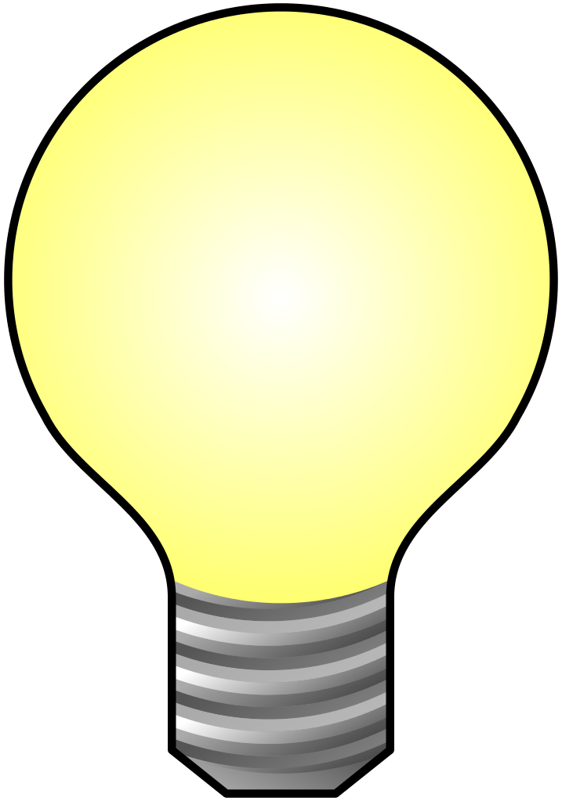
How long does it take the Earth to complete one full rotation on its axis?
What is the cause for Earth to rotate on its axis?
What type of galaxy is the Milky Way classified as?
How long does it take the Earth to complete one full rotation on its axis?
What is the cause for Earth to rotate on its axis?
What type of galaxy is the Milky Way classified as?
Are interactive notebooks effective?
How are interactive notebooks organized?
How are interactive notebooks assessed?

Line of Evidence – Earth as a Peppercorn
As we pieced together our planets of the solar system, we learned how Earth’s position as the third planet from the Sun, is the reason why it takes the Earth 365 days to make one full rotation around the Sun.

Line of Evidence – The Location of Earth
The Earth’s location is the reason that it is the only planet within the solar system that can sustain human life.

Line of Evidence – Living in the Milky Way
Due to our positioning within the Milky Way, there has never been a telescope able to reach far enough and take a picture of the galaxy. We can however, see the disk of the Milky Way at night time due to our position.

Big Aha Thesis Statement
The Earth is the third planet closest to the Sun which is the center point of our solar system. Our solar system is located on a spiral arm about two-thirds of the way from the center of the Milky Way galaxy.

Line of Evidence – Earth as a Peppercorn
As we pieced together our planets of the solar system, we learned how Earth’s position as the third planet from the Sun, is the reason why it takes the Earth 365 days to make one full rotation around the Sun.

Line of Evidence – The Location of Earth
The Earth’s location is the reason that it is the only planet within the solar system that can sustain human life.

Line of Evidence – Living in the Milky Way
Due to our positioning within the Milky Way, there has never been a telescope able to reach far enough and take a picture of the galaxy. We can however, see the disk of the Milky Way at night time due to our position.

Big Aha Thesis Statement
The Earth is the third planet closest to the Sun which is the center point of our solar system. Our solar system is located on a spiral arm about two-thirds of the way from the center of the Milky Way galaxy.

.

Engage - Earth as a Peppercorn
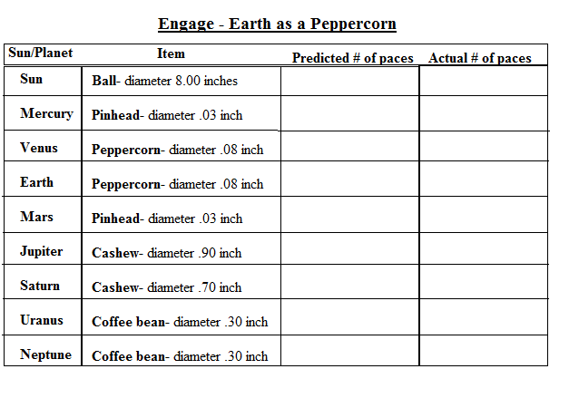
Ottewell, G. (n.d.). THE THOUSAND-YARD MODEL or, The Earth as a Peppercorn. Retrieved March 16, 2017, from https://www.noao.edu/education/peppercorn/pcmain.html
Engage – Earth as a Peppercorn
Ottewell, G. (n.d.). THE THOUSAND-YARD MODEL or, The Earth as a Peppercorn. Retrieved March 16, 2017, from https://www.noao.edu/education/peppercorn/pcmain.html
Explore – The Location of The Earth
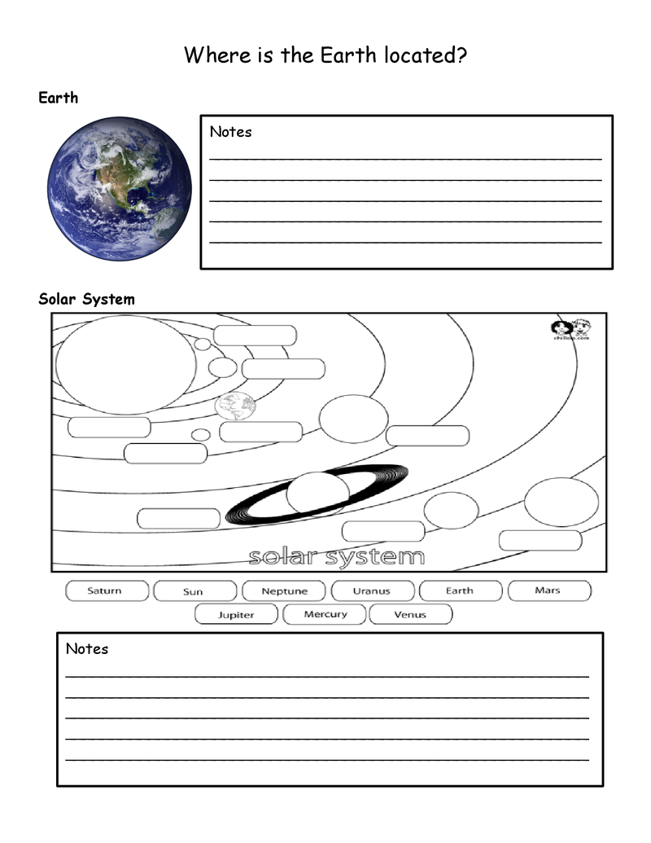
Nelson, K. (n.d.). The Location of Earth. Retrieved March 17, 2017, from https://betterlesson.com/lesson/635652/the-location-of-earth
Explore – The Location of The Earth
Nelson, K. (n.d.). The Location of Earth. Retrieved March 17, 2017, from https://betterlesson.com/lesson/635652/the-location-of-earth
The Location of The Earth CER
Claim (Write a sentence or two, stating where the Earth is located at in the solar system.)

Evidence (Give the name of the galaxy our solar system lies within and name all the planets within the solar system in order from closest to the Sun to the farthest.)

Reasoning (Explain how your evidence supports your claim. Describe the location of the Earth.)
The Location of The Earth CER
Claim (Write a sentence or two, stating where the Earth is located at in the solar system.)

Evidence (Give the name of the galaxy our solar system lies within and name all the planets within the solar system in order from closest to the Sun to the farthest.)

Reasoning (Explain how your evidence supports your claim. Describe the location of the Earth.)

ANSWER KEY The Location of The Earth CER
Claim (Write a sentence or two, stating where the Earth is located at in the solar system.)
The Earth is the third planet closest to the Sun. It is located between Venus and Mars.

Evidence (Give the name of the galaxy our solar system lies within and name all the planets within the solar system in order from closest to the Sun to the farthest.)
The galaxy our solar system is in is called the Milky Way Galaxy. There are eight planets in the solar system, they are Mercury, Venus, Earth, Mars, Jupiter, Saturn, Uranus, and Neptune.

Reasoning (Explain how your evidence supports your claim. Describe the location of the Earth.)
As stated in my evidence, the Earth is the third planet closest to the Sun. I know this is correct because I have the planets in the correct order from closest to farthest from the Sun.

ANSWER KEY The Location of The Earth CER
Claim (Write a sentence or two, stating where the Earth is located at in the solar system.)
The Earth is the third planet closest to the Sun. It is located between Venus and Mars.

Evidence (Give the name of the galaxy our solar system lies within and name all the planets within the solar system in order from closest to the Sun to the farthest.)
The galaxy our solar system is in is called the Milky Way Galaxy. There are eight planets in the solar system, they are Mercury, Venus, Earth, Mars, Jupiter, Saturn, Uranus, and Neptune.

Reasoning (Explain how your evidence supports your claim. Describe the location of the Earth.)
As stated in my evidence, the Earth is the third planet closest to the Sun. I know this is correct because I have the planets in the correct order from closest to farthest from the Sun.

Explain - Informational Texts
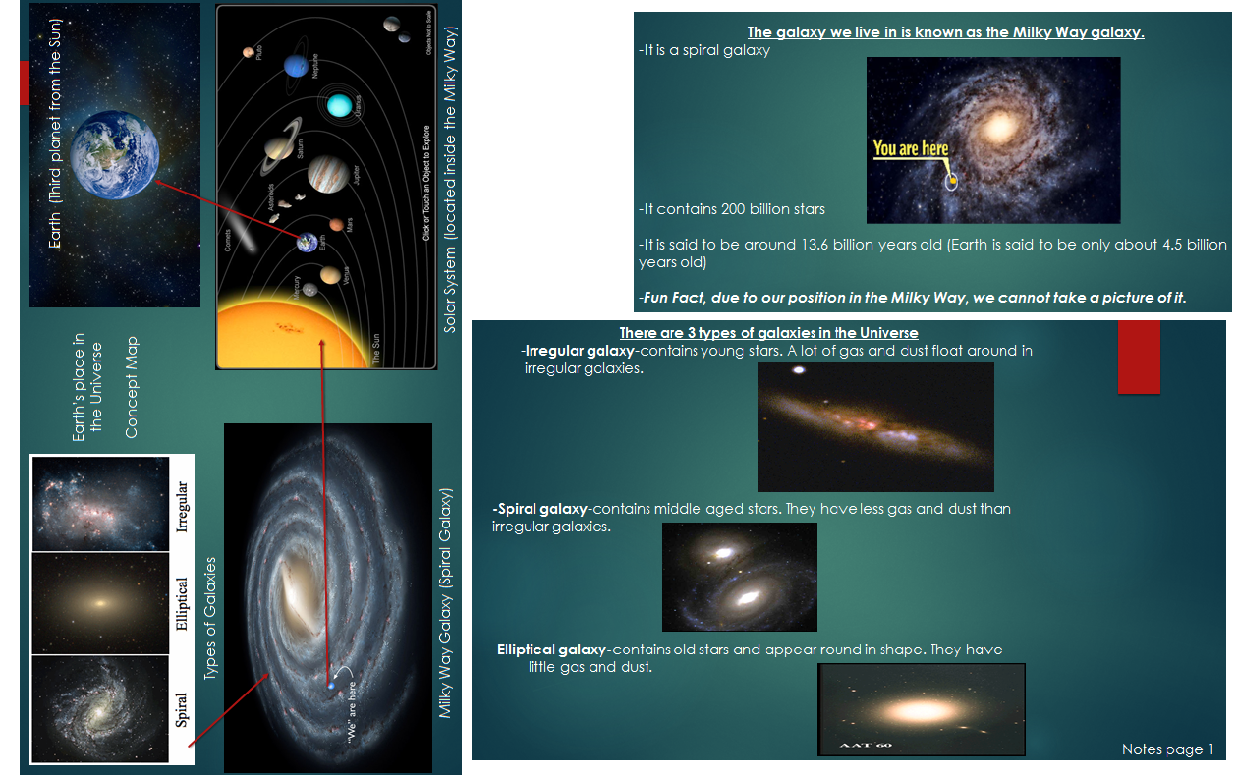

Explain - Informational Texts

Explain - Informational Texts cont.

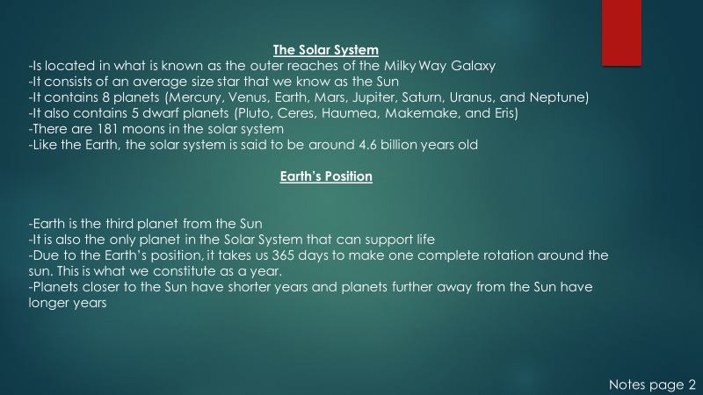
Explain- Informational Texts cont.

Explain - Informational Texts cont.

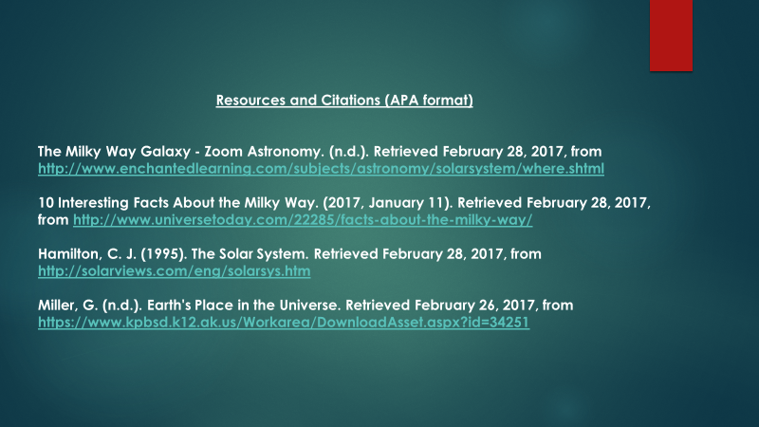

Explain - Informational Texts cont.

Informational Texts Reading Questions
- What type of galaxy contains the youngest stars?

- What type of galaxy contains the oldest stars?

- According to our notes, how much older is the Milky Way galaxy than our solar system?

- What type of galaxy is the Milky Way?

- How many photographs have scientists taken of the Milky Way in the past 20 years?

- Place the planets in order from closest to farthest from the Sun.

- How many planets in our solar system can support life?

- The Sun is the largest star in our solar system, True or False?

Informational Texts Reading Questions
- What type of galaxy contains the youngest stars?

- What type of galaxy contains the oldest stars?

- According to our notes, how much older is the Milky Way galaxy than our solar system?

- What type of galaxy is the Milky Way?

- How many photographs have scientists taken of the Milky Way in the past 20 years?

- Place the planets in order from closest to farthest from the Sun.

- How many planets in our solar system can support life?

- The Sun is the largest star in our solar system, True or False?

ANSWER KEY Informational Texts Reading Questions
- What type of galaxy contains the youngest stars?
Irregular galaxy

- What type of galaxy contains the oldest stars?
Elliptical galaxy

- According to our notes, how much older is the Milky Way galaxy than our solar system?
9.1 billion years

- What type of galaxy is the Milky Way?
Spiral Galaxy
- How many photographs have scientists taken of the Milky Way in the past 20 years?
zero
- Place the planets in order from closest to farthest from the Sun.
Mercury, Venus, Earth, Mars, Jupiter, Saturn, Uranus, Neptune
- How many planets in our solar system can support life?
1
- The Sun is the largest star in our solar system, True or False?
True

ANSWER KEY Informational Texts Reading Questions
- What type of galaxy contains the youngest stars?
Irregular galaxy

- What type of galaxy contains the oldest stars?
Elliptical galaxy

- According to our notes, how much older is the Milky Way galaxy than our solar system?
9.1 billion years

- What type of galaxy is the Milky Way?
Spiral Galaxy
- How many photographs have scientists taken of the Milky Way in the past 20 years?
zero
- Place the planets in order from closest to farthest from the Sun.
Mercury, Venus, Earth, Mars, Jupiter, Saturn, Uranus, Neptune
- How many planets in our solar system can support life?
1
- The Sun is the largest star in our solar system, True or False?
True

Elaborate – Living in the Milky Way
Living in the Milky Way
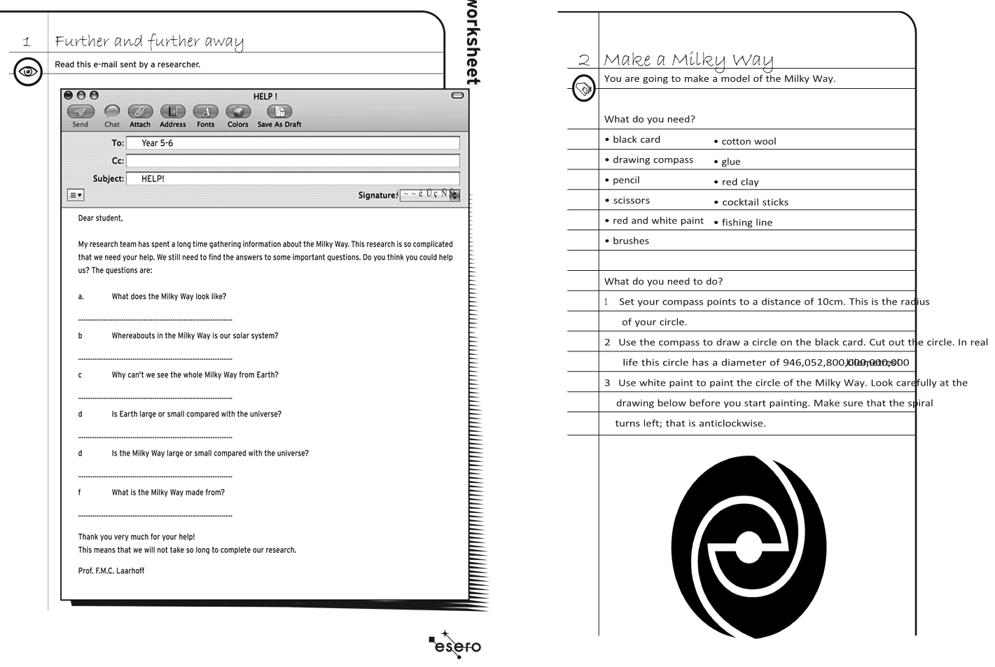
Living in the Milky Way. (n.d.). Retrieved March 21, 2017, from http://astroedu.iau.org/en/activities/living-in-the-milky-way/

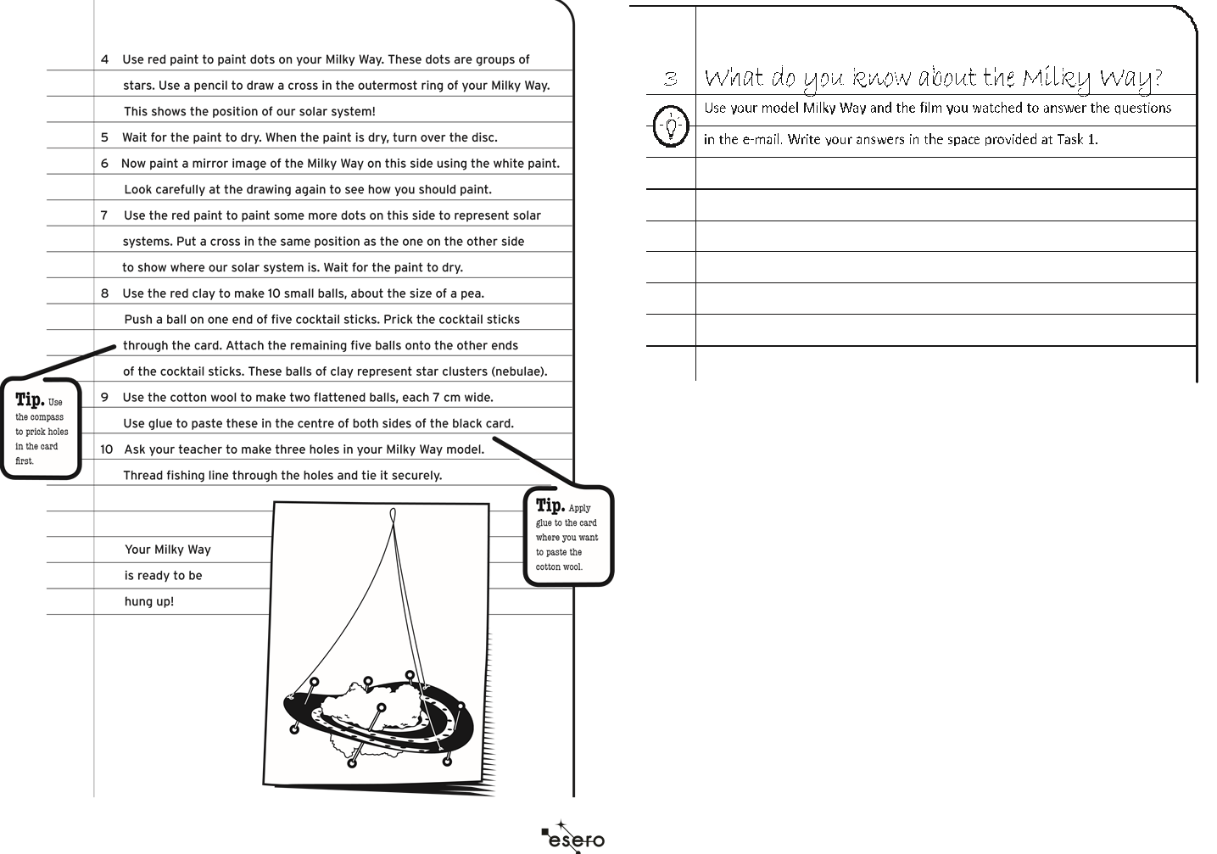
Elaborate – Living in the Milky Way
Living in the Milky Way
Living in the Milky Way. (n.d.). Retrieved March 21, 2017, from http://astroedu.iau.org/en/activities/living-in-the-milky-way/

Living in the Milky Way CER
Claim (Write a sentence stating what type of galaxy the Milky Way is.)

Evidence (Provide evidence from the previous assignment to support your claim. Describe the different materials and features that each type of galaxy consists of.)

Reasoning (Explain how your evidence supports your claim. Describe what type of galaxy the Milky Way is based on your findings in the evidence section.)

Living in the Milky Way CER
Claim (Write a sentence stating what type of galaxy the Milky Way is.)

Evidence (Provide evidence from the previous assignment to support your claim. Describe the different materials and features that each type of galaxy consists of.)

Reasoning (Explain how your evidence supports your claim. Describe what type of galaxy the Milk Way is based on your findings in the evidence section.)

ANSWER KEY Living in the Milky Way CER
Claim (Write a sentence stating what type of galaxy the Milky Way is.)
The Milky Way is a Spiral Type galaxy.

Evidence (Provide evidence from the previous assignment to support your claim. Describe the different materials and features that each type of galaxy consists of.)
Irregular galaxies are made up of young stars, gas, and dust. They look sporadic, because there is no definite shape to an irregular galaxy. Elliptical galaxies are made of old stars, little gas, and dust and they appear as elongated objects. Spiral galaxies contain middle aged stars, less gas and dust compared to an irregular galaxy and appear as a circular object with spiraled arms.

Reasoning (Explain how your evidence supports your claim. Describe what type of galaxy the Milky Way is based on your findings in the evidence section.)
The Milky Way is a spiral galaxy because it contains middle aged stars and appears as a circular object.

ANSWER KEY Living in the Milky Way CER
Claim (Write a sentence stating what type of galaxy the Milky Way is.)
The Milky Way is a Spiral Type galaxy.

Evidence (Provide evidence from the previous assignment to support your claim. Describe the different materials and features that each type of galaxy consists of.)
Irregular galaxies are made up of young stars, gas, and dust. They look sporadic, because there is no definite shape to an irregular galaxy. Elliptical galaxies are made of old stars, little gas, and dust and they appear as elongated objects. Spiral galaxies contain middle aged stars, less gas and dust compared to an irregular galaxy and appear as a circular object with spiraled arms.

Reasoning (Explain how your evidence supports your claim. Describe what type of galaxy the Milky Way is based on your findings in the evidence section.)
The Milky Way is a spiral galaxy because it contains middle aged stars and appears as a circular object.

Big Ah-Ha Thesis
The purpose of this unit was to gain a better understanding of Earth’s position in the solar system, the Milky Way galaxy where our solar system is located, and to learn the difference between the three types of galaxies within the universe.
We created our own solar system using common items and scaling the distance accurately so that we could see the relationship difference between each planet to the Sun. During the activity, we located and labeled Earth’s position as the third planet from the Sun, between Venus and Mars.
Our Location of the Earth activity allowed us to see that due to its precise location within the solar system, it is the only planet that can sustain human life. Once we correctly placed the planets in order from closest to farthest, we were able to see that Earth’s position is perfect for human life because of being in just the right position; any closer to the Sun and we would burn up, any farther away and we would freeze.
We also learned that our solar system is located within the Milky Way Galaxy. The Milky Way is a Spiral galaxy because it contains stars younger than those of an irregular galaxy and that are older than a elliptical galaxy. The Milky Way galaxy also contains spiral arms, one being where our solar system is located.
Each of our activities was a line of evidence. They helped us explain the position of Earth within the solar system and the solar system within the Milky Way galaxy.

Big Ah-Ha Thesis

The purpose of this unit was to gain a better understanding of Earth’s position in the solar system, the Milky Way galaxy where our solar system is located, and to learn the difference between the three types of galaxies within the universe.
We created our own solar system using common items and scaling the distance accurately so that we could see the relationship difference between each planet to the Sun. During the activity, we located and labeled Earth’s position as the third planet from the Sun, between Venus and Mars.
Our Location of the Earth activity allowed us to see that due to its precise location within the solar system, it is the only planet that can sustain human life. Once we correctly placed the planets in order from closest to farthest, we were able to see that Earth’s position is perfect for human life because of being in just the right position; any closer to the Sun and we would burn up, any farther away and we would freeze.
We also learned that our solar system is located within the Milky Way Galaxy. The Milky Way is a Spiral galaxy because it contains stars younger than those of an irregular galaxy and that are older than a elliptical galaxy. The Milky Way galaxy also contains spiral arms, one being where our solar system is located.
Each of our activities was a line of evidence. They helped us explain the position of Earth within the solar system and the solar system within the Milky Way galaxy.

Self-Reflection Paragraph
Before we began this unit, I was unfamiliar with that type of galaxy the Milky Way was, honestly, I always thought the Milky Way was nothing more than a candy bar. I have always heard the Earth being referred to as the “Third Rock from the Sun”, but until I was able to see its position next to the other planets, I never truly understood what that saying meant. The most fun activity was when we got to go outside and create our own solar system, who would have ever known that the farthest planet, Neptune would take so many football fields to reach.

Self-Reflection Paragraph
Before we began this unit, I was unfamiliar with that type of galaxy the Milky Way was, honestly, I always thought the Milky Way was nothing more than a candy bar. I have always heard the Earth being referred to as the “Third Rock from the Sun”, but until I was able to see its position next to the other planets, I never truly understood what that saying meant. The most fun activity was when we got to go outside and create our own solar system, who would have ever known that the farthest planet, Neptune would take so many football fields to reach.

