Presence and Location of Fossils in Rock Strata

Presence and Location of Fossils in Rock Strata

Overarching Question: What can the evidence found from fossils tell us about rock strata?

Overarching Question: What can the evidence found from fossils tell us about rock strata?

Can you determine the age of a fossil based on which rock strata it is found in?
What are the different rock layers that have been found?
Why would a fossil be in a lower rock strata and others be in higher rock strata?
Can you determine the age of a fossil based on which rock strata it is found in?
What are the different rock layers that have been found?
Why would a fossil be in a lower rock strata and others be in higher rock strata?

Line of Evidence – Self Connections/Prior Knowledge
We discussed and came up with everyday examples of the rule of superposition such as a pile of laundry, a stack of papers, and trash in a trash can to show that the things or layers at the bottom are the oldest, or were placed there first, while the things or layers closest to the top are the newest or were put there last

Line of Evidence – Fossil Knowledge & Dating Activity
The rock strata are in order from oldest, at the bottom, to youngest, at the top, and all of the layers have a name that represents the time period in which they were formed.

Line of Evidence – Informational Text
Sedimentary rock is the type of rock in which fossils are most likely to form. Geologic age dating is assigning an age to materials which can be further broken down in the categories of relative and absolute age dating.

Line of Evidence – Checking and Discussion
The learning activities helped us understand that the presence and evidence of fossils in rock strata allows us to determine things like the age, climate, and species of that of the time that rock layer was formed and represents.

Big Aha Thesis Statement
The purpose of this unit was to understand what can be learned about the formation of rock strata from the evidence found from the presence and location of fossils.

Line of Evidence – Self Connections/Prior Knowledge
We discussed and came up with everyday examples of the rule of superposition such as a pile of laundry, a stack of papers, and trash in a trash can to show that the things or layers at the bottom are the oldest, or were placed there first, while the things or layers closest to the top are the newest or were put there last

Line of Evidence – Fossil Knowledge & Dating Activity
The rock strata are in order from oldest, at the bottom, to youngest, at the top, and all of the layers have a name that represents the time period in which they were formed.

Line of Evidence – Informational Text
Sedimentary rock is the type of rock in which fossils are most likely to form. Geologic age dating is assigning an age to materials which can be further broken down in the categories of relative and absolute age dating.

Line of Evidence – Checking and Discussion
The learning activities helped us understand that the presence and evidence of fossils in rock strata allows us to determine things like the age, climate, and species of that of the time that rock layer was formed and represents.

Big Aha Thesis Statement
The purpose of this unit was to understand what can be learned about the formation of rock strata from the evidence found from the presence and location of fossils.

Vocabulary Terms
- Sediment-

- Sedimentary Rocks-

- Rock Strata-

- Fossils-

- Geochronology-.

- Geologic Age Dating-

- Relative Age Dating-

- Absolute Age Dating-

- Rule of Superposition-

- Eon

- Era-

- Period-

- Epoch-

Vocabulary Terms
- Sediment-

- Sedimentary Rocks-

- Rock Strata-

- Fossils-

- Geochronology-.

- Geologic Age Dating-

- Relative Age Dating-

- Absolute Age Dating-

- Rule of Superposition-

- Eon

- Era-

- Period-

- Epoch-

Vocabulary Terms Defined
- Sediment- Silt, sand, rocks, fossils, and other matter carried and deposited by water, wind, or ice.
- Sedimentary Rocks- Rocks formed when soil and other materials on the Earth’s surface are eroded and finally settle down, forming one layer of sediments.
- Rock Strata- Layers of sedimentary rock.
- Fossils- the remains or impression of a prehistoric organism preserved in petrified form or as a mold or cast in rock.
- Geochronology- The branch of geology concerned with the dating of rock formations and geological events.
- Geologic Age Dating- The study of assigning an age to materials.
- Relative Age Dating- The science of determining the relative order of past events without necessarily determining their absolute age
- Absolute Age Dating- The process of determining a specific age of a rock layer.
- Rule of Superposition- The rule that states the newer rock layers will be on top of older rock layers.
- Eon- Longest time unit measured in BILLIONS of years
- Era- Next longest measured in HUNDREDS of MILLIONS of years
- Period- Measured in TENS of MILLIONS of years
- Epoch- Measured in MILLIONS of years

Vocabulary Terms Defined
- Sediment- Silt, sand, rocks, fossils, and other matter carried and deposited by water, wind, or ice.
- Sedimentary Rocks- Rocks formed when soil and other materials on the Earth’s surface are eroded and finally settle down, forming one layer of sediments.
- Rock Strata- Layers of sedimentary rock.
- Fossils- the remains or impression of a prehistoric organism preserved in petrified form or as a mold or cast in rock.
- Geochronology- The branch of geology concerned with the dating of rock formations and geological events.
- Geologic Age Dating- The study of assigning an age to materials.
- Relative Age Dating- The science of determining the relative order of past events without necessarily determining their absolute age
- Absolute Age Dating- The process of determining a specific age of a rock layer.
- Rule of Superposition- The rule that states the newer rock layers will be on top of older rock layers.
- Eon- Longest time unit measured in BILLIONS of years
- Era- Next longest measured in HUNDREDS of MILLIONS of years
- Period- Measured in TENS of MILLIONS of years
- Epoch- Measured in MILLIONS of years

Engage - Self Connections/Prior Knowledge
Let’s look at something we are all pretty familiar with to relate our lesson to something we already understand. As I stack these different papers, we are going to read the date that is marked on top of the page. Turn and talk to your neighbor about what you noticed about the dates on the pages? Are they in order and if so, how? Now I also want you and your neighbor to think about a pile of clothes on the floor in your room or the trash in the trash can and talk about what kind of order you think those things are in? Can you think of any other examples? The examples we have talked about so far are all examples of the Rule of Superposition which states that the newer item or layer of items will be on top of older items or layers of items. This term is actually used when discussing rock layers and the role of fossils in the rock layers.
Now we’re going to look at our fossil dating chart and the activity I have brought for us to do today. I have several different pieces of a cake that are sliced to expose the center which will have cheerios, fruit loops, pretzels, and other various snacks in each layer to represent the different kinds of fossils that have formed at different times during history. For this activity we will be researching these different kinds of fossils, teaching each other about the information we have found, and actually layering our cake pieces according to our findings. Which means we will need to create a key to show which kind of fossils each of the snacks represents and I would like for everyone to mentally make a prediction about the order of the layers based on your prior knowledge of past plant and animal life and the previous discussion about the order in which the layers were formed.

Engage – Self Connections/Prior Knowledge
Let’s look at something we are all pretty familiar with to relate our lesson to something we already understand. As I stack these different papers, we are going to read the date that is marked on top of the page. Turn and talk to your neighbor about what you noticed about the dates on the pages? Are they in order and if so, how? Now I also want you and your neighbor to think about a pile of clothes on the floor in your room or the trash in the trash can and talk about what kind of order you think those things are in? Can you think of any other examples? The examples we have talked about so far are all examples of the Rule of Superposition which states that the newer item or layer of items will be on top of older items or layers of items. This term is actually used when discussing rock layers and the role of fossils in the rock layers.
Now we’re going to look at our fossil dating chart and the activity I have brought for us to do today. I have several pieces of a cake that are sliced to expose the center which will have cheerios, fruit loops, pretzels, and other various snacks in each layer to represent the different kinds of fossils that have formed at different times during history. For this activity we will be researching these different kinds of fossils, teaching each other about the information we have found, and actually layering our cake pieces according to our findings. Which means we will need to create a key to show which kind of fossils each of the snacks represents and I would like for everyone to mentally make a prediction about the order of the layers based on your prior knowledge of past plant and animal life and the previous discussion about the order in which the layers were formed.
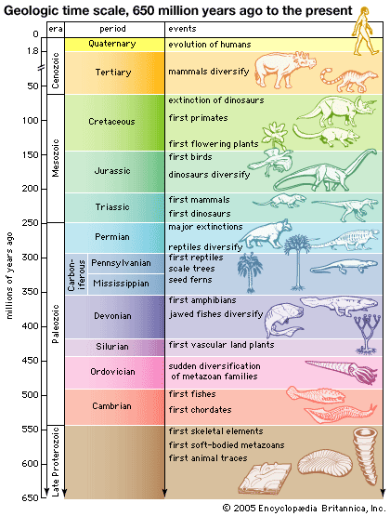
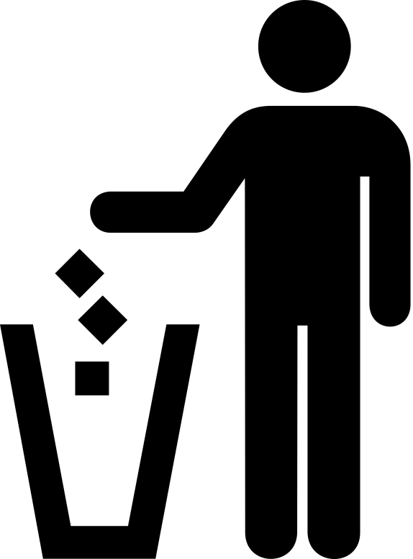
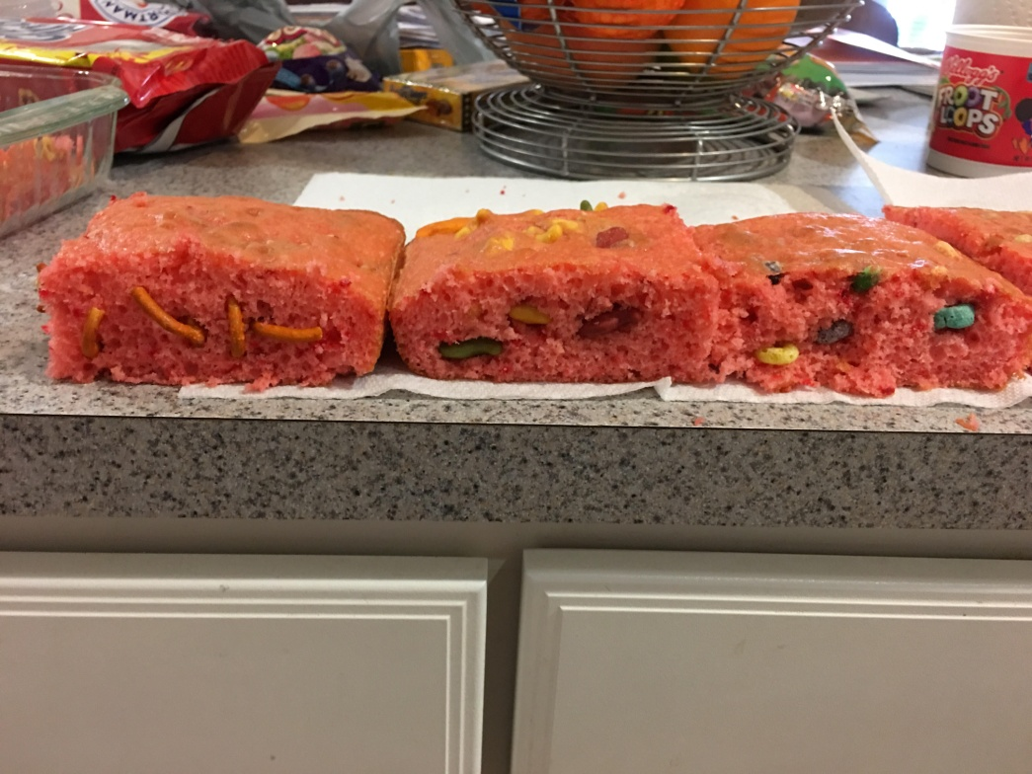
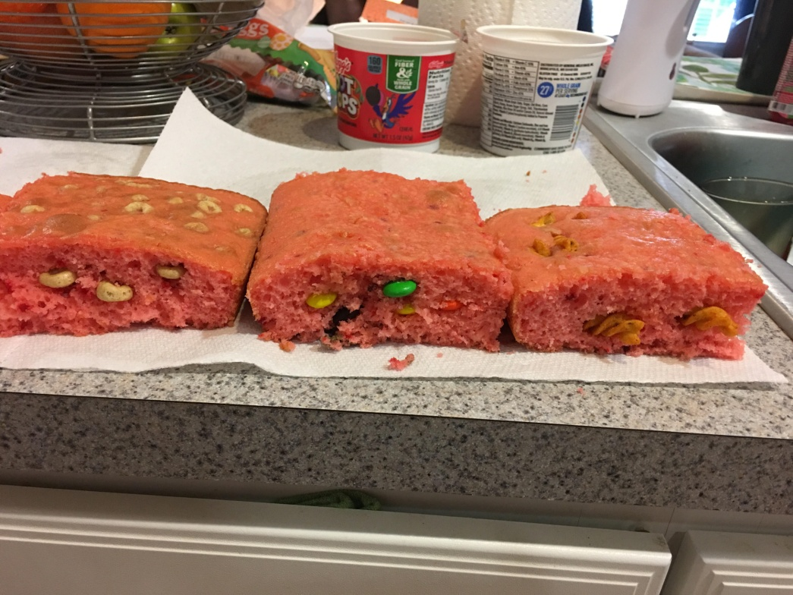
Explore – Fossil Knowledge & Dating Activity
Key:
Cambrian- Gold Fish
Devonian- Pretzels
Carboniferous- M&Ms
Triassic- Fruit Loops
Jurassic- Curly Fritos
Cretaceous- Cheerios
STEM 5 Es Booklet Explore Chart Fossil Knowledge & Dating Activity.docx

Explore – Fossil Knowledge & Dating Activity
Key:
Cambrian- Gold Fish
Devonian- Pretzels
Carboniferous- M&Ms
Triassic- Fruit Loops
Jurassic- Curly Fritos
Cretaceous- Cheerios
STEM 5 Es Booklet Explore Chart Fossil Knowledge & Dating Activity.docx

ANSWER KEY Presence and Location of Fossils in Rock Strata CER
Claim (Write a sentence in your own words defining the law of superposition and fossils).
The law of superposition states that rock strata (layers) farthest from the ground surface are the oldest (formed first) and rock strata (layers) closest to the ground surface are the youngest (formed most recently).
A fossil is the remains or traces of plants and animals that lived long ago.
Evidence (Provide names of the rock strata (time period) and descriptions of the fossils most likely found in those rock strata.)
Cambrian- Fish, Aquatic Creatures
Devonian- Amphibians
Carboniferous- Reptiles, Ferns, Trees
Triassic- First Mammals, First Dinosaurs
Jurassic- First Birds
Cretaceous- Flowering Plants, First Primates (Monkeys), Dinosaurs Extinct
Reasoning (Describe how the presence and location of fossils determine the order in which rock strata were formed).
Knowing the types of plants and animals that were present during the time that rock stratum was formed helps us understand the order because we know when certain plants and animals became known and when they became extinct which gives us a time range of when the rock stratum could have formed.

Presence and Location of Fossils in Rock Strata CER
Claim (Write a sentence in your own words defining the law of superposition and fossils).

Evidence (Provide names of the rock strata (time period) and descriptions of the fossils most likely found in those rock strata.)

Reasoning (Describe how the presence and location of fossils determine the order in which rock strata were formed).

ANSWER KEY Presence and Location of Fossils in Rock Strata CER
Claim (Write a sentence in your own words defining the law of superposition and fossils).
The law of superposition states that rock strata (layers) farthest from the ground surface are the oldest (formed first) and rock strata (layers) closest to the ground surface are the youngest (formed most recently).
A fossil is the remains or traces of plants and animals that lived long ago.
Evidence (Provide names of the rock strata (time period) and descriptions of the fossils most likely found in those rock strata.)
Cambrian- Fish, Aquatic Creatures
Devonian- Amphibians
Carboniferous- Reptiles, Ferns, Trees
Triassic- First Mammals, First Dinosaurs
Jurassic- First Birds
Cretaceous- Flowering Plants, First Primates (Monkeys), Dinosaurs Extinct
Reasoning (Describe how the presence and location of fossils determine the order in which rock strata were formed).
Knowing the types of plants and animals that were present during the time that rock stratum was formed helps us understand the order because we know when certain plants and animals became known and when they became extinct which gives us a time range of when the rock stratum could have formed.

Presence and Location of Fossils in Rock Strata CER
Claim (Write a sentence in your own words defining the law of superposition and fossils).

Evidence (Provide names of the rock strata (time period) and descriptions of the fossils most likely found in those rock strata.)

Reasoning (Describe how the presence and location of fossils determine the order in which rock strata were formed).

Explain - Informational Texts
Sedimentary rocks start forming when soil and other materials on the Earth’s surface are eroded and finally settle down, forming one layer of sediments. As time passes, more and more materials get eroded and settle on the older layers. Thus, layer upon layer is formed. The lower layers undergo intense pressure due to the weight of the upper layers, eventually evolving into rocks.
Some examples of sedimentary rocks are sandstone, limestone, shale, conglomerate, and gypsum. Sandstone, for instance, is a result of depositions of sand from beaches and rivers. You can find them mostly in deltas, since this is where the rivers flow into the ocean.
(http://www.universetoday.com/46594/how-are-rocks-formed/) (Villanueva, J. C.)

Read down to the paragraph that begins with “First, the fossils.”
(http://www.kidsdiscover.com/teacherresources/geologic-age-dating-explained/) (Geiger, B.)
Explain - Informational Texts
Sedimentary rocks start forming when soil and other materials on the Earth’s surface are eroded and finally settle down, forming one layer of sediments. As time passes, more and more materials get eroded and settle on the older layers. Thus, layer upon layer is formed. The lower layers undergo intense pressure due to the weight of the upper layers, eventually evolving into rocks.
Some examples of sedimentary rocks are sandstone, limestone, shale, conglomerate, and gypsum. Sandstone, for instance, is a result of depositions of sand from beaches and rivers. You can find them mostly in deltas, since this is where the rivers flow into the ocean.
(http://www.universetoday.com/46594/how-are-rocks-formed/) (Villanueva, J. C.)

Read down to the paragraph that begins with “First, the fossils.”
(http://www.kidsdiscover.com/teacherresources/geologic-age-dating-explained/) (Geiger, B.)
Vocab/Informational Texts Reading Questions
- The layer is closest to the Earth’s surface.
- Retell in your own words the definition of the Rule of Superposition.

- Draw, label, and explain what you think a fossil of something in your desk might look like.

- What is Geochronology?
a. The study of the stars.
b. The study of fish.
c. The dating of rock formations and geological events.

- True or False. All things that die become fossils?

- Defend your answer for number 5.

- Sediment is matter carried and deposited by water, wind, or ice that forms sedimentary rock. What are some examples of sediment? Check all that apply.
Silt Grass Sand Rocks Fossils

8. Eon A. Measured in MILLIONS of years
Era B. Longest time unit measured in BILLIONS of years
Period C. Measured in TENS of MILLIONS of years
Epoch D. Next longest measured in HUNDREDS of MILLIONS of years

Vocab/Informational Texts Reading Questions
- The layer is closest to the Earth’s surface.
- Retell in your own words the definition of the Rule of Superposition.

- Draw, label, and explain what you think a fossil of something in your desk might look like.

- What is Geochronology?
  - The study of the stars.
  - The study of fish.
  - The dating of rock formations and geological events.

- True or False. All things that die become fossils?

- Defend your answer for number 5.

- Sediment is matter carried and deposited by water, wind, or ice that forms sedimentary rock. What are some examples of sediment? Check all that apply.
Silt Grass Sand Rocks Fossils

8. Eon A. Measured in MILLIONS of years
Era B. Longest time unit measured in BILLIONS of years
Period C. Measured in TENS of MILLIONS of years
Epoch D. Next longest measured in HUNDREDS of MILLIONS of years

ANSWER KEY Informational Texts Reading Questions
- Youngest
- A basic law of geochronology, stating that in any undisturbed sequence of rocks
- Varied responses.
- C
- False.
- Varied answers that should relate to the correct answer for the Entrance Ticket.
- All should be checked except grass.
- B, D, C, A

ANSWER KEY Informational Texts Reading Questions
- Youngest
- A basic law of geochronology, stating that in any undisturbed sequence of rocks
- Varied responses.
- C
- False.
- Varied answers that should relate to the correct answer for the Entrance Ticket.
- All should be checked except grass.
- B, D, C, A

Elaborate – Checking and Discussion
Now we will use the geologic time scale to check and discuss the finished project to see if we made any mistakes during the stacking. Then you will write a few sentences comparing your predictions to the final outcome and elaborate on what you have learned about the presence of fossils in rock layers.

Elaborate – Checking and Discussion
Now we will use the geologic time scale to check and discuss the finished project to see if we made any mistakes during the stacking. Then you will write a few sentences comparing your predictions to the final outcome and elaborate on what you have learned about the presence of fossils in rock layers.

Big Ah-Ha Thesis
The purpose of this unit was to understand what can be learned about the formation of rock strata from the evidence found from the presence and location of fossils. We learned new vocabulary terms, made predictions and everyday connections to the materials, researched and shared information, completed a hands-on activity, and wrapped up the lesson with a written reflection.
We discussed and came up with everyday examples of the rule of superposition such as a pile of laundry, a stack of papers, and trash in a trash can to show that the things or layers at the bottom are the oldest, or were placed there first, while the things or layers closest to the top are the newest or were put there last. Then we discussed the pictures, activity, and made predictions about the outcome of the activity.
The rock strata are in order from oldest, at the bottom, to youngest, at the top, and all of the layers have a name that represents the time period in which they were formed. The layers in order are Cambrian, Ordovician, Silurian, Devonian, Carboniferous, (Mississippian and Pennsylvanian), Permian, Triassic, Jurassic, Cretaceous, Tertiary, and Quaternary.
Sedimentary rock is the type of rock in which fossils are most likely to form. Geologic age dating is assigning an age to materials which can be further broken down in the categories of relative and absolute age dating. Relative age dating is simply saying this is older or younger than that while absolute dating is assigning an actual number age to a material. We learned this and other vocabulary words from our reading and answered some questions to check for comprehension. We also checked for mistakes, compared our predictions to the final outcomes, and elaborated on what we learned during the lesson about the presence of fossils in rock layers.
Each of our learning activities was a line of evidence. The learning activities helped us understand that the presence and evidence of fossils in rock strata allows us to determine things like the age, climate, and species of that of the time that rock layer was formed and represents.

Big Ah-Ha Thesis
The purpose of this unit was to understand what can be learned about the formation of rock strata from the evidence found from the presence and location of fossils. We learned new vocabulary terms, made predictions and everyday connections to the materials, researched and shared information, completed a hands-on activity, and wrapped up the lesson with a written reflection.
We discussed and came up with everyday examples of the rule of superposition such as a pile of laundry, a stack of papers, and trash in a trash can to show that the things or layers at the bottom are the oldest, or were placed there first, while the things or layers closest to the top are the newest or were put there last. Then we discussed the pictures, activity, and made predictions about the outcome of the activity.
The rock strata are in order from oldest, at the bottom, to youngest, at the top, and all of the layers have a name that represents the time period in which they were formed. The layers in order are Cambrian, Ordovician, Silurian, Devonian, Carboniferous, (Mississippian and Pennsylvanian), Permian, Triassic, Jurassic, Cretaceous, Tertiary, and Quaternary.
Sedimentary rock is the type of rock in which fossils are most likely to form. Geologic age dating is assigning an age to materials which can be further broken down in the categories of relative and absolute age dating. Relative age dating is simply saying this is older or younger than that, while absolute dating is assigning an actual number age to a material. We learned this and other vocabulary words from our reading and answered some questions to check for comprehension. We also checked for mistakes, compared our predictions to the final outcomes, and elaborated on what we learned during the lesson about the presence of fossils in rock layers.
Each of our learning activities was a line of evidence. The learning activities helped us understand that the presence and evidence of fossils in rock strata allows us to determine things like the age, climate, and species of that of the time that rock layer was formed and represents.

