Forces
Forces

Overarching Question: What are the effects of balanced and unbalanced forces on the speed and direction of motion of objects?

What is the difference between balanced and unbalanced forces?
What is the relationship between force, speed, and distance?
How does friction and mass affect motion of an object?

What is the difference between balanced and unbalanced forces?
What is the relationship between force, speed, and distance?
How does friction and mass affect motion of an object?
Are interactive notebooks effective?
How are interactive notebooks organized?
How are interactive notebooks assessed?

Overarching Question: What are the effects of balanced and unbalanced forces on the speed and direction of motion of objects?
Line of Evidence – Force Notes
If balanced forces are acting on an object, the forces cancel out and no movement occurs. If unbalanced forces are acting on an object, the forces combine to change the motion of the object.

Line of Evidence – Marshmallow Shooter
When the marshmallow was pulled back the furthest, applying the most force, the marshmallow travelled the fastest and the furthest. Therefore, more force means more speed and more distance.

Line of Evidence – “What is Friction?” Activity
Friction acts as an opposite force on an object which makes the object in motion slow down, come to a stop, or move in the opposite direction given the amount of opposite force applied.

Big Aha Thesis Statement
Forces combine their amount of force when acting on an object. Balanced forces combine to make a net force of 0, meaning no speed or motion occurs. Unbalanced forces combine to either make the object move more quickly or slowly or change the direction of the object depending on the amount and direction of the forces.

Line of Evidence – Force Notes
If balanced forces are acting on an object, the forces cancel out and no movement occurs. If unbalanced forces are acting on an object, the forces combine to change the motion of the object.

Line of Evidence – Marshmallow Shooter
When the marshmallow was pulled back the furthest, applying the most force, the marshmallow travelled the fastest and the furthest. Therefore, more force means more speed and more distance.

Line of Evidence – “What is Friction?” Activity
Friction acts as an opposite force on an object which makes the object in motion slow down, come to a stop, or move in the opposite direction given the amount of opposite force applied.

Big Aha Thesis Statement
Forces combine their amount of force when acting on an object. Balanced forces combine to make a net force of 0, meaning no speed or motion occurs. Unbalanced forces combine to either make the object move more quickly or slowly or change the direction of the object depending on the amount and direction of the forces.

Engage - Forces Make Things Move

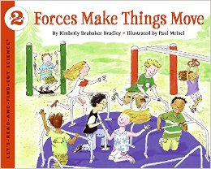

Before reading the book, , fill out the “Know” and “Wonder” columns of the provided KWL chart.
Take turns reading the book outloud with your partner.
After reading the book, fill out the “Learn” column. Discuss your KWL chart with your partner.

Source: Bradley, K. B., & Meisel, P. (2010). Forces make things move. New York, NY: HarperCollins.

Engage – Forces Make Things Move

Before reading the book, , fill out the “Know” and “Wonder” columns of the provided KWL chart.
Take turns reading the book outloud with your partner.
After reading the book, fill out the “Learn” column. Discuss your KWL chart with your partner.

Source: Bradley, K. B., & Meisel, P. (2010). Forces make things move. New York, NY: HarperCollins.

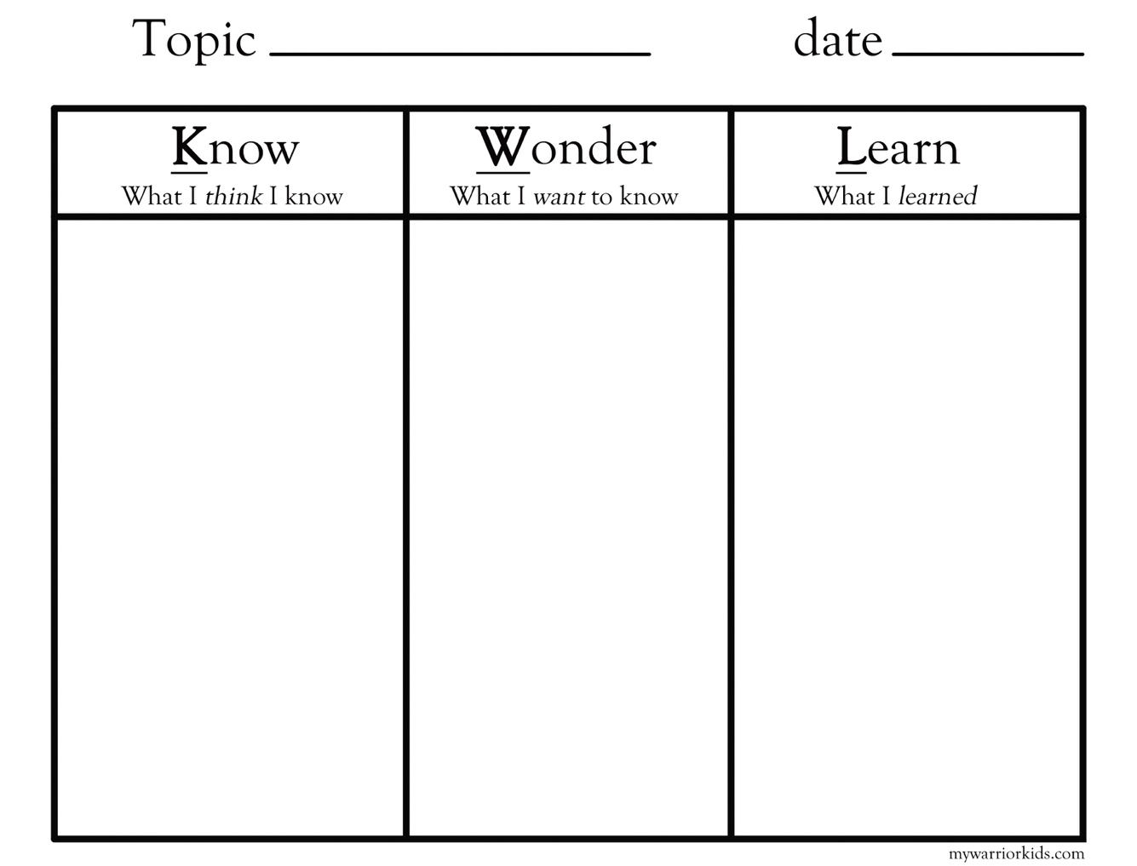

Explore – Marshmallow Shooters
Build your own Marshmallow shooter. Practice pulling back and shooting marshmallows the different designated amounts and record the distances traveled by the marshmallows.

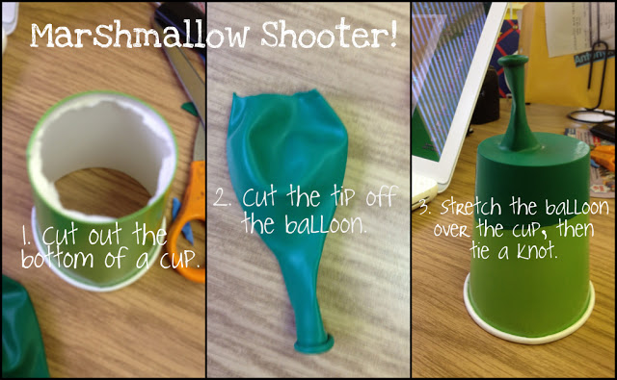

M, M. (1970, January 01). Force and Motion -- Marshmallow Shooters! Retrieved March 20, 2017, from http://tekyteach.blogspot.com/2011/11/force-and-motion-marshmallow-shooters.html

Explore – Marshmallow Shooter
Build your own Marshmallow shooter. Practice pulling back and shooting marshmallows the different designated amounts and record the distances traveled by the marshmallows.

M, M. (1970, January 01). Force and Motion -- Marshmallow Shooters! Retrieved March 20, 2017, from http://tekyteach.blogspot.com/2011/11/force-and-motion-marshmallow-shooters.html

Marshmallow Shooter Data
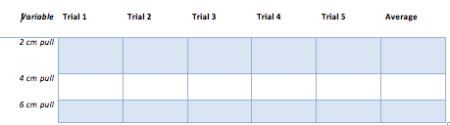
Marshmallow Shooter Data
Marshmallow Shooter CER
Claim (Write a conclusion about the relationship between force, motion, and speed.)

Evidence (Provide data to support your claim.)

Reasoning (Explain how your evidence supports your claim.)
Marshmallow Shooter CER
Claim (Write a conclusion about the relationship between force, motion, and speed.)

Evidence (Provide data to support your claim.)

Reasoning (Explain how your evidence supports your claim.)

ANSWER KEY Marshmallow Shooter CER
Claim (Write a conclusion about the relationship between force, motion, and speed.)
The more force behind an object, the farther and faster in moves.

Evidence (Provide data to support your claim.)
When we pulled back 2 cm, the marshmallow traveled 18 feet, but when we pulled back 6 cm, the marshmallow traveled 28 feet.

Reasoning (Explain how your evidence supports your claim.)

The amount of force behind an object, affects the distance that an object moves and the speed. When more force was applied to the marshmallow shooter, the marshmallow traveled both farther and faster.

ANSWER KEY Marshmallow Shooter CER
Claim (Write a conclusion about the relationship between force, motion, and speed.)
The more force behind an object, the farther and faster in moves.

Evidence (Provide data to support your claim.)
When we pulled back 2 cm, the marshmallow traveled 18 feet, but when we pulled back 6 cm, the marshmallow traveled 28 feet.

Reasoning (Explain how your evidence supports your claim.)

The amount of force behind an object, affects the distance that an object moves and the speed. When more force was applied to the marshmallow shooter, the marshmallow traveled both farther and faster.

Explain
Force Notes
What is a force? A push or pull on an object.
Every force has 2 main characteristics: amount & direction
Balanced forces = NO movement/Net force is 0
Unbalanced forces = movement/Net force is > 0
Net force is the total of all forces acting on an object.
Unit for force: Newtons (N)

Forces in the same direction: ADD
Forces in the opposite direction: SUBTRACT

EXAMPLE:
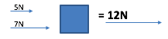

Newton’s First Law of Motion
- Objects at rest stay at rest and objects in motion stay in motion unless acted upon by an unbalanced force.

As force increases, speed increases and motion increases.
As force decreases, speed decreases and motion decreases.
Explain
Force Notes
What is a force? A push or pull on an object.
Every force has 2 main characteristics: amount & direction
Balanced forces = NO movement/Net force is 0
Unbalanced forces = movement/Net force is > 0
Net force is the total of all forces acting on an object.
Unit for force: Newtons (N)

Forces in the same direction: ADD
Forces in the opposite direction: SUBTRACT

EXAMPLE:

Newton’s First Law of Motion
- Objects at rest stay at rest and objects in motion stay in motion unless acted upon by an unbalanced force.

As force increases, speed increases and motion increases.
As force decreases, speed decreases and motion decreases.
Elaborate – “What is Friction?” Activity
Using the items provided (textbook, ruler, etc.), make a ramp for your marbles to roll down.
Use different sandpaper sheets (ranked in degree of coarseness) to stop the marble y laying one sheet at at time at the bottom of the ramp.
Release the marble down the ramp multiple times for each type of sandpaper and record your findings on the chart provided.

Lakeshore. (2007). What is Friction Experiment 2. Retrieved March 20, 2017, from http://www.lakeshorelearning.com/media/product_guides/DD354.pdf

Elaborate – “What is Friction?” Activity
Using the items provided (textbook, ruler, etc.), make a ramp for your marbles to roll down.
Use different sandpaper sheets (ranked in degree of coarseness) to stop the marble y laying one sheet at at time at the bottom of the ramp.
Release the marble down the ramp multiple times for each type of sandpaper and record your findings on the chart provided.

Lakeshore. (2007). What is Friction Experiment 2. Retrieved March 20, 2017, from http://www.lakeshorelearning.com/media/product_guides/DD354.pdf

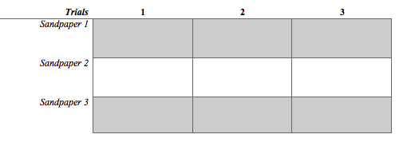
“What is Friction?” CER
Claim (Write a sentence stating what causes objects in motion to stop.)

Evidence (Provide evidence from the activity to support why the marble stopped.)

Reasoning (Explain how your evidence supports your claim.)

“What is Friction?” CER
Claim (Write a sentence stating what causes objects in motion to stop.)

Evidence (Provide evidence from the activity to support why the marble stopped.)

Reasoning (Explain how your evidence supports your claim.)

ANSWER KEY “What is Friction?” CER
Claim (Write a sentence stating what causes objects in motion to stop.)
The more friction between objects, the faster an object in motion will come to a stop.

Evidence (Provide evidence from the activity to support why the marble stopped.)
As the sandpaper become more course, the quicker the marble slowed down.

Reasoning (Explain how your evidence supports your claim.)

Friction acts an opposite force on an object. Newton’s first law explains that objects in motion will remain in motion until it is acted on by an unbalanced force. In this case, the coarseness of the sandpaper acted as the opposite unbalanced force and slowed down the marble.

ANSWER KEY “What is Friction?” CER
Claim (Write a sentence stating what causes objects in motion to stop.)
The more friction between objects, the faster an object in motion will come to a stop.

Evidence (Provide evidence from the activity to support why the marble stopped.)
As the sandpaper become more course, the quicker the marble slowed down.

Reasoning (Explain how your evidence supports your claim.)

Friction acts an opposite force on an object. Newton’s first law explains that objects in motion will remain in motion until it is acted on by an unbalanced force. In this case, the coarseness of the sandpaper acted as the opposite unbalanced force and slowed down the marble.

Big Ah-Ha Thesis
The purpose of this unit was to understand the way balanced and unbalanced forces affect the speed and direction of motion of an object. We completed a read aloud of “Forces Make Things Move” with a KWL chart, a Marshmallow Shooter lab, and the “What is Friction?” activity.
We read about how forces work in daily life. We talked with our classmates about the forces that see in everyday life and how they make life easier or harder. We filled out a KWL chart after reading the book to guide our discussion afterwards.
The amount of force applied to an object makes an object move faster and farther. In our Marshmallow Shooter Lab, we pulled back the balloon to watch the effects that force has on objects.
Some forces work against objects which make them slow down, stop, or even change directions. In our “What is Friction?” activity, we changed the amount of friction to make the marble slow down.
Each of our learning activities was a line of evidence. They helped us explain the effects that balanced and unbalanced forces have on the speed and direction of motion of objects.

Big Ah-Ha Thesis

The purpose of this unit was to understand the way balanced and unbalanced forces affect the speed and direction of motion of an object. We completed a read aloud of “Forces Make Things Move” with a KWL chart, a Marshmallow Shooter lab, and the “What is Friction?” activity.
We read about how forces work in daily life. We talked with our classmates about the forces that see in everyday life and how they make life easier or harder. We filled out a KWL chart after reading the book to guide our discussion afterwards.
The amount of force applied to an object makes an object move faster and farther. In our Marshmallow Shooter Lab, we pulled back the balloon to watch the effects that force has on objects.
Some forces work against objects which make them slow down, stop, or even change directions. In our “What is Friction?” activity, we changed the amount of friction to make the marble slow down.
Each of our learning activities was a line of evidence. They helped us explain the effects that balanced and unbalanced forces have on the speed and direction of motion of objects.

Evaluate

1. A _____ is a push or pull on an object.

2. What is the combination of all forces acting on an object?
a. total force
b. net force
c. combination force
d. whole force

3. True or False: Friction causes objects to move more quickly.

4. When forces are ______, they cancel each other out and do not change the objects motions; when forces are _______, the motion of the object changes.

5. Draw a diagram describing the force being applied to an object. Name the type of force and the direction of force. Explain how you know what type of force it is.

6. Can forces be helpful in daily life? Unhelpful?

Answer Key:
1. force
2. b. net force
3. False
4. balanced, unbalanced
5. (Answers will vary)
6. Forces can be both helpful and unhelpful in the world. The wind is a force. When a hurricane hits, its forces destroys buildings. Water is a force. When I go down water slides, the force is helpful and fun.
Evaluate

1. A _____ is a push or pull on an object.

2. What is the combination of all forces acting on an object?
a. total force
b. net force
c. combination force
d. whole force

3. True or False: Friction causes objects to move more quickly.

4. When forces are ______, they cancel each other out and do not change the objects motions; when forces are _______, the motion of the object changes.

5. Draw a diagram describing the force being applied to an object. Name the type of force and the direction of force. Explain how you know what type of force it is.

6. Can forces be helpful in daily life? Unhelpful?

Answer Key:
1. force
2. b. net force
3. False
4. balanced, unbalanced
5. (Answers will vary)
6. Forces can be both helpful and unhelpful in the world. The wind is a force. When a hurricane hits, its forces destroys buildings. Water is a force. When I go down water slides, the force is helpful and fun.

