Test
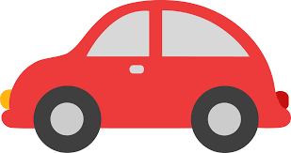
Track

By: Courtney Burgess

Overarching Question: What conditions affect how fast or slow patterns in motion occur?
How does the incline or slope of the test track affect the toy cars speed?
How does friction and unbalanced forces play a role in how fast or slow an object moves?
What causes these patterns in motion?

Line of Evidence – Test Track Lab #1
We saw that the acceleration by force pushing the cars down the ramps was greater when the incline or slope was higher. Acceleration is produced when a force acts on a mass or object like shown in this lab.

Line of Evidence – Test Track Lab #2
We saw that more friction was applied to the toy cars on the rougher surfaces like foil and felt which caused the cars pattern of motion to slow down. These different textured surfaces are unbalanced forces to the cars being pushed down the ramps.

Line of Evidence – Definition Foldable
These patterns in motion are caused by force of a push or pull on an object. Balanced and unbalanced forces that result in no motion or motion can also cause patterns in motion to form.

Big Aha Thesis Statement
The conditions that affect how fast or slow these patterns of motion occur deal with the type of force that is applied to an object. In this lab the force is a push, which causes the pattern of motion for the cars to go straight down all moving in one direction. These conditions also are determined by if the type of force is balanced or unbalanced. In this lab the force Is unbalanced when we add different textured surfaces that cause friction to slow down the toy cars.

Engage - Test Track Intro
- The teacher will ask students to recall their background knowledge about forces and motion. This would be open-ended questions for example, asking students what types of forces they have experienced before. Talk about riding on roller coasters, stopping in cars, or hitting the breaks on a bike to stop moving.

- If video is available the teacher will also show a short video about friction from Bill Nye. https://www.youtube.com/watch?v=MAqrWvkBoHk

- After they have watched the video students will refer back to their definition foldable discussing what a force is and how balanced and unbalanced forces affect it. They will also talk about what friction, motion, and momentum is for the experiment they will be conducting.
The teacher will lead into the lab experiments by asking students the following questions:
- What causes an object to move?
- What causes an object to move faster or slower?
- Do you think these objects show a certain pattern when in motion?

(2014, May 01). Retrieved April 19, 2017, from https://www.youtube.com/watch?v=MAqrWvkBoHk

Explore – Test Track Lab #1
Mann, A. (2010, January 9). Force and Motion Experiment. Retrieved from http://librarianismchronicles.blogspot.ca/2010/01/force-and-motion-experiment.html.
Test Track Explore
Lab Activity #1: Which height of textbooks had the fastest car?
Which had the slowest? Why?
Hypothesis:
Before beginning your test runs make a prediction about which car you think will be the fastest. Why? Which do you think will be the slowest and why? Discuss as a group and then begin your test runs.

Materials:
Stopwatch
Three cardboard cutout ramps
A ruler or meter stick
Three toy cars
Textbooks
Tape

Activity: Test Track Speed
- Place all ramps onto different height textbooks with tape.
- Place each toy car at the top of the different height textbooks and push start the cars down the ramps.
- Continue these test runs for 5 runs and record the height, time, and distance of each toy car.

Factors | Track 1 | Track 2 | Track 3
Height:
Time: | Run #1:  Run #2:  Run #3:  Run #4:  Run #5: | Run #1:  Run #2:  Run #3:  Run #4:  Run #5: | Run #1:  Run #2:  Run #3:  Run #4:  Run #5:
Distance:
(Stays the same)

Was your prediction or hypothesis correct?

Did the slope of the tracks affect the speeds of the toy cars? Explain why or why not?

Test Track Explore CER
Claim (Write a sentence stating what caused the toy car to move faster or slower with different slopes.)

Evidence (Provide evidence from the lab to support the claim. Describe the patterns of motion you saw.)

Reasoning (Explain how your evidence supports your claim. Describe what caused these patterns of motion occur.)

ANSWER KEY Test Track Explore CER
Claim (Write a sentence stating what caused the toy cars to move faster or slower with different slopes.)
Changing the inclines of the ramps made the toy cars move faster or slower across the finish line. The higher the incline the faster the car would get across and the lower the incline the longer it would take for the toy car to get across the finish line.

Evidence (Provide evidence from the lab to support this claim. Describe the pattern of motion you saw.)

Track 1 was 5 ½ inches tall with the fastest time crossing the finish line of 2.15 seconds. Track 3, which was only 2 inches tall having a lower incline had the slowest time of 4.43 seconds. All of the times of the toy car on track 1 were faster than any of the times on track 3 because of the difference in incline. Once force of pushing the cars down the ramp was done all cars went down the ramp in a straight line.

Reasoning (Explain how your evidence supports your claim. Describe what caused this pattern of motion to occur.)
The toy cars that are on track 1 with the most incline and highest slope cause the acceleration to be greater when force by push is acted upon the cars. The toy cars on track 3 move lower because they have less incline to help the cars accelerate faster when force by push is acted on them. This is because acceleration is produced when a force acts on a mass or object (Newton’s Second Law).

Explain – Definition Foldable
Word | Definition | Picture  (Draw a picture for each definition)
Force | A push or pull exerted by one object on another. | 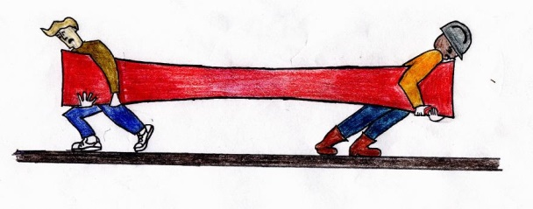
Balanced forces | When opposite forces of an object are equal, resulting in NO motion. | 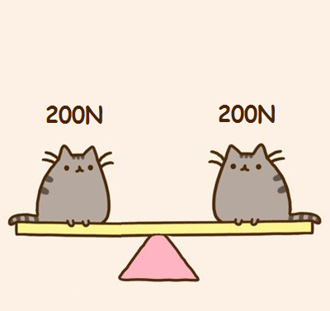
Unbalanced forces | When opposite forces of an object are not equal, resulting in motion. | 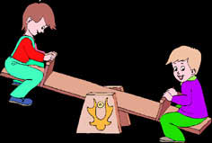
Friction | A force that opposes the motion of an object in contact with a surface. | 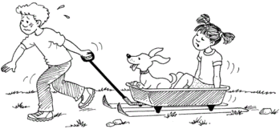
Gravity | A force of attraction that exists between all objects with mass. | 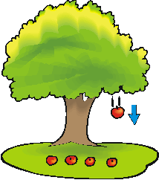
Motion | Process of changing position or place. | 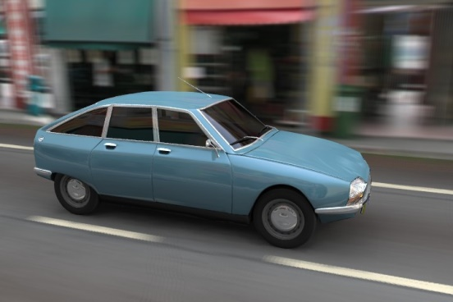
Momentum | Is the measure of how hard it is to slow or stop a moving object. | 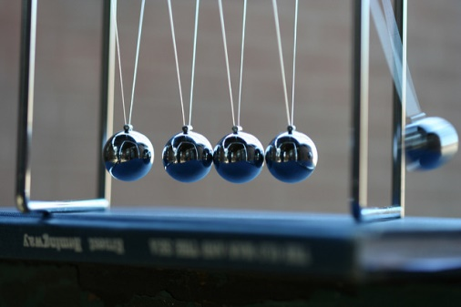
Inertia | An object at rest tends to stay at rest, but an object in motion tends to stay in motion. (Reason behind people swaying forward in their car when it is stopped to fast). | 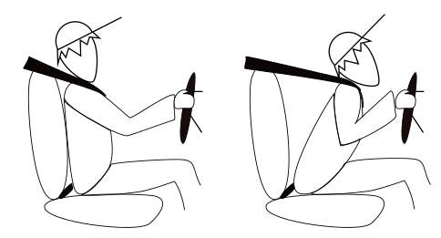

Elaborate – Test Track Lab #2
Mann, A. (2010, January 9). Force and Motion Experiment. Retrieved from http://librarianismchronicles.blogspot.ca/2010/01/force-and-motion-experiment.html.

Test Track Elaborate
Lab #2: Which track surface had the fastest car?
Which track surface had the slowest car? Why?

Hypothesis:
Before you begin you test runs make a prediction about which track surface will have the fastest moving car. Which will have the slowest? Why do you think this is? Discuss as a group and then begin your test runs.

Materials:
Stopwatch
Three Cardboard Cutout ramps (One felt, one cardboard, and one foil)
A ruler or meter stick
Three toy cars
Textbooks
Tape

Activity: Test Track Surface

- Place all ramps onto same height textbooks with tape.
- Place each toy car at the toy of the different textured ramps and push start the car down the ramps.
- Continue these test runs for 5 runs and record the height, time, and distance of each toy car.

Factors | Track 1  (Foil) | Track 2  (Original) | Track 3  (Felt)
Height:
(Should all be the same)
Time: | Run #1:  Run #2:  Run #3:  Run #4:  Run #5: | Run #1:  Run #2:  Run #3:  Run #4:  Run #5: | Run #1:  Run #2:  Run #3:  Run #4:  Run #5:
Distance:
(Stays the same)

Was your prediction or hypothesis correct?

How does the texture of the tracks affect the speed of the cars?

How did friction affect the car’s racing times?

Test Track Elaborate Lab CER
Claim (Write a sentence stating the affects on the toy cars with different textured surfaces.)

Evidence (Provide evidence from the lab to support the claim. Describe how these different textured surfaces affected the pattern of motion.)

Reasoning (Explain how your evidence supports your claim. Describe why the pattern of motion was affected depending on the textured surface.)

ANSWER KEY Test Track Elaborate Lab CER
Claim (Write a sentence stating the affects on the toy cars with different textured surfaces.)
The different textured surfaces caused the toy cars to move faster or slower across the finish line as well. The smoother the surface the faster the toy cars would get across the finish line. The rougher the surface of the track the longer it would take for the car to reach the finish line.

Evidence (Provide evidence from the lab to support the claim. Describe how these different textured surfaces affected the pattern of motion.)
Track 2 was the original textured surface (cardboard) and had the fastest time at 2.54 seconds. The slowest time was on track 3 with the felt at 4.20 seconds. Both the original surface and the foil had faster times than the felt surface because they are smoother and do not cause as much resistance or friction. These different textured surfaces are an unbalanced force that causes the acceleration rates to change by speeding up or slowing down.

Reasoning (Explain how your evidence supports your claim. Describe why the pattern of motion was affected depending on the textured surface.)
The toy car moves faster on the surface texture that is cardboard because it is the smoothest surface. This means that the wheels on the cars are not getting as much friction or resistance to the surface because it is smooth and does not keep it from slowing down. The felt had the slowest time because the texture is not smooth but bumpy causing the wheels to resist more and slowing down the cars speed. Acceleration was changed when the unbalanced force of the textured surfaces were applied to the cars being pushed down the ramp.

Big Ah-Ha Thesis
The purpose of this unit was to understand what conditions affected how fast or slow patterns in motion occurred. We did this by conducting experiments with toy cars testing speed and different textured surfaces. We also did this by completing a definition foldable to expand our knowledge on different types of forces, as well as, learn about what friction is.
We completed an experiment to find out how slope and incline affected the toy cars speed. We found that the acceleration was greater with cars going down the incline that was higher compared to the speed of the toy cars going down the lowest incline. We talked about Newton’s Second law of motion states that acceleration is produced with a force is put on an object.
The next experiment showed us that the patterns of motion depend on unbalanced forces and the friction that was put on the toy cars with rougher surfaces. We saw that the toy cars going down the smoother surface had the fastest time because they did not get as much friction on their wheels.
Patterns in motion occur because of the types of forces that are applied to an object. These types of forces may be balanced or unbalanced. They also affect how fast or slowly these patterns will occur.
Each of our learning activities was a line of evidence. They helped us explain how conditions affect how fast or slow patterns in motion occur and what causes them.

Self-Reflection Paragraph
Before this unit, I did not know the reason behind why patterns of motion can affect how fast or slow an object would move. I could see how the different inclines affected the toy cars acceleration and speeds. I also could see how unbalanced forces like changing the surfaces of the ramps affected the toy cars speed. I saw how friction really affected the toy cars motion during the lab. My favorite part of this unit was seeing if my predictions came out correct after completing the labs.

