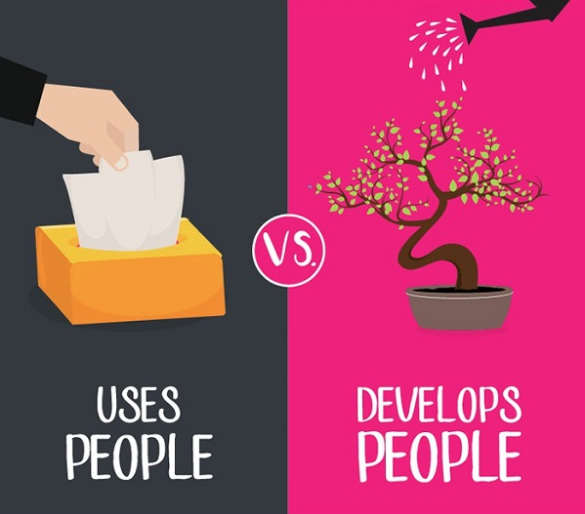

Register for LEAD 5601
Foundations for 21st Century Leadership
Leadership Success Begins with You!
- Study effective team building and team leadership
- Assess organizational support for work teams
#LEARN2LEAD
- Deliver quality workplace feedback
- Create winning work team performance
- Plan for mission, vision, values, and strategy
- Design organizational processes and systems
- Establish decision-making process
Take as an elective or as part of the new Graduate Certificate in Community Leadership
Contact: Dr. Harley-McClaskey, harley@etsu.edu
East Tennessee State University

New Program at ETSU

Graduate Certificate in Community Leadership

Four Courses:
- LEAD 5501 Strategies for Personal Productivity and Interpersonal Effectiveness—A study of self-management, personal leadership growth, dialogue analysis, empathic listening, conflict resolution, trust building, & emotional intelligence
- LEAD 5601 Foundations for 21st Century Leadership—A study of team building, team leadership, & organizational systems, including the alignment of mission, vision, & goals as community leadership best practices
- LEAD 5701 Financial Leadership and Resource Development—A study of financial & resource management of community organizations, to include: monitoring, audits, fundraising, & grant management
- LEAD 5801 Empowerment, Collaboration, and Advocacy for Change—A capstone study of community leadership as a collaborative team engaged in an organizational change initiative
For more information, contact:
Dr. Harley-McClaskey, harley@etsu.edu
423-439-7683
East Tennessee State University

