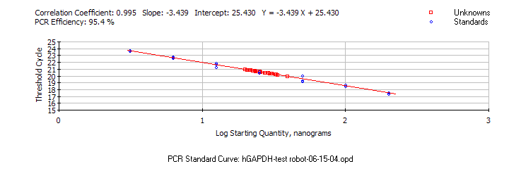
Ex: hGAPDH

Replicate # (each ran in triplicate) Ct (average)  1 20.82  2 20.77  3 20.51  4 20.63  5 20.51  6 20.30  7 20.38  8 20.68 | Robot  Intra-assay reproducibility  Av. = 20.57 + 0.19

