ETSU REDCap

What is it?
It is a Research Electronic Data Capture server. This server offers a database and survey tool for our researchers. Or to be more precise, as quoted from the link below, Redcap is a “mature, secure web application for building and managing online surveys and databases”. Developed at Vanderbilt in 2002, the server software is free for consortium members and currently has over 2000 institutional partners. Here is a web site for the “project” where you can find more background:
Project Redcap home page
The ETSURedCap server cannot be used to store PHI, HIPAA-qualified data. If you have a need for that, please contact Research Computing Services so we may assist you.
*** In the near future, Information Technology Services will set up a Redcap server behind the firewall, and projects containing HIPAA data should/will be stored on this server. This document will be updated to reflect the current information as it becomes available.
How can I access it?
Access to the server requires an ETSU Active Directory account. If you have an etsu email account, you already have this part covered. As an employee, you would only need to submit the Computer Account Request Form (CARF) and check the last box in section 2, then the 2nd “sub-box” for an account on etsuredcap.etsu.edu If you are doing human subjects research, list your IRB protocol number in the appropriate place. Submit the completed and signed form to ITS at Box 70728, or carry it to the ITS Reception Desk on the 4th floor of Nicks Hall. The form will be routed appropriately and once your account is created, you will receive an email from someone in Research Computing Services with instructions on how to log in. Your Redcap server username will the same as your ETSU username, as will the password. Please don’t try to reset your PW on Redcap! When you must change your ETSU password, start using that same one the next time you login to Redcap. You can find the CARF here:
Computer Account Request Form at ETSU
NOTE: If you are collecting/storing Personal Health Information (PHI) or HIPAA-regulated data, you MUST request an account on etsuredcap-h.etsu.edu. Only researchers with Institutional Review Board (IRB) approved protocols containing human subject data will be granted access to use etsuredcap-h.etsu.edu.
Once you have your Redcap server account, go to etsuredcap login at ETSU and log in.
If you are collaborating with individuals off campus (they do NOT have an ETSU email account) that will need access to your project on this server, we can do that! The “sponsoring” employee/researcher will need to fill out the CARF, but use section 4, “Other requests” and explain that you need a domain account and Redcap access for this person. Please be sure and list their email address since that is how they will be informed when their account is ready. Once they are logged in, they can request permission to access the project and you, as the owner of that project, can grant it.

How do I use it?
Individual sessions with users are scheduled through Research Computing Services. If you would like assistance to get started, please contact Dr. Janet Keener at janet@etsu.edu or call x94142. There are also some videos that you may find helpful. They are located at Training videos for Redcap
What about student researchers?
Student researchers, undergraduate, graduate and doctoral, can all have access to this resource. Please fill out the CARF and in section 4, “Other requests”, state that you need the account for an ETSU student and list their ETSU email name. If you would like your class to have access, call or email Janet at janet@etsu.edu, and she will send you a template you can fill out. Then, a mass account creation can be done. They will get the standard notification from us when the account is ready to be used. NOTE: ALL student accounts must have an expiration date. Should a student no longer need access to a project that is ongoing, please notify Janet immediately or beforehand, so she can remove that access.

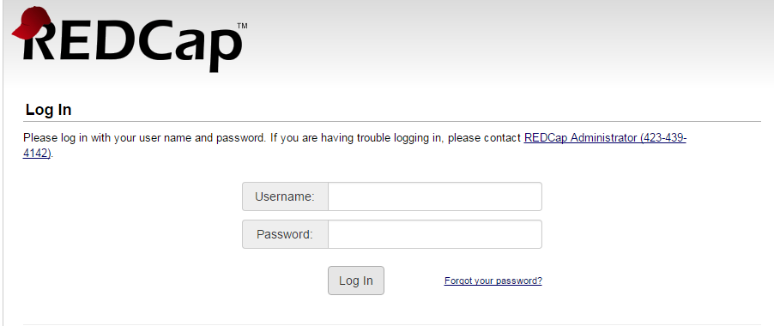
Figure 1 Redcap Login Screen
On the login screen, it is very important to note the text in red:
Notice: If you are collection data for the purposes of human subjects research, review and approval of the project is required by your Institutional Review Board.

