BUC BIKES
FREE Day Use Bikes
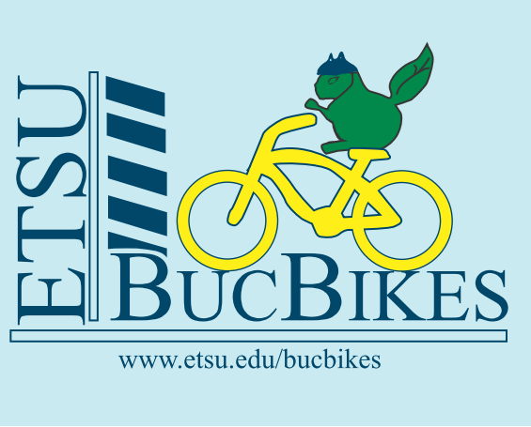
Check-out Locations:
- Basler CPA, front door.
- Culp Center, 2nd Floor Information Desk

The day use bikes are refurbished bikes that have been donated or left in surplus by former students. The bikes all come with a lock and helmet. Before you can check-out a bike you must complete the on-line bike safety quiz found here; https://healthsafety.etsu.edu/index/login

- Log in using your ETSU e-mail and password
- In the left column select “Training Modules”
- Select “Bicycle Safety” under Modules you can take
- Take a few moments to review the information. Take the quiz, and…
- Print the certificate and KEEP IT – you will need it to rent a bike.

Users are responsible for replacement fees for damaged or unreturned bikes/accessories and late fees, a hold will be placed on student accounts for any overdue fees. Please see Daily check out form for fees.

This is a RIDE AT YOUR OWN RISK service. Before you can check-out a “BUC Bike” you must read, agree to and sign the Buc Bikes program Daily Check-out Form

General Safety Guidelines
- Abide by all local and state traffic laws.
- Check the bike for safe operation before using.
- Wear a helmet.

IMPORTANT NOTE: Free Day-Use Bikes must be returned the same day to the location where the bike was checked out during operating hours. Long term or over night check out is not permitted.

For more information:
http://www.etsu.edu/bucbikes
Or to contact us:
BUCBIKES@mail.etsu.edu

