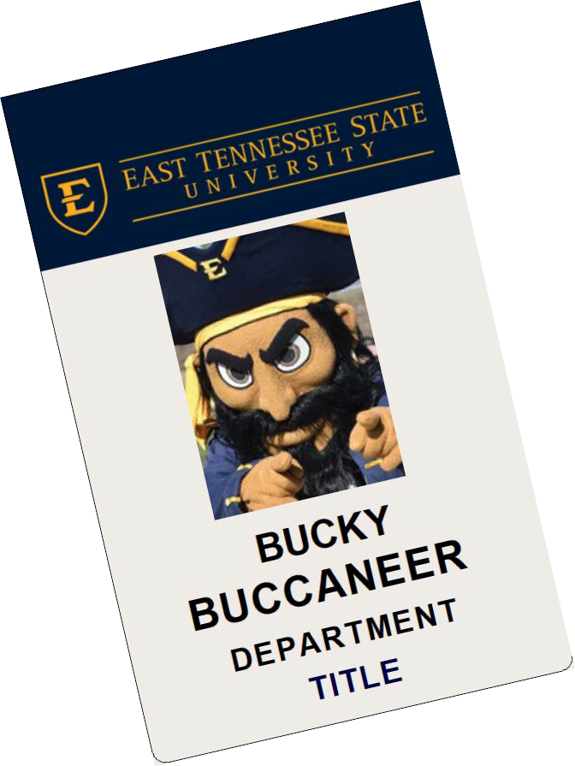
Badge Request Form
Please fill out the fields below to request a badge for people in your department or program. Each badge costs $10 and is to be paid by the either the department or the individual receiving the badge prior to printing. After the initial badge, the price for any duplicated or replacements is equal to that of an ID card replacement, which is $27.38.

Name of individual approved for a badge: E Number (If sending a list of names & E#s, please attach list to this form):

Badge Information:
Badges have room for 2 lines of information, 30 characters per line maximum. Excluding Nursing, which only has a “Title” line. Please specify the information that needs to go on the badge.

Department (line 1): Title _{(line} ₂₎: Delivery method (please circle): Pick-Up Campus Mail Box #:

Payment:
Will the department be charged for the badge(s)? (please circle): Yes / No Is this badge a replacement? (please circle): Yes / No
If "yes" for departmental charge, please provide account code to charge:
By selecting "yes" above and providing an account code, you agree to the charges and allow Campus ID Services to withdraw the total amount charged from the account provided during the next billing cycle.

Approved by: Date:
(print)

Title & Department: Signature:
Office Use Only: Initial: Date:
Phone:

