Log in through GoldLink or at https://etsu.campus.eab.com/; use your ETSU user name and password.
For best results open Navigate in Chrome, Safari, or Firefox.

Setting Up Outlook to Manage Appointment Emails

from Navigate

Create a new email folder in Outlook named Navigate Appointments.

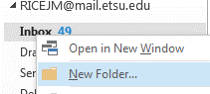

Under the HOME tab click Rules>Create Rule.
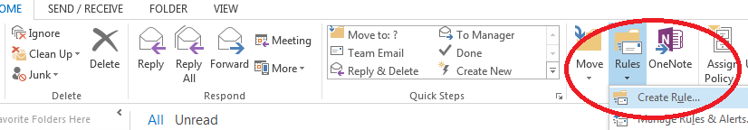

Check Subject contains; type [Appointment Notification].
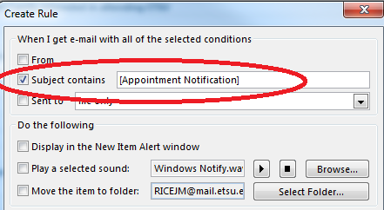

Check Move the item to folder, click Select folder, then find and select the folder you created.
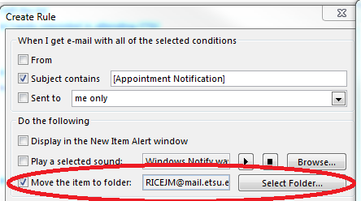

Click OK. A window confirm that the rule has been created. Clicking Run this rule now… will find and move all emails containing [Appointment Notification].

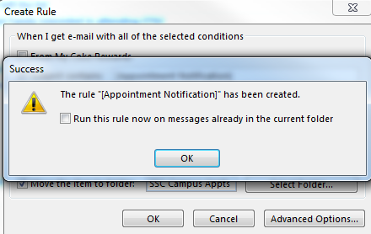

To create a rule to move Navigate appointment reminders to the new folder, repeat steps 2-6 using the subject line [Appointment Reminder].

