Downloading KBport recordings

**You must have Instructor Access to download recordings**
- Navigate to the recording you wish to download.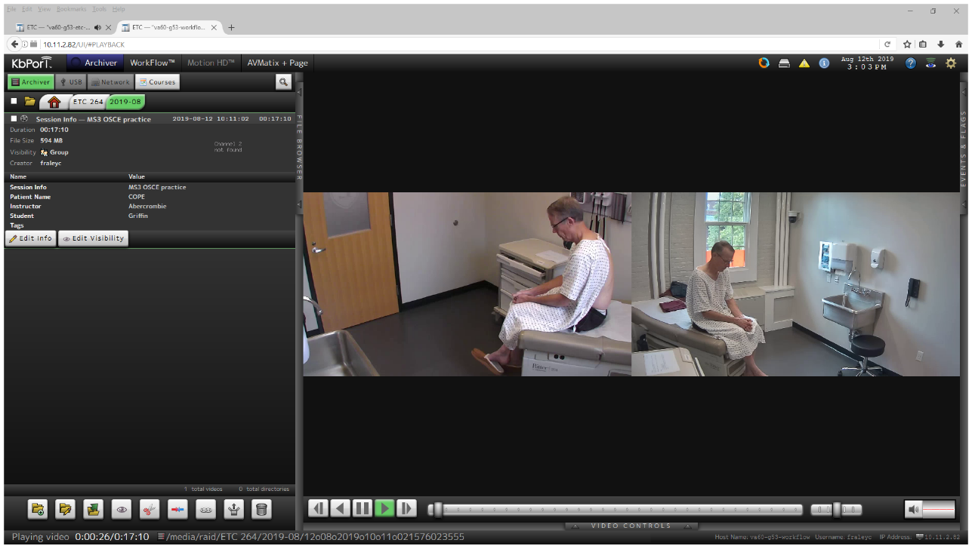
- Select the 8th icon over in the left pane. It looks like a box with an arrow pointing up.
- Choose your export type. .MOV , .MP4 or Native in a custom installed player. I suggest mp4 for general use.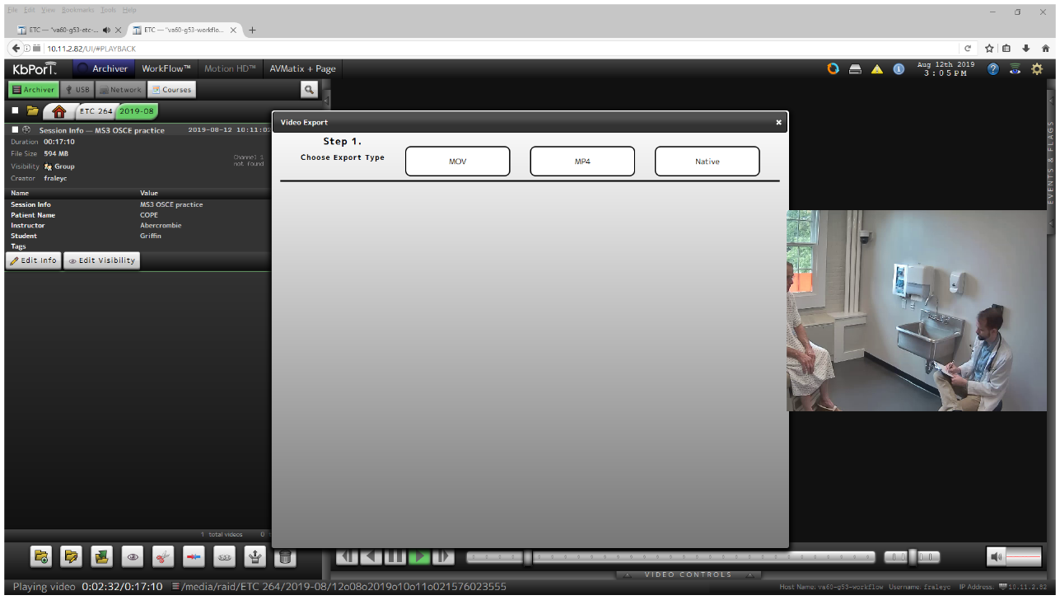
- Select view type. There are generally 2 cameras in each recording so choose Quad. (if you wish to just have one camera available you can choose Single) Drag the 1 and 2 cameras to viewport 1 and 2 respectively.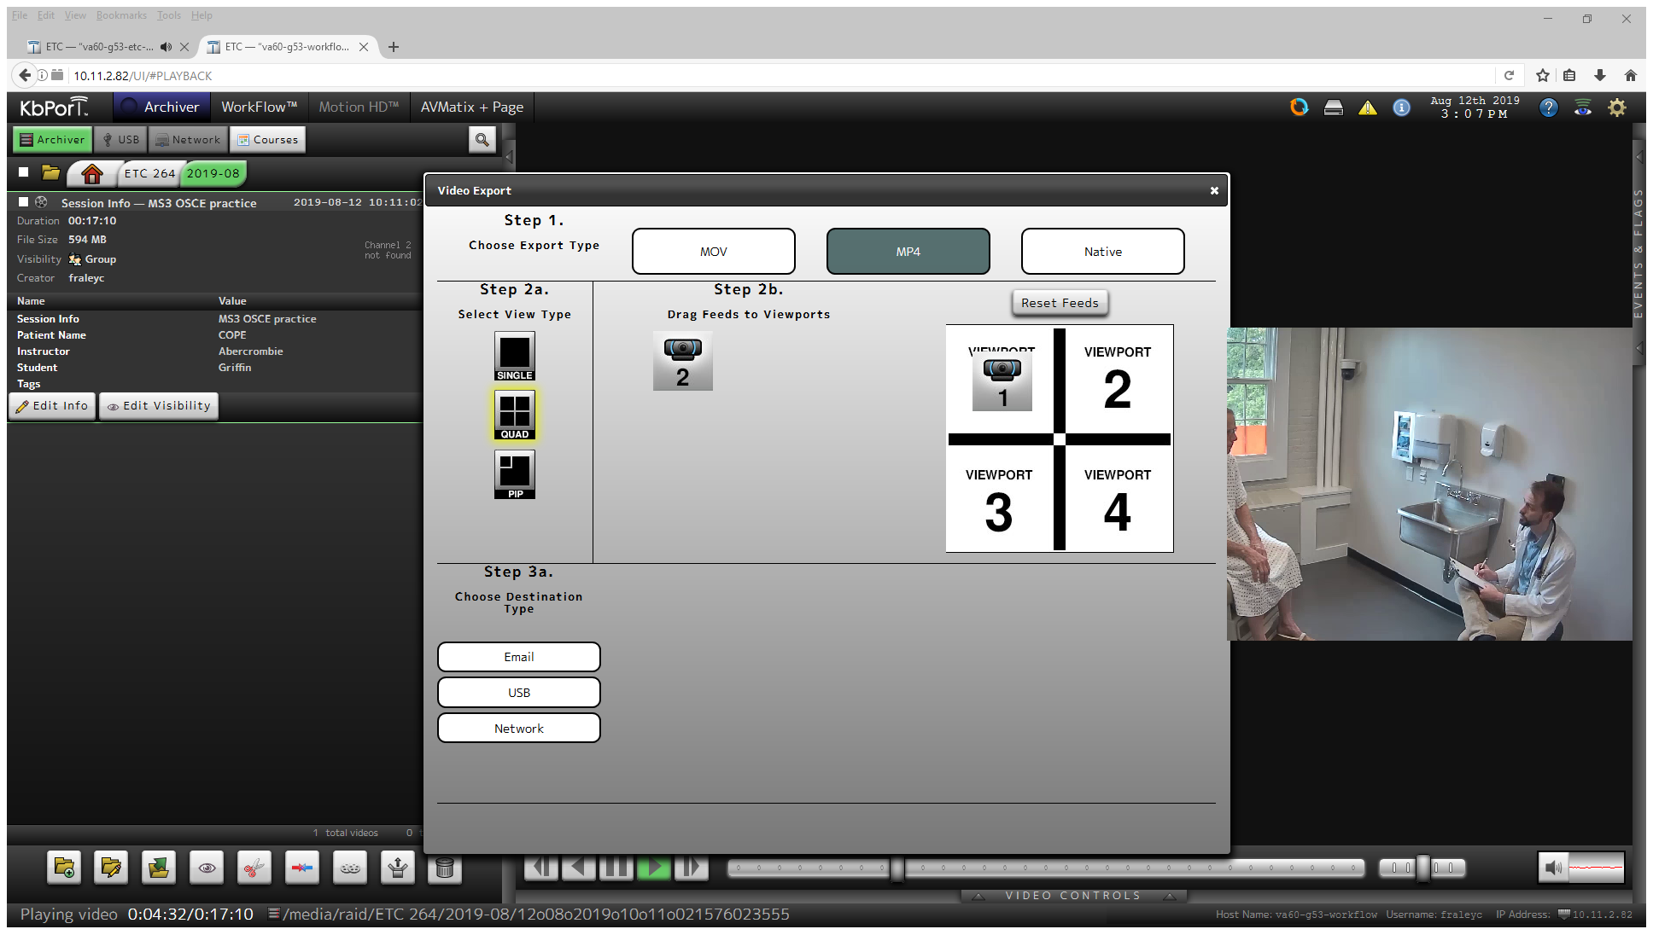
- Select Email option.
- Kbport will select your email automatically, but you can choose others from the list to also receive the download link if needed.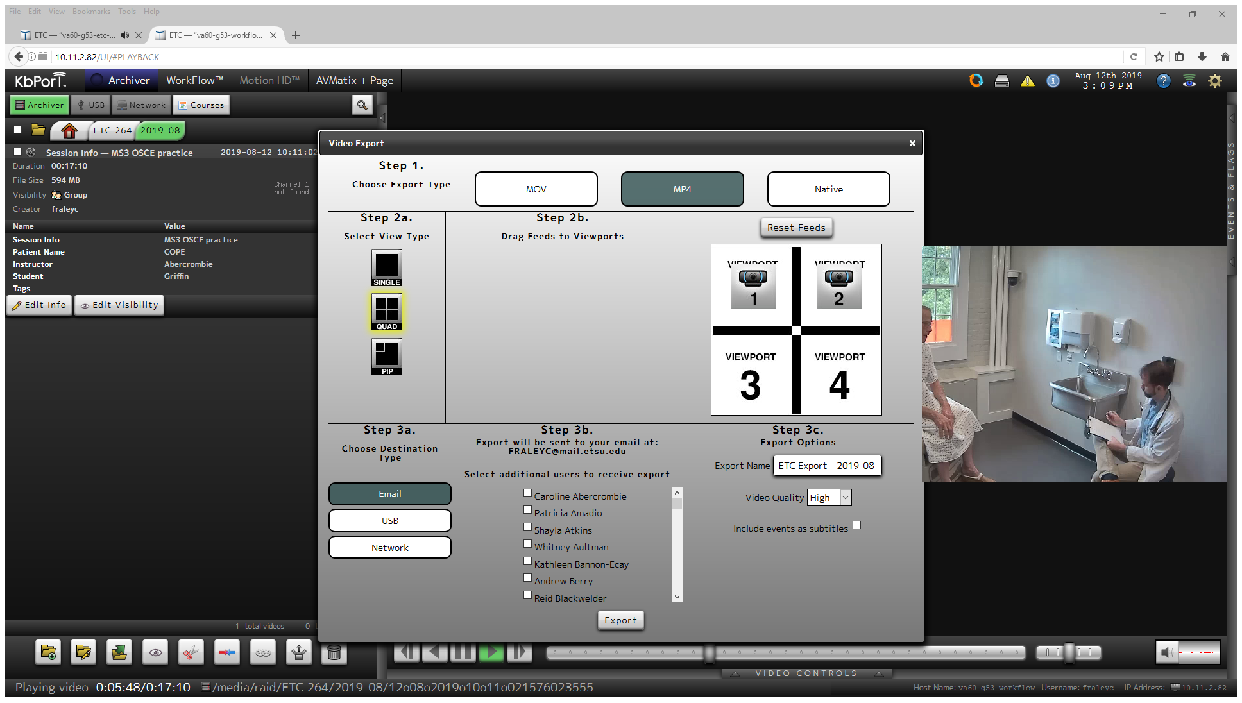
- You can rename the file in the Export Name field and select the video quality you want the final file to be transcoded into.
- Hit Export.
- Once the file is converted you will receive an email with a download link to download the file. It will look like this:
The movie you requested is ready for download at http://10.11.2.82/ETC/bridge/download-converted-video.php?path=/media/raid/ETC 264/2019-10/01o10o2019o14o02o201055071084.video/attachments/ETC Export - 2019-10-02 081856.MP4 (Low Res). This link will expire after 21 days, so please download the file at your earliest convenience.
From va60-g53-workflow (10.11.2.82).
- If you are on campus you can just click the link and download the file. If you are off campus you will need to copy the link, paste it into the address bar on your browser and replace 10.11.2.82 with workflow.etsu.edu then hit enter. This will allow you to download the file off the campus network. We are currently in talks with Kbport to resolve this issue.

