# Guide for watching videos on KBport system.

On a windows computer that you have admin rights on, (*able to install software), if you do not have admin rights on the computer you are attempting to install on, please contact OIT helpdesk at 439-4648

**Download and install the custom ETC browser**

<https://etsu365-my.sharepoint.com/:u:/g/personal/fraleyc_etsu_edu/ESP78eLudLNPs-YOozymuBoB7R-kcoX_yvxamBr-mNA4Gg?e=4wSSal>

*Windows may try to prevent installation with the “Windows has protected your PC” pop up.   If this happens, just click the “more info” link on that pop up and then the “Run Anyway” that appears at the bottom.

*If you are on a Mac please email Chad Fraley [fraleyc@etsu.edu](mailto:fraleyc@etsu.edu) there is an alpha release of the kbport browser for Mac but it is not ready for general release and requires some setup.

1. Open the ETC browser
2. Type in the address bar at the top [workflow.etsu.edu](https://workflow.etsu.edu/) *if the browser says the site is unsafe, click the advanced options on the warning and then proceed to site anyway*
3. Enter your ETSU username and password. *you must be granted permission for access*

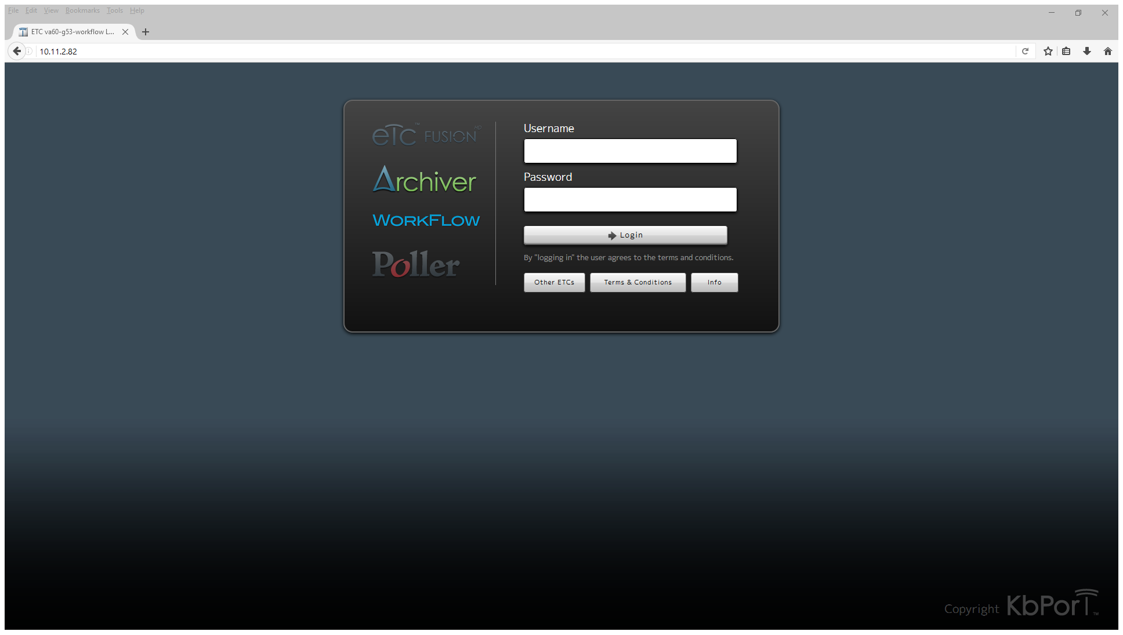

1. After you have entered your username and password you should be taken to the main Archiver interface as follows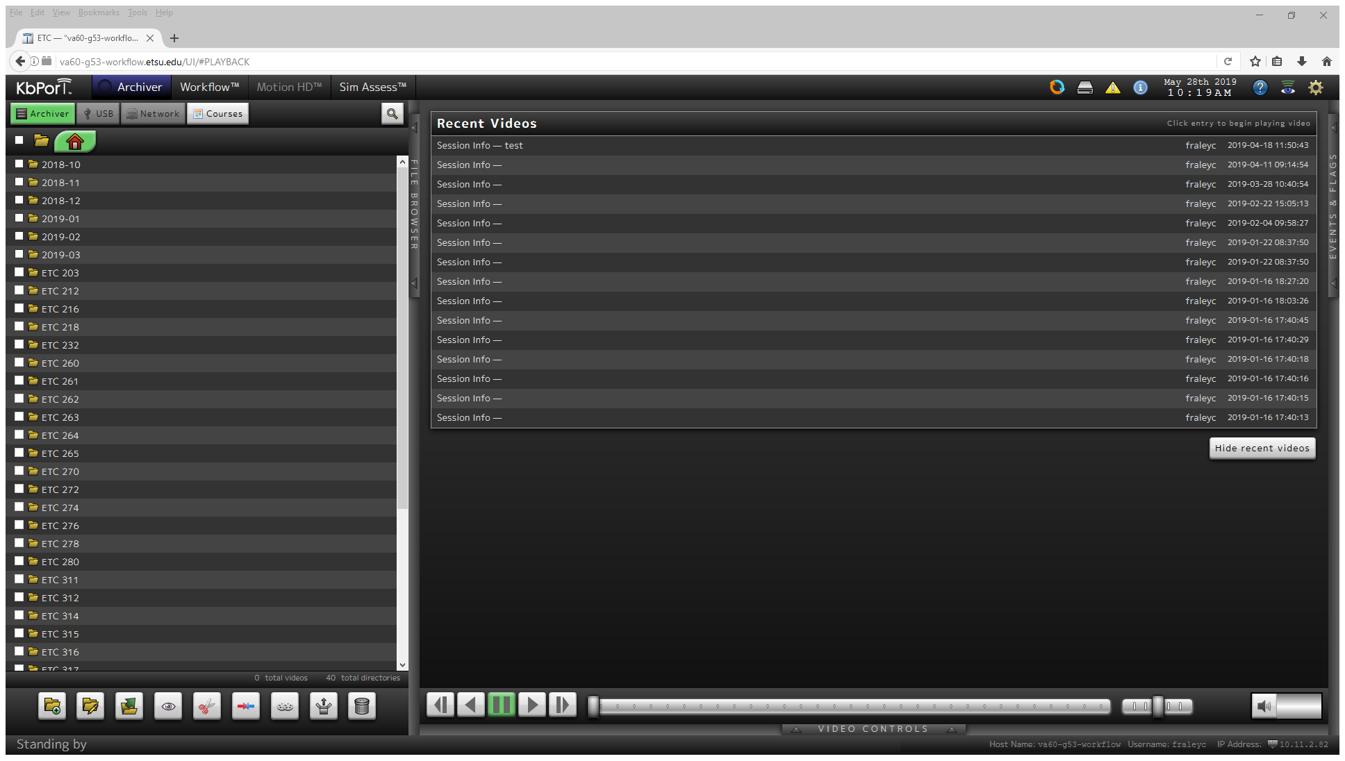
2. The folders are listed by months, then room number, select your room number.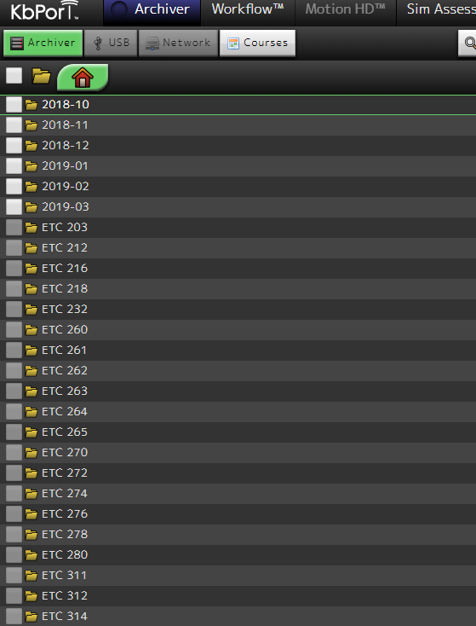
3. Under the room number select your month and year of recording.

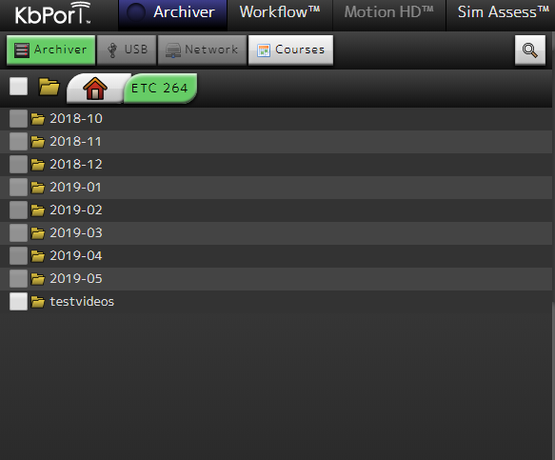

1. Then select by date and time.

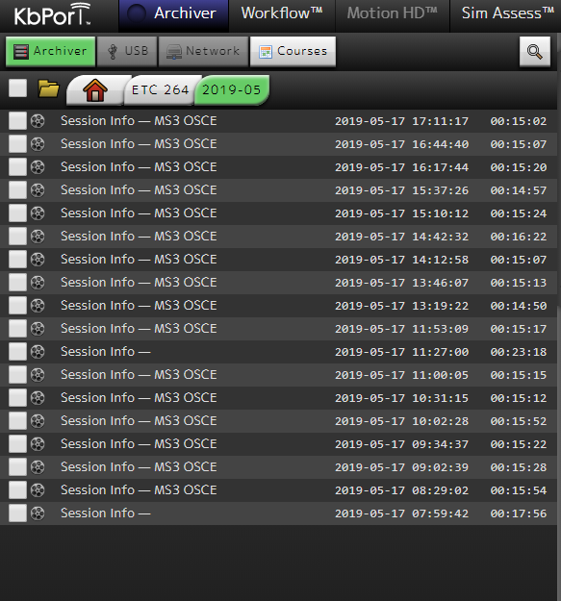

1. You can also hit the search button and sort by student name, but this is a very basic search and can bring up multiple sessions, students or default to last played video if it encounters an error. Caution is advised when using the search function. Knowing the room number and date are more precise.

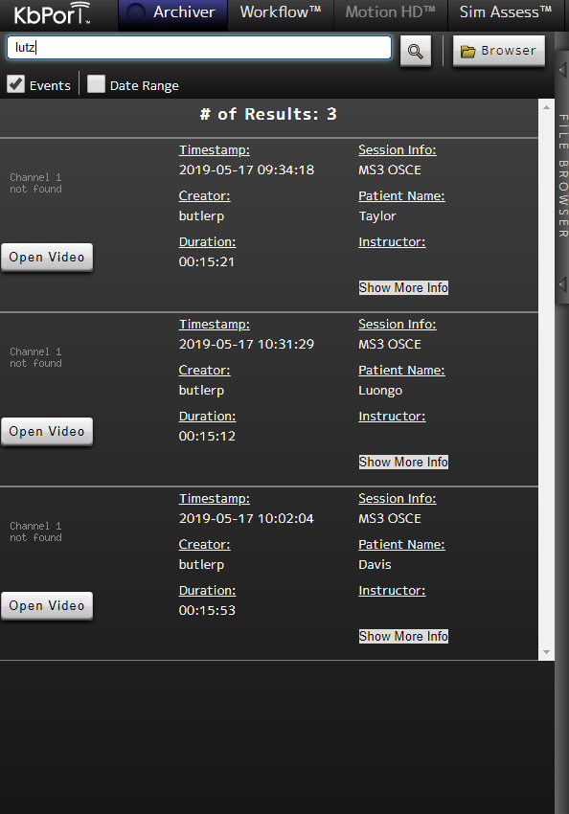

1. Once a file has been selected in the folder view, the video will play with standard controls on the right hand pane.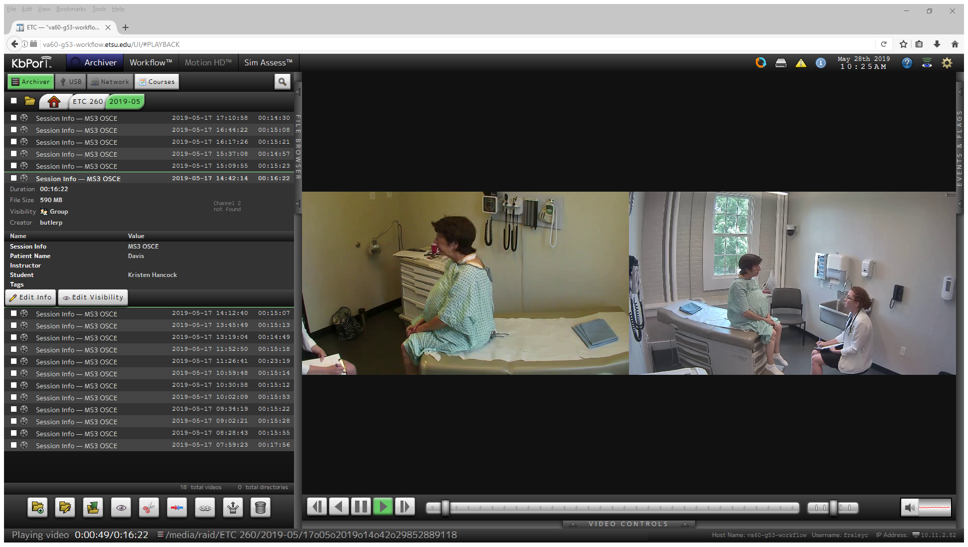
2. To return to the master folder list, click the house shaped icon tab at the top of the folder view window, or to return to the particular ETC room server hit the ETC (room number) tab.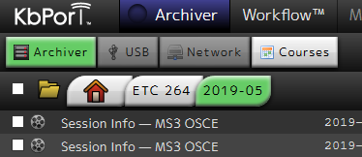

If you have any questions or issues please email Chad Fraley at [fraleyc@etsu.edu](mailto:fraleyc@etsu.edu) or call 439-8101