IPERCStudent BOOKING CALENDAR INSTRUCTIONS

- You can access the calendar at https://ipercstudent.bookedscheduler.com.

- Students of ETSU can log in with their ETSU credentials.
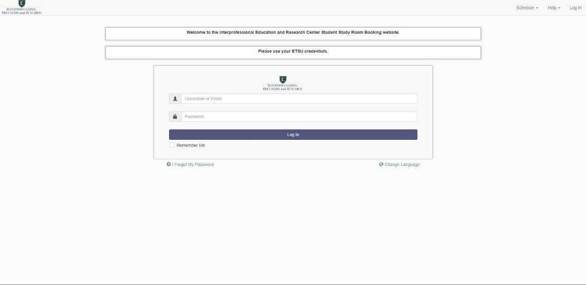

- After logging in, you will see your Dashboard (you can return to this view by hitting Dashboard in the top menu).
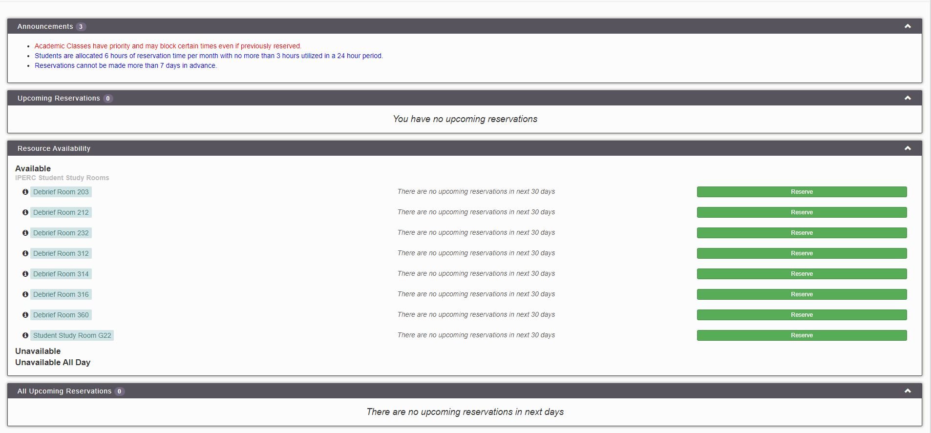
- Please read all Announcements in the Announcement box located at the top of the page.
Academic Classes have priority and may block certain times even if previously reserved.
Students are allocated 6 hours of reservation time per month with no more than 3 hours utilized in a 24 hour period.
Reservations cannot be made more than 7 days in advance.

- If you have upcoming reservations, they will be listed in the Upcoming Reservations box.

- All available rooms are listed in the Resource Availability box. You may reserve a room by clicking on the green Reserve button to the right of the appropriate room.

- If you hover over the black circle with the letter “i”, you will get a pop up that lists the room, available equipment, a photo of the room and, if applicable, the number of participants that can be seated in that room.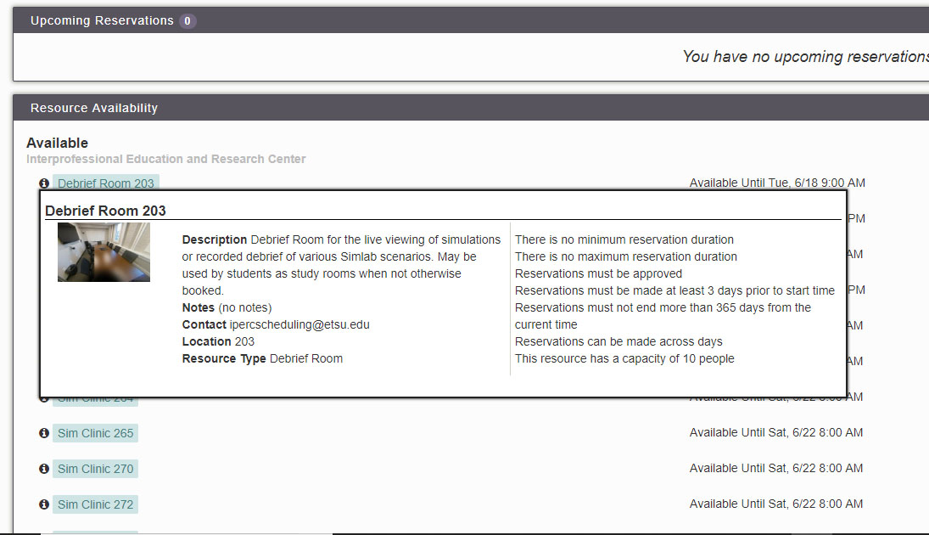

When you have reviewed your form and are satisfied, hit the create button to schedule the selected room. Please fill out all relevant information. When you are done click Create. After a few seconds, a window will let you know the status of the reservation. You will receive an email notification confirming the reservation.

VIEWING THE SCHEDULE CALENDAR

- To view all upcoming reservations and room availability, click the Schedule pulldown menu at the top of the page.
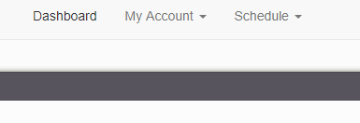
- In the pulldown menu under Schedule, select “Bookings” and you will be taken to a sortable calendar of all upcoming reservations. You can scroll to the top of the page to select date ranges to view.
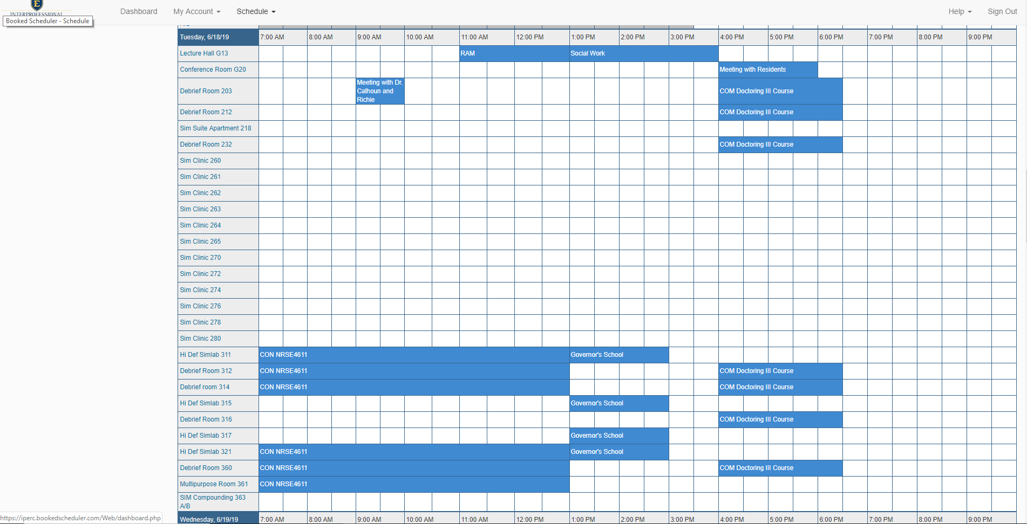

- You may also book reservations from this “Bookings” view by using your curser to select a block of time and room on the appropriate date. This brings up the Reservation window as exampled above.
- You can use the bookings menu option to view all reservations online or, located on the television in the VA60 Café for the days reservations.

VIEWING YOUR SCHEDULED CALENDAR

- Other Options in the Schedule pulldown are “My Calendar” which shows a calendar view of all of your reservations, “Resource Calendar” which is a calendar view of all reservations, and search tools to help “Find a Time” a room is available and “Search Reservations” to find specific reservations through various filters.

