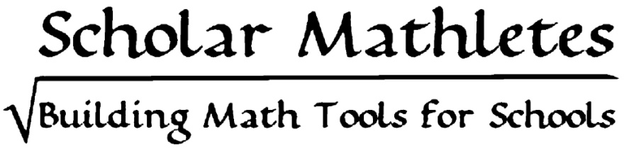

SUMMER 2014

PARTICIPANT DIRECTOR Y
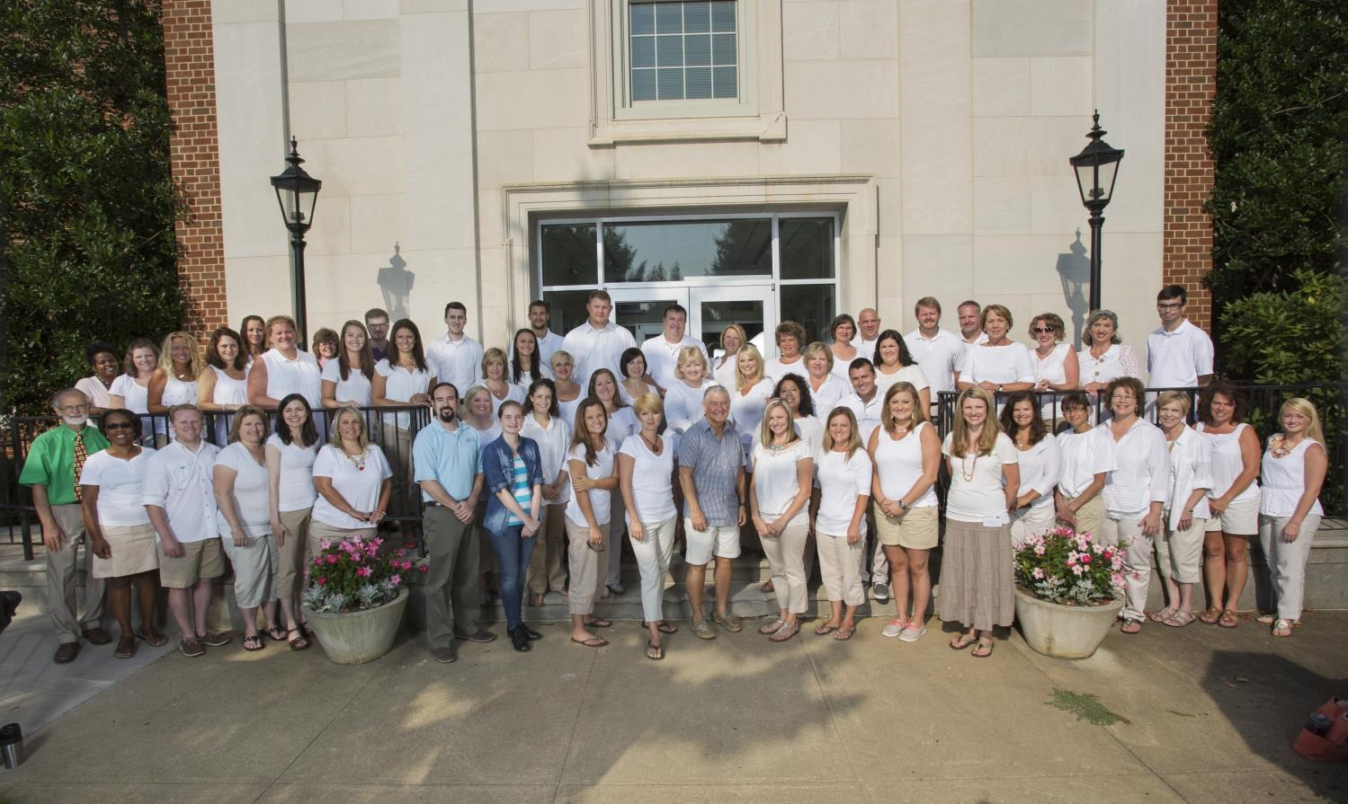

Contents

Eastman Scholar Mathletes Group Photo…………………………………………………………………………………………… 1

Contents Page……………………………………………………………………………………………………………………………………. 2

Directors for the 2014 Eastman Scholar Mathletes Program……………………………………………................... 3

Eastman Scholar Mathletes Partnership………………………………………………………………................................ 4

2nd and 3rd Grade Mathletes Group Photo………………………………………………………………..……………………….. 5 2nd and 3rd Grade Mathletes………………………………………………………………………………………………………………. 6-8

4th and 5th Grade Mathletes Group Photo………………………………………………………………………………………….. 9 4th and 5th Grade Mathletes……………………………………………………………………………….................................. 10-11

Algebra I Mathletes Group Photo………………………………………………………………………………………………………. 12
Algebra I Mathletes………………………………………………………………………………………....................................... 13-14

District Math Coordinators and Math Specialists……………………………………………………………………………….. 15
District Math Coordinators and Math Specialists Group Photo………………………………………………………….. 16

Mathletes Group Photos by School System……………………………………………………………………………….......... 16-17 Bristol TN City Schools……………………………………………………………………………………………………………. 16
Hawkins County Schools…………………………………………………………………………………………………………. 16
Johnson City Schools………………………………………………………………………………………………………………. 16
Kingsport City Schools……………………………………………………………………………………………………………. 16
Scott County, VA Schools……………………………………………………………………………………………………….. 17
Sullivan County Schools………………………………………………………………………………………………………….. 17
Washington County Schools…………………………………………………………………………………………………… 17

Eastman Scholar Mathletes Program Instructors Group Photo…………………………………........................... 18

Eastman Scholar Mathletes Team Group Photo…………………………………………………………......................... 18

Directory layout and design created by: Angela T. Haga
Updated July 2014 by: Donna Harris, Printing Service, Eastman Chemical Company
Photographs provided by: Kelly Hammonds, Studio Photographer, Eastman Chemical Company Copyright 2014

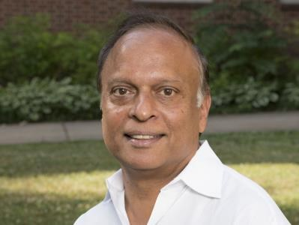
Directors for the 2014 Eastman Scholar Mathletes Program

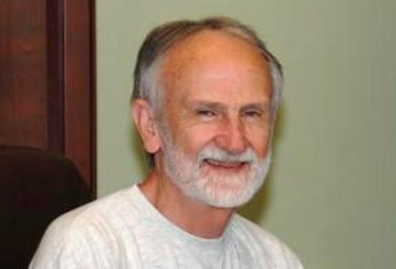
Dr. Jack Rhoton  Executive Director  (Retiring August 1, 2014)  Center of Excellence in Mathematics and Science Education  East Tennessee State University rhotonj@etsu.edu | Dr. Anant Godbole  Executive Director  (Effective August 1, 2014  Center of Excellence in Mathematics and Science Education  East Tennessee State University GODBOLEA@mail.etsu.edu
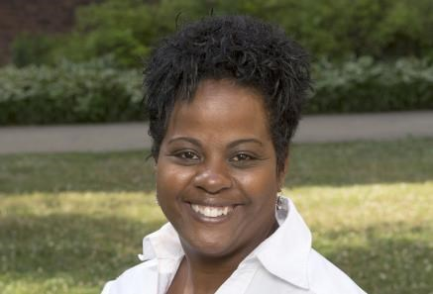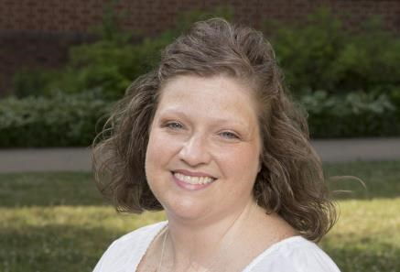

Mrs. Tanya Foreman  Education Manager  Eastman Chemical Company  Office: (423)229-2020 tsf@eastman.com |  | Mrs. Sherry Morelock  Education Coordinator  Eastman Chemical Company  Office: (423)229-5353  sherryj@eastman.com

Eastman Scholar Mathletes Partnership

Eastman Scholar Mathletes is a collaborative partnership between Eastman Chemical and East
Tennessee State University’s Center for Excellence in Math and Science Education. This program provides professional development for selected elementary and middle school math teachers, who work in Eastman’s Putting Children First partnership schools.
The Eastman Scholar Mathletes program is designed to compliment and reinforce ongoing programs of math mentoring in participating school systems. The program provides teachers with an opportunity to participate in an intensive two-week summer workshop focused on math education. Teachers receive conceptual training, such as differentiated learning techniques, as well as specific content knowledge, including information on recent standards changes needed to meet state requirements. The workshop also facilitates networking opportunities between teachers from different school systems to spark innovation in the classroom, build upon their own knowledge and develop better teaching strategies.
The Eastman Scholar Mathletes program aligns with Tennessee’s recent college and work readiness agenda, which proposes increasing state standards to meet American Diploma Project benchmarks. The more rigorous standards include increasing math requirements for high school graduation in Tennessee from three to four credits.
Eastman is committed to helping educators, government, and other business leaders improve K-12 education in Tennessee for the purpose of strengthening the pipeline of qualified workers needed to compete in a global economy and to improve and sustain our communities in the future.
http://www.eastman.com/Company/Putting_Children_First/Programs/Pages/Eastman_Scholar_Mathletes.aspx http://www.eastman.com/Company/Putting_Children_First/Programs/Pages/Workshop_Pictures.aspx

2nd and 3rd Grade Mathletes

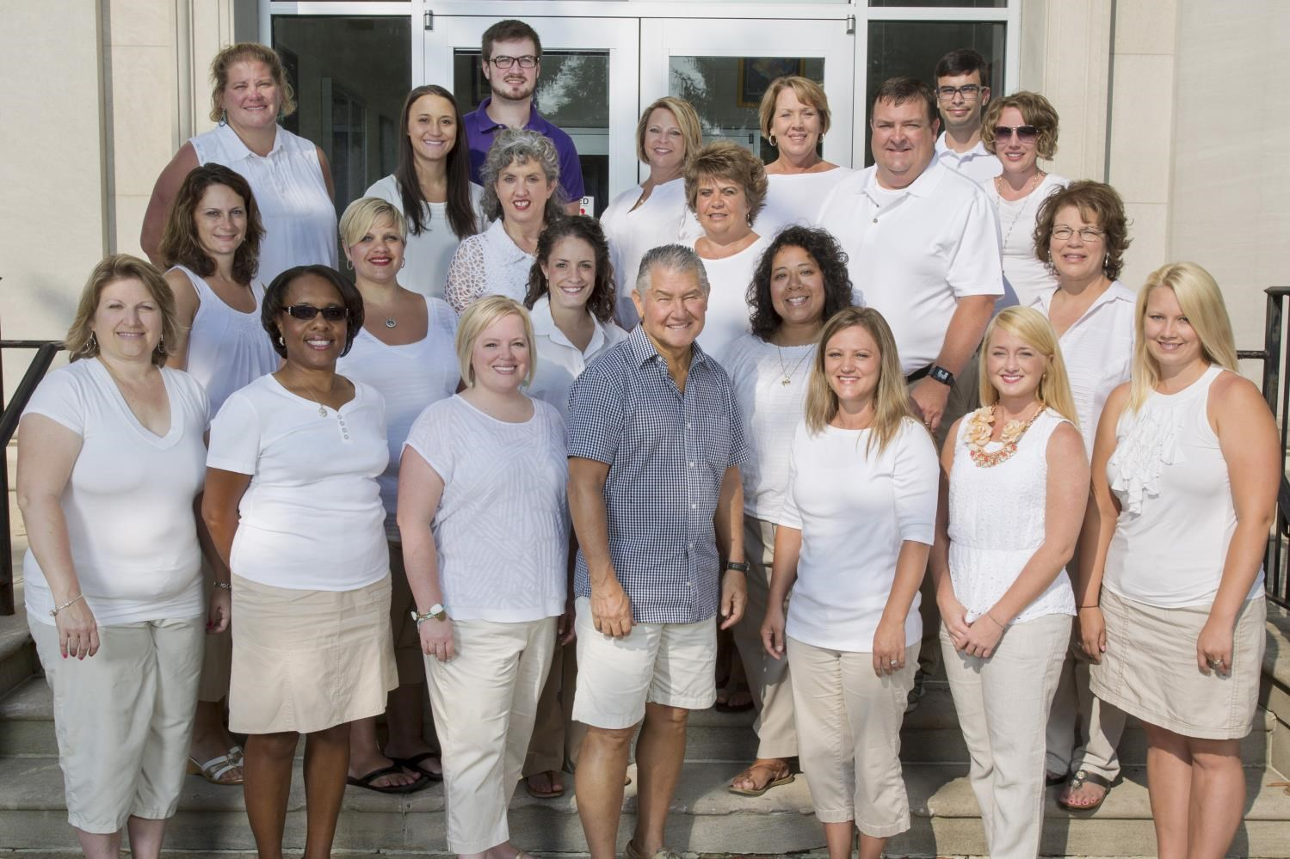

Dr. George Poole Ashley Barbe Jennifer Belt INSTRUCTOR Bristol TN City Schools Hawkins County Schools ETSU Mathematics Department barbea@btcs.org Jenniferbelt1@gmail.com
pooleg@etsu.edu

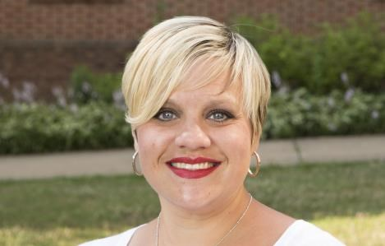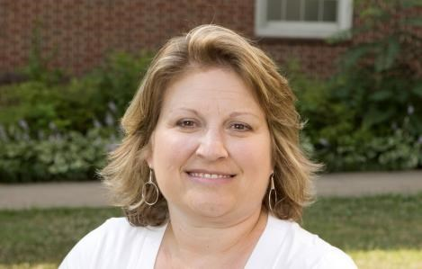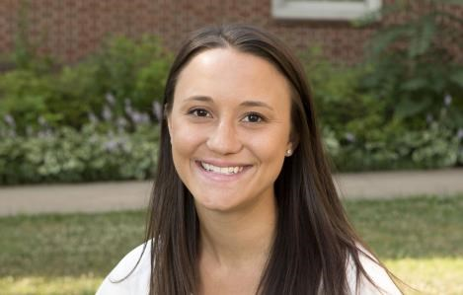

Rachel Black Christy Boggs Amy Bundy
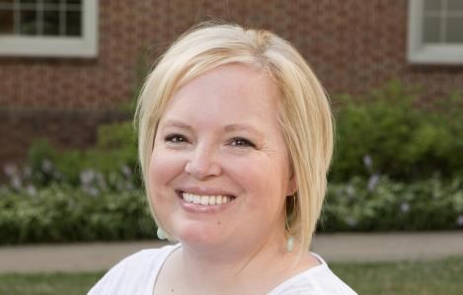Kingsport City Schools Bristol TN City Schools Johnson City Schools rblack@k12k.com barbea@btcs.org bundya@jcschools.org

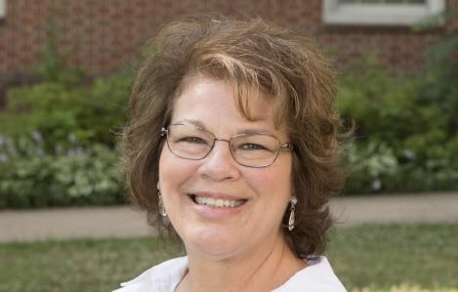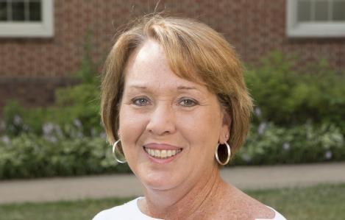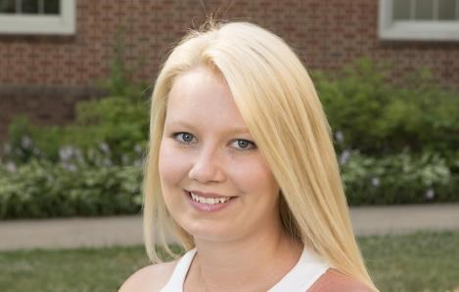

Kim Elkins Sandra Fox Maggie Hall
Sullivan County Schools Washington County Schools Bristol TN City Schools
kim.elkins@sullivank12.net foxs@wcde.org hallm@btcs.org

Melanie Harris Michael Harris Monica Hart
Sullivan County Schools Sullivan County Schools Johnson City Schools melanie.harris@sullivank12.net michael.harris@sullivank12.net hartm@jcschools.org

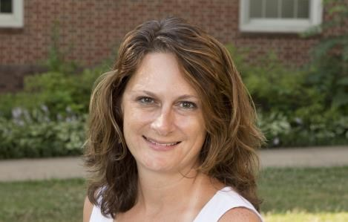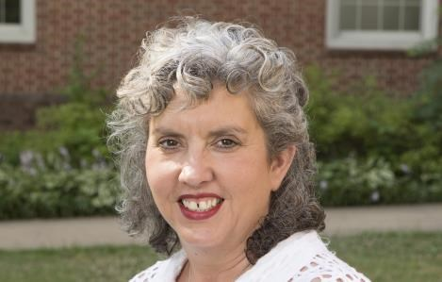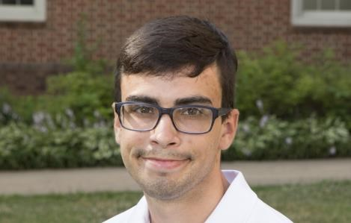

Tammy Kota Robyn Lamb James Laney
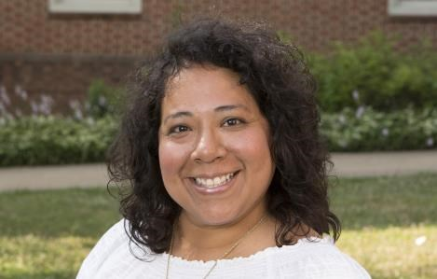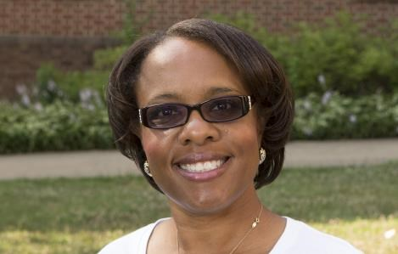Johnson City Schools Johnson City Schools Hawkins County Schools kotat@jcschools.org lambr@jcschools.org james.laney@hck12.net

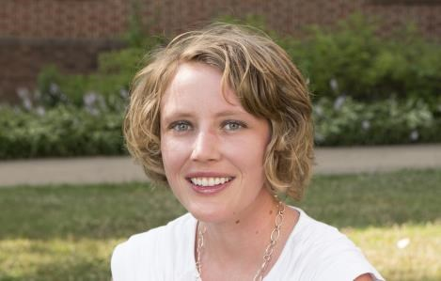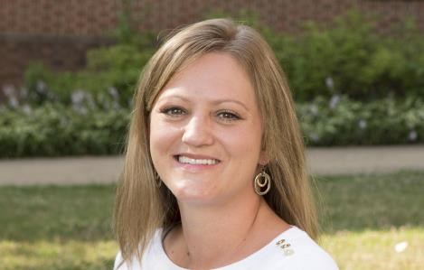

Brad McDannald Ashley Morrow Kesha Ryan
Johnson City Schools Washington County Schools Sullivan County Schools mcdannaldd@jcschools.org morrow@wcde.org debra.ryan@sullivank12.net

Tina Sain Katie Salyer Karen Sizemore
Kingsport City Schools Kingsport City Schools Hawkins County Schools jsain@k12k.com acsalyer@k12k.com karen.sizemore@hck12.net
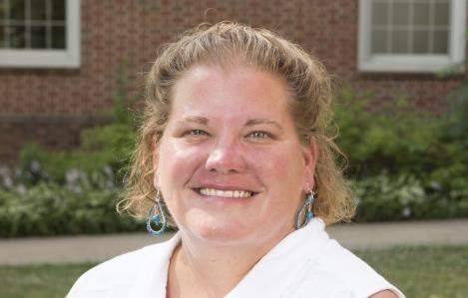
Meredith Woosley 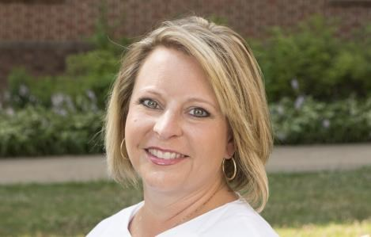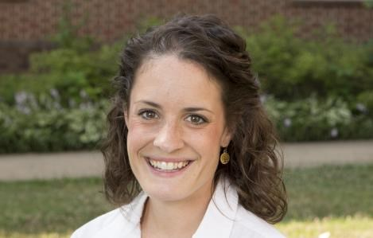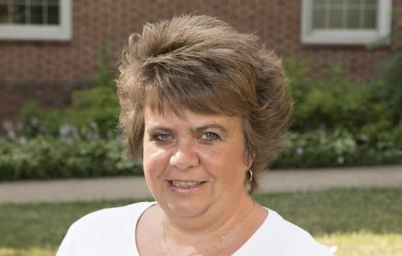 Johnson City Schools
woosleym@jcschools.org

4th and 5th Grade Mathletes

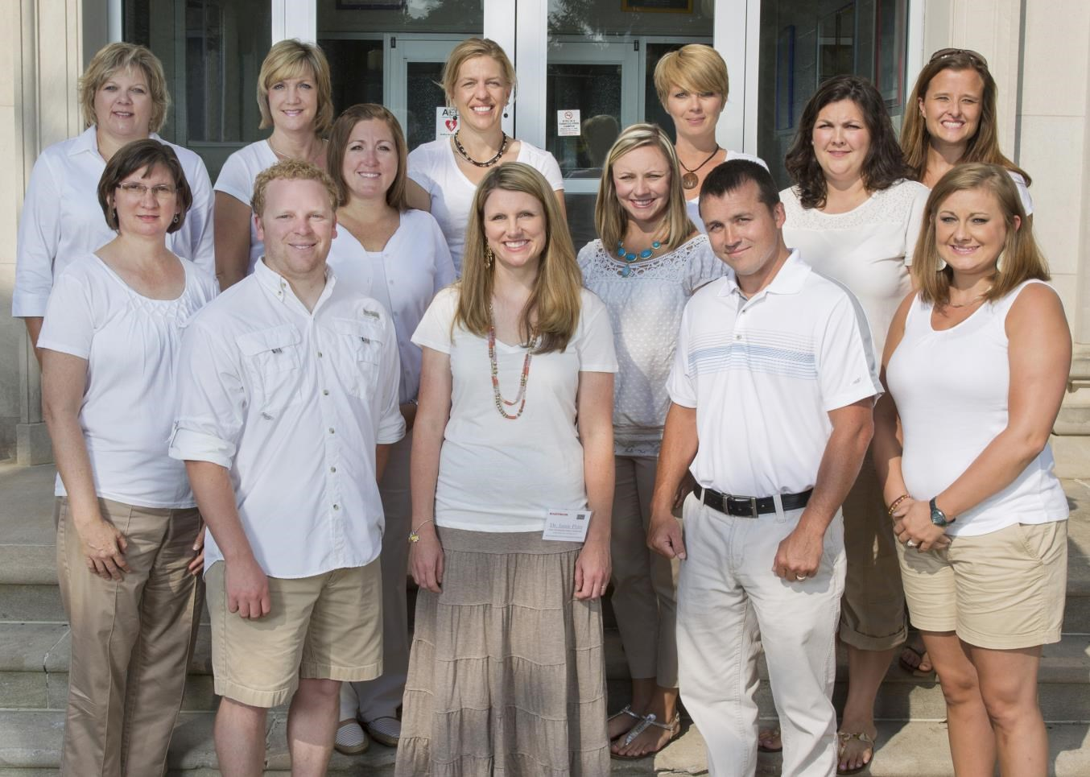

4th & 5th Grade Mathletes

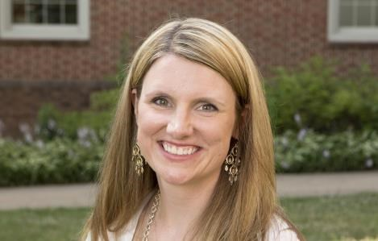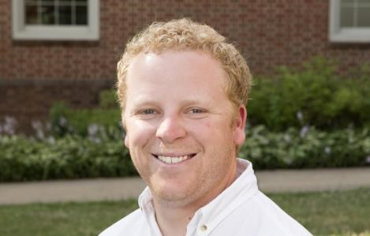

Dr. Jamie Price Cody Dison Tiffany Hibbitts
INSTRUCTOR Bristol TN City Schools Johnson City Schools
Center of Excellence in Mathematics disonk@btcs.org hibbittst@jcschools.org
and Science Education
JHPrice@milligan.edu

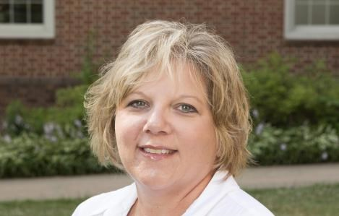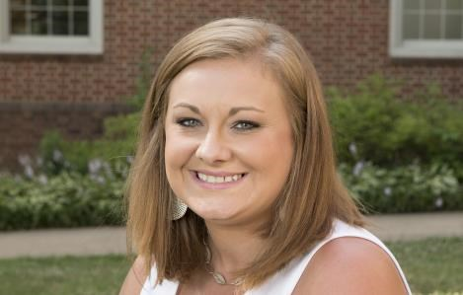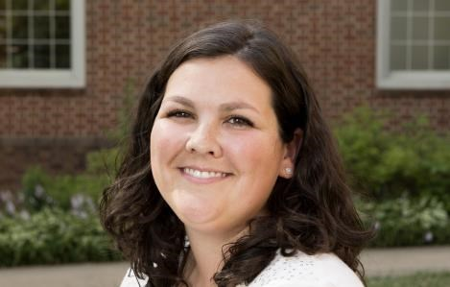

Tracie Hill Heather Petersen Jamie Matthews
Hawkins County Schools Scott County Schools Hawkins County Schools hills92@embarqmail.com heather.petersen@scottschools.co jamie.matthews@hck12.net m

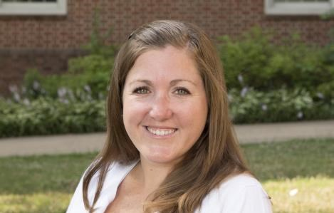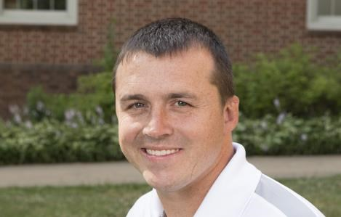

Kyleah Mauk Bethany Paupeck P.J. Ryan
Washington City Schools Kingsport City Schools Kingsport City Schools disneymom2.km@gmail.com bpaupeck@k12k.com pryan@k12k.com

4th & 5th Grade Mathletes

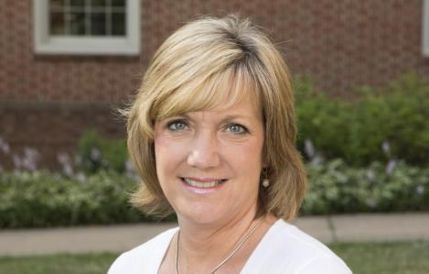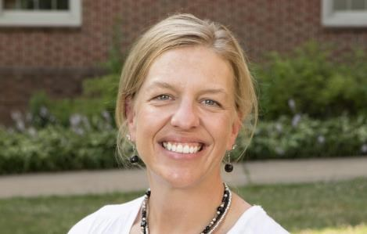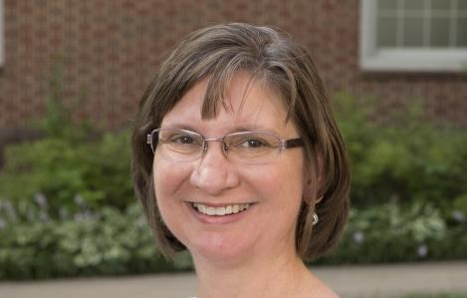

Pam Statzer  Kingsport City Schools pstatzer@k12k.com |  | April Stipes  Bristol TN City Schools stipesa@btcs.org |  | Laura Tipton  Hawkins County Schools laura.tipton@hck12.net
Not Pictured 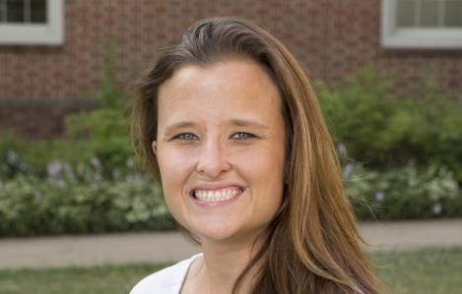
Danielle Triplette Jessica Wilson
Hawkins County Schools Washington County Schools danielle.triplette@hck12.net jw2340@gmail.com

Algebra 1 Mathletes

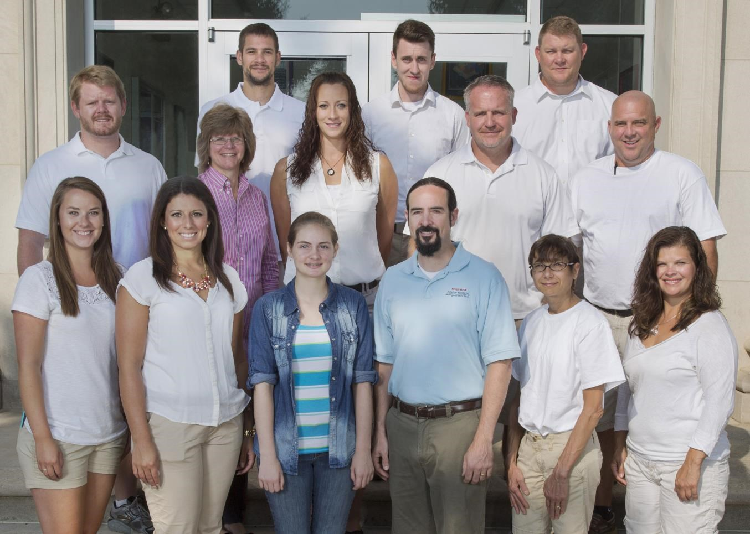

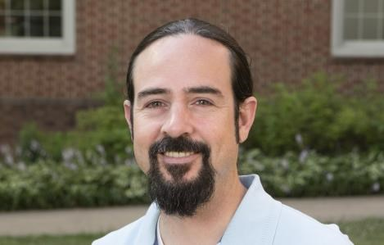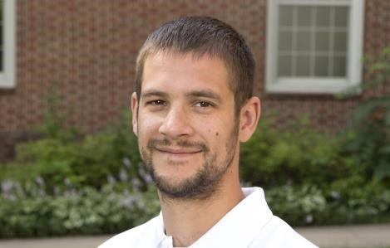

Dr. Ryan Nivens Derek Cassel Aaron Christian
INSTRUCTOR Scott County Schools Bristol TN City Schools
Center of Excellence in Mathematics derek.cassel@scottschools.com christiana@btcs.org
and Science Education
nivens@etsu.edu

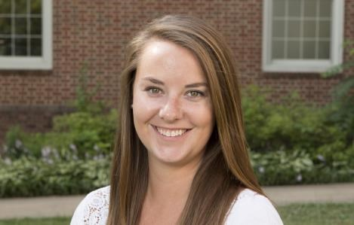

Chancli Declercq Haleigh Garber John Good
Bristol TN City Schools Kingsport City Schools Washington County Schools chancli92@gmail.com hgarber@k12k.com goodj@wcde.org

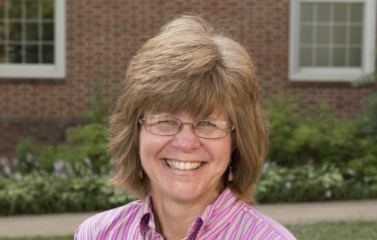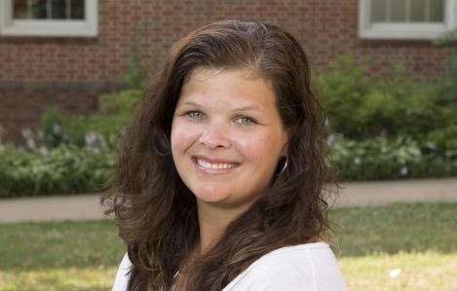

Becky Grese Adam Hall Jaime Hise
Sullivan County Schools Kingsport City Schools Sullivan County Schools rebecca.grese@sullivank12.net ahall@k12k.com jaime.hise@sullivank12.net

Algebra 1 Mathletes

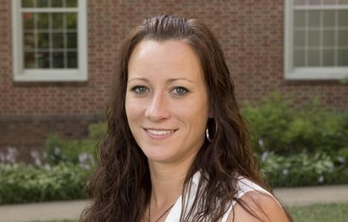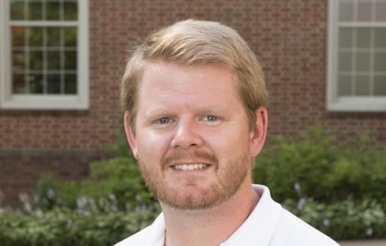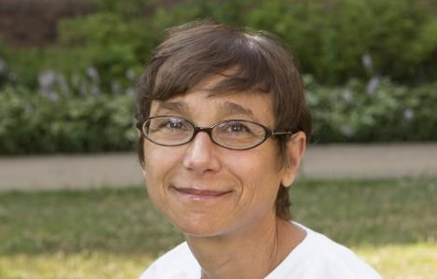

Cheryl McHone Ross Roberts Mary Salamone
Washington County Schools Washington County Schools Sullivan County Schools mchonec@wcde.org Ross.E.Roberts@gmail.com mary.salamone@sullivank12.net
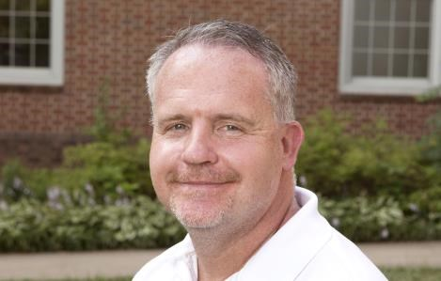

Barry Wade
Bristol TN City Schoolswadeb@btcs.org

District Math Coordinators and Math Specialists
Lori Ann Allen  Hawkins County Schools  Math Specialist lori.allen@hck.12.net |  | Sherry Cockerham  Johnson City Schools  System-wide Math Coach cockerhams@jcschools.org |  | Sherri DeVault  Sullivan County Schools  Math Specialist sherri.devault@sullivank12.net
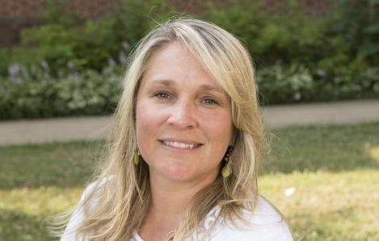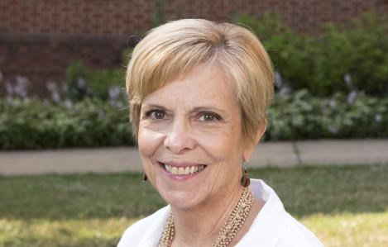

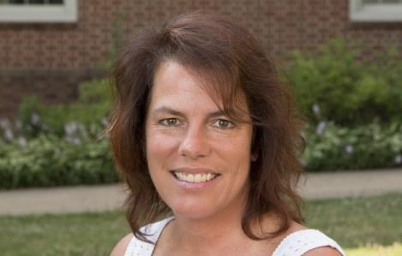
Tracy Easterling  Bristol TN City Schools  Mathematics Coordinator easterlingt@btcs.org |  | Beth Gilbert  Sullivan County Schools  Instructional Math Coach beth.gilbert@sullivank12.net |  | Amy Glass  Hawkins County Schools  Math Specialist amy.glass@hck.12.net
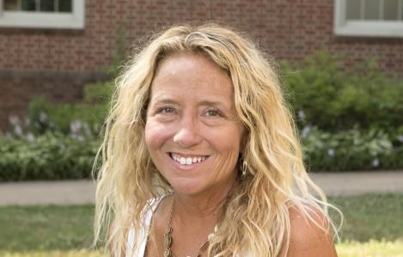
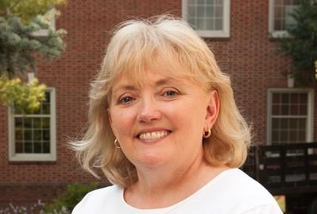
Not Pictured
Cindy Hayes  Washington County Schools  System-wide Math Coach hayesc@wcde.org |  |  | Pam Stidham  Kingsport City Schools  Math Specialist pstidham@k12k.com

Mary Alice McClellan
Scott County Schools
Math Specialists maryalice.mcclellan@scottschools.com

District Math Coordinators and Math Specialists

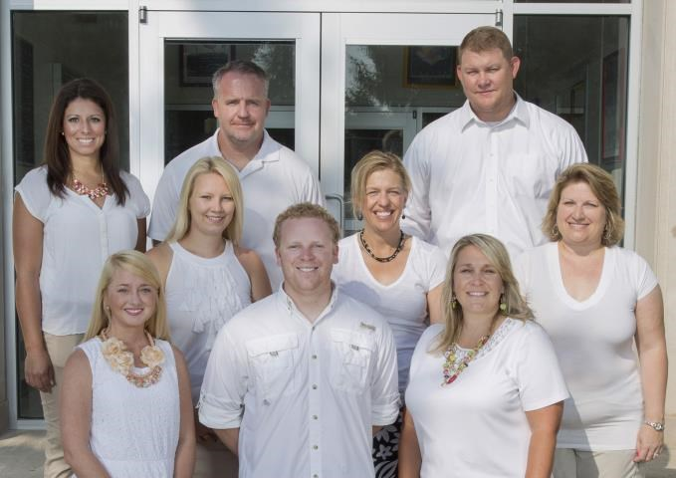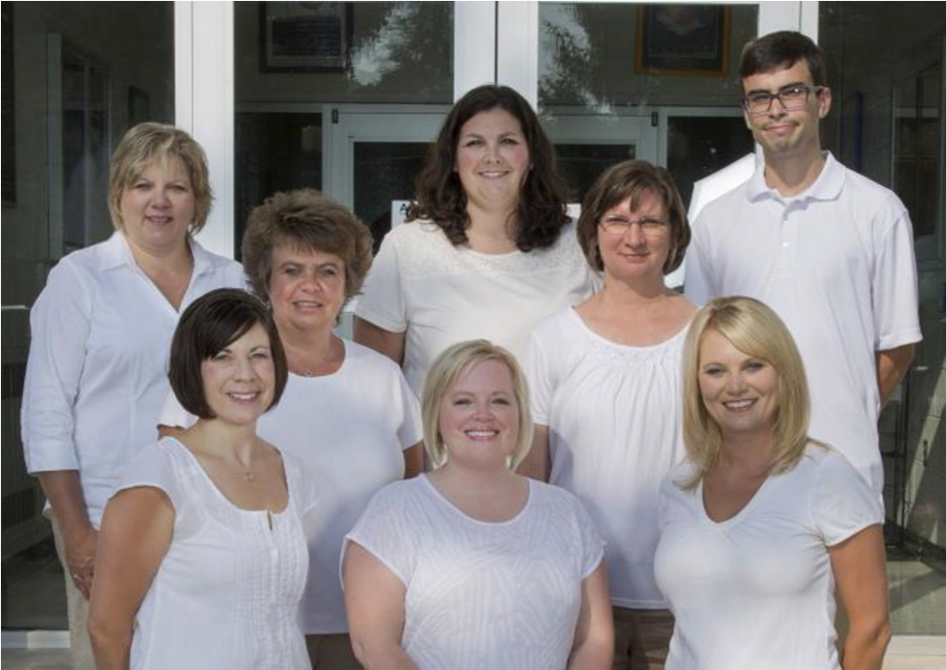

Bristol TN City Schools Hawkins County Schools

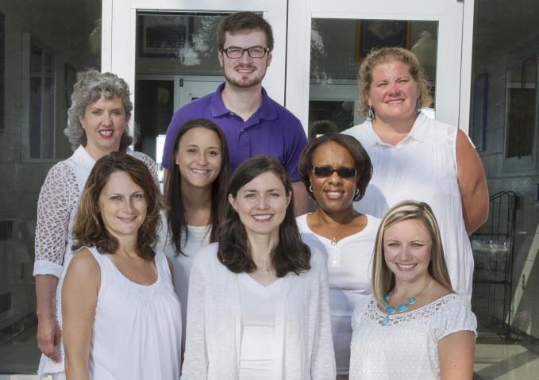

Johnson City Schools Kingsport City Schools

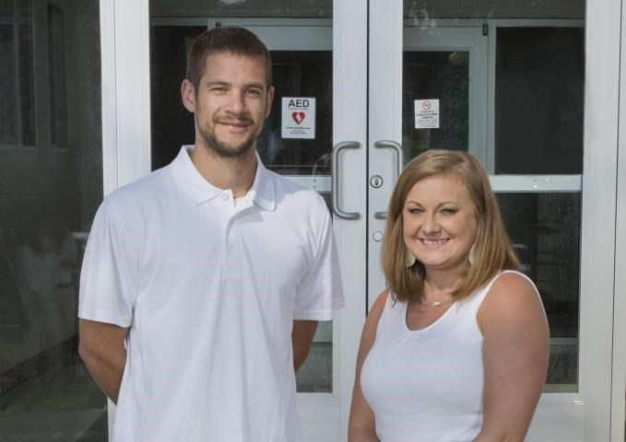

Scott County, VA Schools Sullivan County Schools

Washington County Schools

Eastman Scholar Mathletes Program Instructors

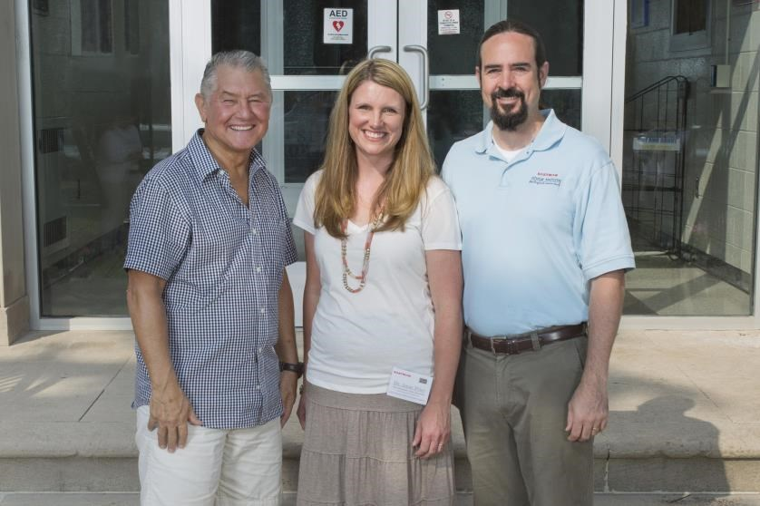
Pictured left to right: Dr. George Poole, Dr. Jamie Price & Dr. Ryan Nivens

Eastman Scholar Mathletes Team

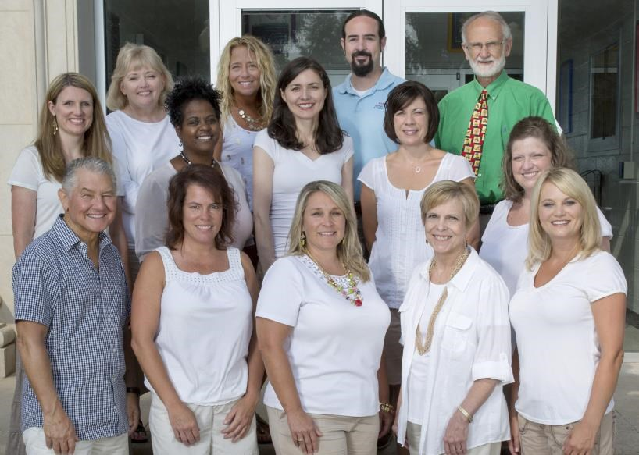
Pictured left to right - Top Row: Dr. Jamie Price, Pam Stidham, Cindy Hayes,
Dr. Ryan Nivens, Dr. Jack Rhoton – Second Row: Tanya Foreman, Sherry
Cockerham, Lori Allen, Sherry Morelock - Bottom Row: Dr. George Poole,
Sherri DeVault, Tracy Easterling, Beth Gilbert and Amy Glass

