Academic Program Review Handbook
2020-2025

East Tennessee State University
Revised June 2023

Contact Us:

Megan Miller
Assessment Coordinator
Burgin Dossett Hall, Room 205B
423-439-6712
millerme2@etsu.edu

Katalin Hajnal
Office Coordinator
Burgin Dossett Hall, Room 206
423-439-4236
hajnal@etsu.edu

Contents
What is Academic Program Review? 4
Why is Program Review Important? 4
What goes into in the self-study? 5
How are reviewers identified, selected, and reimbursed? 6
How should programs prepare for the site visit? 7
Where do I begin? 7
What is the timeline for the Program Review process? 8
Appendix A: Program Review Rubric: Undergraduate Programs 9
Appendix B: Program Review Rubric: Graduate Programs 12
Appendix C: Program Review Criteria Mapped to SACSCOC Requirements 15

What is Academic Program Review?
The Tennessee Higher Education Commission (THEC) provides incentives, through the Quality Assurance Funding (QAF) program, for institutions who achieve and maintain program excellence through external evaluation. For accreditable programs, evaluation is based on the percentage of programs in good standing with accreditors or making adequate progress toward accreditation. For non-accreditable programs, evaluation is based on a set of objective standards related to learning outcomes, curriculum, student experience, faculty, learning resources, and support.
In accordance with the 2020-25 QAF guidelines, all non-accreditable, active degree programs must be evaluated through an Academic Program Review. Program Reviews provide a systematic method to evaluate program needs and productivity and improve program quality.
The Program Review process takes place on a seven-year cycle. During six of the seven years, program leaders monitor and document the extent to which they achieve the aims of the program as described in their institutional effectiveness plans, including identifying and implementing improvement efforts. During the seventh year of the cycle, programs collaborate with the Office of Planning and Decision Support (PDS) to complete a self-study report and host a site visit. The program is reviewed by two qualified external reviewers (at least one must be out-of-state), who read the self-study report and participate in a site visit that includes a tour of program facilities and meetings with students, faculty, administrators, and others. The reviewers then complete a standard evaluation rubric and compile a narrative report that includes recommendations for improvement. Program leaders work with the appropriate college dean to create action plans based on reviewer feedback and incorporate these plans into the existing institutional effectiveness process. Then, the cycle begins again.
PDS coordinates all reviews with the primary goal of showcasing the quality of ETSU’s academic programs. PDS staff serve as a resource as programs compile the self-study and attempt to make the review process as smooth as possible for all involved. PDS is also available to provide guidance and support for strategic planning and improvement activities before and after the site visit. Program leaders are encouraged to contact PDS staff with questions or to request assistance.

Why is Program Review Important?
The Program Review process provides deans, department chairs, program coordinators, and faculty with the guidance and structure needed to identify strengths and weaknesses, opportunities for improvement, and current efforts that are beneficial to the program. This process not only allows programs to identify their unique advantages and needs, but it also provides information on services available across campus to help advance programs. Continuous efforts to improve program quality affirm ETSU’s mission and values – specifically that education is the university’s highest priority – and help to promote improved enrollment, retention, and graduation rates. Therefore, it is important that program leaders and faculty fully engage in the review process, including completing follow-up activities, to ensure that planned changes are implemented and resource needs are addressed in a systematic manner.
Many of the Program Review criteria are closely aligned with SACSCOC core requirements and standards. The documentation compiled and collected during the program review process and self-study compilation can often be used for accreditation purposes, saving program leaders time and reducing duplication of effort. In addition, the rubrics completed by external program reviewers are valuable evidence of ETSU’s compliance with related SACSCOC standards. Appendix A and Appendix B are the Program Review Rubrics for Undergraduate Programs and Graduate programs respectively, which are completed and submitted by the reviewers. Appendix C provides a crosswalk between the undergraduate and graduate Program Review criteria and related SACSCOC standards and core requirements.
Finally, Program Reviews are a significant portion of the QAF point calculation. Successful Program Reviews earn a higher number of QAF points, generating additional funds for the university. ETSU’s participation in the QAF process generates up to $4 million of ETSU’s annual state appropriations, and approximately $700,000 of these funds are directly attributed to Program Review performance.

What goes into in the self-study?
In preparation for the self-study, program faculty and staff members should meet to analyze and discuss the current state of their program, including current strengths, weaknesses, improvement efforts, and areas that makes the program unique and successful. Faculty and staff should also review the self-study template and rubric(s) to ensure all areas of the program review are discussed. Within the self-study template, each rubric item is incorporated to ensure that all rubric items are addressed. Self-studies are written by department chairs or program coordinators with input from faculty and staff or be divided among individual faculty or committees, then combined and edited. Regardless of the process used to complete the self-study, the program’s department chair is responsible for the final product.
Some sections of the self-study template have university-level information that may not be changed. Prompts for program-specific information indicate information that the program should provide. Unless otherwise noted, all sections must be included as these directly correspond to the THEC rubric used by the review team to evaluate the program. In each section, provide a description of that aspect of the program (focusing on the last 5-7 years), any data available to describe or measure that item, and a discussion of the findings of that aspect of the self-study. The template should assist those preparing the self-study in describing the program thoroughly.
Programs are encouraged to respond to self-study prompts honestly, directly, and efficiently – keeping in mind that reviewers are busy professionals often participating in the review process as a service activity to the discipline. If any data that needs to be included is too unwieldy, please provide it as an appendix and summarize the information in the related self-study section. Physical exhibits should be gathered in a convenient location in case they are requested by the review team at the time of the site visit. These could include:
- instructions for or copies of exams, reports, projects, and/or grading rubrics;
- previous Program Review narrative report(s) and summary document(s);
- syllabi for all courses in the program; or
- journal articles or research presentations from students or student/faculty collaborations.
The review team reads the self-study and related materials before the visit and notes questions and concerns to be addressed during the review. During the site visit, they observe, question, and assess the program in light of the self-study. They may also request or examine additional information, such as the materials listed above, during the visit. Before adjourning on the final day, the external reviewers complete the rubric(s) provided by THEC, which are collected by PDS. Copies of the completed rubric(s) are emailed to program leaders and other individuals involved with the review that afternoon or the next working day.

How are reviewers identified, selected, and reimbursed?
Program leaders identify two external reviewers, at least one from outside the state of TN. Typically external reviewers are colleagues known by the department chair or a faculty member, but with whom there is limited personal and professional association (see requirements below). It is helpful if at least one of the reviewers has experience as a department chair or program coordinator, and training or experience as a program reviewer is especially beneficial. Reviewers from institutions similar to ETSU (in size, scope, student population, funding, etc.) are preferred.

Program leaders experiencing difficulty in identifying potential reviewers may:
- ask department faculty for suggestions;
- request assistance from professional associations, as many disciplinary organizations provide training for program reviewers and can provide names of experienced/trained individuals; or
- contact comparable programs at other regional universities for recommendations of individuals who have successfully reviewed their programs.

The THEC QAF guidelines require that program reviewers:
- be professionals in the field under review;
- hold a terminal degree;
- hold an academic position, preferably at a regional public university comparable to ETSU (in rare cases a practicing professional in the field or a retiree is an appropriate substitute);
- NOT be ETSU graduates; and
- NOT have active or previous professional or personal affiliations with faculty in the department to be reviewed, or with other reviewers (co-author, classmate, professor/student, former colleague, etc.).

Department chairs should contact potential reviewers to ask if they are willing to be considered and able to serve during the dates of the site visit. Once the program has established those able to serve, the department chair or program coordinator provides the names, email addresses, and abbreviated CV’s (5 pages or less) of these reviewers to the AC as early in the academic year as possible, but no later than December 1st. All reviewers must meet the qualifications listed above. The Provost and ETSU Board of Trustees will have final approval of the review team.

PDS may include a faculty member, usually a department chair or program coordinator, from a program undergoing the review process in the next academic year in the site visit meetings, in order to mentor those undergoing future reviews. These internal consultants attend all site visit meetings and can provide important campus-related information and context to external reviewers. However, internal consultants cannot sign, participate in, or influence completion of the Program Review rubrics.

The program under review is responsible for reimbursing external reviewers for travel costs in accordance with ETSU’s General Travel policy (https://www.etsu.edu/bf/procurement/travel.php). This includes flight, mileage, meals and incidentals, as well as other expenses incurred such as baggage claim, airport parking, and taxi, Uber, Lyft, or shuttle fees. The program is also responsible for arranging hotel accommodations for external reviewers at the Carnegie Hotel. Programs may choose to offer an honorarium. All program reviewers must visit campus in person, and PDS will provide $1,500 per program to help cover costs. Lunch vouchers will also be provided for the review team (external reviewers and internal consultant) during the site visit.

How should programs prepare for the site visit?
After reviewers are selected and approved, PDS will notify the program so that hotel reservations can be made. Reviewers will need to arrive the evening prior to the visit and may leave after the concluding meeting of the site visit (around 3pm). Reviewers that fly may need to stay an extra night due to availability of flights. Reviewers that fly should arrange flights as soon as possible. PDS will contact reviewers about their responsibilities and send them all of the necessary materials, including the self-study, appendices, rubrics, and itinerary. Once the reviewers arrive in Johnson City, the program will act as their host and therefore be responsible for transportation and information.
PDS provides programs with a Sample Program Review Schedule. PDS is responsible for scheduling all university-level administrators, but the program is responsible for scheduling department personnel where indicated. Additionally, the program will schedule meeting locations for all meetings, except the Welcome Meeting on Day 1 of the visit.
The faculty and staff of the program under review are responsible for:
- Scheduling rooms at the Carnegie Hotel for external reviewers;
- Finalizing the Program Review Schedule (scheduling meeting locations and attendees where indicated on the Sample Program Review Schedule);
- Scheduling participation of departmental faculty, students, and stakeholders;
- Distributing itinerary to departmental participants (PDS will distribute to administrators and reviewers);
- Arranging refreshments (drinks and snacks) in meeting space;
- Providing local transportation for review team;
- Preparing/finalizing all reimbursements to external reviewers.

Where do I begin?
PDS staff have supported programs across the institution in successful program review efforts for nearly ten years. We realize the workload associated with the self-study and the site visit can seem overwhelming. We encourage program leaders and faculty involved in this process to refer to this handbook often, abide by all instructions and deadlines, and to contact us for additional guidance and support. Your success in this process is our ultimate goal.

What is the timeline for the Program Review process?
Activity | Deadline
Program leader(s) meet with the Assessment Coordinator (AC) to go over handbook and discuss process | September 15th (year of review)
Program writes the self-study | Fall semester
Program submits potential site visit dates to AC for approval | October 1st
Program receives data from PDS | October 1st
AC gets approval for site visit dates; programs may begin reserving meeting spaces for site visit | October 15th
Program submits self-study draft to AC to ensure program is on track (Draft does not need to be complete) | October 15th
Program submits completed self-study draft to AC | November: Monday after Thanksgiving break
Program chooses two external reviewers and sends their info to AC, including an abbreviated CV (no more than 5 pages) | December 1st
AC returns self-study to programs with suggested edits | Following winter break
Program edits self-study based on recommendations and returns to AC | January and February
Program finalizes self-study and site visit itinerary (See: Appendix B of this handbook) and submits to AC | 6 weeks before site visit
The program’s Dean is given the opportunity to review the self-study before it’s finalized and distributed | 1 month before site visit
AC distributes self-study to reviewers and campus administrators; program leaders distribute to faculty and staff | At least 2 weeks prior to site visit
Program hosts site visit | Spring semester, typically on a Thur/Fri or Mon/Tues during late-February to mid-April
Review team submits narrative report to AC | 1 month after site visit
AC distributes narrative report to department chair, dean, and others involved in site visit | Within 1 week after receipt of narrative report
Program leaders distribute narrative report to faculty and staff and initiate discussions regarding improvement | Within 1 week after receipt of narrative report
Program schedules meeting with dean to discuss improvements | Summer/Fall after site visit
Program reviews recommendations and improvement initiatives | Annually (Years 1-6)
Program documents progress being made via Institutional Effectiveness process | Annually (Years 1-6)
Program evaluates strengths and weaknesses to determine if additional improvement efforts are needed | Annually (Years 1-6)

Appendix A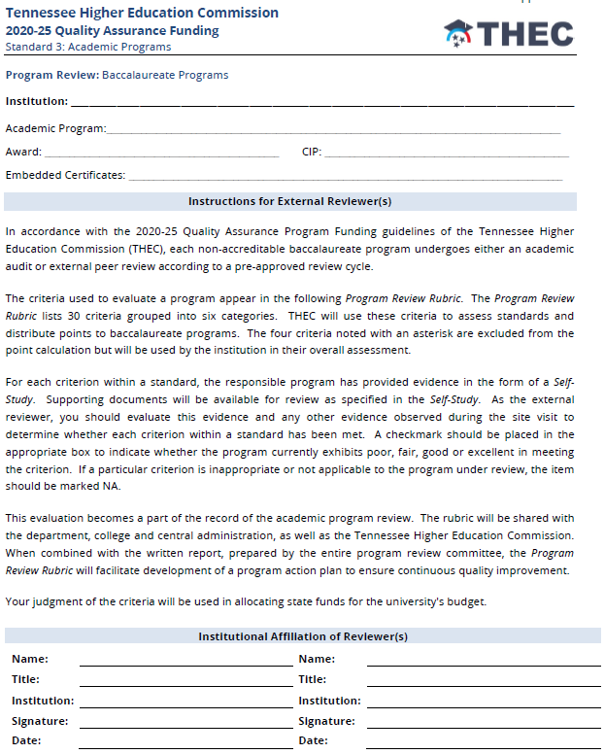 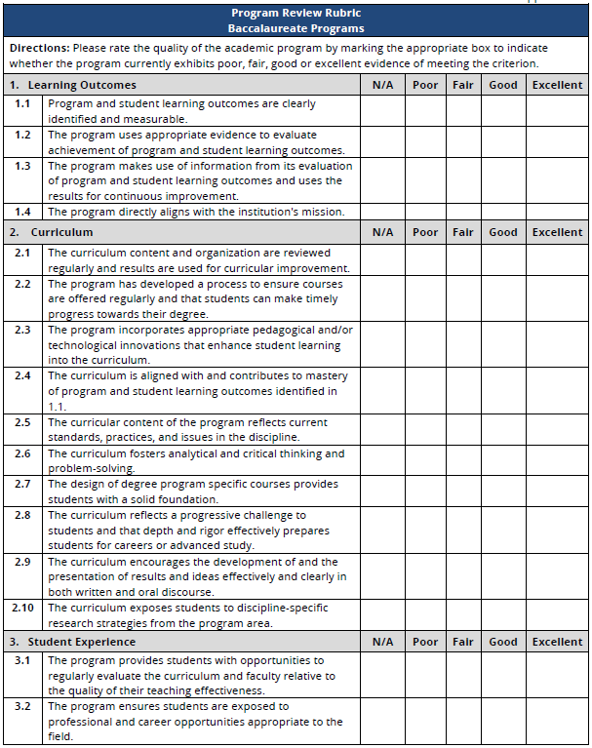 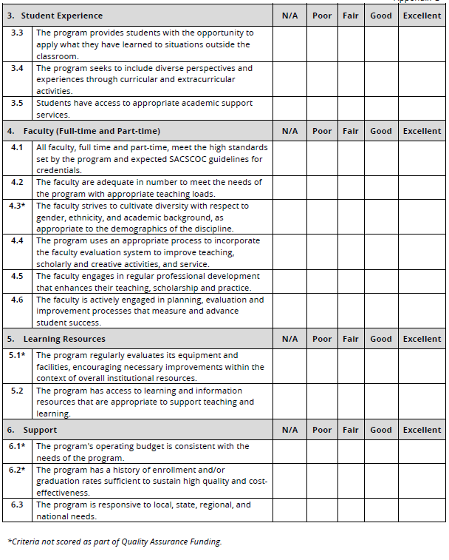

Appendix B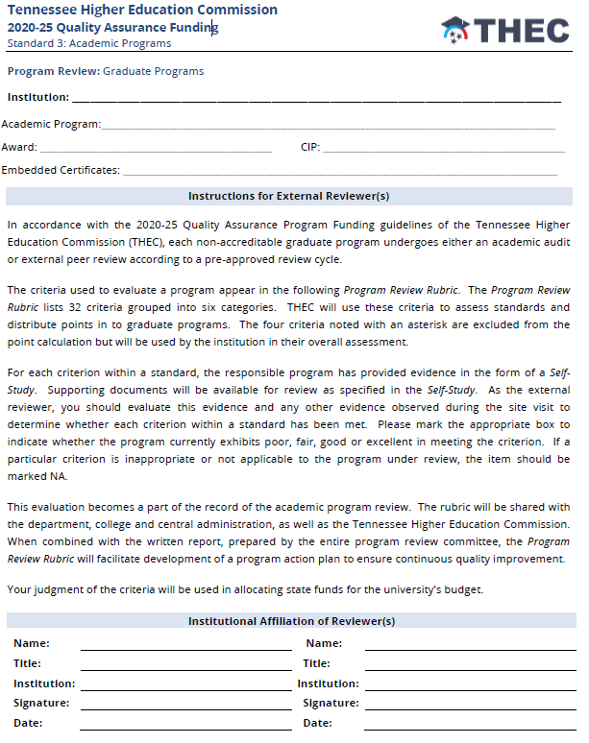 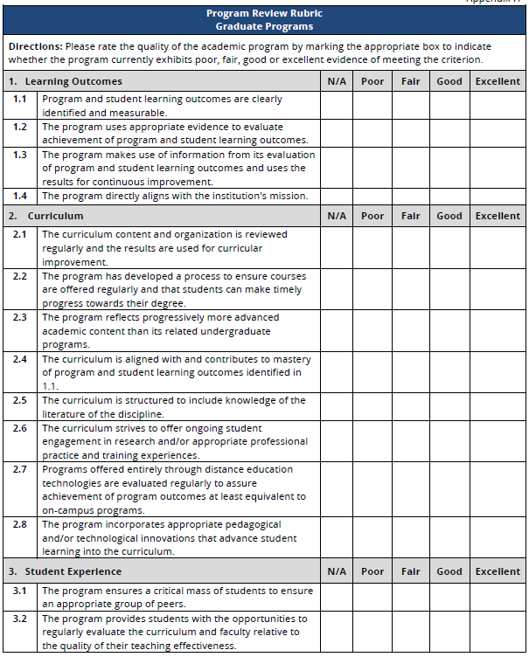 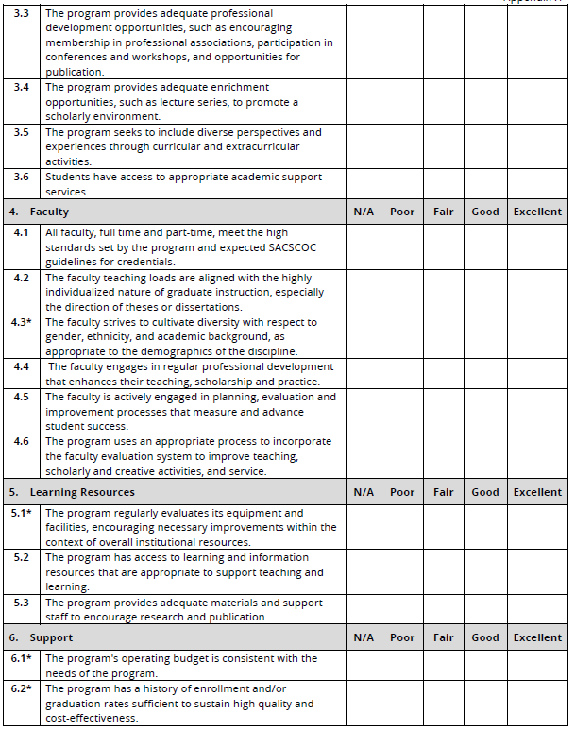

Appendix C

Program Review Criteria Mapped to SACSCOC Requirements

Program Review Rubric Item | SACSCOC Standard or Core Requirement
1. Learning Outcomes
1.1 (UG, G) Program and student learning outcomes are clearly identified and measurable. | 8.2a: The institution identifies expected outcomes, assesses the extent to which it achieves these outcomes, and provides evidence of seeking improvement based on analysis of the results in student learning outcomes for each of its educational programs. (Student outcomes: educational programs)
1.2 (UG, G) The program uses appropriate evidence to evaluate achievement of program and student learning outcomes.
1.3 (UG, G) The program makes use of information from its evaluation of program and student learning outcomes and uses the results for continuous improvement.
1.4 (UG, G) The program directly aligns with the institution's mission. | CR 9.1: Educational programs (a) embody a coherent course of study, (b) are compatible with the stated mission and goals of the institution, and (c) are based on fields of study appropriate to higher education. (Program content)
2. Curriculum
2.1 (UG, G) The curriculum content and organization are reviewed regularly and results are used for curricular improvement. | 6.2b: For each of its educational programs, the institution employs s a sufficient number of full-time faculty members to ensure curriculum and program quality, integrity, and review. (Program faculty)  10.4, part c: The institution places primary responsibility for the content, quality, and effectiveness of the curriculum with its faculty. (Academic governance)
2.3 (UG) The program incorporates appropriate pedagogical and/or technological innovations that enhance student learning into the curriculum.  2.3 (G) The program reflects progressively more advanced academic content than its related undergraduate programs. | 9.6: Post-baccalaureate professional degree programs and graduate degree programs are progressively more advanced in academic content than undergraduate programs, and are structured (a) to include knowledge of the literature of the discipline and (b) to ensure engagement in research and/or appropriate professional practice and training. (Post-baccalaureate rigor and curriculum)
2.4 (UG, G) The curriculum is aligned with and contributes to mastery of program and student learning outcomes identified in 1.1. | 8.2a: The institution identifies expected outcomes, assesses the extent to which it achieves these outcomes, and provides evidence of seeking improvement based on analysis of the results in student learning outcomes for each of its educational programs. (Student outcomes: educational programs)
2.5 (UG) The curricular content of the program reflects current standards, practices, and issues in the discipline.  2.5 (G) The curriculum is structured to include knowledge of the literature of the discipline. | 9.6: Post-baccalaureate professional degree programs and graduate degree programs are progressively more advanced in academic content than undergraduate programs, and are structured (a) to include knowledge of the literature of the discipline and (b) to ensure engagement in research and/or appropriate professional practice and training. (Post-baccalaureate rigor and curriculum)
3. Student Experience
3.5 (UG), 3.6 (G) Students have access to appropriate academic support services. | CR 12.1: The institution provides appropriate academic and student support programs, services, and activities consistent with its mission. (Student support services)
4. Faculty (UG: Full-time and Part-time; G: not specified)
4.1 (UG, G) All faculty, full time and part-time, meet the high standards set by the program and expected SACSCOC guidelines for credentials. | 6.2a: For each of its educational programs, the institution justifies and documents the qualifications of its faculty members. (Faculty qualifications)
4.2 (UG) The faculty are adequate in number to meet the needs of the program with appropriate teaching loads.  4.2 (G) The faculty teaching loads are aligned with the highly individualized nature of graduate instruction, especially the direction of theses or dissertations. | 6.2b: For each of its educational programs, the institution employs s a sufficient number of full-time faculty members to ensure curriculum and program quality, integrity, and review. (Program faculty)
4.4 (UG), 4.6 (G) The program uses an appropriate process to incorporate the faculty evaluation system to improve teaching, scholarly and creative activities, and service. | 6.3: The institution publishes and implements policies regarding the appointment, employment, and regular evaluation of faculty members, regardless of contract or tenure status. (Faculty appointment and evaluation)
4.5 (UG), 4.4 (G) The faculty engages in regular professional development that enhances their teaching, scholarship and practice. | 6.5: The institution provides ongoing professional development opportunities for faculty members as teachers, scholars, and practitioners, consistent with the institutional mission. (Faculty development)
4.6 (UG), 4.5 (G) The faculty is actively engaged in planning, evaluation and improvement processes that measure and advance student success. | 6.2b: For each of its educational programs, the institution employs s a sufficient number of full-time faculty members to ensure curriculum and program quality, integrity, and review. (Program faculty)
5. Learning Resources
5.1* (UG, G) The program regularly evaluates its equipment and facilities, encouraging necessary improvements within the context of overall institutional resources. | CR 11.1: The institution provides adequate and appropriate library and learning/information resources, services, and support for its mission. (Library and learning/information resources)  13.7: The institution ensures adequate physical facilities and resources, both on and off campus, that appropriately serve the needs of the institution’s educational programs, support services, and other mission-related activities. (Physical resources)
5.2 (UG, G) The program has access to learning and information resources that are appropriate to support teaching and learning. | 11.3: The institution provides (a) student and faculty access and user privileges to its library services and (b) access to regular and timely instruction in the use of the library and other learning/information resources. (Library and learning/information access)
5.3 (G) The program provides adequate materials and support staff to encourage research and publication. | 11.2: The institution ensures an adequate number of professional and other staff with appropriate education or experiences in library and/or other learning/information resources to accomplish the mission of the institution. (Library and learning/information staff)
6. Support
6.4 (G) The program regularly and systematically collects data on graduating students and evaluates placement of graduates. | 8.2a: The institution identifies expected outcomes, assesses the extent to which it achieves these outcomes, and provides evidence of seeking improvement based on analysis of the results in student learning outcomes for each of its educational programs. (Student outcomes: educational programs) – could be a required EPO for graduate programs.

