Parenting Tips

Effective communication is very important when it comes to parenting your child. Words are powerful and it is important to think before you speak. Non-verbal communication also has a large impact on how you communicate with others. Sometimes it is not just what you say, but how you say it. Actions speak louder than words (Swartz et al., 2016).
Are you communicating with your child effectively?
Apply it: Understand non-verbal communication and actively practice being aware of what non-verbals you are using. Actively practice thinking before you speak. Pick one non-verbal method to focus on weekly.
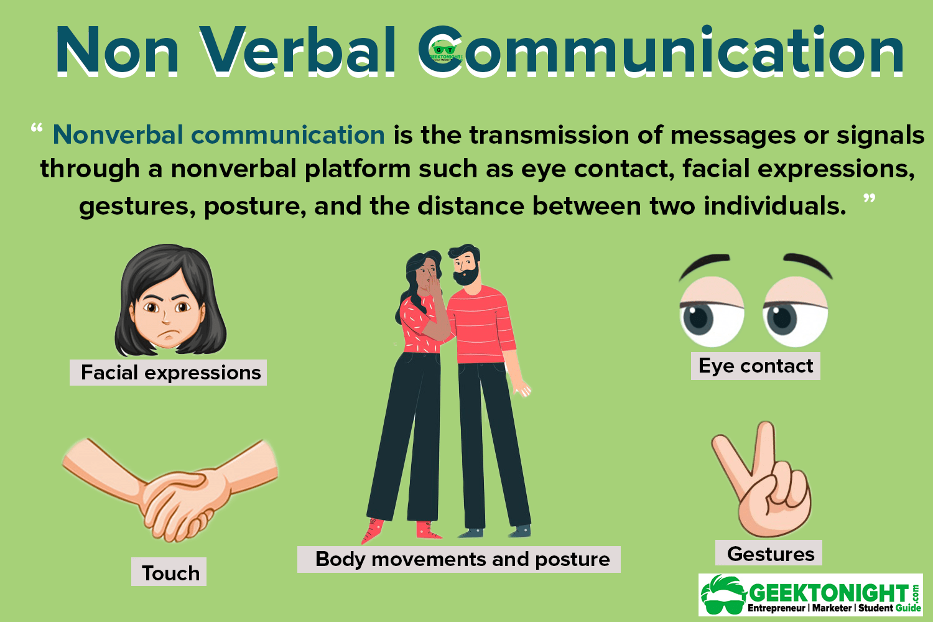
Photo used with permission from Geektonight on Nonverbal Communication https://www.geektonight.com/types-of-nonverbal-communication/

Managing Stress
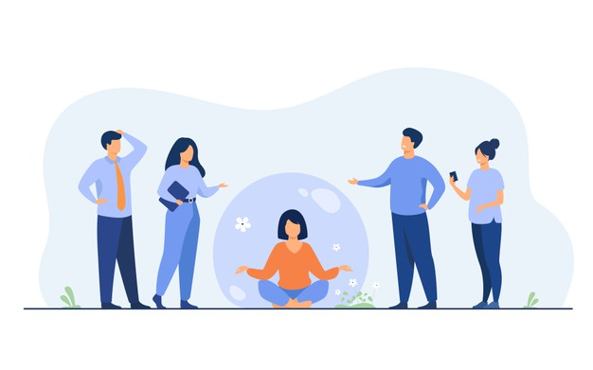
Photo from https://www.freepik.com/vectors/people People vector created by pch.vector - www.freepik.com</a
Stress is normal in everyday life as well as in parenting. Stress is a response to a change or conflict. Stress can be physical, mental, or emotional strain or tension. To appropriately manage stress, you have to identify where it is coming from. Managing stress effectively is critical to parenting effectively. Managing and reducing stress provides a sense of being in control of life. Learning how to manage and cope with stress acts a model for the child on managing and coping with stress (Swartz et al., 2016).
Identify Stressors: A stressor is a factor that contributes to stress. The following link is a worksheet that you can use to identify where your stress is coming from. https://www.therapistaid.com/worksheets/stress-exploration.pdf

Apply It: Now that you have identified what stressors in your life cause stress, find appropriate ways to cope with that stress. Coping strategies are actions that you can use to deal with stress. Healthy coping strategies provide us with long-lasting positive outcomes. Healthy coping skills are one way that you can manage stress. Managing your stress will be easier when you take time to identify people you can rely on when you’re feeling overwhelmed, which emotions you may experience when you begin feeling stressed, and you find how to appropriately balance aspects of your life. The following links provide worksheets to assist you in finding positive coping strategies and give tips on keeping your stress at a minimum.
https://www.therapistaid.com/worksheets/healthy-unhealthy-coping-strategies.pdf
https://www.therapistaid.com/worksheets/stress-management.pdf
https://www.therapistaid.com/worksheets/stress-management-tips.pdf

Family Strengths
Parenting is the most challenging and most important job there is. Parents are the foundation of the family. Positive parenting skills do not come naturally; they are learned (Swartz et al., 2016).
Apply It: Keep a Journal. Identify three positive things you do and one thing you can improve on as a parent each day.
Identify Your Strengths and Your Children’s!
Caring
Trustworthy
Honest
Creative

Family interventions during early childhood that change the balance between risk and protection can shift the odds in the favor of more adaptive development outcomes. Effectiveness of supporting parents, strength-based practice, motivational interviewing, solution-focused coaching (Growing Great Kids Understanding the Research Base: Theoretical and Empirical Foundations, n.d.).
Apply It: Strength-based approaches can be difficult if you are unsure of you or your child’s strengths. Identify your strengths with this quiz https://www.viacharacter.org/
Strength based parenting encourages you to focus on highlighting your child’s strength rather than focusing on their faults. This approach does not require false praise, only praise on their actual strengths! You will not ignore the problems of the child, but letting the child know they have strengths lets them see the whole picture. The following article explains how it is to practice strength-based parenting and how to implement it into your parenting if you would like to. https://greatergood.berkeley.edu/article/item/how_to_be_a_strength_based_parent

Child Self-Care

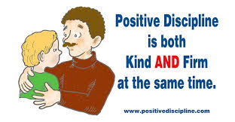
Photo used with permission from https://www.positivediscipline.com/
Discipline
Laying the Foundation - Paying attention to children when they are doing well can prevent them “acting out” to get attention (Swartz et al., 2016).
Apply It: Identifying unwanted behaviors and setting consistent consequences help to prevent unwanted behavior. It is important to explain to your child why the behavior is inappropriate along with implementing consequences. Teach your child ways that they can replace the unwanted behaviors with appropriate behaviors. Reward your child with positive attention such as a hug when they use appropriate behaviors. Use the worksheet provided to assist in identifying unwanted behaviors and replacement behaviors. https://www.therapistaid.com/worksheets/planning-rewards-consequences.pdf

Parents Toolbox - For parents to make positive discipline decisions, the need to be aware of positive solutions (Swartz et al., 2016).
Apply It: Become familiar with how to use rewards and consequences with your children. Using rewards is beneficial in encouraging appropriate behaviors. Setting achievable goals, praising behaviors with desirable rewards, and not taking away rewards are important in getting consistent appropriate behaviors. Using consequences can decrease the reoccurrence of unwanted behaviors. Create clear rules and consequences, follow through, take away privileges, and chose your battles. The linked worksheet gives further in-depth tips for using rewards and consequences in parenting. https://www.therapistaid.com/worksheets/rewards-punishments.pdf

Challenging Behaviors - While prevention is the best medicine, parents need strategies for their child’s challenging behaviors (Swartz et al., 2016).
Apply It: Positive Parenting Solutions offers a completely free online class that gives you the tools to have your children listen to you without yelling, nagging, or losing control. Take the Free Parenting Class at https://www.positiveparentingsolutions.com/
Child Development

Photo from https://www.freepik.com/vectors/background Background vector created by tartila - www.freepik.com</a

Children develop due to the basic human drive to explore and master one’s environment, child guidance (Growing Great Kids Understanding the Research Base: Theoretical and Empirical Foundations, n.d.).
Apply It: Physical, emotional, social, and cognitive development are categories of development that you should be aware of in how your child is developing. Depending on your child’s age, they will be at specific milestones. Specific ages can bring specific behavioral challenges. Understanding which stage your child is at in their development can give you insight to why they are doing things or acting certain ways. Learn about child development and your child’s needs at any stage of life at https://www.verywellfamily.com/child-development-overview-4172261 or https://www.cdc.gov/ncbddd/childdevelopment/positiveparenting/index.html

Human relationships establish the foundation of healthy development (Growing Great Kids Understanding the Research Base: Theoretical and Empirical Foundations, n.d.).
Apply It: Positive relationships between you and your child are important. Childnre learn and develop best when positive relationships are formed. Building a positive relationship takes time. Being in the moment, spending quality time, and creating a trusting environment are among a few ways to build a positive relationship with your child. Review the information on Positive Relationships for Parents and Children to learn more ways to develop a positive relationship with your child at https://raisingchildren.net.au/newborns/connecting-communicating/bonding/parent-child-relationships. Then, apply at least one new practice each month. Keep a journal and reflect on this.

Self-regulation is critical for positive childhood development in all domains of behavior (Growing Great Kids Understanding the Research Base: Theoretical and Empirical Foundations, n.d.).
Apply It: Self-regulation is being able to control emotions. Toddlers and infants are not usually capable of doing that yet. When the child reaches of the age of self-regulation, but they are not able to control those emotions there are ways that you can help. Approaching self-regulation skills is like how you would approach other skills. You will need to isolate that skill and provide practice. Learn How to Help Your Child With Self-Regulation https://childmind.org/article/can-help-kids-self-regulation/

Human development is shaped by sources of vulnerability and sources of resilience to which the developing child remains susceptible throughout the early years of life and into adulthood. Stress and early brain development, adverse childhood experiences, protective factors, and resiliency (Growing Great Kids Understanding the Research Base: Theoretical and Empirical Foundations, n.d.).
Apply It: Some examples of Adverse Childhood Experiences are inappropriate sexual contact, domestic violence, and parental separation or divorce. Most people have experienced at least one ACE in their life. Can you identify one you experienced? Learning about ACES will help you to be aware of any that your child may be at risk of experiencing. Understand the concept of Adverse Childhood Experiences (ACES) at https://www.kidcentraltn.com/health/safety/adverse-childhood-experiences--aces---protecting-your-child-and-building-resiliency.html or https://www.acesconnection.com/blog/handouts-for-parents-about-aces-toxic-stress-and-resilience

Culture impacts all areas of human growth and is reflected in parenting beliefs and practices that work toward healthy development (Growing Great Kids Understanding the Research Base: Theoretical and Empirical Foundations, n.d.).
Apply It: Making your child aware of cultural differences is the first step to having a child that accepts and respects other cultures. Be available to discuss this topic with your child and do so without showing judgement. There are many activities that you can do with your child to teach them about diversity. Explore the links provided to learn ways to help your child accept other cultures. Teach Your Child Cultural Acceptance https://www.scholastic.com/teachers/articles/teaching-content/teaching-diversity-place-begin-0/ , https://www.kidsacademy.mobi/storytime/teaching-kids-about-diversity/ , https://extension.psu.edu/programs/betterkidcare/knowledge-areas/environment-curriculum/activities/all-activities/we-are-different-we-are-the-same-teaching-young-children-about-diversity

“The America Reads Program and ETSU does not endorse or promote any of the resources listed. The resources listed are public resources for the community that may be useful for you.”

Great Kids, Inc. Growing Great Kids Understanding the Research Base: Theoretical and Empirical Foundations [Ebook]. Retrieved 8 March 2021, from https://www.greatkidsinc.org/wp-content/uploads/2018/07/GGKResearchFoundations-Finalized-3-13-17.pdf.
Swartz, L., Seeley, J., Gau, J., & Schroeder, S. (2016). Parenting Now! Results From a Randomized Control Trial of Parenting Intervention for Highly Stressed Families: Make Parenting A Pleasure [Ebook]. Oregon Research Institute. Retrieved 8 March 2021, from https://parentingnow.org/wp-content/uploads/2016/03/MPAP-Evaluation-Results3_1_2016.pdf.

