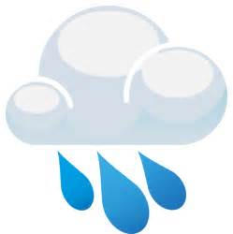
The Water 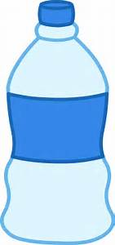 Cycle 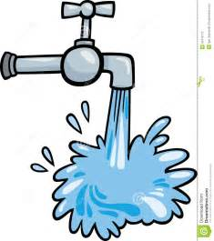
EXPLAIN: Notes
Water is constantly recycled through what we call the ________________________.

Evaporation is when the sun heats up water in rivers or lakes or the ocean and turns it into __________________ or steam. The water vapor or steam leaves the river, lake or ocean and goes into the air.

Condensation: Water vapor in the air gets cold and changes back into liquid, forming __________________. This is called condensation.

Precipitation occurs when so much water has condensed that the air cannot hold it anymore. The clouds get heavy and water falls back to the earth in the form of __________________.

Collection: When water falls back to earth as precipitation, it may fall back in the oceans, lakes or rivers or it may end up on land. When it ends up on land, it will either soak into the earth and become part of the “____________________” that plants and animals use to drink or it may run over the soil and collect in the oceans, lakes or rivers where the cycle starts all over again.
Notes revised from: Guenther, L. The water cycle. KidZone Science. Retrieved from http://www.kidzone.ws/WATER/

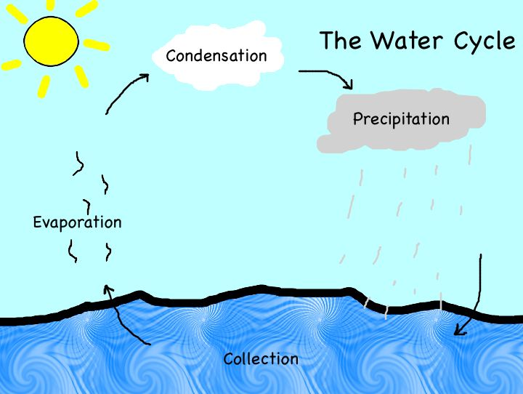

Juani. (2014, March 11). The water cycle. Retrieved from http://bilingualsectionmelendezvaldes.blogspot.com/2014/0 3/the-water-cycle.html

Notes (with Answers)
Water is constantly recycled through what we call the water cycle.

Evaporation is when the sun heats up water in rivers or lakes or the ocean and turns it into vapor or steam. The water vapor or steam leaves the river, lake or ocean and goes into the air.

Condensation: Water vapor in the air gets cold and changes back into liquid, forming clouds. This is called condensation.

Precipitation occurs when so much water has condensed that the air cannot hold it anymore. The clouds get heavy and water falls back to the earth in the form of rain.

Collection: When water falls back to earth as precipitation, it may fall back in the oceans, lakes or rivers or it may end up on land. When it ends up on land, it will either soak into the earth and become part of the “ground water” that plants and animals use to drink or it may run over the soil and collect in the oceans, lakes or rivers where the cycle starts all over again (Guenther).

EXPLORE: Water Cycle In a Bag Directions

You will need:

Blue food coloring Freezer Bag
Tape Sharpie

Steps:

1. Draw a water line, the sun, and a cloud.
2. Fill the bag up to the water line with water.
3. Add 4 drops of food coloring to the water and seal the bag.
5. Hang the bag outside in the sun using the tape.
6. Watch for results.

Hallowell, M. (2015). Water cycle in a bag. Playdough to Plato. Retrieved from http://www.playdoughtoplato.com/water-cycle-bag/
 | Day 1 | Day 2 | Day 3 | Day 4
Sunny/Cloudy | Sunny | Cloudy | Sunny | Cloudy
Warm/ Cool | Cool | Cool | Cool | Cool
Temperature | 60 | 65 | 63 | 62
Can you see it “raining” in the bag? (Yes/No) | Yes | Yes | Yes | Yes
How many droplets can you count in the bag? | 4 | 8 | 9 | 11
Is there as much water in the bottom of the bag as when you first made it? (Yes/No) | Yes | No | No | No

 | Day 1 | Day 2 | Day 3 | Day 4
Sunny/Cloudy
Warm/ Cool
Temperature
Can you see it “raining” in the bag? (Yes/No)
How many droplets can you count in the bag?
Is there as much water in the bottom of the bag as when you first made it? (Yes/No)

CER
Write a sentence stating what happens in the water cycle.
Claim: Water is constantly going through a cycle that is caused by the evaporation, condensation, precipitation, and collection of water which causes the water to constantly be recycled throughout the earth’s atmosphere.

Provide evidence from the experiment to support your claim. Described what happened inside the bag.
Evidence: We saw in our water cycle in a bag activity that when the water was warmed by the sun, it evaporated and rose to the top of the bag. Then the water condensed onto the side of the bag, and then fell (precipitated) back into the bottom of the bag where the water was collecting.

Explain why the evidence supports the claim. Describe how what happened in the bag represents the water cycle on earth.
Reasoning: The energy from the sun warmed the water and caused it to condense on the side of the bag before precipitating back into the pool of water, demonstrating how the water cycle occurs in earth’s atmosphere. This causes the water to move around and around through the cycle.

CER
Write a sentence stating what happens in the water cycle.
Claim:

Provide evidence from the experiment to support your claim. Described what happened inside the bag.
Evidence:

Explain why the evidence supports the claim. Describe how what happened in the bag represents the water cycle on earth.
Reasoning:

