Weather Tools
3.ESS2: Earth’s Systems
3) Use tables, graphs, and tools to describe precipitation, temperature, and wind (direction and speed) to determine local weather and climate.

Explain – Mystery Weather Flaps - Notes
Learning all about Weather Tools: Articles, Activities, & Flip Book. (n.d.). Retrieved March 22, 2017, from https://www.teacherspayteachers.com/Product/Learning-all-about-Weather-Tools-Articles-Activities-Flip-Book-2060081
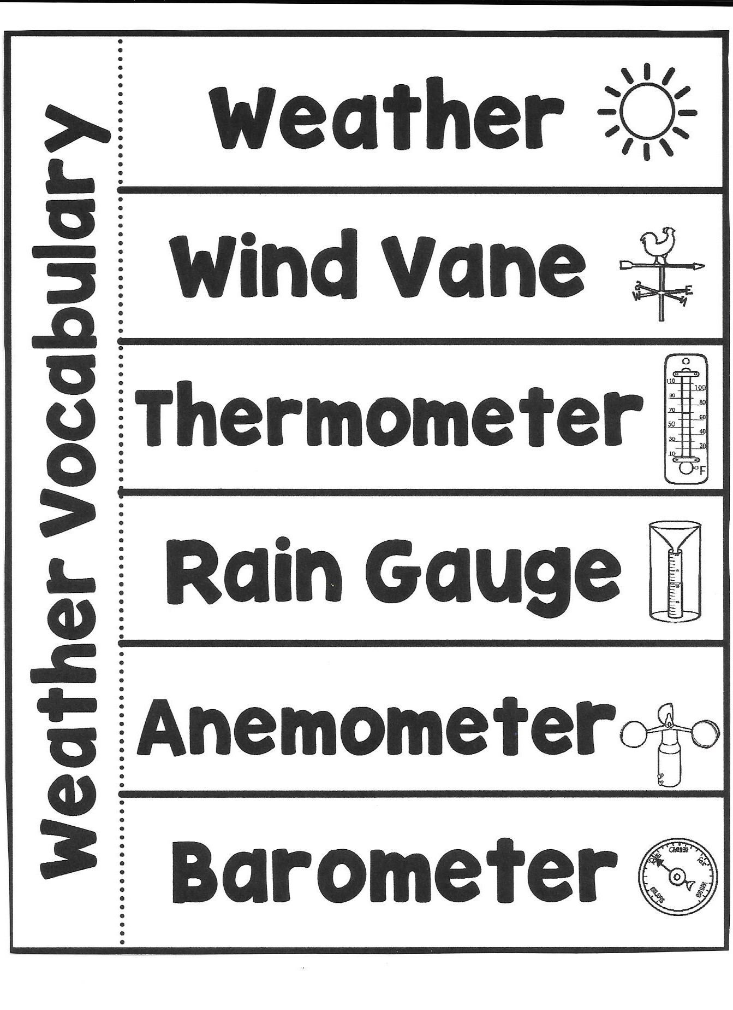

It describes the condition of the air at a particular time and place. Weather also tells how the air moves (wind) and describes anything it might be carrying such as rain, snow or clouds. Thunder, lightning, rainbows, haze and other special events are all part of weather.
An instrument used to tell which direction the wind is blowing.
An instrument used to measure the temperature in degrees on a Fahrenheit or Celsius scale.
An instrument used to measure the amount of rainfall.
An instrument used to measure wind speed and direction.
An instrument used to tell if the pressure in the air is going up or down.

Directions: Over the next 4 weeks, students will monitor the weather. They will have rain gauges and wind vanes. Every day they will record their findings for precipitation and the direction of the wind. After the unit is complete, students are to complete the CER framework table.

Elaborate
April Showers Bring May Flowers Table
Week Of: | Precipitation in Inches: | Direction of Wind:
Monday: Tuesday:
Wednesday: Thursday:
Friday: Saturday:
Sunday:
Monday: Tuesday:
Wednesday: Thursday:
Friday: Saturday:
Sunday:
Monday: Tuesday:
Wednesday: Thursday:
Friday: Saturday:
Sunday:
Monday: Tuesday:
Wednesday: Thursday:
Friday: Saturday:
Sunday:

CER Framework:

Claim: (Write one sentence stating how you would know how much it rained in a certain time frame, and how you would measure the direction of the wind during the storm.)

Evidence: (Provide data to support your claim. Describe how you knew how much it rained on a given day. Describe how you know the direction of the wind.)

Reasoning: (Explain why your evidence supports your claim. Describe how the weather tools helped you collect the information you needed.)

CER Framework Target Answers:

Claim: (Write one sentence stating how you would know how much it rained in a certain time frame, and how you would measure the direction of the wind during the storm.)

A tool called a rain gauge collects and measures rain fall, and a wind vane would be used to measure the direction of the wind.
Evidence: (Provide data to support your claim. Describe how you knew how much it rained on a given day. Describe how you know the direction of the wind.)

During the week of April 24, it rained a total of 1 inch. I knew this was accurate because I kept my rain gauge out for a full week, measuring it daily. On Tuesday, April 25, it rained a total of .5 inches. While checking the rain gauge, I also checked the wind vane to see the direction of the wind. It blew North 4 days and East 3 days.

Reasoning: (Explain why your evidence supports your claim. Describe how the weather tools helped you collect the information you needed.)

When collecting the data with the rain gauge, all the rain will collect until it stops raining. When it stops raining, we have an accurate reading for rainfall if the rain gauge was left out the entire time that it rained. The rain gauge is helpful because without it, we would not know if we are getting as much rain as we should be living in the climate that we live in. The wind was blowing North 4 out of 5 days during the week of April 24.

