Relationship of Magnets
3.PS2 Explain the cause and effect relationship of magnets.

Relationship of Magnets
3.PS2 Explain the cause and effect relationship of magnets.

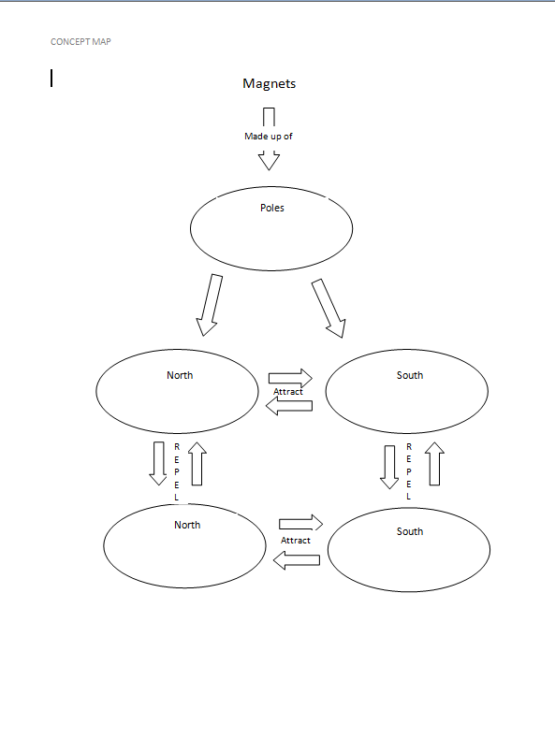
Morgan Chambers material
Engage - The Cause and Effect Relationship of Mangets

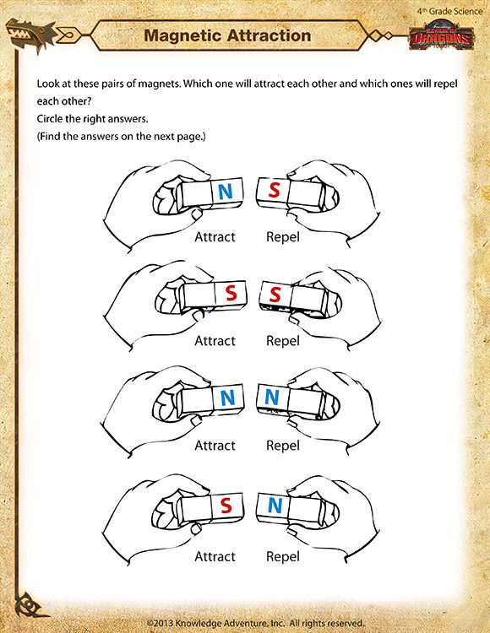
Teaching About Magnets. (n.d.). Retrieved April 25, 2017, from https://www.pinterest.com/pinningteacher/teaching-about-magnets/

Engage – The Cause and Effect Relationship of Magnets

Teaching About Magnets. (n.d.). Retrieved April 25, 2017, from https://www.pinterest.com/pinningteacher/teaching-about-magnets/

Explore Activity Directions
You will need: Matchbox cars, magnets, rulers, pencil, and data table.
- First, you will make a hypothesis about whether the push or pull factor is greater when pushing or pulling a matchbox car with a magnet.
- Then, you will line up your matchbox cars and hold the larger magnet over the top of the car that holds a smaller magnet. You will match the North and South Poles to observe the attraction measurements and you will match like poles to observe the repulsion measurements. You will follow the car to see the distance that it travels.
- You will record the data in your table. When all of the data is collected, you will write a reflection sentence about why your hypothesis was correct or incorrect.
Some instruction was found through Bittman on September 14, 2016 Facebook Pinterest Twitter, E. (2016, October 18). How to Teach Math and Science With Matchbox Cars. Retrieved March 22, 2017, from https://www.weareteachers.com/how-to-teach-math-and-science-with-matchbox-cars/ and other instruction was edited by Morgan Chambers

Relationship of Magnets CER
Claim (Write one sentence stating the cause and effect relationship of magnets.)

Evidence (Provide scientific data to support your claim. The evidence should include how attraction and repulsion is demonstrated by the matchbox cars and the position of the poles of the magnets.)

Reasoning (Explain why your evidence supports your claim. Describe how the poles of the magnet determine whether magnets attract or repel and how your evidence allowed you to see the force of the attraction or repulsion.)

Relationship of Magnets CER
Claim (Write one sentence stating the cause and effect relationship of magnets.)

Evidence (Provide scientific data to support your claim. The evidence should include how attraction and repulsion is demonstrated by the matchbox cars and the position of the poles of the magnets.)

Reasoning (Explain why your evidence supports your claim. Describe how the poles of the magnet determine whether magnets attract or repel and how your evidence allowed you to see the force of the attraction or repulsion.)

ANSWER KEY Relationship of Magnets CER
Claim (Write one sentence stating the cause and effect relationship of magnets.)
In magnets, like poles repel, whereas opposite poles attract.
Evidence (Provide scientific data to support your claim. The evidence should include how attraction and repulsion is demonstrated by the matchbox cars and the position of the poles of the magnets.)
When the North Pole of the magnet (orange) and the South Pole of the magnet (green) came close to one another they attracted and when the North Pole of the magnet (orange) and the North Pole of the magnet (orange) came close to one another, they repelled. The South Pole against the South Pole repelled as well. Therefore confirming that opposite poles attract and like poles repel. We were able to record data to show the distance that each car traveled by using either attraction or repulsion. Four out of five cars give evidence that the repulsion, created by opposing poles, had the stronger force.
Reasoning (Explain why your evidence supports your claim. Describe how the poles of the magnet determine whether magnets attract or repel and how your evidence allowed you to see the force of the attraction or repulsion.)
Magnets have an invisible force around them, called the magnetic field, which has North and South Poles. The opposite poles attract and like poles repel. We saw this through completing the activity by seeing and measuring the distance that was traveled by each car using attraction and repulsion.
ANSWER KEY Relationship of Magnets CER
Claim (Write one sentence stating the cause and effect relationship of magnets.)
In magnets, like poles repel, whereas opposite poles attract.
Evidence (Provide scientific data to support your claim. The evidence should include how attraction and repulsion is demonstrated by the matchbox cars and the position of the poles of the magnets.)
When the North Pole of the magnet (orange) and the South Pole of the magnet (green) came close to one another they attracted and when the North Pole of the magnet (orange) and the North Pole of the magnet (orange) came close to one another, they repelled. The South Pole against the South Pole repelled as well. Therefore confirming that opposite poles attract and like poles repel. We were able to record data to show the distance that each car traveled by using either attraction or repulsion. Four out of five cars give evidence that the repulsion, created by opposing poles, had the stronger force.
Reasoning (Explain why your evidence supports your claim. Describe how the poles of the magnet determine whether magnets attract or repel and how your evidence allowed you to see the force of the attraction or repulsion.)
Magnets have an invisible force around them, called the magnetic field, which has North and South Poles. The opposite poles attract and like poles repel. We saw this through completing the activity by seeing and measuring the distance that was traveled by each car using attraction and repulsion.
Informational Texts Reading Questions
- Which of the magnets attract?
- N&N
- S&N
- S&S
- N&S

- What are the three types of magnets?
- Hot, warm, cold
- Temporary, permanent, natural
- Round, u-shaped, rectangle
- Light, heavy, medium

- Explain how a magnetic field is created.

- The North Pole of a magnet holds a positive charge.
True/ False

- Explain why a magnet attracts a nail.

Informational Texts Reading Questions
- Which of the magnets attract?
- N&N
- S&N
- S&S
- N&S

- What are the three types of magnets?
- Hot, warm, cold
- Temporary, permanent, natural
- Round, u-shaped, rectangle
- Light, heavy, medium

- Explain how a magnetic field is created.

- The North Pole of a magnet holds a positive charge.
True/ False

- Explain why a magnet attracts a nail.

Informational Texts Reading Questions
- Which of the magnets attract?
- N&N
- S&N
- S&S
- N&S

- What are the three types of magnets?
- Hot, warm, cold
- Temporary, permanent, natural
- Round, u-shaped, rectangle
- Light, heavy, medium

- Explain how a magnetic field is created.
Magnetic fields are produced by the motion of electrical charges. A magnetic field of a bar magnet thus results from the motion of negatively charged electrons in the magnet

- The North Pole of a magnet holds a positive charge.
True/ False

- Explain why a magnet attracts a nail.
The magnetic field has so much force from the magnet to a nail that it changes the poles of the nail to match that of the magnet.

Informational Texts Reading Questions
- Which of the magnets attract?
- N&N
- S&N
- S&S
- N&S

- What are the three types of magnets?
- Hot, warm, cold
- Temporary, permanent, natural
- Round, u-shaped, rectangle
- Light, heavy, medium

- Explain how a magnetic field is created.

- The North Pole of a magnet holds a positive charge.
True/ False

- Explain why a magnet attracts a nail.

Car Numbers | Attraction Distance in Inches | Repulsion Distance in Inches
03
4
6
58
88
Morgan Chambers material
Explore Activity Data Table

Car Numbers | Attraction Distance in Inches | Repulsion Distance in Inches
03 | 12.5” | 14.5”
4 | 5” | 13”
6 | 14” | 10”
58 | 8” | 12.5”
88 | 9.5” | 11”
Morgan Chambers material
Explore Activity Data Table Answer Key

