**Erosion and Deposition**

**Erosion and Deposition**

**Overarching Question:** How does erosion (weather and transportation) and deposition change landscapes and create new landforms?



What is erosion?

What is weather and transportation?

What are different types of weathering and transportation?

How do we know what deposition is?

What is erosion?

What is weather and transportation?

What are different types of weathering and transportation?

How do we know what deposition is?

Are interactive notebooks effective?

How are interactive notebooks organized?

How are interactive notebooks assessed?



**Overarching Question:** How does erosion (weather and transportation) and deposition change landscapes and create new landforms?

|  |
| --- |
| **Line of Evidence – Student Erosion Log** |
| *We began investigating by documenting in our log what erosion was and the different types of erosion. We then explored the playground for those erosion and illustrated what we saw in our log.* |

|  |
| --- |
| **Line of Evidence – Erosion Lab** |
| *The erosion lab is a hands- on activity allowing one to see water and wind erosion. Also the making of new landforms can be seen.* |

|  |
| --- |
| **Line of Evidence – Example, Claim, Evidence** |
| *Wind Erosion caused sand dunes, temperature can expand/crack rocks, and flooding forms deposition. There are many examples of erosion and deposition around the world.* |

|  |
| --- |
| **Line of Evidence –Preventing Erosion Investigation**  **Experiment** |
| *Erosion can actually be very bad for certain areas. There are ways to stop erosion from occurring such as placing sticks, rocks, etc. to help prevent.* |

|  |
| --- |
| **Big Aha Thesis Statement** |
| *Erosion (weathering and transportation) and deposition is the cause of forming landforms such as: Grand Canyon, sand dunes, slick rocks, flooding, mudslides, and much more. They can be harmful.* |
| **Line of Evidence – Student Erosion Log** |
| *We began investigating by documenting in our log what erosion was and the different types of erosion. We then explored the playground for those erosion and illustrated what we saw in our log.* |

|  |
| --- |
| **Line of Evidence – Erosion Lab** |
| *The erosion lab is a hands- on activity allowing one to see water and wind erosion. Also the making of new landforms can be seen.* |

|  |
| --- |
| **Line of Evidence – Example, Claim, Evidence** |
| *Wind Erosion caused sand dunes, temperature can expand/crack rocks, and flooding forms deposition. There are many examples of erosion and deposition around the world.* |

|  |
| --- |
| **Line of Evidence –Preventing Erosion Investigation**  **Experiment** |
| *Erosion can actually be very bad for certain areas. There are ways to stop erosion from occurring such as placing sticks, rocks, etc. to help prevent.* |

|  |
| --- |
| **Big Aha Thesis Statement** |
| *Erosion (weathering and transportation) and deposition is the cause of forming landforms such as: Grand Canyon, sand dunes, slick rocks, flooding, mudslides, and much more. They can be harmful.* |

Student_Log_Erosion.pdf

**Engage - Student Erosion Log**

Fink, D., Orrell, L., Levondoski, L, Weathering and Erosion. Retrieved March17,http://gk12.osu.edu/Lessons/0304/Earth%20Science/ WeatheringErosion.pdf.

Student_Log_Erosion.pdf

**Engage – Student Erosion Log**

Fink, D., Orrell, L., Levondoski, L, Weathering and Erosion. Retrieved March17,http://gk12.osu.edu/Lessons/0304/Earth%20Science/ WeatheringErosion.pdf.

**Explore – Erosion Lab**

../../../../../../../../Users/kenzielinebaugh/Mazur, M. (2014, January 19). Learning Lab Resources. Retrieved from http://learninglabresources.com/2014/01/erosion-and- landforms-science-activity-with-a-freebie.html.

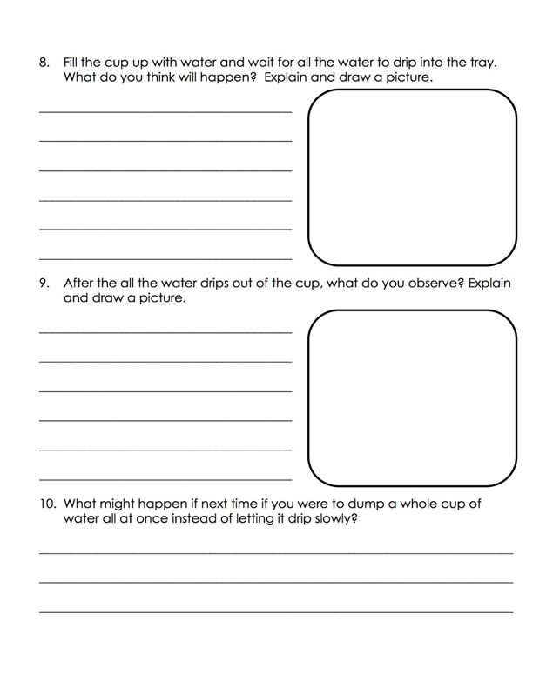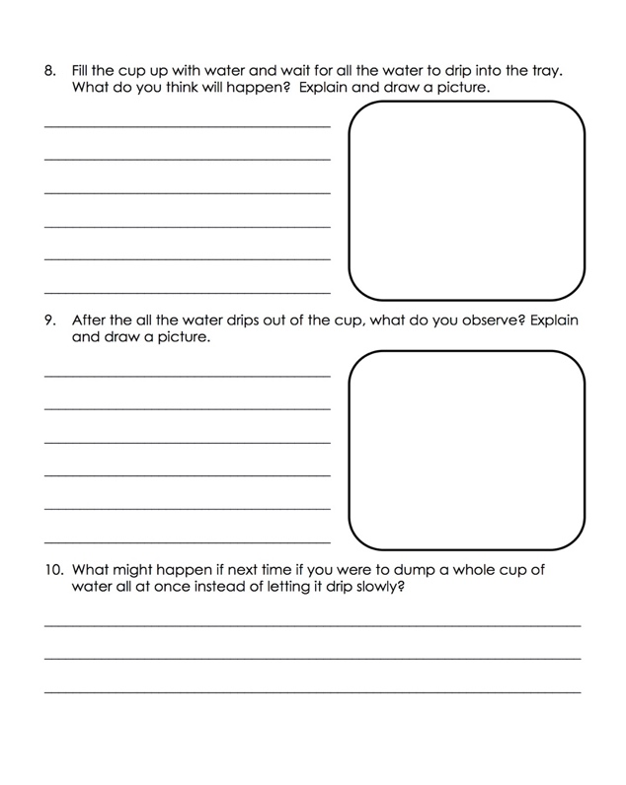**Explore – Erosion Lab**

../../../../../../../../Users/kenzielinebaugh/Mazur, M. (2014, January 19). Learning Lab Resources. Retrieved from http://learninglabresources.com/2014/01/erosion-and- landforms-science-activity-with-a-freebie.html.

**Erosion Lab CER**

**Claim** (Write a few sentences stating the way erosion and deposition are caused.)

**Evidence** (Provide names and descriptions of erosion and deposition to support your claim. Describe how to tell the difference between weathering and transportation.)

**Reasoning** (Explain how your evidence supports your claim. Describe how erosion (weathering and transportation) and deposition effect various landforms.)

**Erosion Lab CER**

**Claim** (Write a few sentences stating the way erosion and deposition are caused.)

**Evidence** (Provide names and descriptions of erosion and deposition to support your claim. Describe how to tell the difference between weathering and transportation.)

**Reasoning** (Explain how your evidence supports your claim. Describe how erosion (weathering and transportation) and deposition effect various landforms.)

**Erosion Lab CER Answer Key**

**Claim** (Write a few sentences stating the way erosion and deposition are caused.)

It is caused by weather and transportation such as wind, rain occurring in different types of areas. Deposition is caused by particles falling while transporting and settling on a surface.

**Evidence** (Provide names and descriptions of erosion and deposition to support your claim. Describe how to tell the difference between weathering and transportation.)

The different types of erosion are wind, rain, glacier, animals, gravity, rivers, and \*temperature. Deposition is various sediments being carried to a new area. The difference between weathering and transportation is that weathering is a physical change, chemical change, or change to objects due to weather conditions. Transportation is the movement of those objects from one point to another.

**Reasoning** (Explain how your evidence supports your claim. Describe how erosion (weathering and transportation) and deposition effect various landforms.)

Erosion causes parts of landforms to be worn away and move the parts by transportation to a new area. This can create a possible new landform or makes changes to the previous one over time.

**Erosion Lab CER Answer Key**

**Claim** (Write a few sentences stating the way erosion and deposition are caused.)

It is caused by weather and transportation such as wind, rain occurring in different types of areas. Deposition is caused by particles falling while transporting and settling on a surface.

**Evidence** (Provide names and descriptions of erosion and deposition to support your claim. Describe how to tell the difference between weathering and transportation.)

The different types of erosion are wind, rain, glacier, animals, gravity, rivers, and \*temperature. Deposition is various sediments being carried to a new area. The difference between weathering and transportation is that weathering is a physical change, chemical change, or change to objects due to weather conditions. Transportation is the movement of those objects from one point to another.

**Reasoning** (Explain how your evidence supports your claim. Describe how erosion (weathering and transportation) and deposition effect various landforms.)

Erosion causes parts of landforms to be worn away and move the parts by transportation to a new area. This can create a possible new landform or makes changes to the previous one over time.

**Explain – Examples, Claim, Evidence**

(2004). UtahLessonPlans. Retrieved March 17, <http://www.uen.org/> Lesson plan/preview?LPid=9862.

|  |  |  |
| --- | --- | --- |
| Examples: | Claim  Is this a result of erosion or deposition? | Evidence  It is a form of \_\_\_\_\_\_\_\_\_ erosion/deposition because… |
| Sand dunes formed in the desert | Wind erosion | It is a form of wind erosion because the wind has pushed the sand in the desert to create a higher level. This changes the landscape. |
| A rock expanding and cracking | Temperature erosions | It is a form of temperature erosions because the temperature causes the rock to expand and crack. This then leads to the parts of the rock breaking off (erosion). |
| Flooding | Deposition | It is a form of deposition because this is what the erosion causes. The rain becomes a flood and carries soil, etc. to a new place. |

**Explain - Examples, Claim, Evidence**

(2004). UtahLessonPlans. Retrieved March 17, <http://www.uen.org/> Lesson plan/preview?LPid=9862.

|  |  |  |
| --- | --- | --- |
| Examples: | Claim  Is this a result of erosion or deposition? | Evidence  It is a form of \_\_\_\_\_\_\_\_\_ erosion/deposition because… |
| Sand dunes formed in the desert | Wind erosion | It is a form of wind erosion because the wind has pushed the sand in the desert to create a higher level. This changes the landscape. |
| A rock expanding and cracking | Temperature erosions | It is a form of temperature erosions because the temperature causes the rock to expand and crack. This then leads to the parts of the rock breaking off (erosion). |
| Flooding | Deposition | It is a form of deposition because this is what the erosion causes. The rain becomes a flood and carries soil, etc. to a new place. |

**Elaborate – Preventing Erosion Investigation**

Boyden,C. Betterlesson. Retrieved March 17,https://betterlesson.com / lesson/resourcee/3191229/investigationcard?from=lessonsectio n\_narrative.

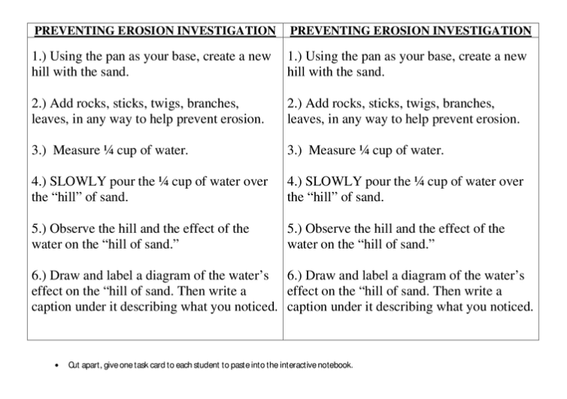**Elaborate – Preventing Erosion Investigation**

Boyden,C. Betterlesson. Retrieved March 17,https://betterlesson.com / lesson/resourcee/3191229/investigationcard?from=lessonsectio n\_narrative.



**Preventing Erosion Investigation**

**Claim** (Write a sentence stating why it is needed to prevent erosion.)

**Evidence** (Provide evidence from the investigation to support your claim. Describe ways to prevent erosion from occurring.)

**Reasoning** (Explain how your evidence supports your claim. Describe how this will help in the future.)

**Preventing Erosion Investigation**

**Claim** (Write a sentence stating why it is needed to prevent erosion.)

**Evidence** (Provide evidence from the investigation to support your claim. Describe ways to prevent erosion from occurring.)

**Reasoning** (Explain how your evidence supports your claim. Describe how this will help in the future.)

**ANSWER KEY Preventing Erosion Investigation**

**Claim** (Write a sentence stating why it is needed to prevent erosion.)

If erosion isn’t prevented, our agriculture, roadways, soil structure, etc. could be harmed.

**Evidence** (Provide evidence from the investigation to support your claim. Describe ways to prevent erosion from occurring.)

While finishing the investigation it shows that using materials to stop the sand from collapsing as quickly and drastically. Ways to prevent this would be by creating a barrier using the correct material.

**Reasoning** (Explain how your evidence supports your claim. Describe how this will help in the future.)

This will be helpful in the future because if we continue to let roadways decrease, soil to shift, and sand to move it could change the the previous needs to prevent erosion. This could change the agriculture, animal’s way of living, soil structure, roadways and much more.

**ANSWER KEY Preventing Erosion Investigation**

**Claim** (Write a sentence stating why it is needed to prevent erosion.)

If erosion isn’t prevented, our agriculture, roadways, soil structure, etc. could be harmed.

**Evidence** (Provide evidence from the investigation to support your claim. Describe ways to prevent erosion from occurring.)

While finishing the investigation it shows that using materials to stop the sand from collapsing as quickly and drastically. Ways to prevent this would be by creating a barrier using the correct material.

**Reasoning** (Explain how your evidence supports your claim. Describe how this will help in the future.)

This will be helpful in the future because if we continue to let roadways decrease, soil to shift, and sand to move it could change the the previous needs to prevent erosion. This could change the agriculture, animal’s way of living, soil structure, roadways and much more.

**Evaluate- Assessment**

**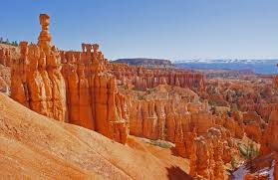1) This picture is an example of:**

1. Rock layers
2. Fossils
3. Erosion
4. All the above

**2) Transportation is the part that involves the movement of the eroded materials or sediment.**

1. True
2. False

**3) Deposition is the process of erosion stops when the transported particles fall out of the transporting medium and settle on a surface.**

1. True
2. False

**4) Wind erosion pushes sand to a new location and making landforms known as sand dunes.**

1. True
2. False

**5) Erosion is also known as mass wasting.**

1. True
2. False

Short answer

**6) what are the different types of erosion?**

**7) Explain the difference between weathering and transportation.**

**Evaluate *–*Assessment**

**1) This picture is an example of:**

1. Rock layers
2. Fossils
3. Erosion
4. All the above

**2) Transportation is the part that involves the movement of the eroded materials or sediment.**

1. True
2. False

**3) Deposition is the process of erosion stops when the transported particles fall out of the transporting medium and settle on a surface.**

1. True
2. False

**4) Wind erosion pushes sand to a new location and making landforms known as sand dunes.**

1. True
2. False

**5) Erosion is also known as mass wasting.**

1. True
2. False

Short answer

**6) what are the different types of erosion?**

**7) Explain the difference between weathering and transportation.**

|  |  |  |
| --- | --- | --- |
| **Erosion** | The wearing away of land surface by running water, wind, ice or other geologic agents, including processes such as gravitational creep. |  |
| **Weathering** | The process where rock is broken down or dissolved into smaller pieces by physical, chemical or biological weathering. |
| **Transportation** | The part that involves the movement of the eroded materials or sediments. |
| **Deposition** | The process of erosion stops when the transported particles fall out of the transporting medium and settle on a surface. Laying down of [sediment](http://www.physicalgeography.net/physgeoglos/s.html#sediment) transported by wind, water, or ice. |

**Big Ah-Ha Thesis**

The purpose of this unit was to understand that over long periods of time, erosion (weathering and transportation) and deposition have changed landscapes and created new landforms. We completed a student erosion log, erosion lab, examples, claim, evidence, table, and a preventing erosion investigation.

We began investigating by documenting in our log what erosion was and the different types of erosion. We then explored the playground for those erosion and illustrated what we saw in our log. Some types we didn’t find while exploring.

The erosion lab is a hands- on activity allowing one to see water and wind erosion. Also the making of new landforms can be seen. In this lab, we made landforms in the pan filled with sand then poured water from a cup into it to create new land forms using water. We also used straws the blow the sand around and cause sand erosion.

Wind Erosion caused sand dunes, temperature can expand/crack rocks, and flooding forms deposition. There are many examples of erosion and deposition around the world. We filled out the table as to what we thought the examples would be.

Erosion can actually be very bad for certain areas. There are ways to stop erosion from occurring such as placing sticks, rocks, etc. to help prevent.

**Big Ah-Ha Thesis**

The purpose of this unit was to understand that over long periods of time, erosion (weathering and transportation) and deposition have changed landscapes and created new landforms. We completed a student erosion log, erosion lab, examples, claim, evidence, table, and a preventing erosion investigation.

We began investigating by documenting in our log what erosion was and the different types of erosion. We then explored the playground for those erosion and illustrated what we saw in our log. Some types we didn’t find while exploring.

The erosion lab is a hands- on activity allowing one to see water and wind erosion. Also the making of new landforms can be seen. In this lab, we made landforms in the pan filled with sand then poured water from a cup into it to create new land forms using water. We also used straws the blow the sand around and cause sand erosion.

Wind Erosion caused sand dunes, temperature can expand/crack rocks, and flooding forms deposition. There are many examples of erosion and deposition around the world. We filled out the table as to what we thought the examples would be.

Erosion can actually be very bad for certain areas. There are ways to stop erosion from occurring such as placing sticks, rocks, etc. to help prevent.

.

**Self-Reflection Paragraph**

Before this unit, I haven’t realized that there is a name for what is occurring when it floods, mudslides, how The Grand Canyon was made and more! I thought rain just made soil a little muddy and wind blew things around sometimes. The activity that helped me the most was the erosion lab with sand, water, and straws. I could see how the water and wind changed the landforms I created in the sand. My favorite lab was the prevention one because we got to see how we can make a difference in the world.

**Self-Reflection Paragraph**

Before this unit, I haven’t realized that there is a name for what is occurring when it floods, mudslides, how The Grand Canyon was made and more! I thought rain just made soil a little muddy and wind blew things around sometimes. The activity that helped me the most was the erosion lab with sand, water, and straws. I could see how the water and wind changed the landforms I created in the sand. My favorite lab was the prevention one because we got to see how we can make a difference in the world.