Patterns in Earth’s Features

Patterns in Earth’s Features

Overarching Question: Why do patterns occur in the locations of mountain ranges, ocean trenches, volcanoes, and earthquakes?

Where do the patterns of Earth’s features occur?
How is each of Earth’s features formed?
What causes the patterns of Earth’s features to occur?
Where do the patterns of Earth’s features occur?
How is each of Earth’s features formed?
What causes the patterns of Earth’s features to occur?

Overarching Question: Why do patterns occur in the locations of mountain ranges, ocean trenches, volcanoes, and earthquakes?

Line of Evidence – Map of the Features We Know
We plotted Earth’s features that we already knew. We observed that the Earth’s features occur close to each other.

Line of Evidence – Mapping Earth’s Features
Mountain ranges, ocean trenches, volcanoes, and earthquakes occur in patterns.

Line of Evidence – Informational Text
The movement of plates causes mountain ranges, ocean trenches, volcanoes, and earthquakes occur. There are three types of plate boundaries (divergent, convergent, and transform).

Line of Evidence – When Plates Collide Lab
Certain features of Earth occur at each of the three types of boundaries. These features move because of movement at plates at the plate boundaries.

Big Aha Thesis Statement
Mountain ranges, ocean trenches, volcanoes, and earthquakes occur in patterns. The movement of plates causes these features to occur. They occur in patterns because certain features are formed at he site of the three types of plate boundaries.

Line of Evidence – Map of the Features We Know
We plotted Earth’s features that we already knew. We observed that the Earth’s features occur close to each other.

Line of Evidence – Mapping Earth’s Features
Mountain ranges, ocean trenches, volcanoes, and earthquakes occur in patterns.

Line of Evidence – Informational Text
The movement of plates causes mountain ranges, ocean trenches, volcanoes, and earthquakes occur. There are three types of plate boundaries (divergent, convergent, and transform).

Line of Evidence – When Plates Collide Lab
Certain features of Earth occur at each of the three types of boundaries. These features move because of movement at plates at the plate boundaries.

Big Aha Thesis Statement
Mountain ranges, ocean trenches, volcanoes, and earthquakes occur in patterns. The movement of plates causes these features to occur. They occur in patterns because certain features are formed at he site of the three types of plate boundaries.

Engage - Map of the Features We Know
Directions: Try to identify as many of Earth’s features as you can.
Step 1: With a blue marker, identify as many mountain ranges as you can.
Step 2. With a red marker, identify the locations of volcanoes.
Step 3: With a yellow marker, identify locations where earthquakes have occurred.
Bonus: Can you identify where ocean trenches occur? Use a purple marker to mark this location
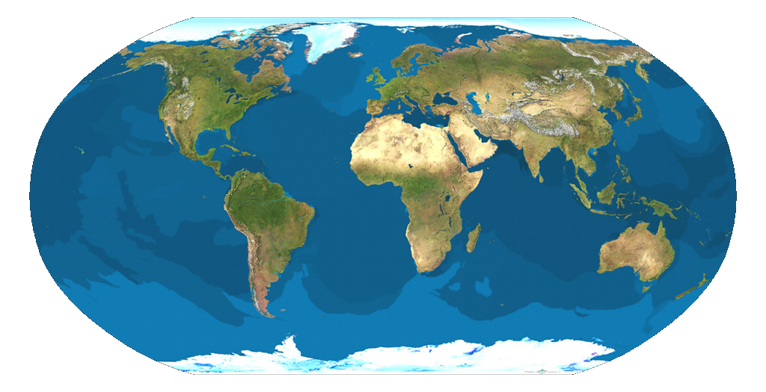

Van Sant, T. (1990). MapCarte 342/365: Satellite map of Earth. [Image]. Retrieved from http://mapdesign.icaci.org/2014/12/mapcarte-342365-satellite-map-of-earth-by-tom-van-sant-1990/
Engage – Map of the Features We Know
Directions: Try to identify as many of Earth’s features as you can.
Step 1: With a blue marker, identify as many mountain ranges as you can.
Step 2. With a red marker, identify the locations of volcanoes.
Step 3: With a yellow marker, identify locations where earthquakes have occurred.
Bonus: Can you identify where ocean trenches occur? Use a purple marker to mark this location

Van Sant, T. (1990). MapCarte 342/365: Satellite map of Earth. [Image]. Retrieved from http://mapdesign.icaci.org/2014/12/mapcarte-342365-satellite-map-of-earth-by-tom-van-sant-1990/
Explore - Mapping Earth’s Features
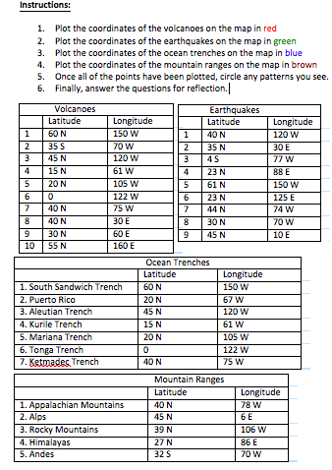

Explore – Mapping Earth’s Features

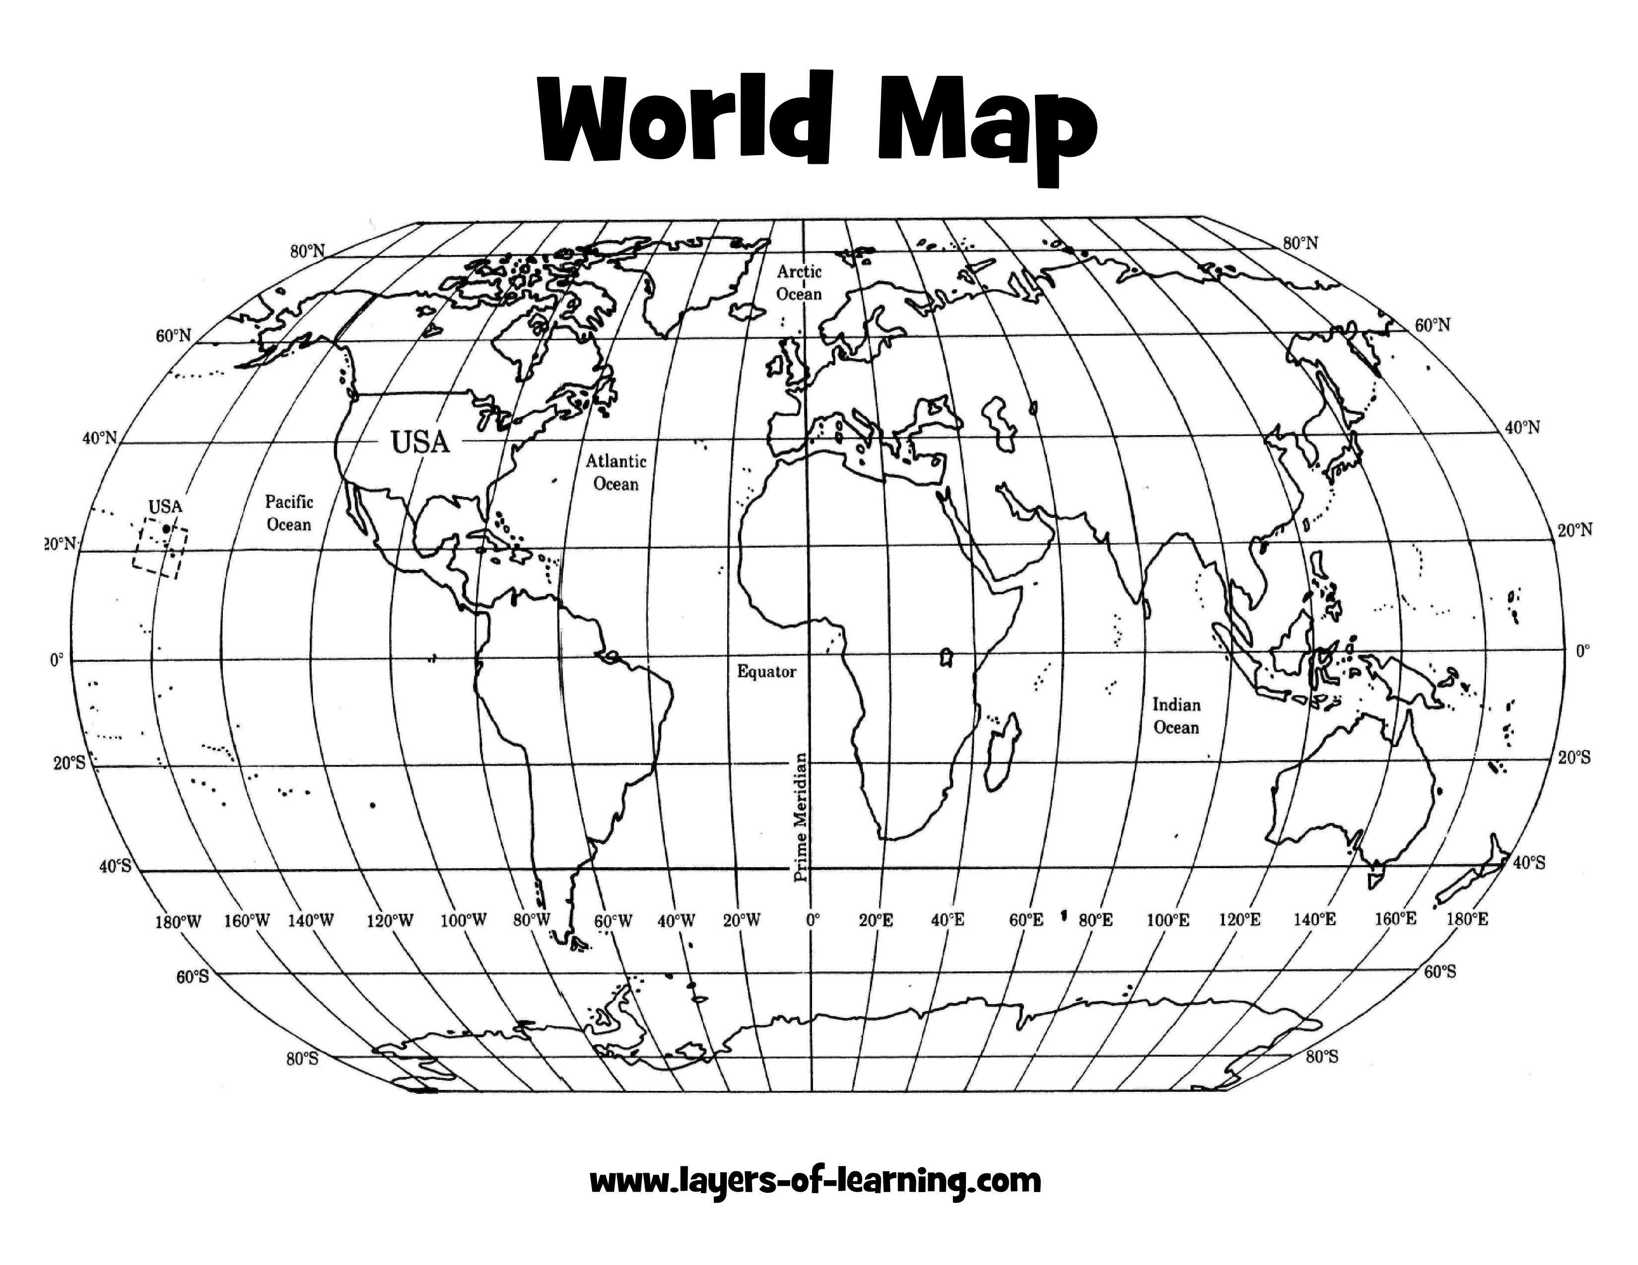

Gerrard. (2017). Coordinate map of world worksheet. [Map of Earth]. Worksheet Printable Blog. Retrieved from http://laventanaestudio.com/worksheet/coordinate-map-of-world-worksheet

Gerrard. (2017). Coordinate map of world worksheet. [Map of Earth]. Worksheet Printable Blog. Retrieved from http://laventanaestudio.com/worksheet/coordinate-map-of-world-worksheet
Questions
- Your map should show that volcanoes are not randomly scattered but concentrated in certain areas. Describe the pattern of volcanoes.

- Where are the majority of the earthquakes and volcanoes located?

- Is there a relationship between the location of the ocean trenches and the location of the other features you plotted on your map?

- Where are mountain ranges typically located? Are they located near volcanoes or earthquakes?

Plotting plate boundaries. Retrieved from https://www.monroecti.org/cms/lib07/PA03000492/Centricity/Domain/37/Plotting%20Plate%20Boundaries.pdf
Questions
- Your map should show that volcanoes are not randomly scattered but concentrated in certain areas. Describe the pattern of volcanoes.

- Where are the majority of the earthquakes and volcanoes located?

- Is there a relationship between the location of the ocean trenches and the location of the other features you plotted on your map?

- Where are mountain ranges typically located? Are they located near volcanoes or earthquakes?

Plotting plate boundaries. Retrieved from https://www.monroecti.org/cms/lib07/PA03000492/Centricity/Domain/37/Plotting%20Plate%20Boundaries.pdf
Mapping Earth’s Features CER
Claim (Write a sentence stating the patterns found at the locations of mountain ranges, ocean trenches, volcanoes, and earthquakes.)

Evidence (Provide descriptions of where mountain ranges, ocean trenches, volcanoes, and earthquakes are found. Describe the locations of mountain ranges, ocean trenches, volcanoes, and earthquakes.)

Reasoning (Explain how your evidence supports your claim. Discuss why mountain ranges, ocean trenches, volcanoes, and earthquakes are located in the same areas.)
Mapping Earth’s Features CER
Claim (Write a sentence stating the patterns found at the locations of mountain ranges, ocean trenches, volcanoes, and earthquakes.)

Evidence (Provide descriptions of where mountain ranges, ocean trenches, volcanoes, and earthquakes are found. Describe the locations of mountain ranges, ocean trenches, volcanoes, and earthquakes.)

Reasoning (Explain how your evidence supports your claim. Discuss why mountain ranges, ocean trenches, volcanoes, and earthquakes are located in the same areas.)

ANSWER KEY Mapping Earth’s Features CER
Claim (Write a sentence stating the pattern of the moon phases.)
Volcanoes, earthquakes, ocean trenches, and mountain ranges are not randomly scattered. They occur in patterns.
.
Evidence (Provide names and descriptions of the phases of the moon to support your claim. Describe how to tell the difference between waxing and waning phases.)
From the map, we can see that the Appalachian Mountains, Ketmadec Trench, a volcano, and an earthquake all occurred close to the same area. Also, the Rocky Mountains, Aleutian Trench, a volcano, and an earthquake are all located near the same area.

Reasoning (Explain how your evidence supports your claim. Describe how the phases of the moon repeat.)
The splitting of tectonic plates causes earthquakes to occur. Once an earthquake has occurred, ocean trenches are formed. Magma rises from the trench, and a volcano erupts. Then, the lava cools, creating mountains and island.
ANSWER KEY Mapping Earth’s Features CER
Claim (Write a sentence stating the pattern of the moon phases.)
Volcanoes, earthquakes, ocean trenches, and mountain ranges are not randomly scattered. They occur in patterns..

Evidence (Provide names and descriptions of the phases of the moon to support your claim. Describe how to tell the difference between waxing and waning phases.)
From the map, we can see that the Appalachian Mountains, Ketmadec Trench, a volcano, and an earthquake all occurred close to the same area. Also, the Rocky Mountains, Aleutian Trench, a volcano, and an earthquake are all located near the same area.

Reasoning (Explain how your evidence supports your claim. Describe how the phases of the moon repeat.)
The splitting of tectonic plates causes earthquakes to occur. Once an earthquake has occurred, ocean trenches are formed. Magma rises from the trench, and a volcano erupts. Then, the lava cools, creating mountains and island.

Explain - Informational Texts
National Oceanic and Atmospheric Administration. (2014). What Features Form at Tectonic Plate Boundaries? Retrieved from http://oceanexplorer.noaa.gov/facts/tectonic-features.html
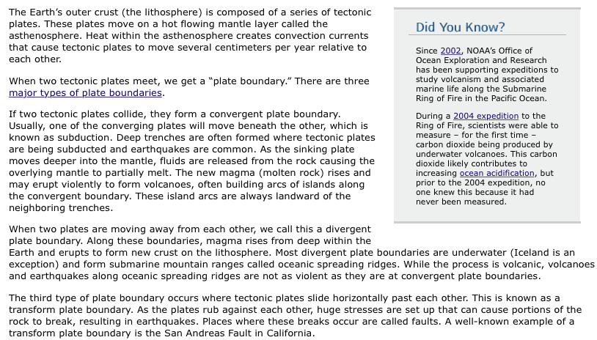
Explain - Informational Texts
National Oceanic and Atmospheric Administration. (2014). What Features Form at Tectonic Plate Boundaries? Retrieved from http://oceanexplorer.noaa.gov/facts/tectonic-features.html
Informational Texts Reading Questions
- What is Earth’s outer crust composed of?

- What is a plate boundary?

- Where are deep ocean trenches formed?

- What happens when magma rises from the sinking plates?

Informational Texts Reading Questions
- What is Earth’s outer crust composed of? Tectonic plates

- What is a plate boundary?

- Where are deep ocean trenches formed?

- What happens when magma rises from the sinking plates?

ANSWER KEY Informational Texts Reading Questions
- What is Earth’s outer crust composed of?
Tectonic plates

- What is a plate boundary?
The place where two tectonic plates meet.

- Where are deep ocean trenches formed?
Deep ocean trenches form where tectonic plates are subducted and earthquakes are common.

- What happens when magma rises from the sinking plates?
A volcano is formed.
ANSWER KEY Informational Texts Reading Questions
- What is Earth’s outer crust composed of?
Tectonic plates

- What is a plate boundary?
The place where two tectonic plates meet.

- Where are deep ocean trenches formed?
Deep ocean trenches form where tectonic plates are subducted and earthquakes are common.

- What happens when magma rises from the sinking plates?
A volcano is formed.

Elaborate – When Plates Collide Lab
Goodwin, M. (n.d.). When plates collide. Retrieved from http://oceanexplorer.noaa.gov/explorations/10chile/background/edu/media/whenplates.pdf

Elaborate – When Plates Collide Lab
Goodwin, M. (n.d.). When plates collide. Retrieved from http://oceanexplorer.noaa.gov/explorations/10chile/background/edu/media/whenplates.pdf

When Plates Collide Lab CER
Claim (Write a sentence stating why mountain ranges, ocean trenches, volcanoes, and earthquakes at plate boundaries.)

Evidence (Provide evidence from the lab to support your claim. Describe the what evens occur at each boundary.)

Reasoning (Explain how your evidence supports your claim. Describe why mountain ranges, ocean trenches, volcanoes, and earthquakes occur at each boundary.)

When Plates Collide Lab CER
Claim (Write a sentence stating why mountain ranges, ocean trenches, volcanoes, and earthquakes at plate boundaries.)

Evidence (Provide evidence from the lab to support your claim. Describe the what evens occur at each boundary.)

Reasoning (Explain how your evidence supports your claim. Describe why mountain ranges, ocean trenches, volcanoes, and earthquakes occur at each boundary.)

ANSWER KEY When Plates Collide Lab CER
Claim (Write a sentence stating why mountain ranges, ocean trenches, volcanoes, and earthquakes at plate boundaries.)
Movement at divergent, convergent, and transform boundaries cause mountain ranges, ocean trenches, volcanoes, and earthquakes to occur.
Evidence (Provide evidence from the lab to support your claim. Describe the what evens occur at each boundary.)
Plates are pulled apart at divergent boundaries, which creates an ocean trench that magma rise from. At convergent boundaries, the continental plate overlaps the oceanic plate, which is subducted. At transform boundaries, the plates are pushed in opposite directions, which causes earthquakes.
Reasoning (Explain how your evidence supports your claim. Describe why mountain ranges, ocean trenches, volcanoes, and earthquakes occur at each boundary.)
At divergent boundaries, ocean trenches are formed and volcanoes erupt. When the continental plate overlaps the oceanic plate, a mountain range is formed. At transform boundaries, the plates slide past each other, which cause earthquakes
ANSWER KEY When Plates Collide Lab CER
Claim (Write a sentence stating why mountain ranges, ocean trenches, volcanoes, and earthquakes at plate boundaries.)
Movement at divergent, convergent, and transform boundaries cause mountain ranges, ocean trenches, volcanoes, and earthquakes to occur.
Evidence (Provide evidence from the lab to support your claim. Describe the what evens occur at each boundary.)
Plates are pulled apart at divergent boundaries, which creates an ocean trench that magma rise from. At convergent boundaries, the continental plate overlaps the oceanic plate, which is subducted. At transform boundaries, the plates are pushed in opposite directions, which causes earthquakes.
Reasoning (Explain how your evidence supports your claim. Describe why mountain ranges, ocean trenches, volcanoes, and earthquakes occur at each boundary.)
At divergent boundaries, ocean trenches are formed and volcanoes erupt. When the continental plate overlaps the oceanic plate, a mountain range is formed. At transform boundaries, the plates slide past each other, which cause earthquakes
Evaluate – Patterns of Earth’s Features Questions
- Where can you find patterns in the locations of mountain ranges, volcanoes, and earthquakes?
  - Continents
  - Plate boundaries
  - Ocean
  - Equator
- List the three types of plate boundaries.

- What is a plate boundary?

- What is Earth’s crust composed of?

- Two tectonic plates have just crashed into each other in the Atlantic Ocean. Predict whether a mountain range, ocean trench, volcano, or earthquake would occur?

Evaluate – Patterns of Earth’s Features Questions
- Where can you find patterns in the locations of mountain ranges, volcanoes, and earthquakes?
  - Continents
  - Plate boundaries
  - Ocean
  - Equator
- List the three types of plate boundaries.

- What is a plate boundary?

- What is Earth’s crust composed of?

- Two tectonic plates have just crashed into each other in the Atlantic Ocean. Predict whether a mountain range, ocean trench, volcano, or earthquake would occur?

Evaluate – ANSWER Key for Patterns of Earth’s Features Questions
- Where can you find patterns in the locations of mountain ranges, volcanoes, and earthquakes?
b. Plate boundaries
- List the three types of plate boundaries.
- Divergent boundaries
- Convergent boundaries
- Transform boundaries
- What is a plate boundary?
The place where two tectonic plates meet
- What is Earth’s crust composed of?
Tectonic plates
- Two tectonic plates have just crashed into each other in the Atlantic Ocean. Predict whether a mountain range, ocean trench, volcano, or earthquake would occur?
Ocean trenches
Evaluate – ANSWER Key for Patterns of Earth’s Features Questions
- Where can you find patterns in the locations of mountain ranges, volcanoes, and earthquakes?
b. Plate boundaries
- List the three types of plate boundaries.
- Divergent boundaries
- Convergent Boundaries
- Transform boundaries
- What is a plate boundary?
The place where two tectonic plates meet
- What is Earth’s crust composed of?
Tectonic plates
- Two tectonic plates have just crashed into each other in the Atlantic Ocean. Predict whether a mountain range, ocean trench, volcano, or earthquake would occur?
Ocean trenches

Types of Boundaries | Earth’s Features that occur at each boundary (mountain ranges, ocean trenches, volcanoes, and earthquakes)
Divergent Boundary
Convergent Boundary
Transform Boundary

Big Ah-Ha Thesis
The purpose of this unit was to understand why patterns occur at the locations of mountain ranges, ocean trenches, volcanoes, and earthquakes. We completed a map of Earth’s features that we already knew, the mapping Earth’s features activity, and the when plates collide lab to gather lines of evidence.
When we mapped features of Earth that we already knew, we identified mountain ranges, ocean trenches, volcanoes, and earthquakes. We observed our map to find patterns. We identified that some of Earth’s features occur close to each other.
We plotted specific mountain ranges, ocean trenches, volcanoes, and earthquakes on a map. After we plotted the points, we could see patterns. In certain areas, mountain ranges, ocean trenches, volcanoes, and earthquakes all occurred in the same area.
We learned that Earth’s features occur at plate boundaries. During the “when plates collide lab,” we saw that certain features occur at each of the three types of boundaries. Ocean trenches and volcanoes form at divergent boundaries. Volcanoes, earthquakes, and mountain ranges can all be found at the site of convergent boundaries. Finally, earthquakes are also found at the site of transform boundaries.
Each of our learning activities was a line of evidence. They helped us find and explain why patterns occur at the locations of mountain ranges, ocean trenches, volcanoes, and earthquakes.

Big Ah-Ha Thesis
The purpose of this unit was to understand why patterns occur at the locations of mountain ranges, ocean trenches, volcanoes, and earthquakes. We completed a map of Earth’s features that we already knew, the mapping Earth’s features activity, and the when plates collide lab to gather lines of evidence.
When we mapped features of Earth that we already knew, we identified mountain ranges, ocean trenches, volcanoes, and earthquakes. We observed our map to find patterns. We identified that some of Earth’s features occur close to each other.
We plotted specific mountain ranges, ocean trenches, volcanoes, and earthquakes on a map. After we plotted the points, we could see patterns. In certain areas, mountain ranges, ocean trenches, volcanoes, and earthquakes all occurred in the same area.
We learned that Earth’s features occur at plate boundaries. During the “when plates collide lab,” we saw that certain features occur at each of the three types of boundaries. Ocean trenches and volcanoes form at divergent boundaries. Volcanoes, earthquakes, and mountain ranges can all be found at the site of convergent boundaries. Finally, earthquakes are also found at the site of transform boundaries.
Each of our learning activities was a line of evidence. They helped us find and explain why patterns occur at the locations of mountain ranges, ocean trenches, volcanoes, and earthquakes.

Self-Reflection Paragraph
Before this unit, I did not realize that mountain ranges, ocean trenches, volcanoes, and earthquakes occur in patterns. I thought that these features occurred randomly. The activity that helped me the most was the mapping Earth’s features. This activity helped me visualize the patterns of Earth’s features.

Self-Reflection Paragraph
Before this unit, I did not realize that mountain ranges, ocean trenches, volcanoes, and earthquakes occur in patterns. I thought that these features occurred randomly. The activity that helped me the most was the mapping Earth’s features. This activity helped me visualize the patterns of Earth’s features.

