Natural Resources
NaturalResources

Overarching Question: Based on the information you have gathered, what is a natural resource, and why are some natural resources renewable or nonrenewable?

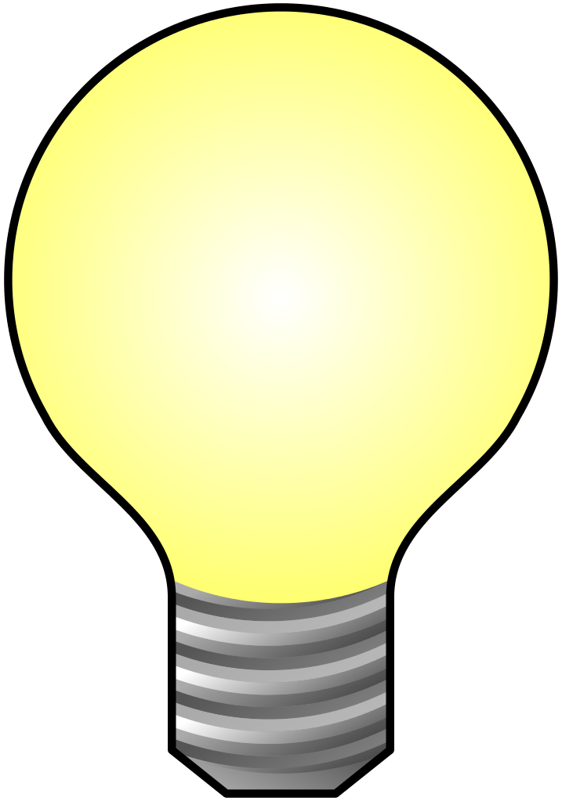
Name one renewable resource and explain why it is classified as a renewable resource/
What characteristics do natural resources have?
What is one nonrenewable resource you use every day?
Name one renewable resource and explain why it is classified as a renewable resource/
What characteristics do natural resources have?
What is one nonrenewable resource you use every day?

Are interactive notebooks effective?
How are interactive notebooks organized?
How are interactive notebooks assessed?

Overarching Question: Based on the information you have gathered, what is a natural resource, and why are some natural resources renewable or nonrenewable?
Line of Evidence – Game Show
We watched a video of kids answering questions common questions about natural resources and which ones are renewable and nonrenewable. They explained that the resources that are not replaced by the earth are nonrenewable. The resources the earth can replace are renewable.

Line of Evidence – KWL Chart
Natural resources are resources that humans use that come from nature.

Line of Evidence – Foldables
All natural resources are classified into two categories, renewable and nonrenewable. Some are limited in quantity and will eventually be used up. Others are part of our everyday environment and are unlimited in number.

Big Aha Thesis Statement
There are natural resources created by the earth’s processes. Renewable resources are natural resources that can be replaced by earth’s processes. Nonrenewable resources cannot be replaced by earth’s processes within our lifetime.
Line of Evidence – Game Show
We watched a video of kids answering questions common questions about natural resources and which ones are renewable and nonrenewable. They explained that the resources that are not replaced by the earth are nonrenewable. The resources the earth can replace are renewable.

Line of Evidence – KWL Chart
Natural resources are resources that humans use that come from nature.
Line of Evidence – Foldables
All natural resources are classified into two categories, renewable and nonrenewable. Some are limited in quantity and will eventually be used up. Others are part of our everyday environment and are unlimited in number.

Big Aha Thesis Statement
There are natural resources created by the earth’s processes. Renewable resources are natural resources that can be replaced by earth’s processes. Nonrenewable resources cannot be replaced by earth’s processes within our lifetime.

Engage - KWL Charts

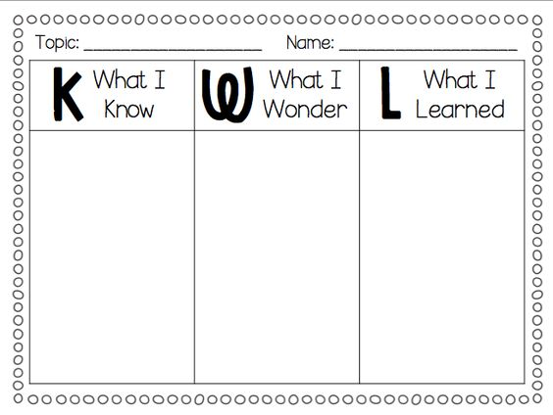

Elementary, I. (2015, October 27). KWL Chart FREEBIE! Retrieved April 22, 2017, from https://www.teacherspayteachers.com/Product/KWL-Chart-FREEBIE-2173904

Engage – KWL Charts

Elementary, I. (2015, October 27). KWL Chart FREEBIE! Retrieved April 22, 2017, from https://www.teacherspayteachers.com/Product/KWL-Chart-FREEBIE-2173904

Explore – Renewable Resources Game Show
Renewable Resources Game Show – BRAIN ZAPPED | Science for Kids!. Retrieved April 21, 2017, from https://www.youtube.com/watch?v=6_adfcO8clo
https://www.youtube.com/watch?v=6_adfcO8clo

Explore – Renewable Resources Game Show
Renewable Resources Game Show – BRAIN ZAPPED | Science for Kids!. Retrieved April 21, 2017, from https://www.youtube.com/watch?v=6_adfcO8clo
https://www.youtube.com/watch?v=6_adfcO8clo

Renewable Resources Gameshow CER
Claim (Write a sentence stating the definition of a natural resource, a renewable resource and a nonrenewable resource.)

Evidence (Provide the names of some natural resources and where they come from. Which of those natural resources have proven to be renewable or nonrenewable?)

Reasoning (Explain how your evidence supports your claim.)

Renewable Resources Gameshow CER
Claim (Write a sentence stating the definition of a natural resource, a renewable resource and a nonrenewable resource.)

Evidence (Provide the names of some natural resources and where they come from. Which of those natural resources have proven to be renewable or nonrenewable?)

Reasoning (Explain how your evidence supports your claim.)

ANSWER KEY Renewable Resources Gameshow CER
Claim (Write a sentence stating the definition of a natural resource, a renewable resource and a nonrenewable resource.)
A natural resource is a resource we use that comes from the earth. If that resource will be replenished by the earth within our lifetime, it is a renewable resource. If it is not replenished by the earth within our lifetime, it is a nonrenewable resource.

Evidence (Provide the names of some natural resources and where they come from. Which of those natural resources have proven to be renewable or nonrenewable?)
A few natural resources include water, sunlight and fossil fuels. Water and sunlight are part of the earth’s constant environment so they are renewable and replenished quickly and easily. Fossil fuels are drilled from the earth, but the earth takes too long to replenish it, so it is a nonrenewable resource.
Reasoning (Explain how your evidence supports your claim.)
These resources are products of the earth’s processes and differ in the time it takes to replenish them.
ANSWER KEY Renewable Resources Gameshow CER
Claim (Write and sentence stating the definition of a natural resource, a renewable resource and a nonrenewable resource.)
A natural resource is a resource we use that comes from the earth. If that resource will be replenished by the earth within our lifetime, it is a renewable resource. If it is not replenished by the earth within our lifetime, it is a nonrenewable resource.

Evidence (Provide the names of some natural resources and where they come from. Which of those natural resources have proven to be renewable or nonrenewable?)
A few natural resources include water, sunlight and fossil fuels. Water and sunlight are part of the earth’s constant environment so they are renewable and replenished quickly and easily. Fossil fuels are drilled from the earth, but the earth takes too long to replenish it, so it is a nonrenewable resource.
Reasoning (Explain how your evidence supports your claim.)
These resources are products of the earth’s processes and differ in the time it takes to replenish them.
Explain – Foldables

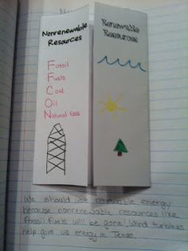
The Science Penguin: Earth Science Interactive Notebook. (2015, October). https://www.pinterest.com/pin/ 174444185539407238/.

Explain - Foldables

The Science Penguin: Earth Science Interactive Notebook. (2015, October). https://www.pinterest.com/pin/ 174444185539407238/.

Elaborate – Types of Energy Point Sheet
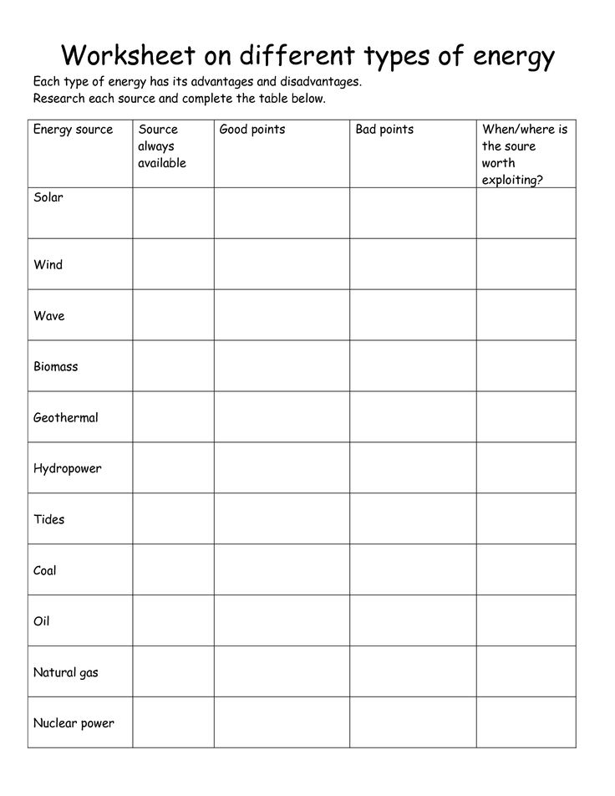
Different Types of Energy. (n.d.). Retrieved April 22, 2017, from https://www.google.com/search?q=renewable%2Band%2Balternative%2Benergy%2Bworksheet%2Bfor%2Bkids&espv=2&tbm=isch&tbo=u&source=univ&sa=X&ved=0ahUKEwiwmbj_uLnTAhUFTCYKHQu3DD4QsAQIKA&biw=1517&bih=708#imgrc=k0bUacWhgCIDrM:
Elaborate – Types of Energy Point Sheet
Different Types of Energy. (n.d.). Retrieved April 22, 2017, from https://www.google.com/search?q=renewable%2Band%2Balternative%2Benergy%2Bworksheet%2Bfor%2Bkids&espv=2&tbm=isch&tbo=u&source=univ&sa=X&ved=0ahUKEwiwmbj_uLnTAhUFTCYKHQu3DD4QsAQIKA&biw=1517&bih=708#imgrc=k0bUacWhgCIDrM:
Types of Energy Research CER
Claim (Write a sentence stating which resources seem to be the most reliable and “earth friendly” resources.)

Evidence (Provide evidence from your research and from your energy chart. Name the resources that are used up faster than others.)

Reasoning (Explain how your evidence supports your claim.)

Types of Energy Research CER
Claim (Write a sentence stating which resources seem to be the most reliable and “earth friendly” resources.)

Evidence (Provide evidence from your research and from your energy chart. Name the resources that are used up faster than others.)

Reasoning (Explain how your evidence supports your claim.)

ANSWER KEY Types of Energy Research CER
Claim (Write a sentence stating which resources seem to be the most reliable and “earth friendly” resources.)
The most reliable resources or forms of energy from the worksheet are solar, wind, wave/tidal, biomass, geothermal and hydropower.
Evidence (Provide evidence from your research and from your energy chart. Name the resources that are used up faster than others.)
There is only a limited supply of oil, coal, natural gas, and nuclear energy created by the earth over a long period of time. If used too rapidly, it will run out. The other resources are renewable and part of our everyday environment, therefore, they will not run out.
Reasoning (Explain how your evidence supports your claim.)
Because there is only a limited supply of oil, coal, natural gas, and nuclear energy over a period of time, they are considered nonrenewable and unreliable resources. Whereas the other resources, solar, wind, wave/tidal, biomass, geothermal and hydropower, are found in our everyday environment. This classifies them as renewable and reliable.
ANSWER KEY Types of Energy Research CER
Claim (Write a sentence stating which resources seem to be the most reliable and “earth friendly” resources.)
The most reliable resources or forms of energy from the worksheet are solar, wind, wave/tidal, biomass, geothermal and hydropower.
Evidence (Provide evidence from your research and from your energy chart. Name the resources that are used up faster than others.)
There is only a limited supply of oil, coal, natural gas, and nuclear energy created by the earth over a long period of time. If used too rapidly, it will run out. The other resources are renewable and part of our everyday environment, therefore, they will not run out.
Reasoning (Explain how your evidence supports your claim.)
Because there is only a limited supply of oil, coal, natural gas, and nuclear energy over a period of time, they are considered nonrenewable and unreliable resources. Whereas the other resources, solar, wind, wave/tidal, biomass, geothermal and hydropower, are found in our everyday environment. This classifies them as renewable and reliable.

Big Ah-Ha Thesis
The purpose of this unit was to discover what natural resources were and which resources are classified as renewable or nonrenewable. We completed a KWL Chart, a video gameshow, made our own notebook foldables and did our own energy type research.
We filled out the KWL chart on the first day and wrote everything we know about natural resources in the K or “Know” column. We also filled in the W or “Wonder” column and asked questions about natural resources. We would fill in the L or “Learned” section at the very end of the unit.
The are many different resources that we use every day, but only the ones that are made by the earth’s processes are considered natural resources. These include things like dirt, minerals, fossil fuels, water, sunlight, animal fur, animal meat, biomass, coal, oil and nuclear power. There are many more but these are just a few examples.
Some of these natural resources are classified as renewable or nonrenewable. Renewable resources are natural resources that replaced by the earth’s processes quickly and easily. Some of these include biomass, water, solar and wind energy. Nonrenewable resources are natural resources that the earth has a limited amount of, and it takes a very long time to replace these resources. Some of these include, oil, coal, nuclear power, and natural gases.
Each of our learning activities was a line of evidence. They helped us define natural resources and to classify natural resource into either renewable or nonrenewable categories.
Big Ah-Ha Thesis
The purpose of this unit was to discover what natural resources were and which resources are classified as renewable or nonrenewable. We completed a KWL Chart, a video gameshow, made our own notebook foldables and did our own energy type research
We filled out the KWL chart on the first day and wrote everything we know about natural resources in the K or “Know” column. We also filled in the W or “Wonder” column and asked questions about natural resources. We would fill in the L or “Learned” section at the very end of the unit.
The are many different resources that we use every day, but only the ones that are made by the earth’s processes are considered natural resources. These include things like dirt, minerals, fossil fuels, water, sunlight, animal fur, animal meat, biomass, coal, oil and nuclear power. There are many more but these are just a few examples.
Some of these natural resources are classified as renewable or nonrenewable. Renewable resources are natural resources that replaced by the earth’s processes quickly and easily. Some of these include biomass, water, solar and wind energy. Nonrenewable resources are natural resources that the earth has a limited amount of, and it takes a very long time to replace these resources. Some of these include, oil, coal, nuclear power, and natural gases.
Each of our learning activities was a line of evidence. They helped us define natural resources and to classify natural resource into either renewable or nonrenewable categories.
Self-Reflection Paragraph
Before this unit, I knew what a natural resource was but did not know that there were so many. I also knew that renewable and nonrenewable resources existed but I did not know what characteristics defined these two types of resources. The research was the coolest part and I got to make my own foldable to study from and draw pictures of different resources and how they come from nature.

Self-Reflection Paragraph
Before this unit, I knew what a natural resource was but did not know that there were so many. I also knew that renewable and nonrenewable resources existed but I did not know what characteristics defined these two types of resources. The research was the coolest part and I got to make my own foldable to study from and draw pictures of different resources and how they come from nature.

