**Criteria,**

**Constraints,**

**& Multiple**

**Solutions**

**Criteria,**

**Constraints,**

**& Multiple**

**Solutions**

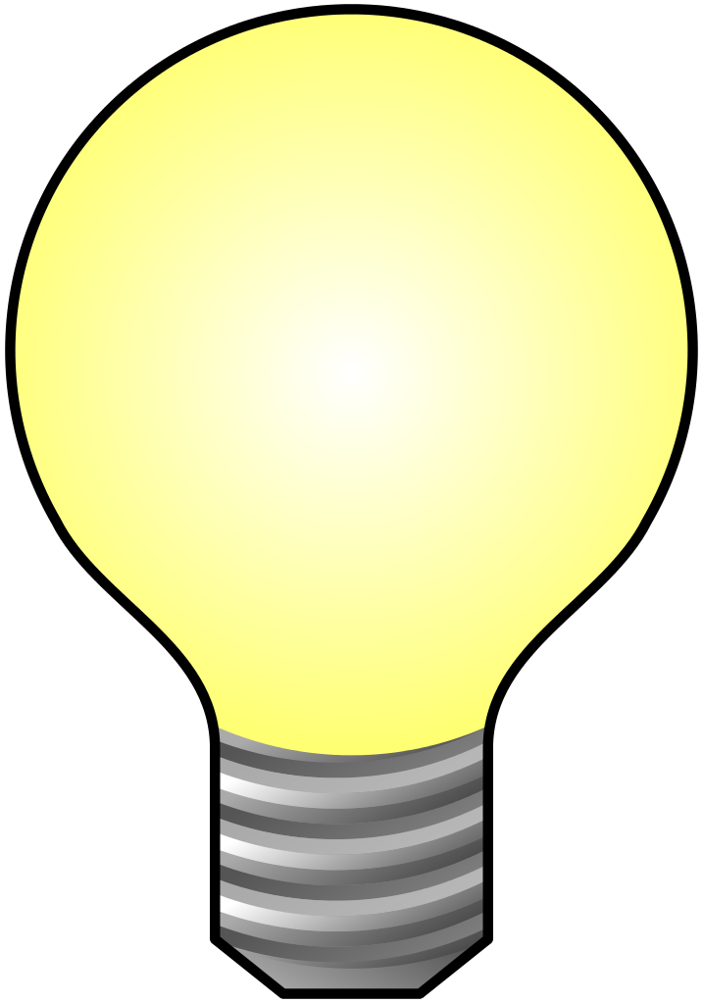

How did the constraints of the materials provided affect the outcome?

What was the effectiveness of multiple solutions to a design problem when determining the given criteria?

How useful would determining the effectiveness of the criteria have been if multiple design solutions didn’t have any constraints?

How did the constraints of the materials provided affect the outcome?

What was the effectiveness of multiple solutions to a design problem when determining the given criteria?

How useful would determining the effectiveness of the criteria have been if multiple design solutions didn’t have any constraints?

**Overarching Question:** Given the criteria and the constraints of using only what materials have been provided, which design solution best met the criteria?

**Overarching Question:** Given the criteria and the constraints of using only what materials have been provided, which design solution best met the criteria?

|  |
| --- |
| **Line of Evidence – Egg Drop Activity** |
| *Not all the materials were equally as effective for determining which solution to the design problem was best to meet the criteria.* |

|  |
| --- |
| **Line of Evidence – Egg Drop Activity** |
| We saw from averaging the five experiments of each of the different materials provided that our claim was supported because the average rate of breakage for the packing peanuts was the least and the other materials were unable to protect the egg as effectively as the packing peanuts. |

|  |
| --- |
| **Line of Evidence – Egg Drop Activity** |
| *It was very effective to have multiple design solutions because it showed which solution was determined to be the best when meeting the criteria.* |

|  |
| --- |
| **Line of Evidence – Egg Drop Activity** |
| *The usefulness in determining which design solution is best to meet the criteria would have been less effective if there were no constraints because it would have been impossible to determine the effectiveness of every possible solution.* |

|  |
| --- |
| **Big Aha Thesis Statement** |
| *Given the criteria which, is to rate the amount of breakage of the egg and the constraints of using only what materials have been provided, the packing peanuts provided the most protection to keep the egg from breaking compared to sand, water, and plastic Easter basket filling when it was dropped from a height of 7 feet.* |

**Line of Evidence – Dynamic Systems**

*Given the option of having multiple solutions to a design problem, we could see that there several ways to meet the criteria using only the materials given.*

**Line of Evidence – Catapult**



*When using only the materials given, it was demonstrated how constraints can affect the effectiveness of a design solution because with only one design solution, we were unable to determine most effective solution because we only had one way of accomplishing it.*

|  |
| --- |
| **Line of Evidence – Egg Drop Activity** |
| *Not all the materials were equally as effective for determining which solution to the design problem was best to meet the criteria.* |

|  |
| --- |
| **Line of Evidence – Egg Drop Activity** |
| We saw from averaging the five experiments of each of the different materials provided that our claim was supported because the average rate of breakage for the packing peanuts was the least and the other materials were unable to protect the egg as effectively as the packing peanuts. |

|  |
| --- |
| **Line of Evidence – Egg Drop Activity** |
| *It was very effective to have multiple design solutions because it showed which solution was determined to be the best when meeting the criteria.* |

|  |
| --- |
| **Line of Evidence – Egg Drop Activity** |
| *The usefulness in determining which design solution is best to meet the criteria would have been less effective if there were no constraints because it would have been impossible to determine the effectiveness of every possible solution.* |

|  |
| --- |
| **Big Aha Thesis Statement** |
| Given the criteria which, is to rate the amount of breakage of the egg and the constraints of using only what materials have been provided, the packing peanuts provided the most protection to keep the egg from breaking compared to sand, water, and plastic Easter basket filling when it was dropped from a height of 7 feet. |

**Line of Evidence – Dynamic Systems**



*Given the option of having multiple solutions to a design problem, we could see that there several ways to meet the criteria using only the materials given.*

**Line of Evidence – Catapult**



*When using only the materials given, it was demonstrated how constraints can affect the effectiveness of a design solution because with only one design solution, we were unable to determine most effective solution because we only had one way of accomplishing it.*

**ENGAGE – Dynamic Systems**

**Standard:** 4.ETS2: Links Among Engineering, Technology, Science, and Society

2) Determine the effectiveness of multiple solutions to a design problem given the criteria and the constraints.

As a class, we will determine multiple design solutions with various constraints to achieve a set criteria by playing the online game found at <http://www.engineering.com/GamesPuzzles/DynamicSystems.aspx>

Once we have completed five levels of this game, answer the following questions:

1. Were there multiple ways to achieve getting the ball into the cup?
2. What were the constraints you were faced with when solving the solution?
3. How can having multiple solutions with set constraints help with the effectiveness of a solution to a design problem?

# Works Cited

*Top Games*. (2016). Retrieved from Engineering.com: http://www.engineering.com/GamesPuzzles/DynamicSystems.aspx

**ENGAGE – Dynamic Systems**

**Standard:** 4.ETS2: Links Among Engineering, Technology, Science, and Society

2) Determine the effectiveness of multiple solutions to a design problem given the criteria and the constraints.

As a class, we will determine multiple design solutions with various constraints to achieve a set criteria by playing the online game found at <http://www.engineering.com/GamesPuzzles/DynamicSystems.aspx>

Once we have completed five levels of this game, answer the following questions:

1. Were there multiple ways to achieve getting the ball into the cup?
2. What were the constraints you were faced with when solving the solution?
3. How can having multiple solutions with set constraints help with the effectiveness of a solution to a design problem?

# Works Cited

*Top Games*. (2016). Retrieved from Engineering.com: http://www.engineering.com/GamesPuzzles/DynamicSystems.aspx

**EXPLORE – Catapults**

**Materials:**

9 craft sticks. Popsicle sticks may work, but wider sticks are much better.

4-6 rubber bands

1 plastic spoon

## **Instructions**

## **Step 1** – Take 7 of the craft sticks and tie a rubber band tightly around one end.

## **Step 2** – Tie another rubber band tightly around the opposite end so all 7 sticks are bound together.

* **Step 3** – Take the remaining 2 sticks and tie a rubber band on one of the ends. Try to tie the band close to the edge of the sticks.
* **Step 4** – Insert the 7 sticks banded together through the 2 stick bundle as shown in the illustration below.
* **Step 5** – Tie a rubber band in a cross fashion joining the two pieces. The closer the 7 stick bundle gets to the edge, the more leverage the catapult will have.
* **Step 6** – Use a few rubber bands and attach the plastic spoon on the end.

Source: <http://www.devincollier.com/how-to-build-a-simple-small-marshmallow-catapult/>

**EXPLORE – Catapults**

**Materials:**

9 craft sticks. Popsicle sticks may work, but wider sticks are much better.

4-6 rubber bands

1 plastic spoon

## **Instructions**

## **Step 1** – Take 7 of the craft sticks and tie a rubber band tightly around one end.

## **Step 2** – Tie another rubber band tightly around the opposite end so all 7 sticks are bound together.

* **Step 3** – Take the remaining 2 sticks and tie a rubber band on one of the ends. Try to tie the band close to the edge of the sticks.
* **Step 4** – Insert the 7 sticks banded together through the 2 stick bundle.
* **Step 5** – Tie a rubber band in a cross fashion joining the two pieces. The closer the 7 stick bundle gets to the edge, the more leverage the catapult will have.
* **Step 6** – Use a few rubber bands and attach the plastic spoon on the end.

Source: <http://www.devincollier.com/how-to-build-a-simple-small-marshmallow-catapult/>

**Catapult CER**

**Claim** (Write a sentence stating the effectiveness of achieving the criteria of building a catapult given the constraints of the materials provided.)

**Evidence** (Provide a description of how the constraints affected the design solution given the materials you were given. Describe how only having these materials affected your design.)

**Reasoning** (Explain how your evidence supports your claim. Describe how the constraints of the materials given affected the effectiveness of your catapult design.)

**Catapult CER**

**Claim** (Write a sentence stating the effectiveness of achieving the criteria of building a catapult given the constraints of the materials provided.)

**Evidence** (Provide a description of how the constraints affected the design solution given the materials you were given. Describe how only having these materials affected your design.)

**Reasoning** (Explain how your evidence supports your claim. Describe how the constraints of the materials given affected the effectiveness of your catapult design.)

**ANSWER KEY Catapult CER**

**Claim** (Write a sentence stating the effectiveness of achieving the criteria of building a catapult given the constraints of the materials provided.)

*The building of the catapult with only the materials provided greatly affected the effectiveness of the design because there was only one way to build it therefore we could not test its effectiveness compared to other designs.*

**Evidence** (Provide a description of how the constraints affected the design solution given the materials you were given. Describe how only having these materials affected your design.)

*We only had craft sticks and rubber bands and a plastic spoon to design our catapult so there was only a certain way it could be put together so that it worked. Because of this, we couldn’t see if there was another more effective way to make a catapult using other materials.*

**Reasoning** (Explain how your evidence supports your claim. Describe how the constraints of the materials given affected the effectiveness of your catapult design.)

*The catapult was only as effective as the craft sticks, rubber bands, and plastic spoon we were given to design it and because of this we had no way to determine if there was another more effective way to design a catapult using other materials than what we were given.*

**ANSWER KEY Catapult CER**

**Claim** (Write a sentence stating the effectiveness of achieving the criteria of building a catapult given the constraints of the materials provided.)

*The building of the catapult with only the materials provided greatly affected the effectiveness of the design because there was only one way to build it therefore we could not test its effectiveness compared to other designs.*

**Evidence** (Provide a description of how the constraints affected the design solution given the materials you were given. Describe how only having these materials affected your design.)

*We only had craft sticks and rubber bands and a plastic spoon to design our catapult so there was only a certain way it could be put together so that it worked. Because of this, we couldn’t see if there was another more effective way to make a catapult using other materials.*

**Reasoning** (Explain how your evidence supports your claim. Describe how the constraints of the materials given affected the effectiveness of your catapult design.)

*The catapult was only as effective as the craft sticks, rubber bands, and plastic spoon we were given to design it and because of this we had no way to determine if there was another more effective way to design a catapult using other materials than what we were given.*

*The Engineering Design Process*. (2002-2017). Retrieved from Science Buddies: http://www.sciencebuddies.org/engineering-design-process/engineering-design-process-steps.shtml#theengineeringdesignprocess

**Define the Problem**

**EXPLAIN**

**Do Background Research**

**Specify Requirements**

**Brainstorm Solutions**

**Choose the Best Solution**

**Develop the Solution**

**Build a Prototype**

**Test and Redesign**

**Communicate Results**

The engineering design process starts when you ask the following questions about problems that you observe

What is the problem or need or criteria?

Who has the problem or need?

Why is it important to solve?

What are the constraints I have when determining the solution to the problem?

**Define the Problem**

**Communicate Results**

**Test and Redesign**

**Build a Prototype**

**Develop the Solution**

**Choose the Best Solution**

**Brainstorm Solutions**

**Specify Requirements**

**Do Background Research**

Learn from the experiences of others — this can help you find out about existing solutions to similar problems, and avoid mistakes that were made in the past using the same criteria and constraints.

Design requirements state the important characteristics and constraints that your solution must meet to succeed. One of the best ways to identify the design requirements for your criteria is to analyze the concrete example of a similar, existing product, noting each of its key features and constraints.

There are always multiple design solutions for solving design problems. If you focus on just one before looking at the alternatives, it is almost certain that you are overlooking a better solution. Good designers try to generate as many possible solutions as they can to meet their criteria within their constraints.

Look at whether each possible solution meets your design criteria. Some solutions probably meet more criteria than others. Reject solutions that do not meet the criteria using the given constraints.

Development involves the refinement and improvement of a solution, and it continues throughout the design process, often even after a product ships to customers.

A prototype is an operating version of a solution. Often it is made with different materials than the final version, and generally it is not as polished. Prototypes are a key step in the development of a final solution, allowing the designer to test how the solution will work.

The design process involves multiple iterations and redesigns of your final solution. You will likely test your solution, find new problems, make changes, and test new solutions before settling on a final design.

To complete your project, communicate your results to others in a final report and/or a display board. Professional engineers always do the same, thoroughly documenting their solutions so that they can be manufactured and supported.

ELABORATE – EGG DROP ACTIVITY

**Standard**: **4.ETS2: Links Among Engineering, Technology, Science, and Society**

2) Determine the effectiveness of multiple solutions to a design problem given the criteria and the constraints.

**Activity**: Egg Drop (loosely adapted from the Naked Egg Project on teachengineering.com)

* Students will construct an egg dropping container made from materials provided.
* Students will then have their egg dropped in the egg container they designed from a height of 7ft using a ladder.
* Students will rate on a scale of 1 - 5 which materials provided the least amount of breakage to the egg using the scale’s criteria.
* Students will make predictions before the drop on how well they expect their design to work and why.
* Students will then check to see if their predictions were correct after their container and egg are dropped.
* Students will get five attempts to construct a design which will prevent the egg from breaking.
* Students will then use that data to determine which design was the most effective using the permitted materials and given the criteria of the activity.

**EGG BREAKAGE SCALE**

1 – No Breakage

2 – Cracked but not leaking

3 – Cracked with leaking

4 – Cracked into two whole pieces

5 – Cracked into more than two pieces to several pieces

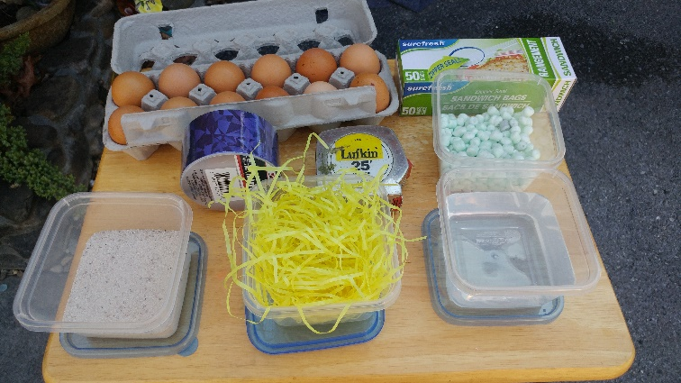**MATERIALS**

* Plastic egg container (provided)
* Zip lock baggie (to place egg in for easy cleaning)
* Raw egg
* Sand
* Water
* Easter basket plastic filling
* Styrofoam packing peanuts
* Duct tape
* Tape measure

# Works Cited

Jabusch, L. (n.d.). *Hands-on Activity: Naked Egg Drop*. Retrieved from TeachEngineering: https://www.teachengineering.org/activities/view/ucd_eggdrop_activity1

**ELABORATE – EGG DROP ACTIVITY WRAP-UP**

**Student Presentations**

* In your own words, define the problem that was given and the materials you to choose to use solve the problem and any other constraints or guidelines you needed to follow.
* Explain the processes involved to come to your final solution including ideas by all team members which contributed to the end solution.
  + What previous experiences did you pull from to establish what would work and what would not work when crafting your final solution will be presented.
  + Be able to discuss what new vocabulary you encountered and how that vocabulary was defined and applied to your process.
* Explain the steps involved with your solution and the processes which occurred to achieve the goal and solve the problem. (Ex: First we had to solve this aspect to the problem. Once we had this aspect solved we looked at what was needed next.) This will demonstrate a clear and organized thought process which contributed to the problem-solving process.
* Demonstrate your solution using the materials you chose to incorporate and working with the guidelines and constraints given to you.
* Answer questions from your classmates on your problem and solution. Each classmate will be required to ask one question related to the above aspects of the assignment. Each question should use one of the following word phrases: How did you…, Why did you choose…, What made you decide to…, Can you explain…. Other questions will be acceptable if they are focused on the problem/solution given and encourage both the students being asked and the class to extend their own understanding on the subject and can provide the students answering an opportunity to demonstrate their ability to explain their methods. Students will be able to compare and contrast how the problem-solving methods varied or were the same as their own.

|  |  |  |  |
| --- | --- | --- | --- |
| Material Used | Result Prediction | Egg Breakage Scale | Detailed Observations |
|  |  |  |  |
|  |  |  |  |
|  |  |  |  |
|  |  |  |  |
|  |  |  |  |
|  |  |  |  |
|  |  |  |  |
|  |  |  |  |
|  |  |  |  |

|  |  |  |  |
| --- | --- | --- | --- |
| Material Used | Result Prediction | Egg Breakage Scale | Detailed Observations |
|  |  |  |  |
|  |  |  |  |
|  |  |  |  |
|  |  |  |  |
|  |  |  |  |
|  |  |  |  |
|  |  |  |  |
|  |  |  |  |
|  |  |  |  |

**Egg Drop CER**

**Claim** (Write a sentence stating how, given the constraints and the criteria of the egg drop activity, which of the materials was the most effective design solution.)

**Evidence** (Provide evidence from the lab to support your claim. Describe the data gained from this activity that supports which materials of the constraints provided were the most effective in achieving the criteria.)

**Reasoning** (Explain how your evidence supports your claim. Describe how you determined the most effect design solution to the criteria given the constraints.)

**Egg Drop CER**

**Claim** (Write a sentence stating how, given the constraints and the criteria of the egg drop activity, which of the materials was the most effective design solution.)

**Evidence** (Provide evidence from the lab to support your claim. Describe the data gained from this activity that supports which materials of the constraints provided were the most effective in achieving the criteria.)

**Reasoning** (Explain how your evidence supports your claim. Describe how you determined the most effect design solution to the criteria given the constraints.)

**ANSWER KEY Egg Drop CER**

**Claim** (Write a sentence stating how, given the constraints and the criteria of the egg drop activity, which of the materials was the most effective design solution.)

*Given the criteria which is to rate the amount of breakage of the egg and the constraints of using only what materials have been provided, the packing peanuts provided the most protection to keep the egg from breaking compared to sand, water, and plastic Easter basket filling.*

**Evidence** (Provide evidence from the lab to support your claim. Describe the data gained from this activity that supports which materials of the constraints provided were the most effective in achieving the criteria.)

Packing Peanuts – When using packing peanuts the average amount of breakage on the scale was 1

Sand – When using the sand, the average amount of breakage on the scale was 1.8

Plastic Easter Basket Filling – When using the plastic Easter basket filling, the average amount of breakage on the scale was 2.6

Water – When using the water, the average amount of breakage on the scale was 4.8.

**Reasoning** (Explain how your evidence supports your claim. Describe how you determined the most effect design solution to the criteria given the constraints.)

*We saw from averaging the five experiments of each of the different materials provided that our claim was supported because the average rate of breakage for the packing peanuts was the least and the other materials were unable to protect the egg as effectively as the packing peanuts.*

**ANSWER KEY Egg Drop CER**

**Claim** (Write a sentence stating how, given the constraints and the criteria of the egg drop activity, which of the materials was the most effective design solution.)

*Given the criteria which is to rate the amount of breakage of the egg and the constraints of using only what materials have been provided, the packing peanuts provided the most protection to keep the egg from breaking compared to sand, water, and plastic Easter basket filling.*

**Evidence** (Provide evidence from the lab to support your claim. Describe the data gained from this activity that supports which materials of the constraints provided were the most effective in achieving the criteria.)

Packing Peanuts – When using packing peanuts the average amount of breakage on the scale was 1

Sand – When using the sand, the average amount of breakage on the scale was 1.8

Plastic Easter Basket Filling – When using the plastic Easter basket filling, the average amount of breakage on the scale was 2.6

Water – When using the water, the average amount of breakage on the scale was 4.8.

**Reasoning** (Explain how your evidence supports your claim. Describe how you determined the most effect design solution to the criteria given the constraints.)

*We saw from averaging the five experiments of each of the different materials provided that our claim was supported because the average rate of breakage for the packing peanuts was the least and the other materials were unable to protect the egg as effectively as the packing peanuts.*

**Big Ah-Ha Thesis**

The purpose of this unit was to determine the effectiveness of multiple solutions to a design problem given criteria and some constraints. We looked at multiple solutions with our Dynamic Systems activity, how constraints can affect design with our Catapult Activity, and then looked at how constraints and multiple solutions to a design problem can be used to determine the most effective solution to criteria with our Egg Drop Activity.

We played our engineering game, Dynamic Systems, to explore how we could solve the problem of getting the ball into the cup multiple ways using only what the game gave us to accomplish the task. Sometimes it took several tries to achieve the criteria. It also took several people’s solutions to see that more than one solution was possible.

We built a catapult using only the materials given which demonstrated how constraints can affect the effectiveness of a design solution. We were able to understand that with only one design solution, we were unable to determine most effective solution to building a catapult because we only had one way of accomplishing it.

The Egg Drop Activity was able to show us that we can effectively determine the best solution to a design problem from multiple solutions using the criteria given and the constraints of the materials provided.

Each of our learning activities helped us understand how to determine the effectiveness of multiple solutions to a design problem given the criteria and constraints by demonstrating each of those components and how they affect effectiveness.

**Big Ah-Ha Thesis**

The purpose of this unit was to determine the effectiveness of multiple solutions to a design problem given criteria and some constraints. We looked at multiple solutions with our Dynamic Systems activity, how constraints can affect design with our Catapult Activity, and then looked at how constraints and multiple solutions to a design problem can be used to determine the most effective solution to criteria with our Egg Drop Activity.

We played our engineering game, Dynamic Systems, to explore how we could solve the problem of getting the ball into the cup multiple ways using only what the game gave us to accomplish the task. Sometimes it took several tries to achieve the criteria. It also took several people’s solutions to see that more than one solution was possible.

We built a catapult using only the materials given which demonstrated how constraints can affect the effectiveness of a design solution. We were able to understand that with only one design solution, we were unable to determine most effective solution to building a catapult because we only had one way of accomplishing it.

The Egg Drop Activity was able to show us that we can effectively determine the best solution to a design problem from multiple solutions using the criteria given and the constraints of the materials provided.

Each of our learning activities helped us understand how to determine the effectiveness of multiple solutions to a design problem given the criteria and constraints by demonstrating each of those components and how they affect effectiveness.

**Self-Reflection Paragraph**

Before this unit, I had not considered how multiple solutions, criteria, and constraints can affect the effectiveness of a design problem. I thought if you came up with one solution and it worked it was probably the best. The activity that helped me the most to understand how important constraints are was the catapult activity because it showed me that it can be good to have more than one solution. The Egg Drop activity helped me see how to determine the best solution when I only have certain constraints and criteria I have to follow. My favorite was the Egg Drop because we got to squish eggs a bunch of times!

**Self-Reflection Paragraph**

Before this unit, I had not considered how multiple solutions, criteria, and constraints can affect the effectiveness of a design problem. I thought if you came up with one solution and it worked it was probably the best. The activity that helped me the most to understand how important constraints are was the catapult activity because it showed me that it can be good to have more than one solution. The Egg Drop activity helped me see how to determine the best solution when I only have certain constraints and criteria I have to follow. My favorite was the Egg Drop because we got to squish eggs a bunch of times!

**EVALUATE**

1. The diagram below shows a balance. Side A has five blocks and side B has three blocks. The mass of each block is shown in grams (g). (York, 2016)

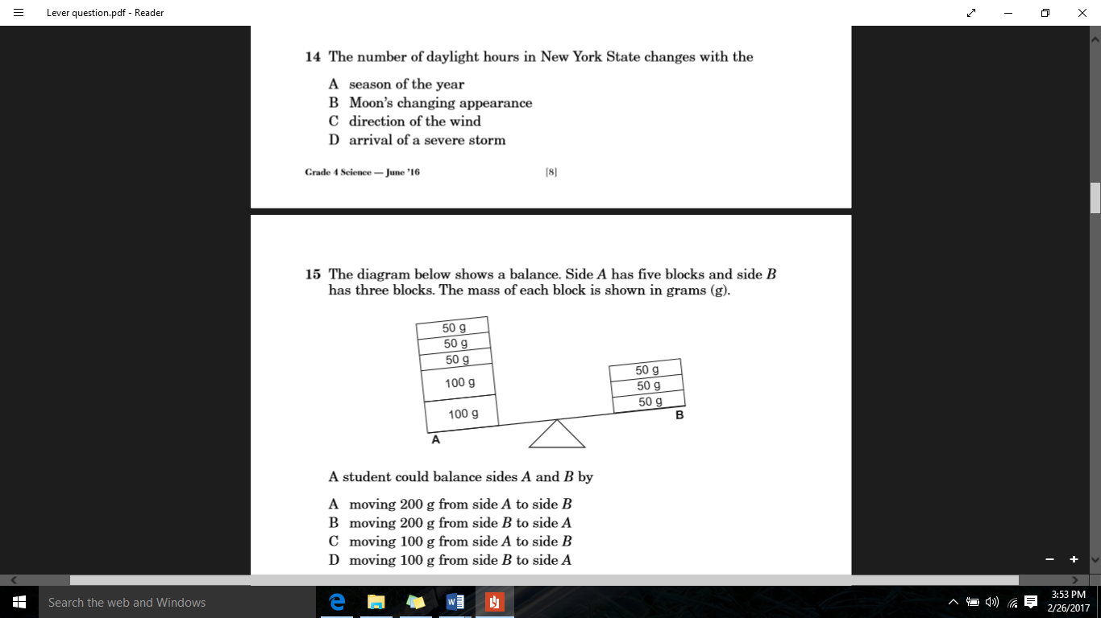

A student could balance sides A and B by:

A moving 200 g from side A to side B

B moving 200 g from side B to side A

C moving 100 g from side A to side B

D moving 100 g from side B to side A

1. The diagrams A and B below show a student moving the same boxes in two different ways. In diagram B, the student is using wheels, which are part of a simple machine. (York, 2016)

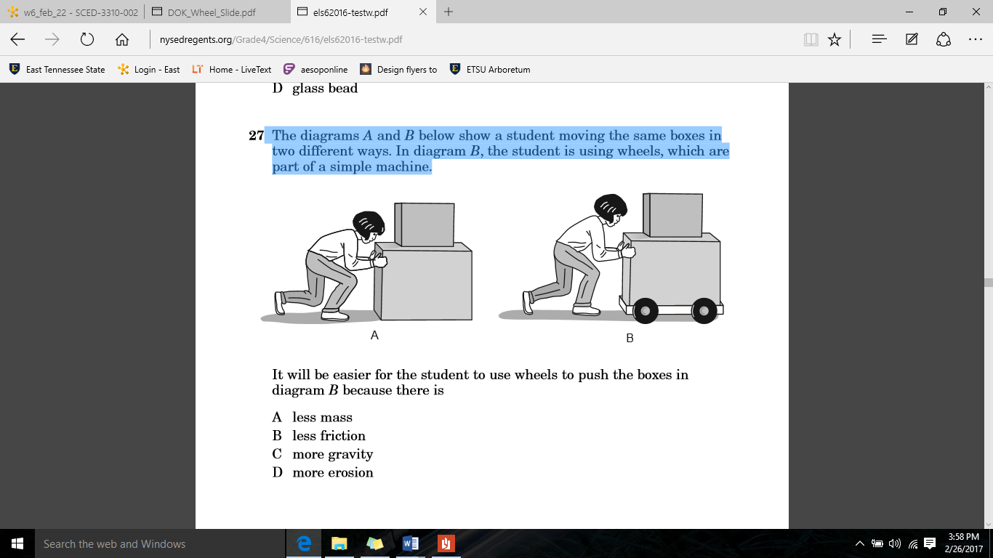

It will be easier for the student to use wheels to push the boxes in diagram B because there is (York, 2016)

A less mass

B less friction

C more gravity

D more erosion

1. On a field trip, a student holds a frog and reports that it has slippery skin. This is an example of (York, 2016)

A a measurement

B a prediction

C an explanation

D an observation

1. The diagrams below show three different simple machines. Use the three terms to complete the chart by identifying each simple machine shown. (York, 2016)

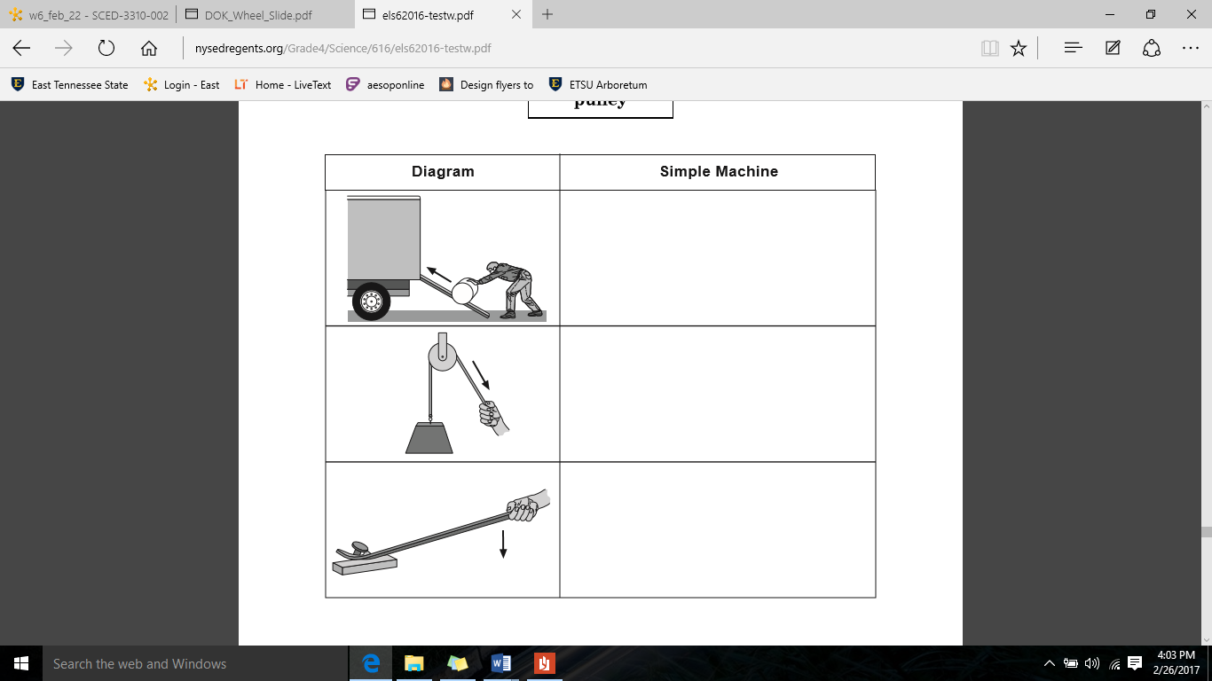

LEVER

INCLINED PLANE

PULLEY

**INCLINED PLANE**

**PULLEY**

**LEVER**

1. List the 8 steps to the Engineering Process in order:
2. (Define the Problem)
3. (Do background Research)
4. (Specify Requirements)
5. (Brainstorm solutions)
6. (Choose the best solution)
7. (Do development work)
8. (Build a prototype)
9. (Test and redesign)
10. The engineering design process is a process used to solve a problem by creating new products, systems, or environments (Engineering Design Process Quiz (Intermediate), 2002 - 2017)

True or False

Lisa's grandfather is very old and has hands that shake a lot. He often drops his fork, which embarrasses him. Lisa wants to develop a fork that is easier for her grandfather to hold. Read the following statements about Lisa, and choose the best answer based on your knowledge about the engineering design process.

1. Before brainstorming solutions, Lisa should do an internet search for silverware that is marketed as easy for people who have shaky hands to use. (Engineering Design Process Quiz (Intermediate), 2002 - 2017)

True or False

1. Lisa should take the first solution she comes up with and quickly build her prototype from that one solution. (Engineering Design Process Quiz (Intermediate), 2002 - 2017)

True or False

1. Once Lisa has what she *thinks* is a better fork, she should: (Engineering Design Process Quiz (Intermediate), 2002 - 2017)
2. Find a manufacturer to mass produce it
3. Have her grandfather test the new fork design
4. File a patent
5. Call a press conference to tell everyone about her invention
6. I don’t know
7. The most valuable thing I learned about solving the problem I was given for my group project was:

**<ANSWERS WILL VARY>**

______________________________________________________________________________________________________________________________________________________________________________________________________________________________________________________________________________________________________________________________________________________________________________________________________________________________________________________________________________________________________________________________________________________________________________________________________________________________________________________________________________________________________________________________________________________________________________________________________________________________________________________________________________________________________________________________________________________________________________________________________________________________________________________________________________________________________

# Works Cited

*Engineering Design Process Quiz (Intermediate)*. (2002 - 2017). Retrieved from Science Buddies: https://www.sciencebuddies.org/science-fair-projects/engineering_design_process/quiz-001

York, T. U. (2016, June 6). *Elementary-Level Science Test Grade 4.* Retrieved from NYSED.gov: http://www.nysedregents.org/Grade4/Science/