Ecosystems: Producers, Consumers and Decomposers
Ecosystems: Producers, Consumers, and Decomposers

Overarching Question: How are producers, consumers, and decomposers connected?
Overarching Question: How are producers, consumers, and decomposers connected?

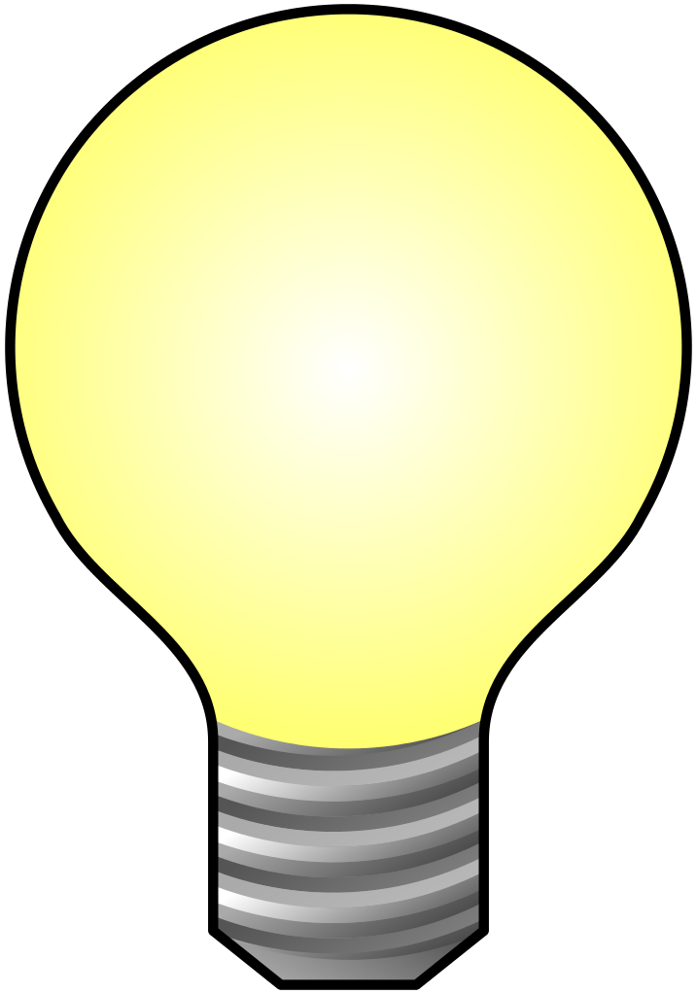
What is a producer and what role does it serve?
What is a consumer and what role does it serve?
What is a decomposer and what role does it serve?
What is a food web?
What is a producer and what role does it serve?
What is a consumer and what role does it serve?
What is a decomposer and what role does it serve?
What is a food web?
Are interactive notebooks effective?
How are interactive notebooks organized?
How are interactive notebooks assessed?

Line of Evidence – Reading Introduction
We read the fiction book Secrets of the Garden to introduce the concept of producers, consumers, decomposers, and food webs.

Line of Evidence – Food Chain Stimulation
The food chain stimulation gets the students interacting and shows them the roles of producers, consumers, and decomposers and how they interact with each other in a food web.

Line of Evidence – Informational References
The ecosystem contains organisms such as producers, consumers, and decomposers. These groups of organisms interconnect in a food web and work together to maintain a balanced ecosystem.

Line of Evidence – Coral Reef Reading
In the coral reef of the ocean, there are producers, consumers, and decomposers. These organisms work in the same way to interconnect and create a food web.

Big Aha Thesis Statement
All over the world, there are producers, consumers, and decomposers that work together and interconnect in a food web to maintain a balanced ecosystem.

Line of Evidence – Reading Introduction
We read the fiction book Secrets of the Garden to introduce the concept of producers, consumers, decomposers, and food webs.

Line of Evidence – Food Chain Stimulation
The food chain stimulation gets the students interacting and shows them the roles of producers, consumers, and decomposers and how they interact with each other in a food web.

Line of Evidence – Informational References
The ecosystem contains organisms such as producers, consumers, and decomposers. These groups of organisms interconnect in a food web and work together to maintain a balanced ecosystem.

Line of Evidence – Coral Reef Reading
In the coral reef of the ocean, there are producers, consumers, and decomposers. These organisms work in the same way to interconnect and create a food web.

Big Aha Thesis Statement
All over the world, there are producers, consumers, and decomposers that work together and interconnect in a food web to maintain a balanced ecosystem.

Engage - Reading Introduction

To engage my students at the beginning of the project, I will ask the students to define the following terms: Role, Organism, Producer, Consumer, Decomposer, Food Chain, and Food Web. After the students have attempted to define the terms, I will introduce and read a fiction book to them. The book I have chosen is:
Secrets of the Garden by Kathleen Weidner Zoehfeld. It is an appropriate reading level text for fourth grade students. After reading this book that generates interest, frames the idea of the project, and establishes students’ prior knowledge of food chains and food webs, I will ask the students to define the terms again and give examples from the book.

Engage – Reading Introduction

To engage my students at the beginning of the project, I will ask the students to define the following terms: Role, Organism, Producer, Consumer, Decomposer, Food Chain, and Food Web. After the students have attempted to define the terms, I will introduce and read a fiction book to them. The book I have chosen is:
Secrets of the Garden by Kathleen Weidner Zoehfeld. It is an appropriate reading level text for fourth grade students. After reading this book that generates interest, frames the idea of the project, and establishes students’ prior knowledge of food chains and food webs, I will ask the students to define the terms again and give examples from the book.

Explore – Food Chain Stimulation
For the Explore section of the project, I will have my students participate and interact in a food chain stimulation. This stimulation will examine the students’ thinking and begin to establish a true understanding of food chains, food webs, and how organisms affect each other. I will distribute each student a colored photo card with a picture of an organism on it. The students will keep their assigned organisms to themselves as I also ask them to come up with a motion to describe their organism (such as when playing charades). The student will lay the card on the floor and start a string of yarn at that card The student will hand the ball of string to another student after identifying what organism they are, saying “I eat ‘that organism’” or “I get my energy from ‘that organism’”. The game goes on and on until it finishes with Sun, where all organisms draw energy from.

Explore – Food Chain Stimulation
For the Explore section of the project, I will have my students participate and interact in a food chain stimulation. This stimulation will examine the students’ thinking and begin to establish a true understanding of food chains, food webs, and how organisms affect each other. I will distribute each student a colored photo card with a picture of an organism on it. The students will keep their assigned organisms to themselves as I also ask them to come up with a motion to describe their organism (such as when playing charades). The student will lay the card on the floor and start a string of yarn at that card The student will hand the ball of string to another student after identifying what organism they are, saying “I eat ‘that organism’” or “I get my energy from ‘that organism’”. The game goes on and on until it finishes with Sun, where all organisms draw energy from.

Food Chain Stimulation CER

Claim (Write a sentence stating how producers, consumers, and decomposers are all interconnected.)

Evidence (Describe how to tell that the roles of producers, consumers, and decomposers interact with each other.)

Reasoning (Explain how your evidence supports your claim. Describe how the roles are interconnected.)
Food Chain Stimulation CER

Claim (Write a sentence stating how producers, consumers, and decomposers are all interconnected.)

Evidence (Describe how to tell that the roles of producers, consumers, and decomposers interact with each other.)

Reasoning (Explain how your evidence supports your claim. Describe how the roles are interconnected.)

ANSWER KEY Food Chain Stimulation CER
Claim The roles of producers, consumers, and decomposers are all interconnected in a food web.

Evidence We know this because in our activity, we stimulated the roles of decomposers, consumers, and producers, and herbivores, carnivores, and omnivores. Using the ball of yarn, we demonstrated how the roles feed off of and interact with each other.

Reasoning What we stimulated in our activity represents how the roles of producers, consumers, and decomposers are all interconnected in a food web. At all times, the different roles interact and depend upon one another.
ANSWER KEY Food Chain Stimulation CER
Claim The roles of producers, consumers, and decomposers are all interconnected in a food web.

Evidence We know this because in our activity, we stimulated the roles of decomposers, consumers, and producers, and herbivores, carnivores, and omnivores. Using the ball of yarn, we demonstrated how the roles feed off of and interact with each other.

Reasoning What we stimulated in our activity represents how the roles of producers, consumers, and decomposers are all interconnected in a food web. At all times, the different roles interact and depend upon one another.

Explain – Informational References

http://www.sheppardsoftware.com/content/animals/kidscorner/foodchain/producersconsumers.htm

http://www.sheppardsoftware.com/content/animals/kidscorner/games/producersconsumersgame.htm

http://www.geography4kids.com/files/land_foodchain.html

Explain - Informational References

http://www.sheppardsoftware.com/content/animals/kidscorner/foodchain/producersconsumers.htm

http://www.sheppardsoftware.com/content/animals/kidscorner/games/producersconsumersgame.htm

http://www.geography4kids.com/files/land_foodchain.html

Informational References Reading Questions
- What are organisms that eat other organisms called?

- What organism would grasshoppers, lizards, and birds be?

- What is a group of food chains that overlap called?

- What is an animal that is eaten by another animal called?

Informational References Reading Questions
- What are organisms that eat other organisms called?

- What organism would grasshoppers, lizards, and birds be?

- Why is a group of food chains that overlap called?

- What is an animal that is eaten by another animal called?

ANSWER KEY Informational References Reading Questions
- What are organisms that eat other organisms called?

Consumers

- What organism would grasshoppers, lizards, and birds be?

Consumers

- What is a group of food chains that overlap called?

Food web

- What shows how food chains are related?

Food web
ANSWER KEY Informational References Reading Questions
- What are organisms that eat other organisms called?

Consumers

- What organism would grasshoppers, lizards, and birds be?

Consumers

- What is a group of food chains that overlap called?

Food web

- What shows how food chains are related?

Food web

Elaborate – Coral Reef Reading

For the Elaborate section of the project, I will continue to explain the concept in further depth to students. The students and I will read the article Coral Reef from the National Geographic Kids magazine, and each student will take a piece of paper and using the organisms listed in the Coral Reef article, they will draw a food chain diagram on their paper representing how the corals reefs, algae, tropical fish, shrimp, and clams work together in a food chain. The students are welcome to include other ocean organisms such as sharks, dolphins, sea turtles, etc. if so inclined. This article also discusses the idea of what will happen if one organism, in this case the coral reefs, are removed from the ecosystem. This idea is a good concept for students to think about and elaborate on. The students will communicate their understanding of a food chain in the diagram that they will draw based on the Coral Reef organisms.

Elaborate – Coral Reef Reading

For the Elaborate section of the project, I will continue to explain the concept in further depth to students. The students and I will read the article Coral Reef from the National Geographic Kids magazine, and each student will take a piece of paper and using the organisms listed in the Coral Reef article, they will draw a food chain diagram on their paper representing how the corals reefs, algae, tropical fish, shrimp, and clams work together in a food chain. The students are welcome to include other ocean organisms such as sharks, dolphins, sea turtles, etc. if so inclined. This article also discusses the idea of what will happen if one organism, in this case the coral reefs, are removed from the ecosystem. This idea is a good concept for students to think about and elaborate on. The students will communicate their understanding of a food chain in the diagram that they will draw based on the Coral Reef organisms.

Coral Reef CER
Claim (Write a sentence stating what a food web diagram in the coral reef is made up of.)

Evidence (Provide evidence from the lab to support your claim. Describe the positions of the producers, consumers, and decomposers in the food web of the coral reef.)

Reasoning (Explain how your evidence supports your claim. Describe how the food web of the coral reef interconnect with each other.)

Coral Reef CER
Claim (Write a sentence stating what a food web diagram in the coral reef is made up of.)

Evidence (Provide evidence from the lab to support your claim. Describe the positions of the producers, consumers, and decomposers in the food web of the coral reef.)

Reasoning (Explain how your evidence supports your claim. Describe how the food web of the coral reef interconnect with each other.)

ANSWER KEY Coral Reef CER
Claim (Write a sentence stating what a food web diagram in the coral reef is made up of.)
The coral reef food web consists of coral reefs, algae, tropical fish, shrimp, and clams.

Evidence (Provide evidence from the lab to support your claim. Describe the positions of the producers, consumers, and decomposers in the food web of the coral reef.)
The coral reefs and algae are producers in the coral reef. Tropical fish, shrimp, and clams are consumers in the coral reef. Ocean organisms like sharks, dolphins, and sea turtles are consumers.
Reasoning (Explain how your evidence supports your claim. Describe how the food web of the coral reef interconnect with each other.)

Since coral reefs and algae are producers in the coral reef, they interconnect with the consumers, which are tropical fish, shrimp, and clams. This shows us that producers, consumers, and decomposers all interconnect in a food web together in the coral reef.
ANSWER KEY Coral Reef CER
Claim (Write a sentence stating what a food web diagram in the coral reef is made up of.)
The coral reef food web consists of coral reefs, algae, tropical fish, shrimp, and clams.

Evidence (Provide evidence from the lab to support your claim. Describe the positions of the producers, consumers, and decomposers in the food web of the coral reef.)
The coral reefs and algae are producers in the coral reef. Tropical fish, shrimp, and clams are consumers in the coral reef. Ocean organisms like sharks, dolphins, and sea turtles are consumers.
Reasoning (Explain how your evidence supports your claim. Describe how the food web of the coral reef interconnect with each other.)

Since coral reefs and algae are producers in the coral reef, they interconnect with the consumers, which are tropical fish, shrimp, and clams. This shows us that producers, consumers, and decomposers all interconnect in a food web together in the coral reef.

Big Ah-Ha Thesis
The purpose of this unit was to understand how producers, consumers, and decomposers work together and interconnect. We completed a reading introduction, food chain stimulation, informational references, and a coral reef reading to gather lines of evidence.
We read a fiction book titled Secrets of the Garden and introduced the concepts of producers, consumers, and decomposers and how they interconnect to work together. We then participated in a food chain stimulation and created a food web stimulation with animal cards and string. We looked at additional informational references and then finished by doing an elaborative coral reef reading.
Each of our learning activities was a line of evidence. They helped us explain how producers, consumers, and decomposers work together all over the world and interconnect to create a food web that maintains a balanced ecosystem.

Big Ah-Ha Thesis
The purpose of this unit was to understand how producers, consumers, and decomposers work together and interconnect. We completed a reading introduction, food chain stimulation, informational references, and a coral reef reading to gather lines of evidence.
We read a fiction book titled Secrets of the Garden and introduced the concepts of producers, consumers, and decomposers and how they interconnect to work together. We then participated in a food chain stimulation and created a food web stimulation with animal cards and string. We looked at additional informational references and then finished by doing an elaborative coral reef reading.
Each of our learning activities was a line of evidence. They helped us explain how producers, consumers, and decomposers work together all over the world and interconnect to create a food web that maintains a balanced ecosystem.

