Ecosystems
…and their…
- Components,
- Roles, &
- Species
By: Madison Ownby, 4th Grade
Overarching Question:
What are the effects of introducing a species into and removing a species from an ecosystem?
1. What is an ecosystem?

2. What are some primary roles in an ecosystem?

3. What are some different types of ecosystems?

Line of Evidence- Creating your Ecosystem
When the population of lions doubled in my grasslands ecosystem, the population of their prey- giraffes, elephants and zebra- decreased, which in turn caused the population of grass and trees to increase. The lions will now have to be more competitive when hunting their prey for food. Evidence- Creating your Ecosystem
When the population of lions doubled in my grasslands ecosystem, the population of their prey- giraffes, elephants and zebra- decreased, which in turn caused the population of grass and trees to increase. The lions will now have to be more competitive when hunting their prey for food.
Line of Evidence- Creating your Ecosystem
When the population of lions doubled in my grasslands ecosystem, the population of their prey- giraffes, elephants and zebra- decreased, which in turn caused the population of grass and trees to increase. The lions will now have to be more competitive when hunting their prey for food.
Line of Evidence- Ecosystem Hunting
There are four main ecosystems: the rainforest, desert, temperate forest, and grasslands. They are all four made up of their own plants and animals that are unique to each ecosystem. of Evidence- Ecosystem Hunting
There are four main ecosystems: the rainforest, desert, temperate forest, and grasslands. They are all four made up of their own plants and animals that are unique to each ecosystem.
Big Ah-Ha Thesis Statement
An ecosystem is a community of organisms that interact in the same environment. Removing a species from or adding a species to an ecosystem can damage the ecosystem greatly, while affecting all other species in the ecosystem. h-Ha Thesis Statement
An ecosystem is a community of organisms that interact in the same environment. Removing a species from or adding a species to an ecosystem can damage the ecosystem greatly, while affecting all other species in the ecosystem.
Line of Evidence- Your Food Chain
I eat a lot of chicken. If chicken was removed from my environment, I might eat a lot more steak, which would eventually cause the population of the cows and availability of steak to decrease from my ecosystem. of Evidence- Your Food Chain
I eat a lot of chicken. If chicken was removed from my environment, I might eat a lot more steak, which would eventually cause the population of the cows and availability of steak to decrease from my ecosystem.
Line of Evidence- Opening Activity
My ecosystem takes place in Pigeon Forge, Tennessee. It is made up of my friends and family, our town, work, and schools, and me. If my school was removed from my ecosystem, I wouldn’t be able to continue my education and may have to relocate to another ecosystem to continue school.
Engage- Small Group Discussion & Writing

Small Group Opening Activity

- An ecosystem is a community of organisms and its environment functioning as a unit.

- What ecosystem are you a part of? What are some of the big factors in your ecosystem? Draw a picture of your own ecosystem below after discussing this with your group.

Independent Thinking & Writing

- Think about what might happen if you removed one of the major factors in your ecosystem drawn above. If one of the big factors in your life is removed completely, how might that change you? Write a couple of sentences explaining how taking one of your ecosystem’s factors out of your life might affect you.

____________________________________________________________________________________________________________________________________________________________________________________________________________________________________________________________________________________________________________________________________________________________________________________________________________________________________________________________________________________________________

Explore- Ecosystem Hunting

Ecosystems & All Their Parts

For this exploration activity, you will work in science groups of five. As a group in the computer lab, head to the website listed on your worksheet to get all the information you need to fill in the graphic organizer dealing with four major ecosystems. Fill out this organizer as a group, and be sure to add any information you think is helpful and important. Once you are done and your organizer is complete, bring it to me so I can check it, and then you will be assigned an ecosystem to create yourself. Work hard, enjoy, and learn as much as you can!!

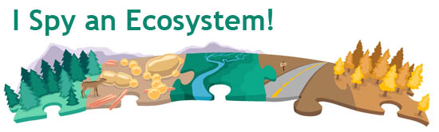
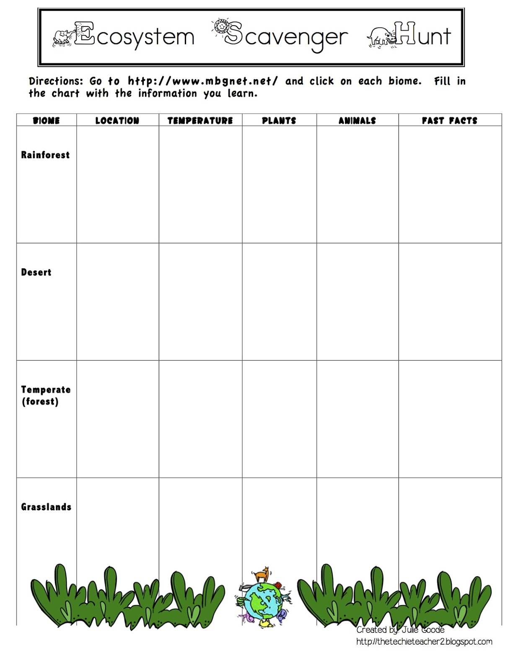
Group Names:

Now that we are all familiar with what ecosystems look like and all of the components that keep them going, each group has been assigned one of the four ecosystems to focus on. For part two of this assignment, using the classroom workshop materials (poster boards, markers, construction paper, etc.) your group will create a CER hypothesis addressing the following question (specific to your ecosystem):

- For the rainforest group- What will happen if a new species of tiger is introduced to the ecosystem you’ve been studying?

- For the desert group- What will happen if half of the plants originally found in your ecosystem are removed?

- For the temperate forest group- If the black bear species was removed from your ecosystem, what effect would it have on the other species?
4. For the grasslands group- If the number of lions in your ecosystem doubled, what effect would this have on your ecosystem and its other species?

Explore- Ecosystem Scenario CER
“If the number of lions in your ecosystem doubled, what effect would this have on your ecosystem and its other species?”

Claim- (Write a sentence stating what will happen to other species if the lion species is doubled.)

Evidence- (Provide information about the grasslands food chain to help explain your answer and back up your reasoning.)

Reasoning- (Explain how your evidence supports your claim. Describe the relationships between the lions and other species.)

ANSWER KEY- Ecosystem Scenario CER
“If the number of lions in your ecosystem doubled, what effect would this have on your ecosystem and its other species?”

Claim- (Write a sentence stating what will happen to other species if the lion species is doubled.)
The species of giraffes, zebras, and elephants will decrease if the lion species doubles.

Evidence- (Provide information about the grasslands food chain to help explain your answer and back up your reasoning.)
In the grassland ecosystem, the lion is the highest predator in the food chain, and primarily preys on giraffes, zebras and elephants for food. If the lions are doubled, that means twice the amount of giraffes, zebras and elephants will be killed for food.

Reasoning- (Explain how your evidence supports your claim. Describe the relationships between the lions and other species.)
Giraffes, zebras and elephants are a lion’s biggest prey. When the amount of their predator is doubled, the amount of them being killed for food will also double, which will lead to their populations decreasing by about one half.

Explain- Ecosystems & Their Parts
Ecosystems & Food chains
Key terms:
Ecosystem: the complex of a community of organisms and its environment functioning as an ecological unit
Food chain: an arrangement of the organisms of an ecological community according to the order of predation in which each uses the next usually lower member as a food source
Predator: any organism that exists by preying upon other organisms
Prey: an animal that is hunted and killed by another for food.
Effect: power to bring about a result
Species: a class of individuals having common attributes and designated by a common name
Hypothesis: something not proved but assumed to be true for purposes of argument or further study or investigation
Ecosystems vs. food chains

Ecosystems
- Living parts of the environment
- Interrelated populations that interact with one-another
- Non-living parts of the environments
Food chain
- Producers
- Consumers
- Network of energy
- Sequence of food sources

Food chain of marine animals
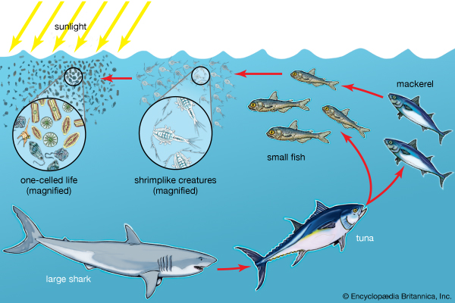
This food chain shows the chain of energy and dominance that flows through this ecosystem of marine life. As you can see in this picture, the large shark is shown to be this ecosystem’s biggest predator. Without the large shark around, the number of tuna in this ecosystem would flourish.

Use this model as an example to create a food chain of you and your food choices. Place this food chain in your notebook, and describe the changes that would occur if you remove one of these foods from your own food chain.

Elaborate- Creating Your Ecosystem
Removing/Adding to and from Ecosystems
For our next lesson on ecosystems, we will be elaborating on our hypotheses that we made during the last activity using a hands-on building activity. For the next week, we will be building our ecosystems of choice in class, according to our graphic organizer information and our food chains, including the new removal or addition of a species given at the end of the last class. Using this information, each group will build their ecosystem, using classroom workshop materials such as boxes, paper, glue, markers, and toys, which will help us see how our ecosystems will change based on the new additions and removals. After we build our original and affected ecosystems and share our information and ideas with the class, complete the given bar graphs in your notebook to chart the ecosystem’s changes before and after it was affected. There will be a short refection writing assignment for each group that will test if our hypotheses were correct or not. Included are pictures of some sample ecosystems you could take ideas from. Be creative and be curious- ecosystems change around us all the time, whether we notice or not!

Some Examples:

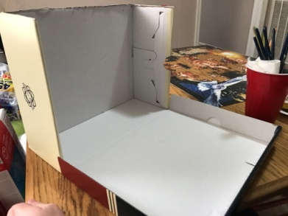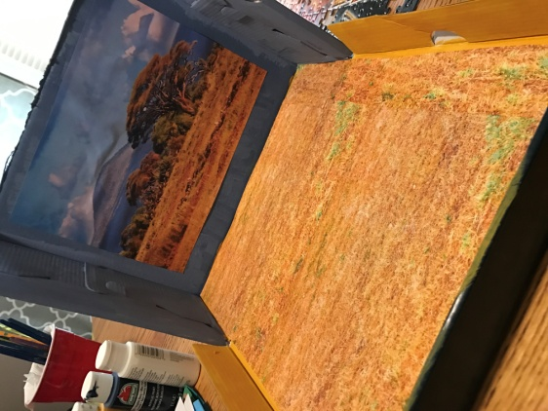
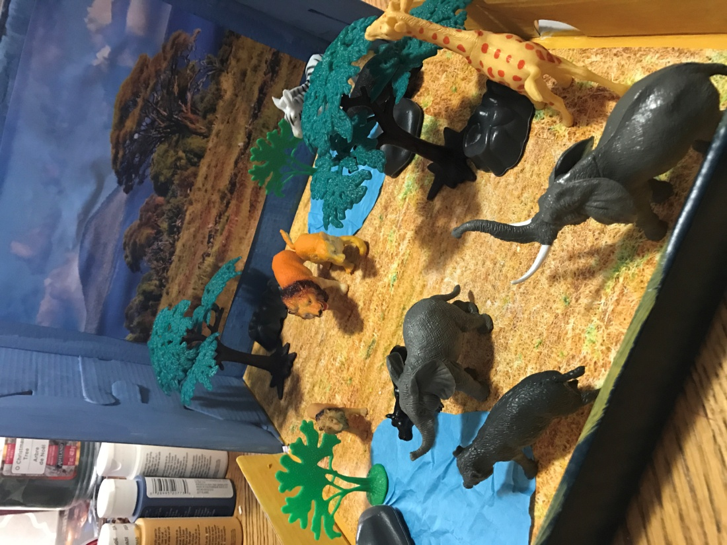

Now that we have made our ecosystems, acted out and recorded the changes, and elaborated on our ideas and thoughts about our affected ecosystems, as a group, write a reflective response to the following question and then turn it in to me to check for understanding:
Do you still agree with your original CER hypothesis? Why or why not? Explain one way you could help regulate your ecosystem after the latest changes occurred to it.

Analyzing our Results

_____________________________________________________________________________________________________________________________________________________________________________________________________________________________________________________________________________________________________________________________________________________________________________________________________________________________________________________________________________________________________________________________________________

Elaborate- Ecosystem Project CER
“When the number of lions in your ecosystem doubled, what effect did this have on your ecosystem and its other species?”

Claim- (Write a sentence stating the changes that occurred in your ecosystem.)

Evidence- (Provide evidence from your charts and other documents used in your project to support your claim. Describe what caused these changes that occurred.)

Reasoning- (Explain how your evidence supports your claim. Describe how the lions numbers affect other species in the ecosystem.)

ANSWER KEY- Ecosystem Project CER
“When the number of lions in your ecosystem doubled, what effect did this have on your ecosystem and its other species?”

Claim- (Write a sentence stating the changes that occurred in your ecosystem.)
When the lion population increased by two times, the amount of giraffes, zebras and elephants all decreased greatly. Also, the amount of trees and grass increased.

Evidence- (Provide evidence from your charts and other documents used in your project to support your claim. Describe what caused these changes that occurred.)
After the ecosystem was affected, the population of lions doubled, the populations of the giraffes, zebras, elephants all decreased by half. The amount of trees increased, because there were less animals eating it.

Reasoning- (Explain how your evidence supports your claim. Describe how the lions’ numbers affect other species in the ecosystem.)
Since ecosystems involve many organisms that interact with one another, when one species’ population changes, others’ will too. When the ultimate predator’s population increased by two times its original amount, the preys’ populations decreased from being preyed on for food by two times the amount of predator as they were used to.

Evaluate- Quiz
Summative Assessment for Ecosystem Lesson
- What are two key components in an ecosystem?

____________________________________________________________________
- Which of the following is an extinct species?

- Orangutan
- Asian elephant
- Blue whale
- Mammoth

- True or false: Introducing a new species of sharks would cause the number of tuna fish to decrease?

____________________________________________________________________
4) In a desert food chain, place these species into order from the bottom (prey) to the top (Predator)- snake, fox, and mouse.

____________________________________________________________________

5) Describe the effect that removing a regular species from an ecosystem can have on the other species in the ecosystem?

____________________________________________________________________
____________________________________________________________________

Quiz Answers
Answer Key

- (any 2) Organisms, unit, community, interrelated species, populations, non-living, relationships

2) D) Mammoth

3) True

4) Mouse, snake, fox

5) Shows a basic understanding and explanation of the effect a lost species can cause on an ecosystem

Big Ah-Ha Thesis

The purpose of this unit was to understand the effects of introducing a species into or removing a species from an ecosystem. We completed thinking maps, an ecosystem hunt, and created our own ecosystems to gather as lines of evidence.

We learned about ecosystems as a whole to understand what would happen if our own ecosystems changed. We also researched the different types of ecosystems including their roles, components, and species (predators and prey). Lastly, we created our own ecosystems, caused changes to them, and charted the results from the species added to our ecosystem.

Each of the learning activities was a line of evidence. These activities helped us to see that ecosystems act as a unit and if one species is changed in an ecosystem, it will harm/affect others as well.

Self- Reflection Paragraph

Before this unit, I didn’t realize how different ecosystems can be or how important all the different roles are in an ecosystem. I liked creating our own ecosystems the best because it showed me how much one species can affect the others.

