Heredity: Inheritance and Variation of Traits
Heredity: Inheritance and Variation of Traits

Overarching Question: What evidence shows us that traits are inherited from parents and that there are variations of groups of similar organisms?

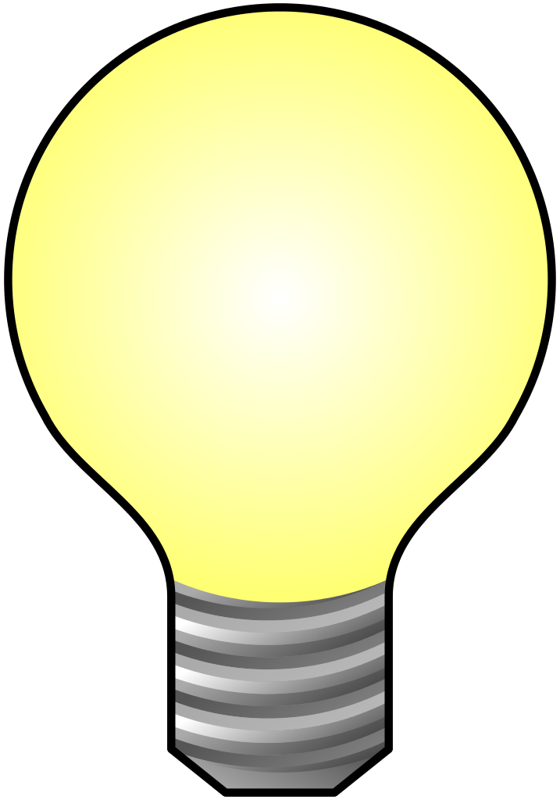
How traits inherited from parents?
How can data prove that variations of traits exist in groups of similar organisms?
What evidence proves that plants and animals have inherited traits from parents?
How traits inherited from parents?
How can data prove that variations of traits exist in groups of similar organisms?
What evidence proves that plants and animals have inherited traits from parents?

Overarching Question: What evidence shows us that traits are inherited from parents and that there are variations of groups of similar organisms?
Line of Evidence – Plant Growth Observation
We watched the plants for one month and observed and recorded the changes our plants made each week. We observed till the plants had bloomed and we could see the variations of flowers produced.

Line of Evidence – A Recipe for Traits
DNA can be created and decoded for observation of how variations in DNA lead to the inheritance of different traits.

Line of Evidence – M&M Genetics
Punnett Squares are used to determine what offspring would be possible from such a crosses of the different genes that each mate has to offer.

Big Aha Thesis Statement
Plants and animals have traits inherited from parents and variation of these traits exists in a group of similar organisms because no two organisms has the exact copy of DNA.

Line of Evidence – Plant Growth Observation
We watched the plants for one month and observed and recorded the changes our plants made each week. We observed till the plants had bloomed and we could see the variations of flowers produced.

Line of Evidence – A Recipe for Traits
DNA can be created and decoded for observation of how variations in DNA lead to the inheritance of different traits.

Line of Evidence – M&M Genetics
Punnett Squares are used to determine what offspring would be possible from such a crosses of the different genes that each mate has to offer.

Big Aha Thesis Statement
The moon goes through a repeating pattern of phases that takes about 28 days. Each phase has a specific name. The phases are caused by the positions of the Earth, moon, and sun.

Engage - Plant Growth Observation
How My Seed Grows Observation Chart
Locate your flower pot in the classroom window sill. Record the date and time in the blank balow each flower pot in which you are observing. Sketch with a pencil a picture of what your plant is looking like at the time and date in which you are observing.

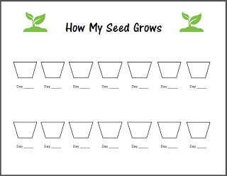

Let's Celebrate Spring! SEEDS. (n.d.). Retrieved April 25, 2017, from http://www.livingandlearningathome.com/2013/03/lets-celebrate-spring-seeds.html

Engage - Plant Growth Observation
How My Seed Grows Observation Chart
Locate your flower pot in the classroom window sill. Record the date and time in the blank balow each flower pot in which you are observing. Sketch with a pencil a picture of what your plant is looking like at the time and date in which you are observing.

Let's Celebrate Spring! SEEDS. (n.d.). Retrieved April 25, 2017, from http://www.livingandlearningathome.com/2013/03/lets-celebrate-spring-seeds.html

Explore – A Recipe for Traits
A Recipe for Traits. (2008). Retrieved March 21, 2017, from http://learn.genetics.utah.edu/content/basics/activities/pdfs/A%20Recipe%20for%20Traits_Public.pdf
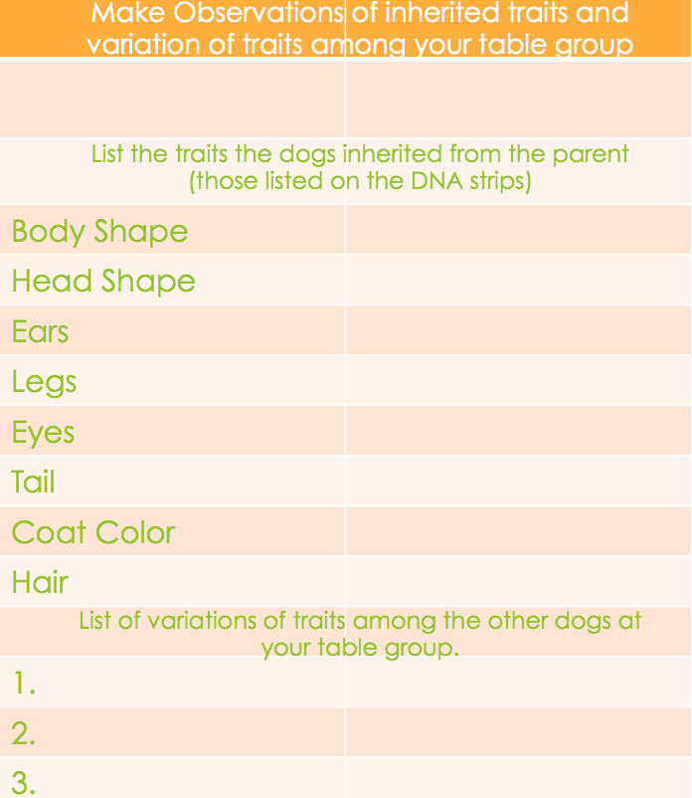

Explore – A Recipe for Traits
A Recipe for Traits. (2008). Retrieved March 21, 2017, from http://learn.genetics.utah.edu/content/basics/activities/pdfs/A%20Recipe%20for%20Traits_Public.pdf

A Recipe For Traits CER and ANSWER KEY
Claim (Write a sentence stating the linkage between DNA and traits.)
Variations in DNA lead to the inheritance of different traits
Evidence (Provide a sketch and description of your partner’s dog that they created to support your claim. Describe the difference between your dogs DNA inherited and your classmates dogs DNA that you observed.)
My Partner’s Dog My Dog 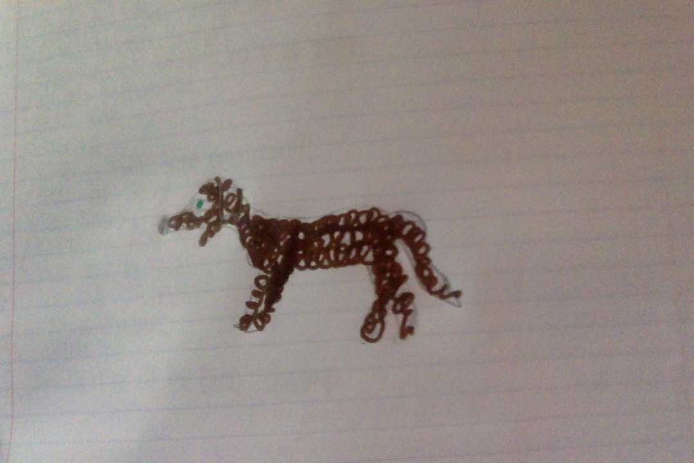 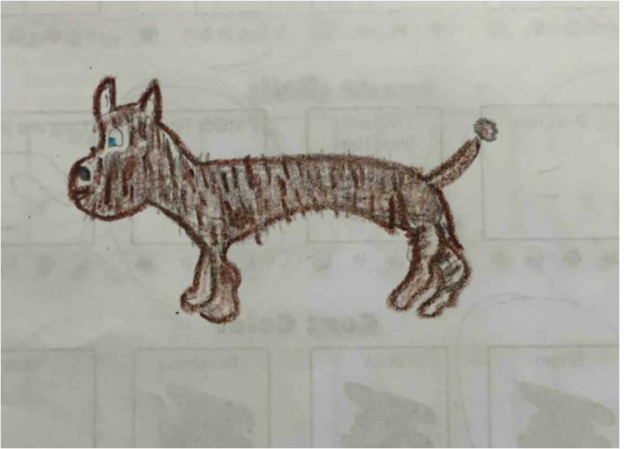
The difference between my dos DNA and my partner’s dogs DNA is my dog has a large, thin, long, tapered body shape and my partners has a large, semi-muscular, straight body shape. My dog has a droopy head shape and my partner’s dog has a long, thin head shape. My dog has small, pointy ears whereas my partners has big droopy ones. My dog has stocky, muscular legs and my partners has long, thin ones. My dog has blue eyes and brown, straight, short hair and my partner’s dog has green eyes and brown, curly, short hair. Finally in compassion between the two dogs, mine has a pompon tipped tail and my partner’s dog’s tail is long with short brown hair.
Reasoning (Explain why there is variations of traits among animals and how those variations impact their life styles.)
There are variations of traits in a species that provides a survival advantage for some individuals in a given environment.
A Recipe For Traits CER and ANSWER KEY
Claim (Write a sentence stating the linkage between DNA and traits.)
Variations in DNA lead to the inheritance of different traits
Evidence (Provide a sketch and description of your partner’s dog that they created to support your claim. Describe the difference between your dogs DNA inherited and your classmates dogs DNA that you observed.)
My Partner’s Dog My Dog
The difference between my dos DNA and my partner’s dogs DNA is my dog has a large, thin, long, tapered body shape and my partners has a large, semi-muscular, straight body shape. My dog has a droopy head shape and my partner’s dog has a long, thin head shape. My dog has small, pointy ears whereas my partners has big droopy ones. My dog has stocky, muscular legs and my partners has long, thin ones. My dog has blue eyes and brown, straight, short hair and my partner’s dog has green eyes and brown, curly, short hair. Finally in compassion between the two dogs, mine has a pompon tipped tail and my partner’s dog’s tail is long with short brown hair.
Reasoning (Explain why there is variations of traits among animals and how those variations impact their life styles.)
There are variations of traits in a species that provides a survival advantage for some individuals in a given environment.
Explain - Heredity: Inheritance and Variation of Traits
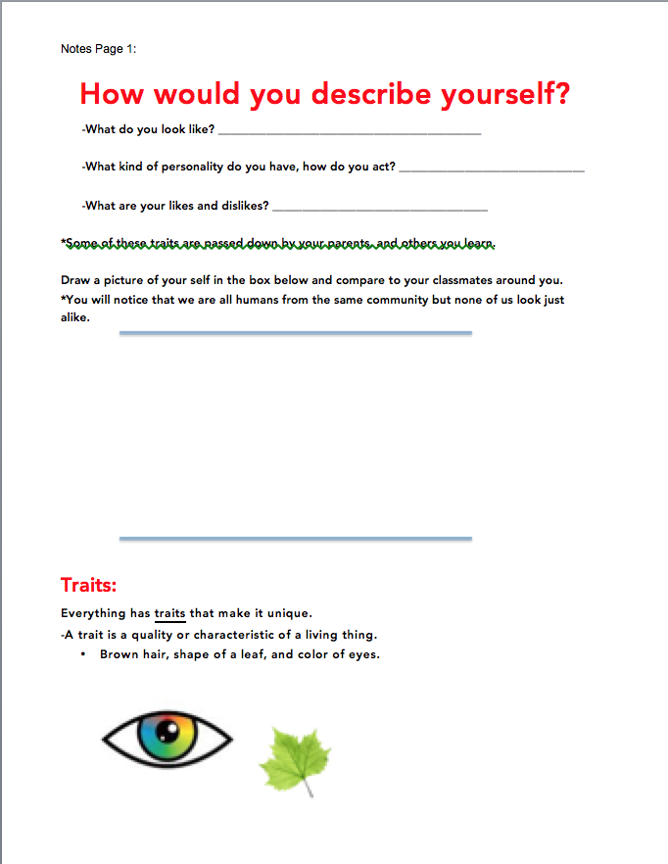

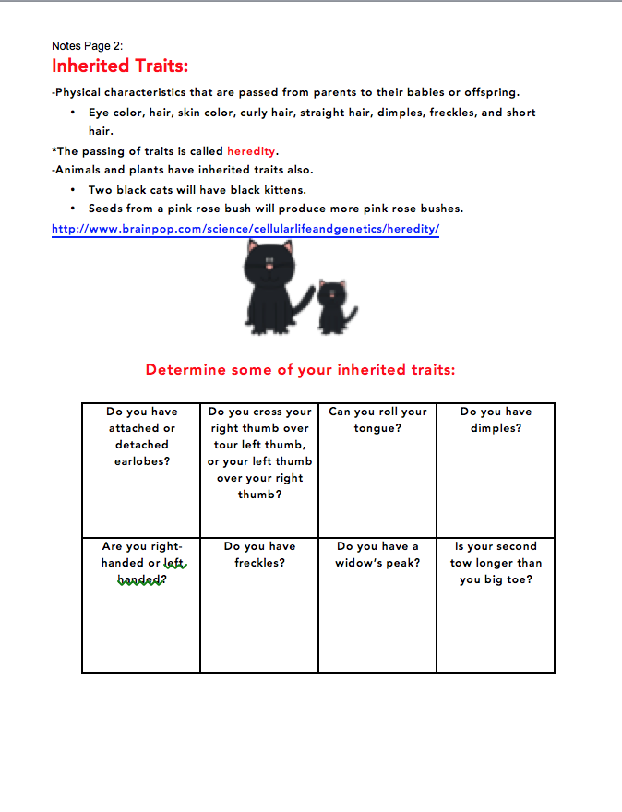

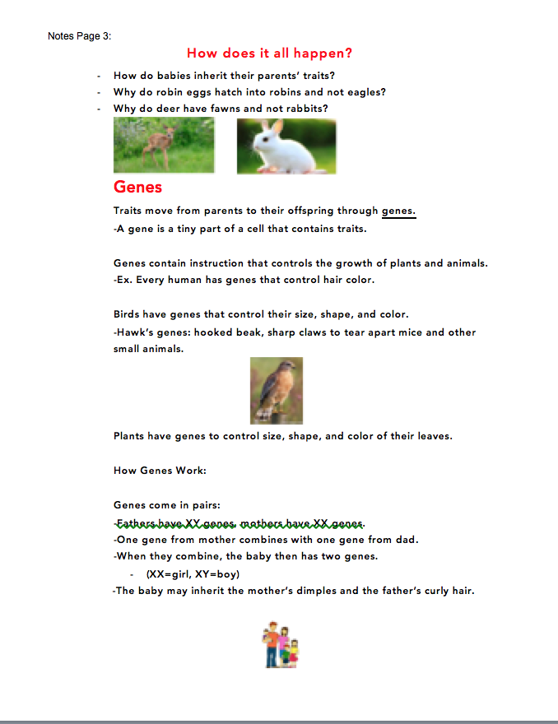

Explain - Heredity: Inheritance and Variation of Traits

Assessment Questions and ANSWER KEY
- Which of the following have you inherited completely from your parents? Choose the best answer.
- The shape of your blood cells
- Your intelligence
- Your personality
- Your weight

- What is heredity?
- The passing of traditions from parents to their children
- A type of asexual reproduction
- The passing of traits from parents to off spring
- Another term for sexual reproduction

- True or False: You inherit traits from your siblings.
4-9. Match the word with the definition.
- Recessive Trait d. Unique
- Genetics e. Dominant Trait
- Inherited Traits f. Gene

- ___d__ One of a kind
- __ c__ Personal characteristics that are passed to offspring
from parents-dimples, hitchhikers thumb, eye color
- ___b__ The study of heredity
- ___e__ A trait that is more common
- ___a__ A trait that is rare
- ___f__ A set of instructions for an inherited trait

10. Animals and Plants have genes that control
- Size
- Shape
- Color
- All the above
Assessment Questions and ANSWER KEY
- Which of the following have you inherited completely from your parents? Choose the best answer.
- The shape of your blood cells
- Your intelligence
- Your personality
- Your weight

- What is heredity?
- The passing of traditions from parents to their children
- A type of asexual reproduction
- The passing of traits from parents to off spring
- Another term for sexual reproduction

- True or False: You inherit traits from your siblings.
4-9. Match the word with the definition.
- Recessive Trait d. Unique
- Genetics e. Dominant Trait
- Inherited Traits f. Gene

- ___d__ One of a kind
- __ c__ Personal characteristics that are passed to offspring
from parents-dimples, hitchhikers thumb, eye color
- ___b__ The study of heredity
- ___e__ A trait that is more common
- ___a__ A trait that is rare
- ___f__ A set of instructions for an inherited trait

10. Animals and Plants have genes that control
- Size
- Shape
- Color
- All the above
Elaborate – Easter Egg Genetics
Easter Egg Genetics. (n.d.). Retrieved March 21, 2017, from http://www.accessexcellence.org/AE/ATG/data/released/0256-AnneBuchanan/index.html
*Fill in according to the color and type of M&M’s that were in your Easter Egg.
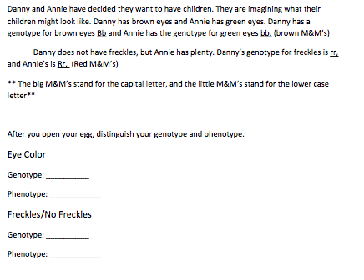

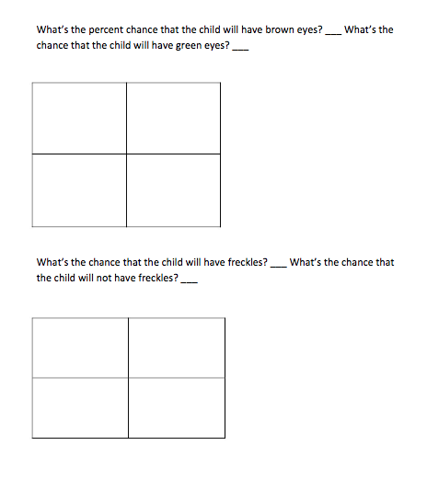
Elaborate – Easter Egg Genetics
Easter Egg Genetics. (n.d.). Retrieved March 21, 2017, from http://www.accessexcellence.org/AE/ATG/data/released/0256-AnneBuchanan/index.html
*Fill in according to the color and type of M&M’s that were in your Easter Egg.

Easter Egg Genetics CER
Claim (Write a sentence stating what a Punnett square determines.) Punnett Squares are to determine what offspring would be possible from such a cross.
Evidence (Provide evidence from the lab to support your claim. Describe how the candies inside link to the results of the Punnett Square.)
Example of what a students Punnett square might look like
R R
r
Rr | Rr
Rr | Rr

r

* The candies inside my egg match the results of their Punnett Square therefore my calculations are correct.
Reasoning (Explain how your evidence supports your claim. Describe how Danny and Annie’s offspring would look according to the traits of your egg.) The Punnett Square allowed me to calculate the percentage of possibility that the offspring of Danny and Annie would have brown eyes and freckles or not. According to my Easter egg traits their offspring has a 50% chance of having both brown eyes and freckles or not.
Easter Egg Genetics CER
Claim (Write a sentence stating what a Punnett square determines.) Punnett Squares are to determine what offspring would be possible from such a cross.
Evidence (Provide evidence from the lab to support your claim. Describe how the candies inside link to the results of the Punnett Square.)
Example of what a students Punnett square might look like
R R
r
Rr | Rr
Rr | Rr

r

* The candies inside my egg match the results of their Punnett Square therefore my calculations are correct.
Reasoning (Explain how your evidence supports your claim. Describe how Danny and Annie’s offspring would look according to the traits of your egg.) The Punnett Square allowed me to calculate the percentage of possibility that the offspring of Danny and Annie would have brown eyes and freckles or not. According to my Easter egg traits their offspring has a 50% chance of having both brown eyes and freckles or not.

Vocabulary Word  Unique | (Definition)  One of a kind
Inherited Traits | Personal characteristics that are passed to offspring from parents-dimples, hitchhikers thumb, eye color
Genetics | The study of heredity
Dominant Trait | A trait that is more common
Gene | A set of instructions for an inherited trait

Big Ah-Ha Thesis
The purpose of this unit was to provide evidence and analyze data that plants and animals have traits inherited from parents and that variations of these traits exist in a group of similar organisms.
We watched our plants for one month and observed the changes in the ways they looked as they grew then bloomed. Our seeds all started out looking the same in the beginning, but in the end they each bloomed into a different blossom. We observed how the seeds started with look the same but once the individual flowers bloomed we observed the variation of flowers we had in our class.
We created and decoded a “DNA recipe” for man’s best friend to observe how variations in DNA lead to the inheritance of different traits. Strips of paper (representing DNA) were randomly selected and used to assemble a DNA molecule. Participants read the DNA recipe to create a drawing of their pet and compare it with others in the group to note similarities and differences.
During Easter egg genetics we observed that Punnett squares are to determine what offspring would be possible from such a cross. Punnett Squares allow us to calculate the percentage of possibility that an offspring many have or not.
Each of our learning activities was a line of evidence. They helped us explain and observe that variations of traits are inherited from parents and that variation of these traits exists in a group of similar organisms.

Big Ah-Ha Thesis
The purpose of this unit was to provide evidence and analyze data that plants and animals have traits inherited from parents and that variations of these traits exist in a group of similar organisms.
We watched our plants for one month and observed the changes in the ways they looked as they grew then bloomed. Our seeds all started out looking the same in the beginning, but in the end they each bloomed into a different blossom. We observed how the seeds started with look the same but once the individual flowers bloomed we observed the variation of flowers we had in our class.
We created and decoded a “DNA recipe” for man’s best friend to observe how variations in DNA lead to the inheritance of different traits. Strips of paper (representing DNA) were randomly selected and used to assemble a DNA molecule. Participants read the DNA recipe to create a drawing of their pet and compare it with others in the group to note similarities and differences.
During Easter egg genetics we observed that Punnett squares are to determine what offspring would be possible from such a cross. Punnett Squares allow us to calculate the percentage of possibility that an offspring many have or not.
Each of our learning activities was a line of evidence. They helped us explain and observe that variations of traits are inherited from parents and that variation of these traits exists in a group of similar organisms.

