Heredity: Inheritance and Variation of Traits

Heredity: Inheritance and Variation of Traits

Overarching Question: What is the difference between inherited characteristics and those characteristics that result from a direct interaction with the environment?

What is an inherited characteristic?
What is a learned behavior?
What are examples of characteristics of living organisms that are influenced by both?

What is an inherited characteristic?
What is a learned behavior?
What are examples of characteristics of living organisms that are influenced by both?
Are interactive notebooks effective?
How are interactive notebooks organized?
How are interactive notebooks assessed?

Overarching Question: What is the difference between inherited characteristics and those characteristics that result from a direct interaction with the environment?

Line of Evidence – Flash Card Warm-Up
We made notecards, one with “Inherited Trait” and one with “Learned behavior”. Each with a definition of the word, and example of the word. Then a drawing of a personal example. We learned what these words meant by using personal examples.
Line of Evidence – Flash Card Warm-Up
We made notecards, one with “Inherited Trait” and one with “Learned behavior”. Each with a definition of the word, and example of the word. Then a drawing of a personal example. We learned what these words meant by using personal examples.

Line of Evidence – Narf Species Game
Inherited traits are a part of your DNA and cannot be changed. Learned behaviors are skills learned after birth. Both work together for survival.

Line of Evidence – Informational Text/Notes
Genes are the characteristics in cells that determine what characteristics will be passed from parents to children. These are inherited traits. Organisms have both inherited traits and acquired traits.

Line of Evidence – Class Data Chart
Putting outcomes into a class data chart shows how many students survived their situations based on their inherited traits and learned behaviors.

Big Aha Thesis Statement
Inherited traits are physical traits that are passed down from parents to offspring, they are a part of your DNA and cannot be changed. Learned behaviors must be directly taught or learned from experience. Both used for survival.
Line of Evidence – Narf Species Game
Inherited traits are a part of your DNA and cannot be changed. Learned behaviors are skills learned after birth. Both work together for survival.

Line of Evidence – Informational Text/Notes
Genes are the characteristics in cells that determine what characteristics will be passed from parents to children. These are inherited traits. Organisms have both inherited traits and acquired traits.

Line of Evidence – Class Data Chart
Putting outcomes into a class data chart shows how many students survived their situations based on their inherited traits and learned behaviors.

Big Aha Thesis Statement
Inherited traits are physical traits that are passed down from parents to offspring, they are a part of your DNA and cannot be changed. Learned behaviors must be directly taught or learned from experience. Both used for survival.

Engage - Flash Card Warm-Up
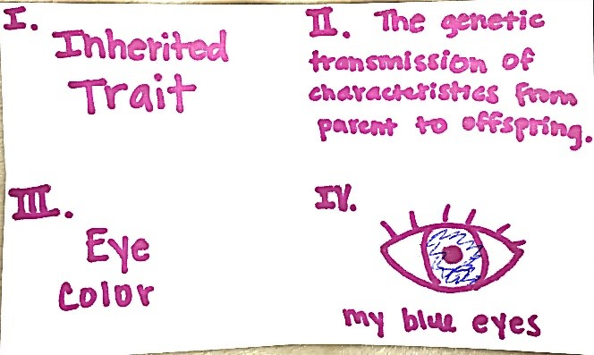

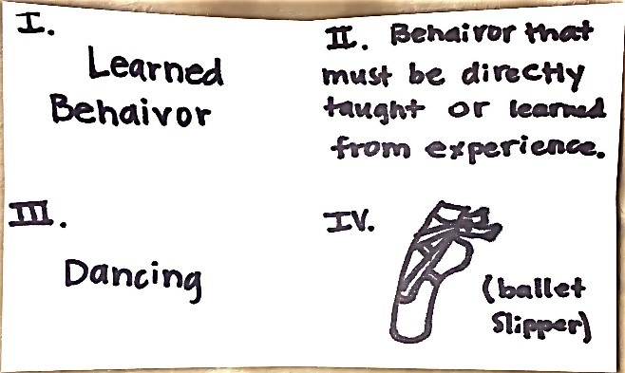
Students will create their own flash cards by folding their notecard to make 4 squares. Square 1 put word, square 2 put definiton, square 3 put an example, square 4 draw a personal example.

5th Grade Adaptation and Behavior Unit. (n.d.). Retrieved April 24, 2017, from https://learning-in-action.williams.edu/opportunities/elementary-outreach/science-lessons/5th-grade-adaptation-and-behavior-unit/

Engage – Flash Card Warm-Up

Students will create their own flash cards by folding their notecard to make 4 squares. Square 1 put word, square 2 put definiton, square 3 put an example, square 4 draw a personal example.

5th Grade Adaptation and Behavior Unit. (n.d.). Retrieved April 24, 2017, from https://learning-in-action.williams.edu/opportunities/elementary-outreach/science-lessons/5th-grade-adaptation-and-behavior-unit/
Explore – Narf Species Game
Learned Traits vs. Inherited Traits. (n.d.). Retrieved March 21, 2017, from http://www.uen.org/Lessonplan/preview.cgi?LPid=33034

Explore – Narf Species Game
Learned Traits vs. Inherited Traits. (n.d.). Retrieved March 21, 2017, from http://www.uen.org/Lessonplan/preview.cgi?LPid=33034

NARF SPECIES GAME
Background information: You are all a member of a species known as Narfus cillius, commonly known as the Narfs. Narfs are very intelligent creatures with many amazing abilities. They are about 3 feet tall. They come in a variety of colors, but the two most common varieties are blue and green. They live in rainforest environments. Remarkably, they have the ability to learn skills very much like humans do. It is not uncommon to see them painting or playing basketball. Narfs are typically gentle creatures, but are sometimes fierce when challenged by a predator. Narfs are slow creatures, and they do not migrate unless forced out by unforeseen circumstances. They typically stay in the lower branches of trees. Narfs are omnivorous and will eat nearly anything. They have teeth very similar to human teeth. They prefer fruits from the trees, but can also eat small animals. Small animals are sometimes difficult for them to eat if their teeth are not extremely sharp.
Rules of the game: You will draw four inherited traits. These are traits that are part of your DNA and cannot be changed. Once they are drawn, there is nothing you can do about it. For each round, you may also draw one learned behavior. Perhaps this newly acquired skill will allow for survival, perhaps not. A situation will be read to you. Based on the situation, you will have to determine whether you will survive or not.
Here are the words that will be on the “Inherited Trait” cards:
Blue Fur Long legs
Green Fur Short legs
Extremely sharp teeth Long arms (more than 3-5 ft)
Human-like teeth Short arms (3 feet or less)
Sharp claws Webbed toes
No claws Not webbed toes
Thick skin Large lung capacity (can hold their breath for more than 1 minute)
Thin skin Small lung capacity (can hold their breath for less than 1 minute)
Blue eyes Able to digest meat
Brown eyes Unable to digest meat

Here are the words that will be on the “Learned Behavior” cards:
Playing Piano Gardening Swimming
Playing the ukulele Archery Painting
Sewing Fencing (sword fighting) Long distance running
Weight lifting Playing basketball Singing
Campfire Cooking Woodworking Parkour
Drawing Ride a unicycle Juggling
Ballet Dancing Good at Math Fast reader
Playing guitar Knitting Nunchuck skills

After students have drawn their 4 inherited trait cards, the game will begin. Before each situation is read, students will draw 1 learned behavior card. The situation will then be read. The students will fill this chart out throughout the activity:
Inherited traits | Learned behavior
 | Situation 1:
 | Situation 2:
 | Situation 3:
 | Situation 4:

We will stop after each situation so the student can fill out the chart above and also fill out this chart as well:

Situation 1:
Would your inherited traits help you survive? (yes or no) | Why?
Would your learned behavior help you survive?  (yes or no) | Why?
Is it likely that you would survive this situation?______________________________________
They will be given 4 of these total, 1 for each situation. After each situation, students will quietly fill out their charts without sharing what happened with their Narfs with the rest of the group yet. After everyone is finished, then we will share! After that, we will move on to the next situation.
Here are the situations (read by the teacher):
Situation 1:
All is well in the lush green rainforest. All narfs are enjoying a nice climate and abundant food sources. All of a sudden, disaster strikes! A giant narf eating monster attacks! The monster is scientifically knows as Killus narfus and commonly known as the sharp tooth. The sharp tooth is far superior to other animals physically. It is extremely fast and very strong. It can jump high enough to reach the lower branches of trees in a single leap. The sharp tooth, as its name suggests, has very large sharp teaching for its carnivorous eating habits. The teeth look similar to that of a lion. The sharp tooth does, however, have poor eyesight. It can see mostly differences in color, but cannot make out shapes very well. It has an average sense of smell, but impeccable hearing. The sharp tooth does have one major weakness, music. Any music will put the sharp tooth immediately to sleep for long periods of time.

Situation 2:
Unfortunately, things are not going well for the entire narf species. Human poachers have been killing narfs for their incredibly soft fur. Many people enjoy narf fur coats, or even narf skin rugs. The green narfs have been particularly targeted. The green narfs have much softer fur. The poachers typically hunt with bow and arrow because guns will draw attention to their illegal poaching practices. Some narfs have extremely thick skin, which is difficult to penetrate with an arrow.
Situation 3:
Deforestation practices have been destroying the trees where narfs live and the fruits that they commonly eat. Some narfs are able to change food sources, but most narfs are not fast enough to catch live animals nor do they have sharp enough teeth. Some narfs have learned to garden and grow food which has allowed for the survival of some, but not the ones that do not know how to grow food.

Situation 4:
Many trees in the area where the narfs live have been destroyed. This has caused heavy flooding due to high levels of rainfall. Before, the rainfall would have been regulated by the dense trees and vegetation. This has caused pools of water to form in the area where the narfs live. Some of these pools can be quite deep, 6 feet or more. There are some food sources available at the bottom of these pools, so narfs that can dive or swim can easily get this food.

Narf Species Game CER
Claim (Write a sentence stating the difference between inherited traits vs. learned behaviors.)
Inherited traits are a part of your DNA and cannot be changed. Learned behaviors develop after birth and can be changed.
Evidence (Provide examples of inherited traits and learned behaviors to support your claim. Describe how to tell the difference between the two.)
Inherited traits, such as your eye color, are a part of your genetics and DNA from birth. They are passed down from parent to offspring, and therefore cannot be changed. Learned Behaviors are developed after birth and can be affected or changed. For example: Playing the violin is a learned behavior.
Reasoning (Explain how your evidence supports your claim.)
Playing the violin is a learned behavior because I did not inherit that from my parents. I worked hard to be able to play the violin, but if I stop playing I can forget how to play. My blue eyes are an inherited characteristic that I received from both of my parents. I cannot change my eye color no matter what.
Narf Species Game CER
Claim (Write a sentence stating the difference between inherited traits vs. learned behaviors.)
Inherited traits are a part of your DNA and cannot be changed. Learned behaviors develop after birth and can be changed.
Evidence (Provide examples of inherited traits and learned behaviors to support your claim. Describe how to tell the difference between the two.)
Inherited traits, such as your eye color, are a part of your genetics and DNA from birth. They are passed down from parent to offspring, and therefore cannot be changed. Learned Behaviors are developed after birth and can be affected or changed. For example: Playing the violin is a learned behavior.
Reasoning (Explain how your evidence supports your claim.)
Playing the violin is a learned behavior because I did not inherit that from my parents. I worked hard to be able to play the violin, but if I stop playing I can forget how to play. My blue eyes are an inherited characteristic that I received from both of my parents. I cannot change my eye color no matter what.

Explain - Informational Text/Notes
Heredity
Inherited v. Acquired Traits
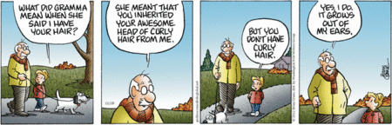

- What are genes? The characteristics in cells that determine what characteristics will be passed from parents to children.
- What are inherited traits? Physical characteristics that are passed down from parents to their offspring. Ex: eye color, skin color, hair type
- What are acquired traits? Developed after birth usually as a result of environmental forces. Ex: dyed hair.

Explain - Informational Text/Notes
Heredity
Inherited v. Acquired Traits

- What are genes? The characteristics in cells that determine what characteristics will be passed from parents to children.
- What are inherited traits? Physical characteristics that are passed down from parents to their offspring. Ex: eye color, skin color, hair type
- What are acquired traits? Developed after birth usually as a result of environmental forces. Ex: dyed hair.
Informational Texts Reading Questions
1. True or False: You inherit traits from your siblings.
False

2. Circle the traits that are inherited:

Blood type Intelligence Eye Color Cleft chin

Creativity Freckles Color Blindness

3. Describe one trait you inherited from your parents and one trait that you learned from your parents.
I inherited my blonde hair. I learned how to be generous.

4. Which of the following characteristics is a lion least likely to pass on to its offspring?
A. colors of its fur
B. length of its tail
C. scars on its leg
D. size of its body

5. Which inherited physical trait does this bird most likely inherit from its parents?
A. eating from bird feeders
B. flying to search for food
C. Having long tail feathers
D. Building a nest

Informational Texts Reading Questions
1. True or False: You inherit traits from your siblings.
False

2. Circle the traits that are inherited:

Blood type Intelligence Eye Color Cleft chin

Creativity Freckles Color Blindness

3. Describe one trait you inherited from your parents and one trait that you learned from your parents.
I inherited my blonde hair. I learned how to be generous.

4. Which of the following characteristics is a lion least likely to pass on to its offspring?
A. colors of its fur
B. length of its tail
C. scars on its leg
D. size of its body

5. Which inherited physical trait does this bird most likely inherit from its parents?
A. eating from bird feeders
B. flying to search for food
C. Having long tail feathers
D. Building a nest

Elaborate – Class Data Chart
Learned Traits vs. Inherited Traits. (n.d.). Retrieved March 21, 2017, from http://www.uen.org/Lessonplan/preview.cgi?LPid=33034

Elaborate – Class Data Chart
Learned Traits vs. Inherited Traits. (n.d.). Retrieved March 21, 2017, from http://www.uen.org/Lessonplan/preview.cgi?LPid=33034

Class Data Chart
 | How many students survived? List as a fraction | What percent of the class is this?
First Situation
Second Situation
Third Situation
Fourth Situation

Graph
Create a bar graph that shows what percent of students survived each of the four situations.

Round 1 Round 2 Round 3 Round 4

Class Data Chart CER
Claim (Write a sentence stating the results of the class data chart.)
The class had different percents and fractions for every situation.
Evidence (Provide evidence from the chart to support your claim.)
For the first situation the percent of students who survived was very low at 15%. For the second situation that increased, to go up to a very high 75%! On the third situation the percent dropped to 45%. On the fourth situation, the percent was 22%.
Reasoning (Explain how your evidence supports your claim. Describe why the bar graph was needed.)
The class data chart was used to compare all 4 situations. The percentage of the class who survived was noted. The bar graph is used to display the data in a more visual way. All of the percentages were very different from one another.

Class Data Chart CER
Claim (Write a sentence stating the results of the class data chart.)
The class had different percents and fractions for every situation.
Evidence (Provide evidence from the chart to support your claim.)
For the first situation the percent of students who survived was very low at 15%. For the second situation that increased, to go up to a very high 75%! On the third situation the percent dropped to 45%. On the fourth situation, the percent was 22%.
Reasoning (Explain how your evidence supports your claim. Describe why the bar graph was needed.)
The class data chart was used to compare all 4 situations. The percentage of the class who survived was noted. The bar graph is used to display the data in a more visual way. All of the percentages were very different from one another.

Evaluate: Conclusion Questions
- Were you able to change any of your inherited traits at all in the game? Why or why not?

- Were there certain traits that seemed to help you survive better then others?

- Were there certain situations that seemed easier for the class to have survived then others? If so why do you think so?

- Was it beneficial for you to be able to draw a new learned behavior for each situation?

- What is the main difference between a learned behavior and inherited traits?

Evaluate: Conclusion Questions
- Were you able to change any of your inherited traits at all in the game? Why or why not?

- Were there certain traits that seemed to help you survive better then others?

- Were there certain situations that seemed easier for the class to have survived then others? If so why do you think so?

- Was it beneficial for you to be able to draw a new learned behavior for each situation?

- What is the main difference between a learned behavior and inherited traits?

(Image/Example)  USED FOR ANY DEFINTIONS IN UNIT | (Definition)  USED FOR ANY DEFINTIONS IN UNIT
USED FOR ANY DEFINTIONS IN UNIT | USED FOR ANY DEFINTIONS IN UNIT
USED FOR ANY DEFINTIONS IN UNIT | USED FOR ANY DEFINTIONS IN UNIT
USED FOR ANY DEFINTIONS IN UNIT | USED FOR ANY DEFINTIONS IN UNIT
USED FOR ANY DEFINTIONS IN UNIT | USED FOR ANY DEFINTIONS IN UNIT

Big Ah-Ha Thesis
The purpose of this unit was to understand the difference between inherited traits and learned behaviors. We completed a definition flash card, the Narf Species Game, and the Class Data Chart to gather lines of evidence.
We made notecards, one with “Inherited Trait” and one with “Learned behavior”. Each with a definition of the word, and example of the word. Then a drawing of a personal example. We learned what these words meant by using personal examples.
Inherited traits are a part of your DNA and cannot be changed. Learned behaviors are skills learned after birth. Both work together for survival. In the Narf Species Game, we played a game as a new species. Given inherited characteristics and learned behaviors, we read situations and determined whether or not our traits helped us to survive.
Genes are the characteristics in cells that determine what characteristics will be passed from parents to children. These are inherited traits. Organisms have both inherited traits and acquired traits. We read about this. We used what we read and have learned thus far to answer questions after the text.
Each of our learning activities was a line of evidence. They helped us explain what the difference is between inherited characteristics, and those characteristics that result from a direct interaction with the environment.

Big Ah-Ha Thesis
The purpose of this unit was to understand the difference between inherited traits and learned behaviors. We completed a definition flash card, the Narf Species Game, and the Class Data Chart to gather lines of evidence.
We made notecards, one with “Inherited Trait” and one with “Learned behavior”. Each with a definition of the word, and example of the word. Then a drawing of a personal example. We learned what these words meant by using personal examples.
Inherited traits are a part of your DNA and cannot be changed. Learned behaviors are skills learned after birth. Both work together for survival. In the Narf Species Game, we played a game as a new species. Given inherited characteristics and learned behaviors, we read situations and determined whether or not our traits helped us to survive.
Genes are the characteristics in cells that determine what characteristics will be passed from parents to children. These are inherited traits. Organisms have both inherited traits and acquired traits. We read about this. We used what we read and have learned thus far to answer questions after the text.
Each of our learning activities was a line of evidence. They helped us explain what the difference is between inherited characteristics, and those characteristics that result from a direct interaction with the environment.

