Mass, Distance, & Gravity

Mass, Distance, & Gravity

Overarching Question: What is the cause and effect relationship of two factors (mass and distance) that affect gravity?
Overarching Question: What is the cause and effect relationship of two factors (mass and distance) that affect gravity?

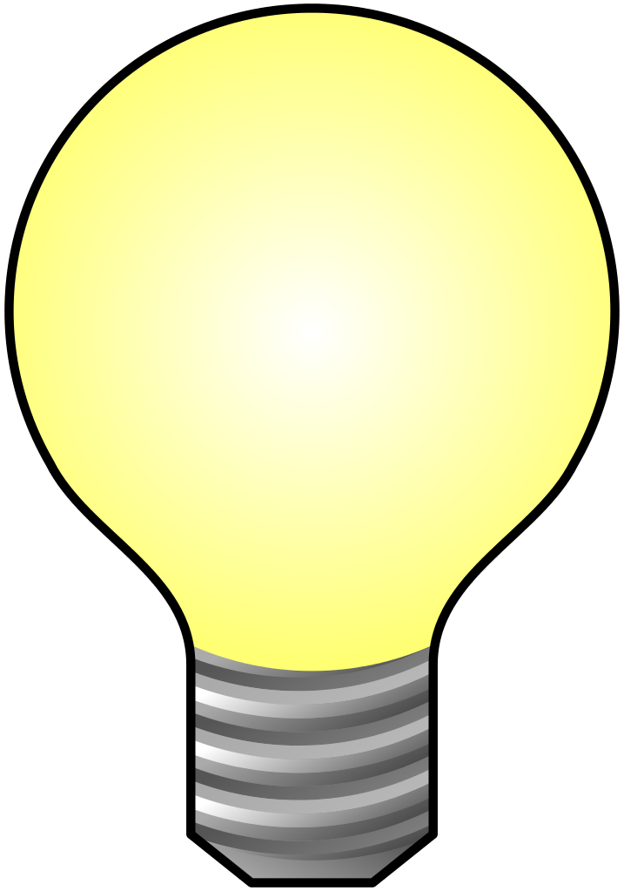
How does mass affect gravity?
How does distance affect gravity?
If an object’s weight is greater than another object’s weight, which object will land first?
How does mass affect gravity?
How does distance affect gravity?
If an object’s weight is greater than another object’s weight, which object will land first?
Are interactive notebooks effective?
How are interactive notebooks organized?
How are interactive notebooks assessed?

Line of Evidence – KWL Chart
We create a KWL Chart and fill out the first two columns, and leave the L column alone until later.

Line of Evidence – Ball Dropping Experiment
When we drop the different balls, they each land at the same time.

Line of Evidence – Mass, Distance, and Gravity
Mass is a measure of the amount of matter in an object. Distance is the measurement from the ground to the object. Gravity is a force of attraction between two objects.

Line of Evidence – Elaborate: Ball Dropping Experiment
Dropping objects on the moon has a different outcome than dropping objects on Earth.

Big Aha Thesis Statement
Mass and distance affect gravity by causing object to land on the ground at the same time when dropped at the same time and distance.

Line of Evidence – KWL Chart
We create a KWL Chart and fill out the first two columns, and leave the L column alone until later.

Line of Evidence – Ball Dropping Experiment
When we drop the different balls, they each land at the same time.

Line of Evidence – Mass, Distance, and Gravity
Mass is a measure of the amount of matter in an object. Distance is the measurement from the ground to the object. Gravity is a force of attraction between two objects.

Line of Evidence – Elaborate: Ball Dropping Experiment
Dropping objects on the moon has a different outcome than dropping objects on Earth.

Big Aha Thesis Statement
Mass and distance affect gravity by causing the objects to land on the ground at the same time when dropped at the same time and distance.

Engage - KWL Chart

What do I already Know? | What do I Want to learn? | What did I Learn?

Engage – KWL Chart
What do I already Know? | What do I Want to learn? | What did I Learn?

Explore – Ball Dropping Experiment
Trial 1: Tennis Ball vs. Ping Pong Ball | Trial 2: Ping Pong Ball vs. Golf Ball | Trial 3: Tennis Ball vs. Golf Ball

Explore – Ball Dropping Experiment
Trial 1: Tennis Ball vs. Ping Pong Ball | Trial 2: Ping Pong Ball vs. Golf Ball | Trial 3: Tennis Ball vs. Golf Ball

Ball Dropping Experiment CER
Claim (Write a sentence stating if the balls hit the ground at the same time or not.)

Evidence (Describe what happened when you dropped the tennis ball, ping pong ball, and golf ball at the same time.)

Reasoning (Explain how your evidence supports your claim. Describe why and how the objects hit the ground at the same time.)
Ball Dropping Experiment CER
Claim (Write a sentence stating if the balls hit the ground at the same time or not.)

Evidence (Describe what happened when you dropped the tennis ball, ping pong ball, and golf ball at the same time.)

Reasoning (Explain how your evidence supports your claim. Describe why and how the objects hit the ground at the same time.)

ANSWER KEY Ball Dropping Experiment CER
Claim (Write a sentence stating if the balls hit the ground at the same time or not.)
The balls must hit the ground at the same time because of gravity.

Evidence (Describe what happened when you dropped the tennis ball, ping pong ball, and golf ball at the same time.)
When I dropped the tennis ball, ping pong ball, and golf ball at the same time for each trial, the balls hit at the same time. Two objects that are subject only to the force of gravity with the same acceleration will hit the ground at the same time.

Reasoning (Explain how your evidence supports your claim. Describe why and how the objects hit the ground at the same time.)
By dropping the different balls at the same time, the balls hit the ground at the same time. I watched the balls hit the ground at an almost eye level view instead of from the person dropping the balls point of view.
ANSWER KEY Ball Dropping Experiment CER
Claim (Write a sentence stating if the balls hit the ground at the same time or not.)
The balls must hit the ground at the same time because of gravity.

Evidence (Describe what happened when you dropped the tennis ball, ping pong ball, and golf ball at the same time.)
When I dropped the tennis ball, ping pong ball, and golf ball at the same time for each trial, the balls hit at the same time. Two objects that are subject only to the force of gravity with the same acceleration will hit the ground at the same time.

Reasoning (Explain how your evidence supports your claim. Describe why and how the objects hit the ground at the same time.)
By dropping the different balls at the same time, the balls hit the ground at the same time. I watched the balls hit the ground at an almost eye level view instead of from the person dropping the balls point of view.
Explain – Mass, Distance, and Gravity
- Mass is a measure of the amount of matter in an object
- Distance is the measurement from the ground to the object
- Gravity is a force of attraction between two objects
- Gravity is affected by the size of an object and the distance between the objects.
- When the mass of an object increases the force of gravity increases as well.
- If an object’s weight is greater than the other object’s weight, then the object with the greater weight will land first.

“Science Notebook” (2013). Force and Motion [PDF document]. Retrieved from:http://www.nclack.k12.or.us/cms/lib6/OR01000992/Centricity/Domain/98/force%20and%20motion%20science%20notebook%20grade%205.pdf
Explain – Mass, Distance, and Gravity
- Mass is a measure of the amount of matter in an object
- Distance is the measurement from the ground to the object
- Gravity is a force of attraction between two objects
- Gravity is affected by the size of an object and the distance between the objects.
- When the mass of an object increases the force of gravity increases as well.
- If an object’s weight is greater than the other object’s weight, then the object with the greater weight will land first.

“Science Notebook” (2013). Force and Motion [PDF document]. Retrieved from:http://www.nclack.k12.or.us/cms/lib6/OR01000992/Centricity/Domain/98/force%20and%20motion%20science%20notebook%20grade%205.pdf

Mass, Distance, and Gravity Questions
- A force of attraction between two objects is
- Force
- Mass
- Gravity

- Gravity is affected by the _________ of the objects and the _________ between objects.
- Size, distance
- Pull, weight

- A measure of the amount of matter in an object is
- Force
- Mass
- Weight

- An object with a greater mass falls faster than an object with a smaller mass?
- True
- False

- When the distance between two objects increases, does the force of gravity increase or decrease?

Mass, Distance, and Gravity Questions
- A force of attraction between two objects is
- Force
- Mass
- Gravity

- Gravity is affected by the _______ of the objects and the _______between objects.
- Size, distance
- Pull, weight

- A measure of the amount of matter in an object is
- Force
- Mass
- Weight

- An object with a greater mass falls faster than an object with a smaller mass?
- True
- False

- When the distance between two objects increases, does the force of gravity increase or decrease?
ANSWER KEY Mass, Distance, and Gravity Questions
- A force of attraction between two objects is

Gravity
- Gravity is affected by the _______ of the objects and the _______ between objects.

Size, distance

- A measure of the amount of matter in an object is
Mass
- An object with a greater mass falls faster than an object with a smaller mass.
True
- When the distance between two objects increases, does the force of gravity increase or decrease?
The force of gravity will decrease when the distance between the two objects increases.
ANSWER KEY Informational Texts Reading Questions
- A force of attraction between two objects is

Gravity

- Gravity is affected by the _______ of the objects and the _______ between objects.

Size, distance
- A measure of the amount of matter in an object is
Mass
- An object with a greater mass falls faster than an object with a smaller mass.
True
- When the distance between two objects increases, does the force of gravity increase or decrease?
The force of gravity will decrease when the distance between the two objects increases.

Elaborate – Ball Dropping Experiment
Fill out last column on KWL Chart.
What would happen if you did this experiment on the moon?

Explore further knowledge:
Have two pieces of paper.
Wad one piece of paper into a tight ball and leave the other paper alone.
What do you believe will happen when we drop both pieces of paper at the same time?

Test your prediction.

Elaborate – Ball Dropping Experiment
Fill out last column on KWL Chart.
What would happen if you did this experiment on the moon?

Explore further knowledge:
Have two pieces of paper.
Wad one piece of paper into a tight ball and leave the other paper alone.
What do you believe will happen when we drop both pieces of paper at the same time?

Test your prediction.

Big Ah-Ha Thesis
The purpose of this unit was to understand what how mass and distance can affect gravity. We completed a KWL Chart, the Ball Dropping Experiment, and the Explore phase by dropping two pieces of papers, one being in a ball and the other left alone.
We created a KWL Chart and filled out the first two columns, and left the L column alone for now. We talked about What we already know and put what we discussed into the “What do I already Know” column. Then, we talk about what we want to learn during this activity. We wrote in the “What do I Want” to learn column what we discussed.
When we performed the Ball Dropping Experiment, we found that for each trial with the tennis ball, ping pong ball, and golf ball, each ball hit the ground at the same time. When one partner was dropping the ball, the other partner sat on the floor to be more eye level with the ground and watched each ball hit the ground and wrote down their observations in the table in Explore.
We learned that mass is a measure of the amount of matter in an object. Gravity is affected by the size of objects and the distance between objects. A measure of the amount of matter in an object is mass. An object with a greater mass falls faster than an object with a smaller mass. When the distance between two objects increases, the force of gravity decreases.
Each of our learning activities was a line of evidence. They helped us explain how mass and distance affect gravity.
Big Ah-Ha Thesis
The purpose of this unit was to understand what how mass and distance can affect gravity. We completed a KWL Chart, the Ball Dropping Experiment, and the Explore phase by dropping two pieces of papers, one being in a ball and the other left alone.
We created a KWL Chart and filled out the first two columns, and left the L column alone for now. We talked about What we already know and put what we discussed into the “What do I already Know” column. Then, we talk about what we want to learn during this activity. We wrote in the “What do I Want” to learn column what we discussed.
When we performed the Ball Dropping Experiment, we found that for each trial with the tennis ball, ping pong ball, and golf ball, each ball hit the ground at the same time. When one partner was dropping the ball, the other partner sat on the floor to be more eye level with the ground and watched each ball hit the ground and wrote down their observations in the table in Explore.
We learned that mass is a measure of the amount of matter in an object. Gravity is affected by the size of objects and the distance between objects. A measure of the amount of matter in an object is mass. An object with a greater mass falls faster than an object with a smaller mass. When the distance between two objects increases, the force of gravity decreases.
Each of our learning activities was a line of evidence. They helped us explain how mass and distance affect gravity.

