  
  
The Tennessee Department of Health and East Tennessee State University Quillen College of Medicine present  
The New Issues, Data, and Laws in the Opioid Epidemic Symposium  
Thursday, May 3, 2018  
 ETSU Quillen College of Medicine   
Stanton-Gerber Hall Large Auditorium  
Johnson City, TN

|  |  |
| --- | --- |
| **Activity Director** | Mitchell Mutter, MD, Medical Director, Special Projects, State of Tennessee Department of Health, Nashville, TN |
|  |  |
| **Target Audience** | This program is designed for all levels of healthcare providers, as well as medical and nursing students. |
|  |  |
| **Overall Conference Objectives** | As a result of participating in this activity, the attendee should be able to:   * Review changes to the Tennessee Controlled Substance Monitoring Database (CSMD) since January 1, 2016 * Discuss Pain Clinic laws and changes * List CSMD Enhancements - New rules/laws regarding pain management specialists * Analyze overdose deaths and NAS per capita * Utilize updates to Chronic Pain Guidelines * Perform supervisory roles in Pain Clinics * Identify preventative measure for potential high risk HIV/HCV areas. * Identify patients at risk for substance use disorder * Identify ways to protect their practice from potential substance abuse disorders patients or diverters |

**AGENDA & LEARNING OBJECTIVES**

|  |  |  |  |
| --- | --- | --- | --- |
| **Thursday, May 3rd** |  | | **Learning Objective(s)** As a result of participating in this activity, the attendee will be able to: |
| 5:00 PM – 6:00 PM | **Registration and dinner** |  | |
|  |  | | |
| 6:00 PM – 6:10 PM | **Welcome and Introductory Remarks**  *Mitchell Mutter, MD*  *Medical Director of Special Projects*  *Tennessee Department of Health* | | |
|  |  | | |
| 6:10 PM – 6:40 PM | **2018 Tennessee Controlled Substances Monitoring Database Program and the 2016 Prescription Safety Act**  *D. Todd Bess, PharmD*  *Director of TN CSMD Program* | | * Review the Controlled Substance Monitoring Database (CSMD). * List new laws pertaining to the CSMD. * Visualize CSMD enhancement. |
| 6:40 PM – 7:10 PM | **Chronic Pain Guidelines**  *Timothy S. Smyth, MD*  *Diplomat: ABPrevM, ABAM, ABPainM, ABA*  *Medical Director of Catalyst Health Solutions*  *Medical Director of OverMountain Recovery* | | * Review the State of Tennessee guidelines on opioid prescribing. * Discuss the concept of MEDD. |
|  |  | |  |
| 7:10 PM – 7:30 PM | **Lessons Learned 2017**  *Mitchell Mutter, MD*  *Medical Director of Special Projects*  *Tennessee Department of Health* | | * Discuss Tennessee Chronic Pain Guidelines updates, outcomes of previous efforts in the state, and be able to visualize current prescription related trends. * Demonstrate an understanding of prescription opioid misuse and abuse trends.   Identify strategies to incorporate evidence-based best practice. |
|  |  | |  |
| 7:30 PM – 7:40 PM | **Break** | |  |
|  |  | |  |
| 7:40 PM – 8:00 PM | **APN & PA Updates/Screening Brief Intervention Review/Adverse Childhood Experiences (ACE) Study Review**  *Linda Johnson, DNP, APRN, FNP-C, MSN, RN*  *APRN Consultant/Overprescribing Team*  *Tennessee Board of Nursing* | | * Identify where to find the Board of Nursing website. * Describe the two items needed on the Notice and Formulary. * Identify the rules that guide a supervising physician and know where to find them. * Discuss methods to screen patients for substance use disorders (SUD). * Describe the concept of behind adverse childhood experiences (ACE). |
|  |  | |  |
| 8:00 PM – 8:20 PM | **Law Enforcement**  *Thomas Farmer*  *Special Agent in Charge*  *TN Bureau of Investigation* | | * Describe fentanyl and its dangers. * List fentanyl analogs. * List the adverse health effects of fentanyl exposure. |
|  |  | |  |
| 8:20 PM – 8:40 PM | **Addiction**  *Michael Baron, MD, MPH, DFASAM*  *Medical Director*  *Tennessee Medical Foundation – Physician Health Program* | | * Define addiction. * Discuss the etiologies of addiction. * Identify the concepts and potencies of non-opioid analgesics. * Describe problems and consequences of the opioid crisis. * Recognize misprescribing and drug-seeking behaviors. |
|  |  | |  |
| 8:40 PM – 9:00 PM | **Question and Answer Panel** | |  |
|  |  | |  |
|  |  | |  |
|  |  | |  |
|  |  | |  |
|  |  | |  |
|  |  | |  |
|  |  | |  |

  
  
The Tennessee Department of Health and East Tennessee State University Quillen College of Medicine present  
The New Issues, Data, and Laws in the Opioid Epidemic Symposium  
Thursday, May 3, 2018  
 ETSU Quillen College of Medicine   
Stanton-Gerber Hall Large Auditorium  
Johnson City, TN

|  |  |  |
| --- | --- | --- |
| **Disclosure Information and Potential Conflicts of Interest** | East Tennessee State University’s Quillen College of Medicine, Office of Continuing Medical Education (OCME) holds the standard that its continuing medical education programs should be free of commercial bias and conflict of interest. It is the policy of the OCME that each presenter and planning committee member of any CME activity must disclose any significant financial interest/arrangement or affiliation with corporate organizations whose products or services are being discussed in a presentation. | |
|  |  | |
| **Participants with No Potential Conflicts of Interest** | Each of the following speakers have completed a disclosure form indicating that neither they nor members of their immediate family have a financial interest/arrangement or affiliation that could be perceived as a real or apparent conflict of interest related to the content or supporters involved with this activity: | |
|  |  | |
|  | |  |  | | --- | --- | | **Activity Director** | **Speakers** | | Mitchell Mutter, MD | D. Todd Bess, PharmD | |  | Tim Smyth, MD | | **Planning Committee members** | Mitchell Mutter, MD | | Mitchell Mutter, MD | Linda L. Johnson, APRN | | Tim Smyth, MD | Tommy Farmer | | Patricia Harnois-Church, MSN, RN | Michael Baron, MD, MPH, DFASAM | | Melissa Hood, BS |  | |  |  | | |
|  |  | |
| **Commercial Support Disclosure** | The mission of the OCME is to provide lifelong learning opportunities that meet the needs of faculty, community physicians, and other health professionals. In addition, the OCME is committed to excellence and dedicated to the improvement of health care in Northeast Tennessee and the surrounding Appalachian region.  It is the policy of the Office of Continuing Medical Education at Quillen College of Medicine, East Tennessee State University to disclose all commercial supporters of this educational activity.  **This activity has received no commercial support.** | |
| **Presentations** | Where the author has granted permission, presentations will be posted online and available to view or download [here](https://drive.google.com/drive/folders/1QdkY770FGyAfx1fJ_12NMeAolq_uGb8_?usp=sharing).  Not all presentations may be provided to OCME prior to the conference. All available presentations will be posted at the above web address within two weeks of the activity. | |
| **Conference Planner** | Melissa Hood, BS Educational Coordinator Office of Continuing Medical Education Quillen College of Medicine East Tennessee State University 423-439-8026 [hoodms@etsu.edu](mailto:hoodms@etsu.edu) |  |
| **Accreditation and Designation** |  | |
|  | This activity has been planned and implemented in accordance with the Essential Areas and Policies of the Accreditation Council for Continuing Medical Education (ACCME) through the joint providership of the Quillen College of Medicine, East Tennessee State University and the Tennessee Department of Health. The Quillen College of Medicine, East Tennessee State University is accredited by the ACCME to provide continuing medical education for physicians. | |
|  |  | |
|  | The Quillen College of Medicine, East Tennessee State University designates this live activity for a maximum of 3.0 *AMA PRA Category 1 Credits™*. Physicians should claim only the credit commensurate with the extent of their participation in the activity. | |
|  |  | |
|  | Up to 2.75 continuing nursing education contact hours and 2.75 credit hours for pharmacology continuing education will be offered for this conference. East Tennessee State University College of Nursing is an approved provider of continuing nursing education by the Tennessee Nurses Association, an accredited approver by the American Nurses Credentialing Center's Commission on Accreditation.  The ETSU College of Nursing implements a $15 certificate fee per conference. This fee must be paid no later than 30 days after the session. The certificate fee covers the following: cost of being a provider of nursing contact hours, supplies, and nursing education coordinator’s time to ensure accreditation compliance Questions? Contact [etsucne@etsu.edu](mailto:etsucne@etsu.edu). | |

**Remember to log in and claim your credit for attending!**

**You have 72 hours from the end of the conference to complete the credit claiming process.**

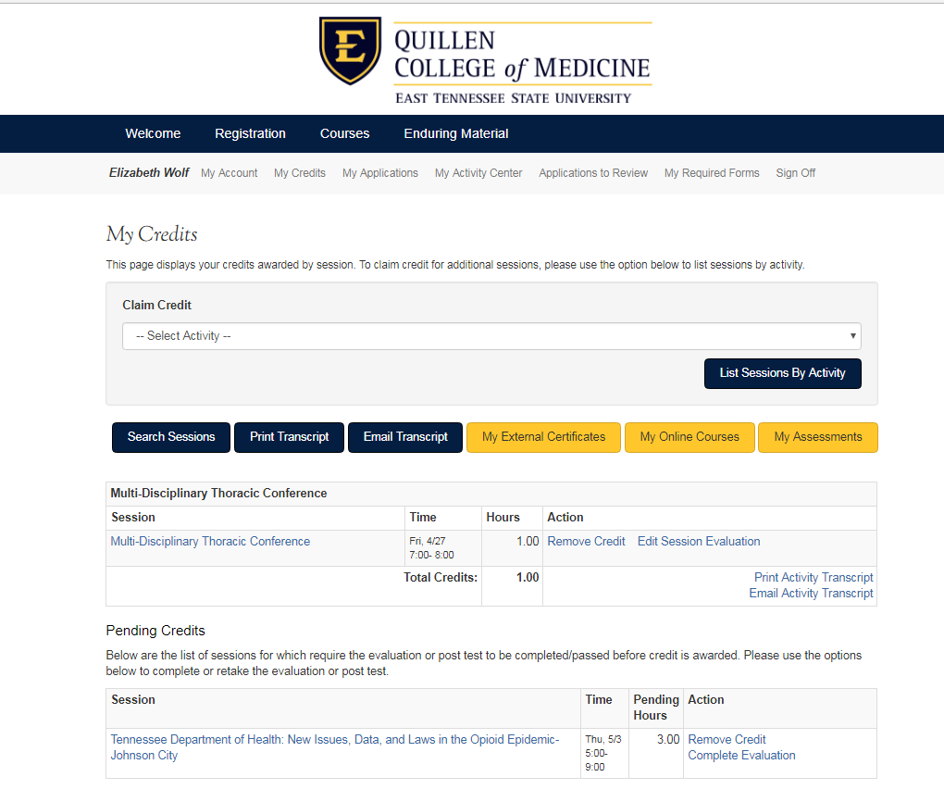

1

3

2

1. Log in to your HighMarks account at ww2.highmarksce.com/etsu.
2. Click **‘My Credits’** and Locate *Tennessee Department of Health New Issues, Data, and Laws in the Opioid Epidemic – Johnson City* in the **‘Pending Credits’** section.
3. Click **‘Complete Evaluation’** – this will take you through the completion of the course evaluation and post-test.
4. You are finished! The hours will show up under hours instead of pending once the process is complete.



**How to Retrieve and Upload Your Previous CME Transcript into the New System**

The new online management system (HighMarks) is now live.  The information on this page will help ensure a smooth transition of your history of credits earned, and provide step-by-step tutorials for easy use of the new system.

Please take a few minutes to complete the following TWO STEPS:

1. **Retrieve your Transcript of credits earned from the “old” Tracker system.**

CME credit earned prior to May 1, 2018 will not be automatically transferred into the new HighMarks system.  To ensure you retain a record of past credits earned you will need to log into the old system and print or download your transcript.  Transcripts will be available at no charge until June 30, 2018.  Beginning July 1, 2018 there will be a charge for the CME staff to manually retrieve an archived record of your previous credits.  Detailed instructions for accessing your old transcript can be found on our main CME webpage, as well as troubleshooting FAQs for problems accessing your account.

1. **Transfer your “old” Transcript into the HighMarks system.**

One of the exciting features of the HighMarks system is the ability to enter a record of CME/CE credits earned from other institutions.  This allows you to keep all of your records in one online space for easy retrieval.  Detailed instructions on uploading or entering transcripts from other systems can be found at our website, [www.etsu.edu/com/cme](http://www.etsu.edu/com/cme).

The good news is that we will walk you through the process every step of the way via detailed instructions. We appreciate your patience and assistance through this transition. Please visit [www.etsu.edu/com/cme](http://www.etsu.edu/com/cme) for additional information or to create your profile.

|  | **Notes** |
| --- | --- |
|  | |
|  | |
|  | |
|  | |
|  | |
|  | |
|  | |
|  | |
|  | |
|  | |
|  | |
|  | |
|  | |
|  | |
|  | |
|  | |
|  | |
|  | |
|  | |
|  | |
|  | |
|  | |

|  | **Notes** |
| --- | --- |
|  | |
|  | |
|  | |
|  | |
|  | |
|  | |
|  | |
|  | |
|  | |
|  | |
|  | |
|  | |
|  | |
|  | |
|  | |
|  | |
|  | |
|  | |
|  | |
|  | |
|  | |
|  | |