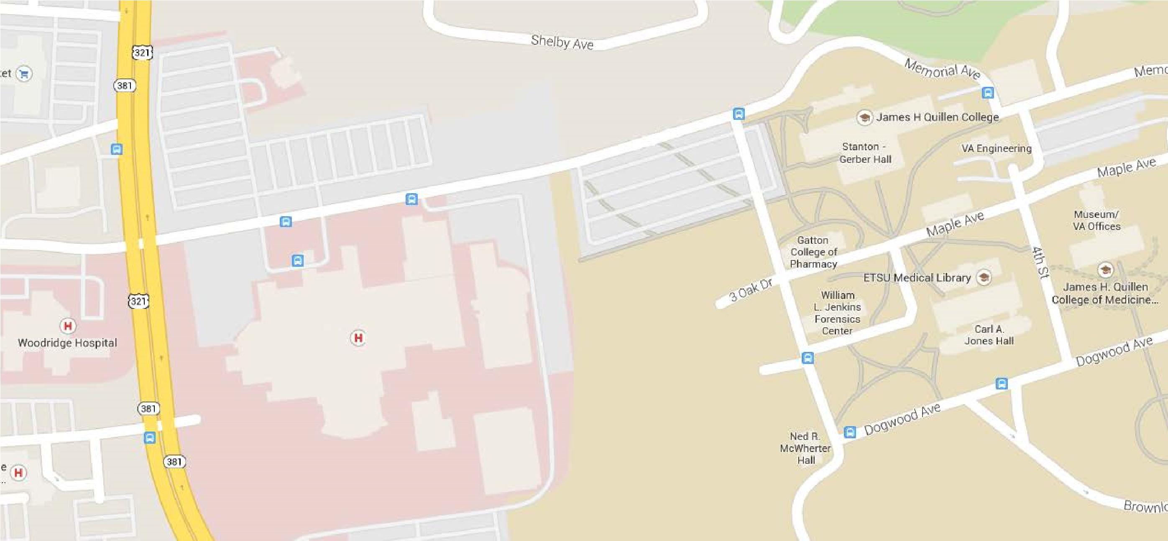
- From State of Franklin Road, turn at traffic light at Johnson City Medical Center onto Vonderfecht way (400 N. State of Franklin Rd) turns in to Memorial Avenue
JCMC
Parking Lot
Stanton-Gerber Hall
Entrance
- Continue straight, past JCMC and Niswonger Children’s Hospital onto the VA Campus
- Turn right on Fifth Street
- Parking is located is located on your left.
- Stanton-Gerber Hall is next to parking lot
Office of Graduate Medical Education
Stanton-Gerber Hall, A-102
(423) 439-8023
423-439-8023

