QPCR set up
Manual vs. Robot
Ex. hBeta-2 Microglobulin

Manual
Std Curve:
Slope -3.430
Efficiency 96.5%
Correl. Coeff. 0.997
Unknown: Ct 24.74±0.36
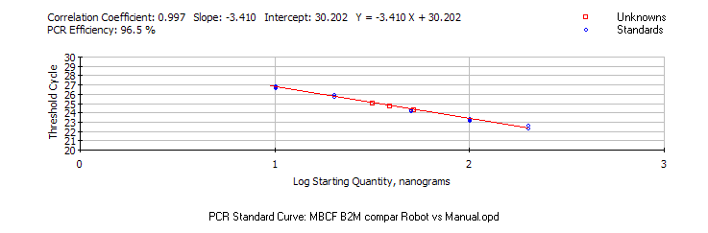

Robot

Std Curve:
Slope -3.341
Efficiency 99.2%
Correl. Coeff. 0.996
Unknown: Ct 24.68±0.50
