Overview: Children with Sensory Processing Disorders (SPD)
For some children, a trip to the dentist involves experiences in the environment which may trigger sensory avoidance, a type of Sensory Processing Disorder (SPD). A new environment, unfamiliar interactions, and a host of new tactile, auditory, and gustatory/olfactory sensations may trigger behavioral challenges related to Sensory Processing Disorder (SPD). Autism is the developmental disability most widely associated with SPD. However, Sensory Processing Disorder (SPD) can manifest in a variety of other conditions (attention deficit hyperactivity disorder, balance/coordination disorders, post-traumatic stress disorder, anxiety, etc.). Educating dental professionals with helpful strategies for accommodating the experience can ease the feelings of overstimulation that children who have Sensory Processing Disorder face during a dental visit.
Our senses relay information to our brains about the environment around us. When these signals are received from the senses, the brain processes this information and responds. When a person has a Sensory Processing Disorder (SPD), the brain has difficulty receiving, organizing, and responding to sensory input. The signals may be received either “too loudly” or “too quietly”, creating a “traffic jam” type response in the brain as it becomes over or under stimulated. A child with SPD will display atypical behaviors, ranging from mild to severe, in response to everyday life situations.
Children who have difficulty with sensory processing may demonstrate behavior that is sensory avoidant, sensory seeking, or both (depending on the sensation). Sensory avoiders typically display behaviors which may seem overly reactive to a stimulus and/or avoidant of certain situations or sensations. These children may be harder to engage during interaction, withdraw from touch, become easily overwhelmed (sensory overload) in new environments, and have a low pain threshold. Sensory seekers, on the other hand, crave or search for stimulation to increase sensory input. They tend to display hyperactive type behaviors like fidgeting, rough housing, talk excessively, and have a higher pain tolerance.
In order to determine the most appropriate accommodations, it would be beneficial to predetermine if the child is a sensory avoider or seeker. This requires obtaining information from the child’s parents/caregiver prior to their appointment. If possible, it may also be beneficial to allow the child to visit the clinic before his/her appointment day to become familiarized with the environment and clinic staff.

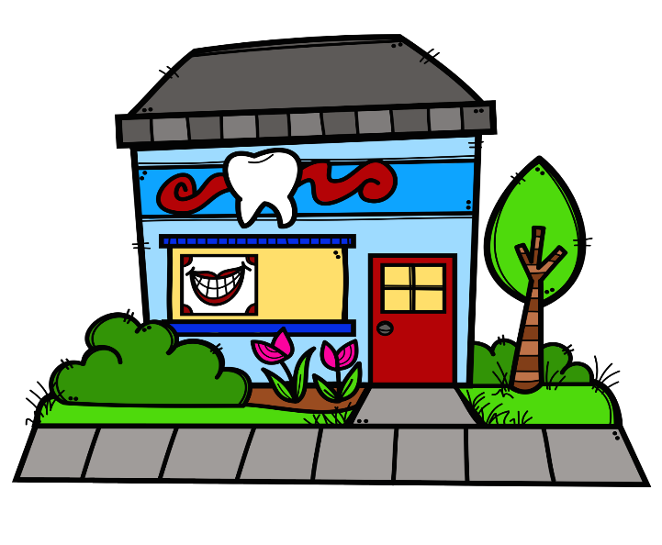
Sensory Adaptive Environmental Fact Sheet
General Suggestions for Sensory Avoiders:
- Interview parents prior to appointments to gain understanding of their child’s individual triggers and responses.
- Invite parents to bring helpful equipment from home (noise cancelling ear phones, weighted blankets, sensory toys, etc.)
- Inform the parents of helpful activities prior to the appointment.
  - Oral desensitization: Eat something crunchy or chewy, chewy necklaces/toys, vibration from a mini-massager (NUK massager) or electric toothbrush, apply deep pressure massage manually to the gums/mouth, drink thick liquids through a straw.
  - Provide the parents with a sample of the preferred flavor/s available for fluoride and pumice pastes to introduce the taste, smell, and texture.
  - Perform heavy work through play: Anything that provides resistance to the body; pushing/pulling, jumping, climbing, lifting/carrying heavy objects.
  - Deep touch pressure: Joint compressions, firm touch massage/squeezing, vibration, brushing, weighted or tight/stretchy clothing, sandwiching between pillows, rolling with foam rollers or yoga balls.
  - Provide parents and patients with social stories to introduce the child to what happens during a visit, post visual schedules of steps taken during the appointment, and provide the child with an interactive schedule when they arrive.
- Reduce unnecessary stimuli in the office and create a calming environment.
  - Decrease background noise: turn off office & dental equipment that isn’t needed during the appointment, have clinic staff speak in calm quiet voices.
  - Turn off overhead and fluorescent lighting, use lamps instead where possible.
  - Soothing visuals: fiber optic lights, light projecting lamps, lava lamps.
  - Use privacy screens or separate exam rooms to limit stimulation exposure.
  - Schedule sensory avoiders and sensory seekers at different times or in different areas of the clinic.
- During the appointment
  - Schedule extra appointment time and allow the child a break if needed.
  - Allow the parent/caregiver to accompany the child throughout if needed.
  - Use wedges for positioning and/or textured mats on the dental chair.
  - Allow the child to wear the X-ray vests for added deep pressure.
  - Allow the child to wear dark sunglasses to block out bright light.
  - Allow the child to listen to calming music through headphones.
  - Allow the child to play with fidgeting toys or handheld mini-massagers.
  - Use visual aids: clocks, timers, mirrors, show the child the tools.
  - Enter the child’s field of vision before touching or speaking to them.
  - Verbally inform the child of each step you are going to take and provide a time limit (“until the small hand on the clock reaches”, “for X seconds”, “for the count of X”)
  - Use firm touch/pressure when touching the patient.

Adapting the Environment for Sensory Avoiders: These children tend to have greater sensory defensiveness and increased anxiety in new situations. Recommendations are to reduce stimulation and aimed at providing calming input. It would be helpful to allow these children to visit or tour the clinic prior to their appointment if possible. Also, advise parents/caregivers to reduce overstimulation during the day of the appointment, uphold normal routines, and plan a calming activity for after the visit.
Visual: Avoid bright lights, reduce unnecessary light, use lamps with calming colors or that project water patterns onto the walls/ceilings, cover any blinking lights on equipment, avoid hand gestures when speaking, avoid sudden/jerky/unexpected movements if possible, avoid prolonged eye contact, allow the child to wear sunglasses or night masks during the appointment.
Auditory: Reduce excessive or loud noises; turn phone ringer off or down, turn off fluorescent lights (buzzing), turn off dental equipment that’s not being used or office equipment within earshot (fax machines, copiers, etc), place a towel or something soft between the tools and metal tray, provide earplugs or allow them to use noise cancelling headphones, speak in a quiet and calm voice.
Touch: Replace abrasive or irritating textures with softer ones; put a soft cover over the dental chair, tape down loose plastic covers on dental equipment, remove rings/jewelry that may touch the child during procedures, allow the child to feel the gloves prior to touching them. Avoid light touch sensations and apply firm pressure when touching the child. Deep touch pressure (weighted or restrictive) and vibration are typically calming sensations.
Taste: Avoid or reduce strong flavors when possible. Give the child a choice between 2-3 flavors.
Smell: Reduce smells by using cleaning or dental products without scent, avoid wearing hair/body products or using clothing detergents with strong smells, avoid chewing gum or using breath mints during the procedure.
Adapting the Environment for Sensory Seekers: These children have a hard time sitting still and constantly seek out stimulation. Recommendations are highly stimulating and aimed at providing significant sensory input. It would be helpful to advise parents of sensory seekers to plan for time just before their child’s appointment to allow them to release extra energy. For example; taking them to the playground to climb or swing, riding their bikes, running around the building before entering, jumping on a trampoline, activities requiring heavy lifting, or attending after team practices.
Visual: Seekers may prefer visual stimulation through brighter lights, changing light patterns, or projected scenes/movies to watch during the appointment.
Auditory: May prefer music with changes in volume, instrument/sound, pitch, or beat frequency. Audio books with kid friendly stories.
Touch: Busy textured mat/disc/blankets to sit on, applying weighted blankets/vests/pillows/objects during appointment time, fidget spinners or other toys to keep their hands busy, tools or devices that vibrate.
Taste: Give them a choice of flavors. If possible, allow them to pick more than one switch flavors during procedures.
Smell: Use products with stronger smells, good or bad.

References
Lane, S., Miller, L. & Hanft, B. (2000). Towards a consensus in terminology in sensory integration practice: Part 2: Sensory integrations patterns of function and dysfunction. American Occupational Therapy Association’s Sensory Integration Special Interest Section Quarterly,23(2), 1-4.
Wilbarger, P. & Wilbarger, J. (1991). Sensory Defensiveness in Children Aged 2- 12. Denver, CO. Avanti Education Programs.
STAR Institute for Sensory Processing Disorder. Spdstar.org. https://www.spdstar.org. Published 2019. Accessed February 9, 2019.
Autismspectrum.org.au. https://www.autismspectrum.org.au/sites/default/files/BB-Understanding-Sensory-Processing-2015.pdf. Published 2019. Accessed February 9, 2019.
Supporting Sensory Processing Differences for People with Autism Spectrum Disorders. Downloads.pearsonclinical.com. http://downloads.pearsonclinical.com/images/Assets/SensoryProfile2/SP2-Infogrfx.pdf. Published 2019. Accessed February 9, 2019.
Dunn W. Supporting Children to Participate Successfully in Everyday Life by Using Sensory Processing Knowledge. Infants & Young Children. 2007;20(2):84-101. doi:10.1097/01.iyc.0000264477.05076.5d
Dunn W. The Impact of Sensory Processing Abilities on the Daily Lives of Young Children and Their Families: A Conceptual Model. Infants & Young Children. 1997;9(4):23-35. doi:10.1097/00001163-199704000-00005

This project is supported by the Health Resources and Services Administration (HRSA) of the U.S. Department of Health and Human Services (HHS) under grant #T73MC30767, Vanderbilt Consortium LEND. This information or content and conclusions are those of the author and should not be construed as the official position or policy of, nor should any endorsements be inferred by HRSA, HHS or the U.S. Government.

