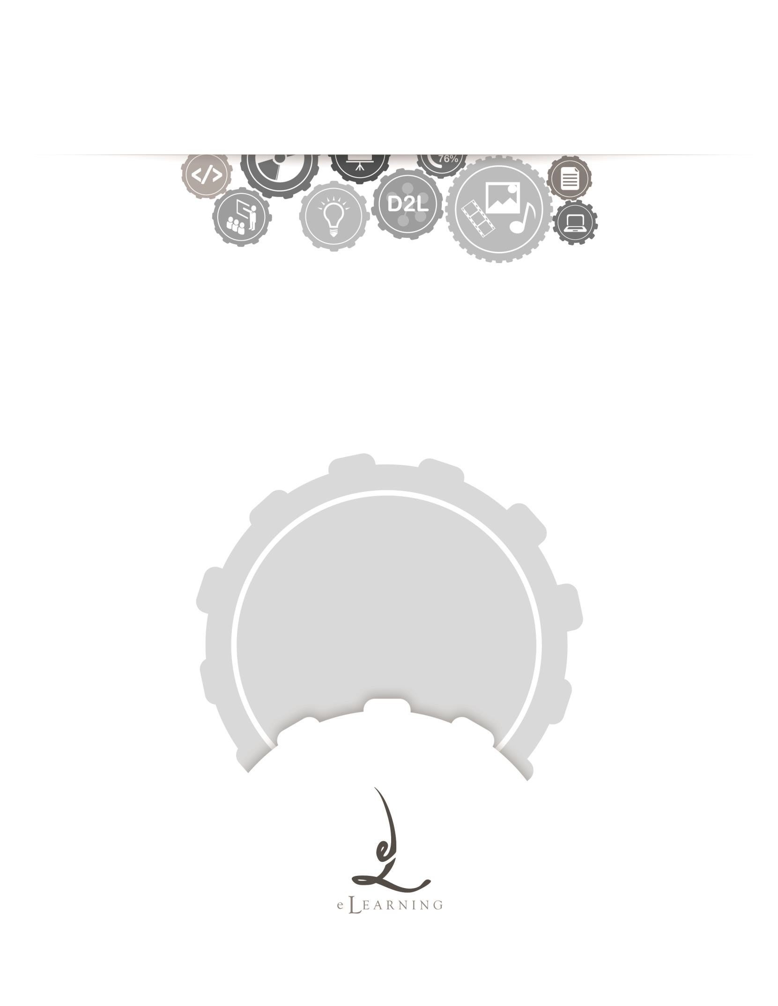
ACADEMIC TECHNOLOGY SUPPORT

Dropbox
Student Quick Start Guide

ats@etsu.edu | 439-8611 www.etsu.edu/ats

Table of Contents:
Accessing Dropbox 1
Navigating the Dropbox 1
Adding Files to the Dropbox 2
Viewing Dropbox Submission History 4
View Feedback 4

Accessing Dropbox
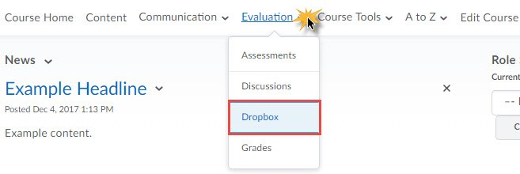
To access the Dropbox in D2L, click on the Evaluation link group located in the top navigation bar and select Dropbox from the drop-down menu.
The Dropbox Board is a tool used to receive electronic files for evaluation and feedback. The Dropbox can also be used to coordinate and organize group projects. The Dropbox allows instructors and students to exchange electronic files through D2L. Students submit assignments by uploading files to folders in the Dropbox. Instructors view submitted files, provide grades and feedback all from within the Dropbox.

Navigating the Dropbox
Clicking on the Dropbox link from the Evaluation drop-down menu will direct you to the Dropbox Folders List page. This page holds all dropbox folders available to you.

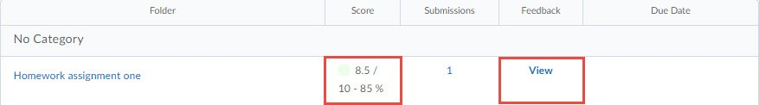
View History – Clicking 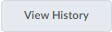 will allow you to review your submission history. You can check each file's size, when it was submitted, whether comments were included with it, and who has retrieved it.
Dropbox Folder Name – Your instructor will label each folder so that you know where to upload your files.

Score – If your Dropbox submission is a graded assignment you will receive your grade here. This will remain blank until your Instructor grades your Dropbox submission.

Submissions – This area will show you how many submissions you have made to this Dropbox folder. If you click the number you will be taken to your submission History to view details of the submissions.

Feedback – If your Instructor has left you Feedback on a Dropbox submission you will be able to view that here. Simply click the blue hyperlinked text that says View and you will be taken to the View Feedback page.

Due Date – This column lists the date by which you should submit your file(s).

Adding Files to the Dropbox
Clicking on a particular dropbox folder’s name will take you the submission page. Once on the submission page, click the Add a File button.
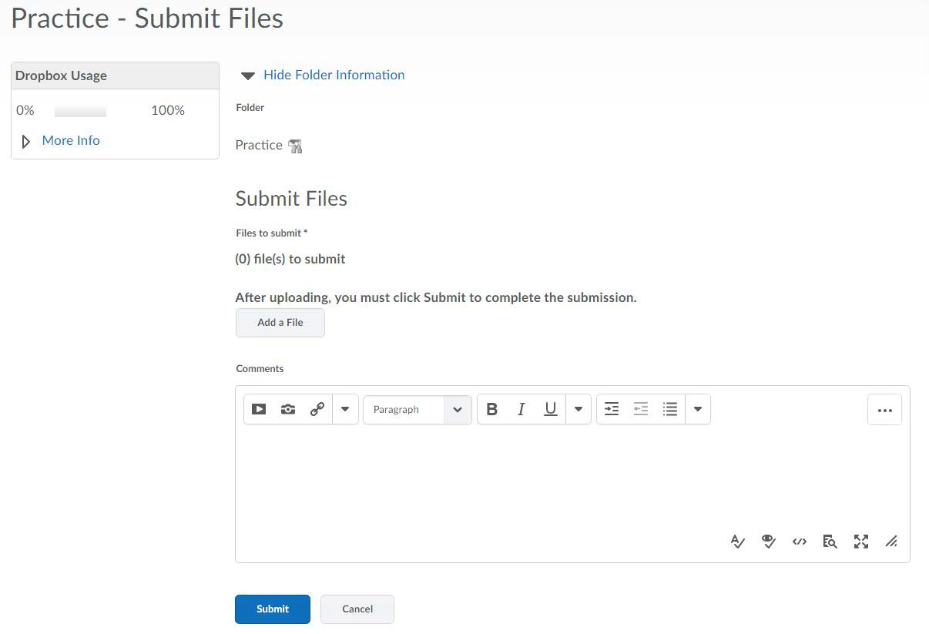
Click the Upload button. Using the file browser, find the file you wish to upload; double-click on the filename to prepare the file for uploading. Alternately, you may be able to drag and drop your file from the file browser into the dotted box housing the upload button.

DRAG AND DROP FUNCTIONALITY IS NOT SUPPORTED BY INTERNET EXPLORER. IN ORDER TO UTILIZE THIS FUNCTION, MAKE SURE THAT YOU ARE USING CHROME, FIREFOX, SAFARI, OR A DIFFERENT WEB BROWSER OF YOUR CHOOSING.

Once your filename displays in the dotted box, click the blue Add button.
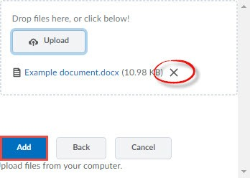
If you have multiple files you wish to upload to the dropbox, simply repeat the steps listed above. Alternately, to remove a file you have added in error, click the X icon.

Back on the Submit Files screen, enter in any additional comments in the textbox labeled

Comments.

Click the blue Submit button to complete the upload process.

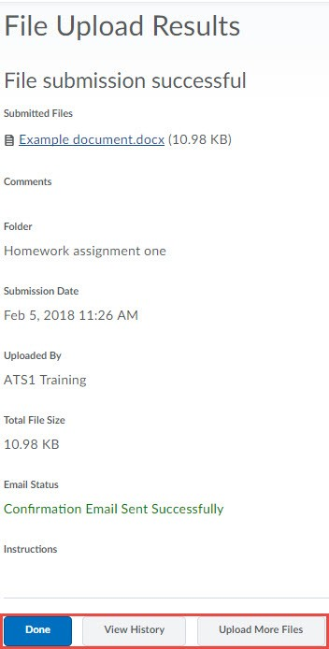
If the file submission is successful you will receive a confirmation page. Additionally, you will receive a submission receipt via email. Click the blue Done button to return back to the Dropbox folders list. Click the View History button to view a history of all uploaded assignments.

Viewing Dropbox Submission History
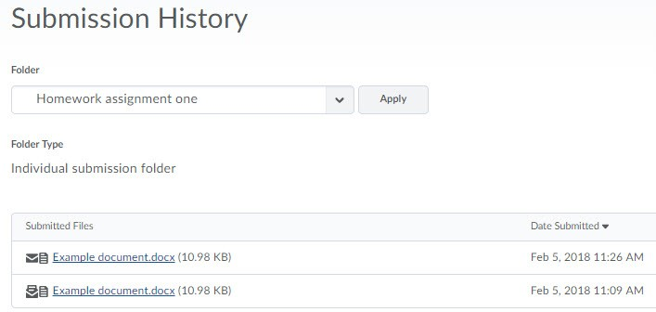
View History stores all assignments you have submitted electronically to the dropbox. Organized by folder, this page will list each file and the date that files was submitted. Toggle between folders using the Folder dropdown menu. Click on a file’s name to view that particular submission.

Viewing Grades and Feedback from your Instructor

Once your instructor publishes your grade, that grade, along with any additional feedback, will be accessible via the Dropbox Folders page. At a glance you will be able to see your grade and if you have any additional feedback from your instructor. The Score column houses the grade you received on your electronic submission. The Feedback Column will contain a conversation bubble icon which signifies that you have received feedback from your instructor. Click on the conversation bubble icon to access your feedback.

View Feedback
Your instructor can include plain text as well as additional files for your review. The View Feedback page allows you to see the file and the date of your submission, your grade, and any instructor comments.

