East Tennessee State University
Facilities Management
Department of Environment Health & Safety

2007-10 Fire Safety Report

The East Tennessee State University Department of Environmental Health & Safety has developed and implemented a Life Safety Policy, primarily established to protect ETSU students, faculty and staff, and to reduce potential large fire losses of ETSU properties. The policy recognizes the fact that life safety is more than just a matter of safe egress. The policy includes inspection and testing requirements necessary to achieve an acceptable degree of life safety and outlines the safeguards to provide egress time and protection from fire exposure.

Life safety from fire is accomplished through fire prevention and response training, installation and maintenance of fire protection systems and periodic building inspections.

Training
All resident directors and resident assistants are trained annually in the proper use of fire extinguishers, fire evacuation procedures, and fire prevention practices. This encompasses hands-on training using a state-of-the-art fire simulator. The resident directors and resident assistants are also trained in the following policies:
- No smoking on-campus, except for personal vehicles
- No open flames allowed in housing facilities
  - No candles allowed
  - No incense allowed
- No misuse of fire alarms, fire detection devices, or fire extinguishers
- No flammable materials allowed in housing facilities, such as gasoline, paint thinner, oil lamps, fireworks or live Christmas trees
- Fire doors are to remain closed
- Never leave food cooking on a stove unattended
- Never use an elevator to exit a building
- “Stop, drop, and roll

To reinforce evacuation training, three fire drills are conducted each semester at every on-campus housing facility. Fire drills are documented and annually assessed for effectiveness by Environmental Health & Safety personnel.

Evacuation Procedures & Preparedness
Every housing facility features evacuation diagrams that show the location of exits, fire extinguishers, and manual pull stations. All residents are encouraged to familiarize themselves with the diagrams, paying close attention to evacuation routes to exits. An example has been provided below:

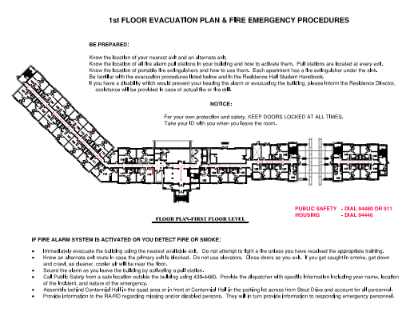
Every housing facility posts evacuation plaques, which provide evacuation procedures in case of fire, as well as emergency procedures in case of severe weather, hazardous material releases, and power outages. The evacuation plaques also provides a map showing the location of the designated assembly area, where building occupants are to report after evacuation. An example has been provided below:

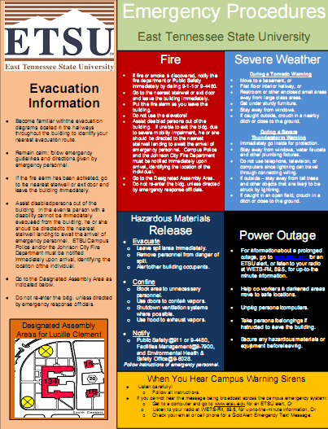

Fire & Life Safety Inspections
Every housing facility is inspected once every thirty days for the following:
- Fire extinguishers are inspected and noted on date tags
- Exit lights are lit during normal and backup power
- Emergency lights are tested
- Fire alarm control panel checked for operability and trouble signals
- Sprinkler system water control valves checked to be open
- Sprinkler system gauges checked for normal pressure

Fire Protection Systems
Most of ETSU’s on-campus housing facilities provide automatic fire protection such as sprinkler, standpipe, and fire alarm systems. ETSU has set a goal to have all on-campus housing fully sprinklered by the summer of 2014. All sprinkler systems, fire alarm systems, and fire pumps are tested and inspected annually by the maintenance contractor certified by the state fire marshal’s office. All fire hydrants are annually test-flowed by the Johnson City Fire Department. Please note that all housing facilities feature exit signs, emergency lighting, and fire extinguishers. The following is a compilation of current fire protection systems on a building-by- building basis:

ETSU On-Campus Housing Facilities – Fire Protection Systems
Building Name | Sprinkler System | Fire Alarm System | Standpipe System
Buccaneer Ridge Apts., Phase 1 | Yes | Yes | No
Buccaneer Ridge Apts., Phase 2 | Yes | Yes | No
Buccaneer Ridge Apts., Phase 3 | Yes | Yes | No
Buccaneer Ridge Apts., Phase 4 | Yes | Yes | No
Buccaneer Village Apts. | No | No | No
Carter Hall | Yes | Yes | Yes
Centennial Hall | Yes | Yes | Yes
Davis Apartments | Yes | Yes | No
Governors Hall | Yes | Yes | Yes
Lucille Clement Hall | Yes | Yes | Yes
Luntsford Apts. | Yes | Yes | Yes
Married Student Housing-Bldg. F | Yes | Yes | No
Married Student Housing-Bldg. G | Yes | Yes | No
Nell Dossett Hall | Yes | Yes | No
Powell Hall | Yes | Yes | No
Stone Hall | Yes | Yes | No
West Hall | Yes | Yes | No

Fire Incident Data
ETSU’s fire incident data for the years 2007-10 is as follows:

ETSU Fire Incidents During 2007-10
Date | Time | Location | Cause | Injuries | Deaths | Property Loss
10-29-07 | 01:27 | Lucille Clement  Hall – 4th Floor Kitchen | Arson – Roll of toilet paper placed in kitchen oven | None | None | $75.00
10-30-07 | 03:07 | Lucille Clement  Hall–1st Flr. Kitchen | Arson – Phone book placed in kitchen oven | None | None | $50.00

ETSU Fire Incident Totals for 2007-10
Total # of Fires | Total # of Injuries | Total # of Deaths | Total Property Loss
2 | 0 | 0 | $125.00

*This report has been provided in accordance with Public Law #110-315, the 2008 Higher Education Opportunity Act.

