Determining if a Student has a First Mate (GPAPRXY)
For additional information about First Mate, visit www.etsu.edu/firstmate/staffTutorial.aspx

In INB, go to the form GPAPRXY:
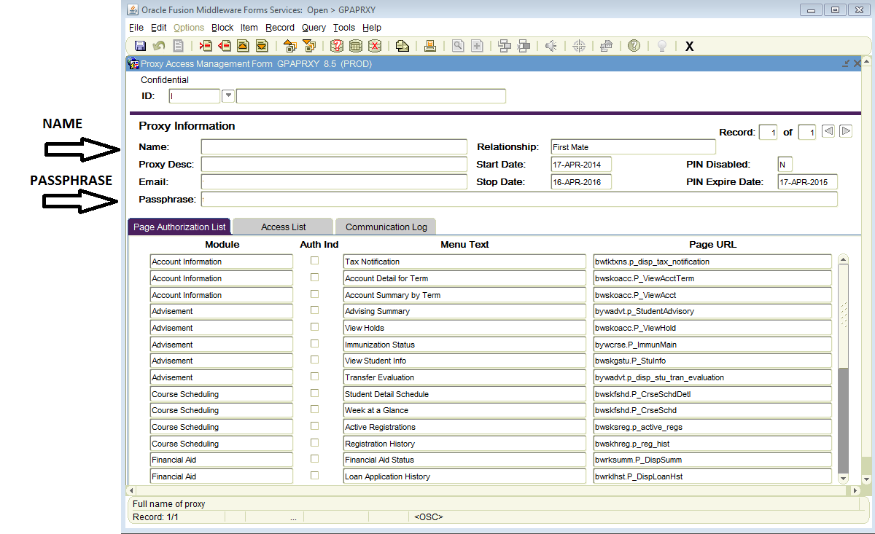
- NOTE: Many questions over the phone can be answered without having to give FERPA protected information about the student. For example, when classes begin, where the ID office is located, etc.
- When speaking with a parent, spouse or other type of First Mate (Proxy) over the phone, they must confirm their Name and Passphrase shown under “Proxy Information” to validate their authorization to hear the student’s confidential information. In addition, the current date must be within the Start Date and Stop Date.
- Once the First Mate (Proxy) has been authenticated, use the Page Authorization List to determine if they are authorized to hear information from your office. Look for the checkmark next to your Module area.
Other useful information about GPAPRXY:
- Note that a student may have more than one First Mate (Proxy). You may have to click on the arrows next to the Record fields to find the correct First Mate (Proxy).
- Refer to this system as the First Mate system when communicating with students and their First Mates (Proxies) so as to avoid confusion. The ETSU legal department guided us not to name this system “Proxy for Parent” as proxy has a different legal meaning than the intended purpose of this system.
- The “Access List” tab will show the history of authorizations for this First Mate (Proxy) which can be used for nonrepudiation (proving that a student did something they are currently denying).
- The “Communication Log” tab will show the history of emails that were sent to this First Mate (Proxy).

