When leader dots are manually entered, page numbers do not to line up correctly.
- Select the leader dots for one entry and delete them (see 1. INTRODUCTION below – the dots have been deleted but the page number remains)
- Keep your cursor between the subheading and the page number
- Set a tab stop by opening the paragraph window (see red circle below)

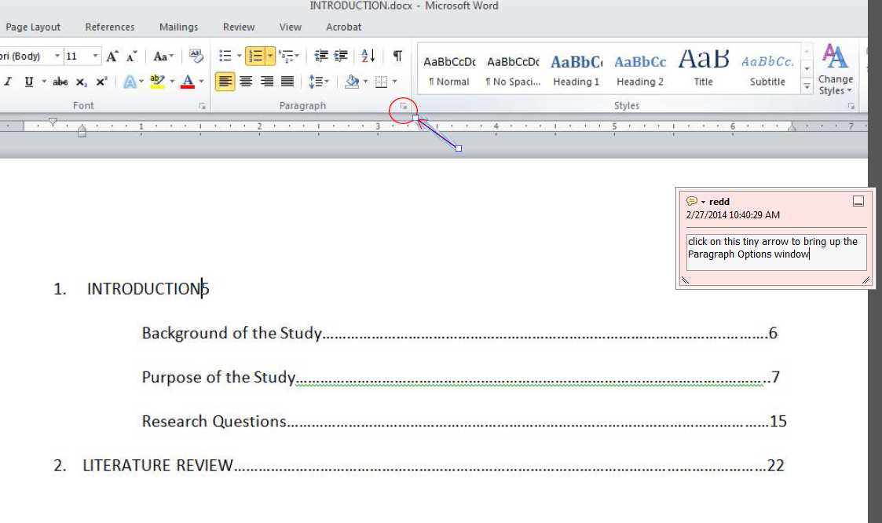

- Click on Tabs at the bottom of this window

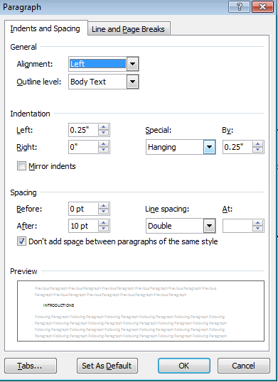

- Your tab stop position should be your right margin (usually 6.5 on the ruler). Select right alignment and the 2….. leader. Click Set. Then click OK.

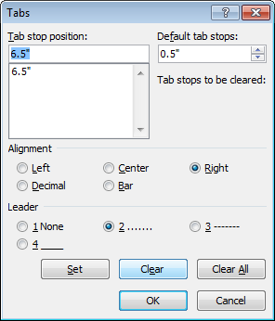

- THEN (with your cursor still between the heading and the page number as shown above) hit the Tab key on your keyboard and your page number will tab over with connection dots and align with the 6.5inch spot (see example with ruler below).

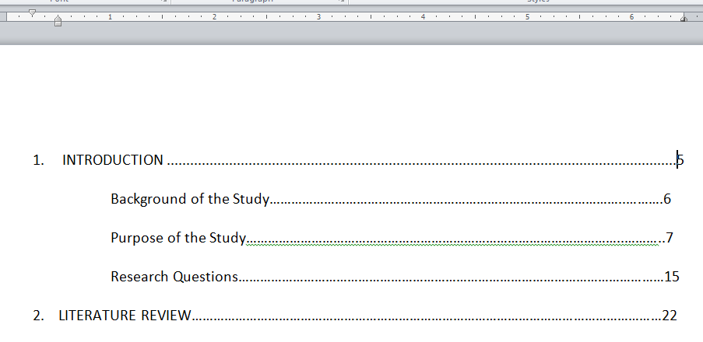

- Repeat this for each entry that is not aligned. This is tedious if you have to do the entire TOC but you can select all entries, set your tab stop for all, then delete the dots for each one, hit tab, and it should work.

Your end result will look like this. Perfectly aligned page numbers:

