ETSU Board of Trustees

**East Tennessee State University**

**Organizational Structure**

**Division of Student Life and Enrollment**

July 2020

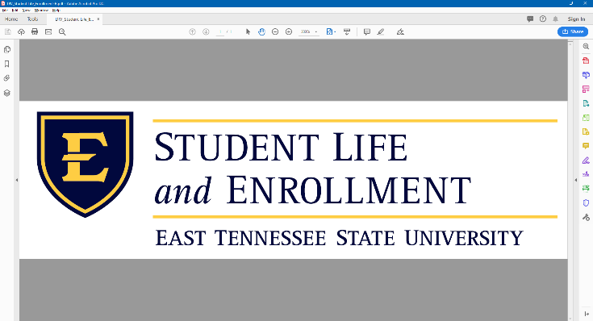

President

Vice President for

Student Life and Enrollment

[Dr. Joe Sherlin](mailto:SHERLIN@mail.etsu.edu)

Student Life and Enrollment

Advancement

[Dessi Foster](mailto:FOSTERDK@mail.etsu.edu)

Roan Scholars Leadership Program

[Scott Jeffress](mailto:JEFFRESS@mail.etsu.edu)

University Advancement

Housing & Residence Life

[Dr. Bonnie Burchett](mailto:BONNIE@mail.etsu.edu)

Student Life and Enrollment Council

SLE Planning and Operations Group

Office

of the

Provost

Associate Vice President for Student Life and Enrollment

[Dr. Jeff Howard](mailto:howardjs@etsu.edu)

Associate Vice President for Student Life and Enrollment

[Dr. Bill Kirkwood](mailto:KIRKWOOD@mail.etsu.edu)

Associate Vice President for Student Life and Enrollment

[Dr. Sam Mayhew](mailto:MAYHEW@mail.etsu.edu)

Associate

Dean of Students

[Dr. Leah Adinolfi](mailto:adinolfi@etsu.edu)

Student

Media

[Don Armstrong](mailto:ARMSTROD@mail.etsu.edu)

Learning Services

[Dr. Deidre Johnson](mailto:JOHNSONDR4@mail.etsu.edu)

Student Government

Association (SGA)

[Shivam Patel](mailto:sgapres@etsu.edu)

Multicultural Center

[Carshonda Martin](mailto:HARRISCM@mail.etsu.edu)

Dean of Students

[Dr. Michelle Byrd](mailto:BYRDT@mail.etsu.edu)

University

Advisement

[Teresa Williams](mailto:WILLIATA@mail.etsu.edu)

Admissions (Undergrad)

[Heather Levesque](mailto:LEVESQUE@mail.etsu.edu)

University Advisement

Center

[Dr. Stacy Onks](mailto:ONKSS@mail.etsu.edu)

New Student & Family Programs

[Dr. Jake Allen](mailto:ALLENJL1@mail.etsu.edu)

D.P. Culp Student Center

[Laura Hensley](mailto:HENSLEY1@mail.etsu.edu)

Fraternity & Sorority Life

[Maggie Darden](mailto:DARDENM@mail.etsu.edu)

TRIO Programs

[Dr. Ronnie Gross](mailto:GROSSRD@mail.etsu.edu)

Center for Academic Achievement (CFAA)

The Ronald & Edith J. Carrier Center for Student Success and Engagement

Student Conduct & CARE

Campus Recreation

[Kari Albarado](mailto:ALBARADO@mail.etsu.edu)

University Career Services

[Dr. Jeffrey Alston](mailto:ALSTONJ@mail.etsu.edu)

Testing Services

[Eric Hunt](mailto:huntej@etsu.edu)

Veterans Affairs

[Guy Hurd](mailto:HURDGD@mail.etsu.edu)

Leadership & Civic Engagement

[Joy Fulkerson](mailto:FULKERSJ@mail.etsu.edu)

Campus

ID

Services

Financial Aid & Scholarships

[Catherine Morgan](mailto:MORGANCA1@mail.etsu.edu)

Disability Services

[Mary Little](mailto:LITTLEME@mail.etsu.edu)

Counseling Center

[Dr. Dan Jones](mailto:JONESDL4@mail.etsu.edu)

Dining

Services

[Kelvin Tarukwasha](mailto:Kelvin.Tarukwasha@sodexo.com)

Student Activities &

Organizations

[Carter Warden](mailto:WARDENCE1@mail.etsu.edu)

ETSU 1020/First Year Experience