Natural Reader: Text to Speech software
Follow these instructions to download Natural Reader Software:
**User must have Google Chrome downloaded prior to downloading Natural Reader**
- Open Google Chrome browser and search “Natural Reader”
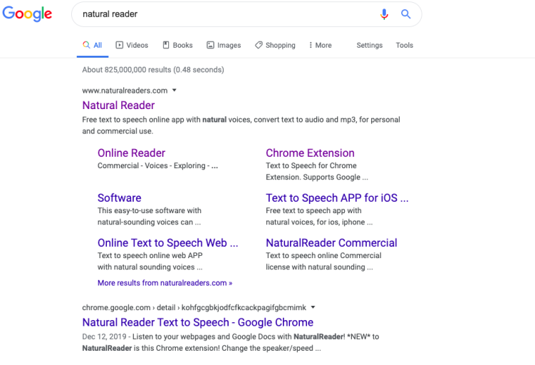
- Select the Natural Reader website – www.naturalreaders.com

- Select “Go to Online Reader”

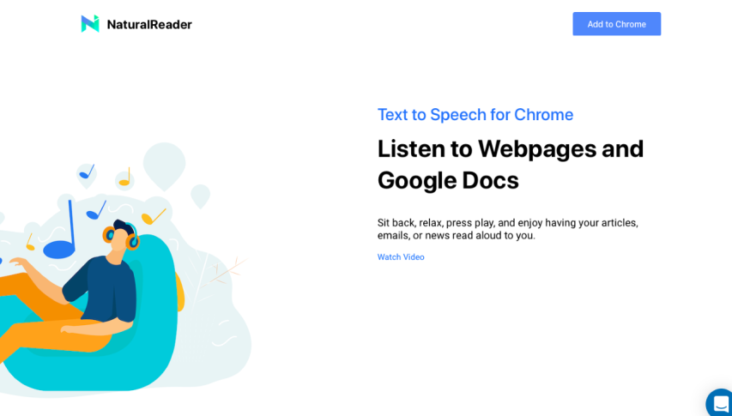
- Scroll downward to select “Add to Chrome” for the Free Software selection
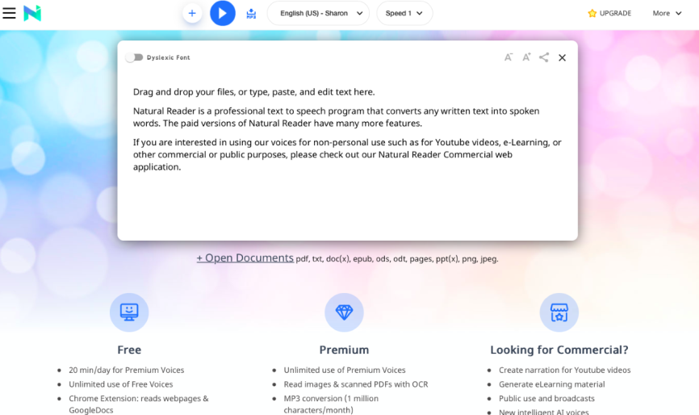

- Next click the “Add to Chrome” button in the top right hand corner.
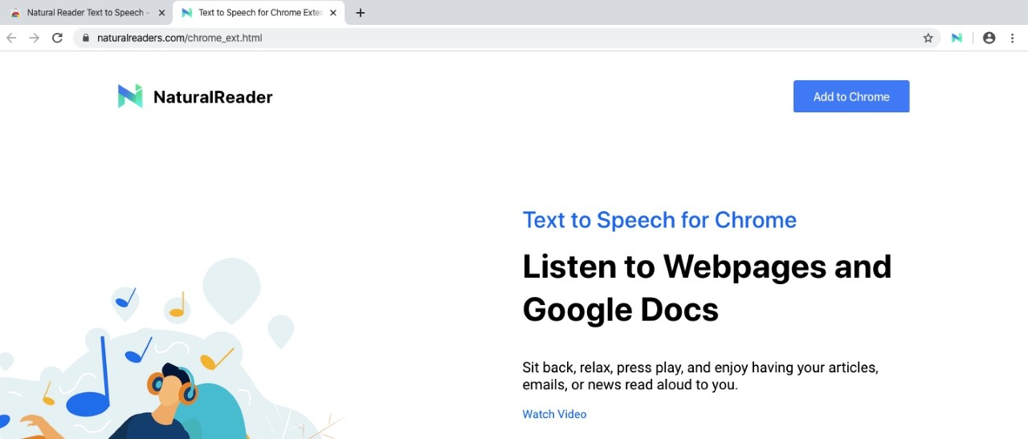

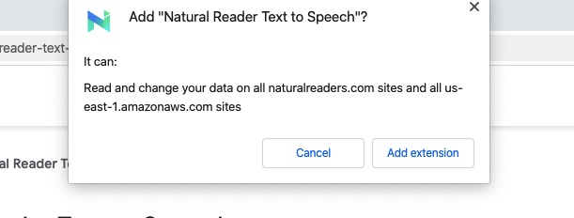
- A drop down box will appear, click “Add Extension”.

- Natural Reader is now installed, an additional tab will open in the Google Chrome browser where you will see a “N” in the top right hand corner. This is the Natural Reader program installed to the Google Chrome Browser.

