
Online Tutoring

- Free, live, interactive tutoring sessions with ETSU tutors for writing, math, science, and more!  - Every subject supported in the CFAA is now available online through GoBoard. | What you need to participate:  - Chrome or Firefox web browser.  - Audio and a microphone.  - We recommend a headset with microphone. You do not need a webcam.  - Images of anything you would like to share with your tutor (paper, homework problems, lecture slides) saved as pdf files.
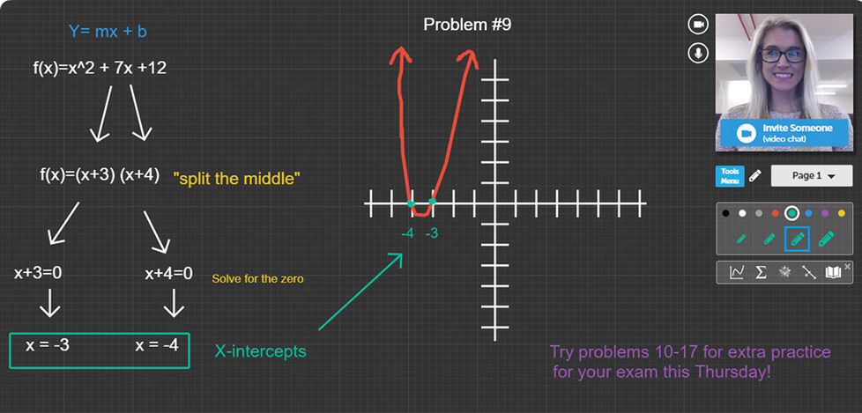
How to sign up and participate:
- Create an account in the CFAA’s online tutoring scheduling system (www.etsu.mywconline.com).
- Log in to the schedule and use the “Limit to” drop-down menu at the top of the page to see available times for tutors in your desired subject area.
- Click in any white, open space to schedule an appointment. Appointments must be either 45 or 60 minutes long. Fill out the appointment form and select the “Meet Online” option. Save the appointment.
- On the day of your appointment, you will receive an email with instructions for accessing and participating in your appointment. You can also access your appointment by copying and pasting the GoBoard link inside your appointment in WCOnline into the address bar in your web browser.

*If you need help with your computer or microphone, please call the ITS help desk at 423-439-4648.

**For assistance with scheduling or participating in your tutoring session, call the CFAA front desk at 423-439-7111.

