1st Floor
LL

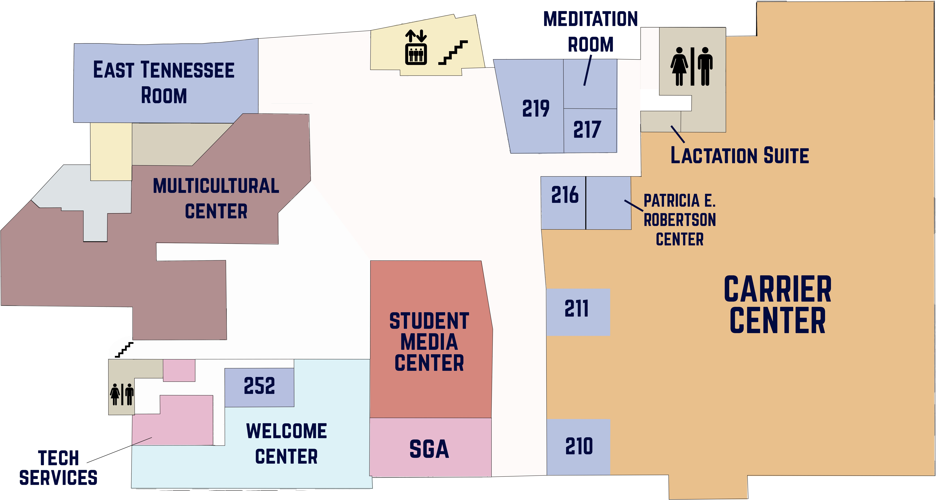
2nd Floor
ML


D.P. CULP STUDENT CENTER
etsu.edu/culp

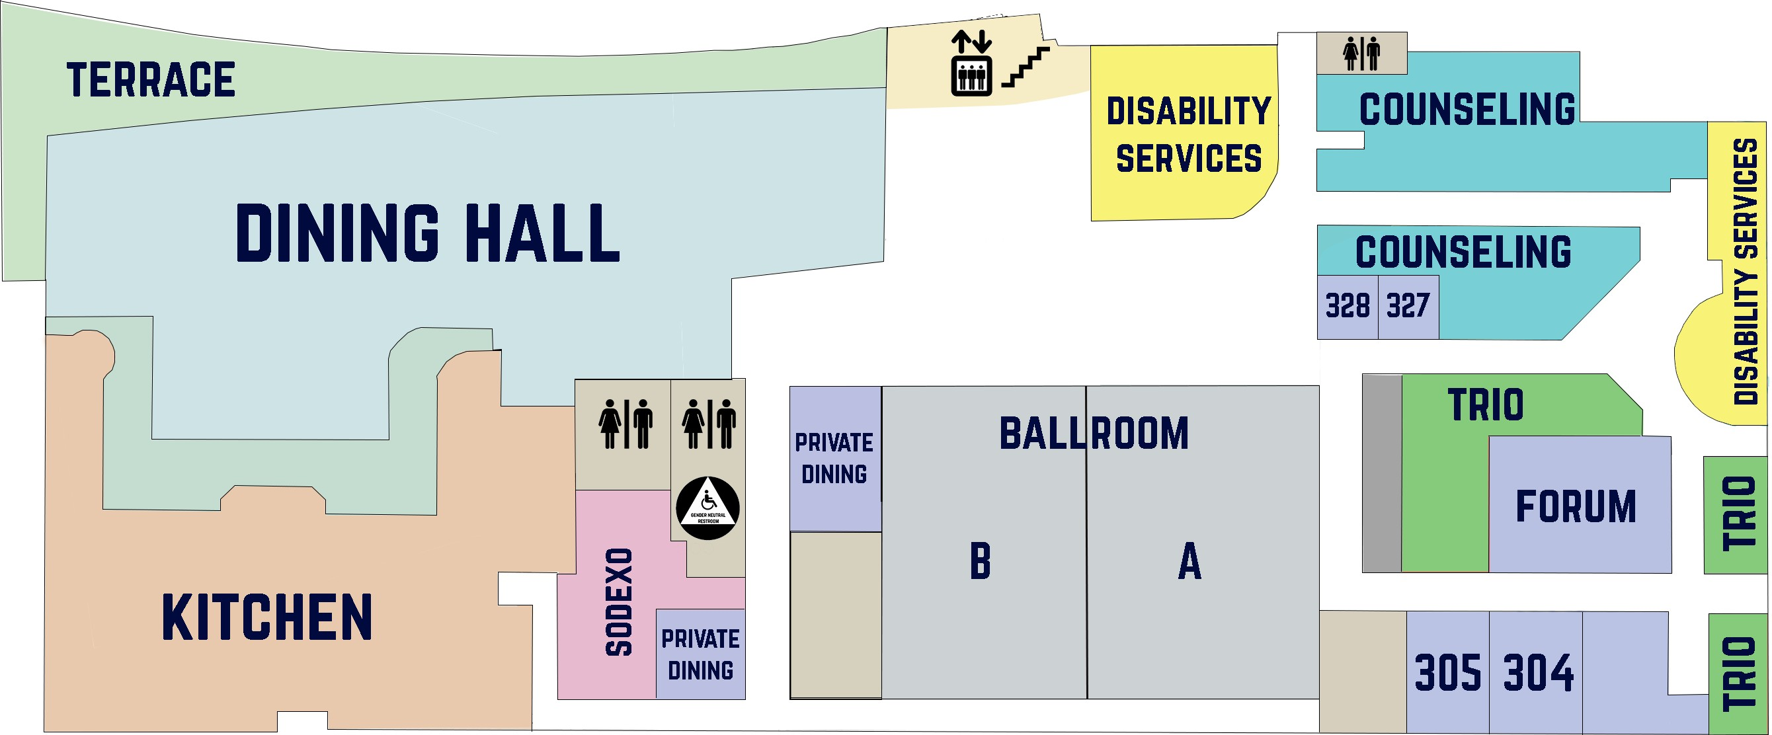
3rd Floor
UL

