ETSU EcoNut 2019-2020
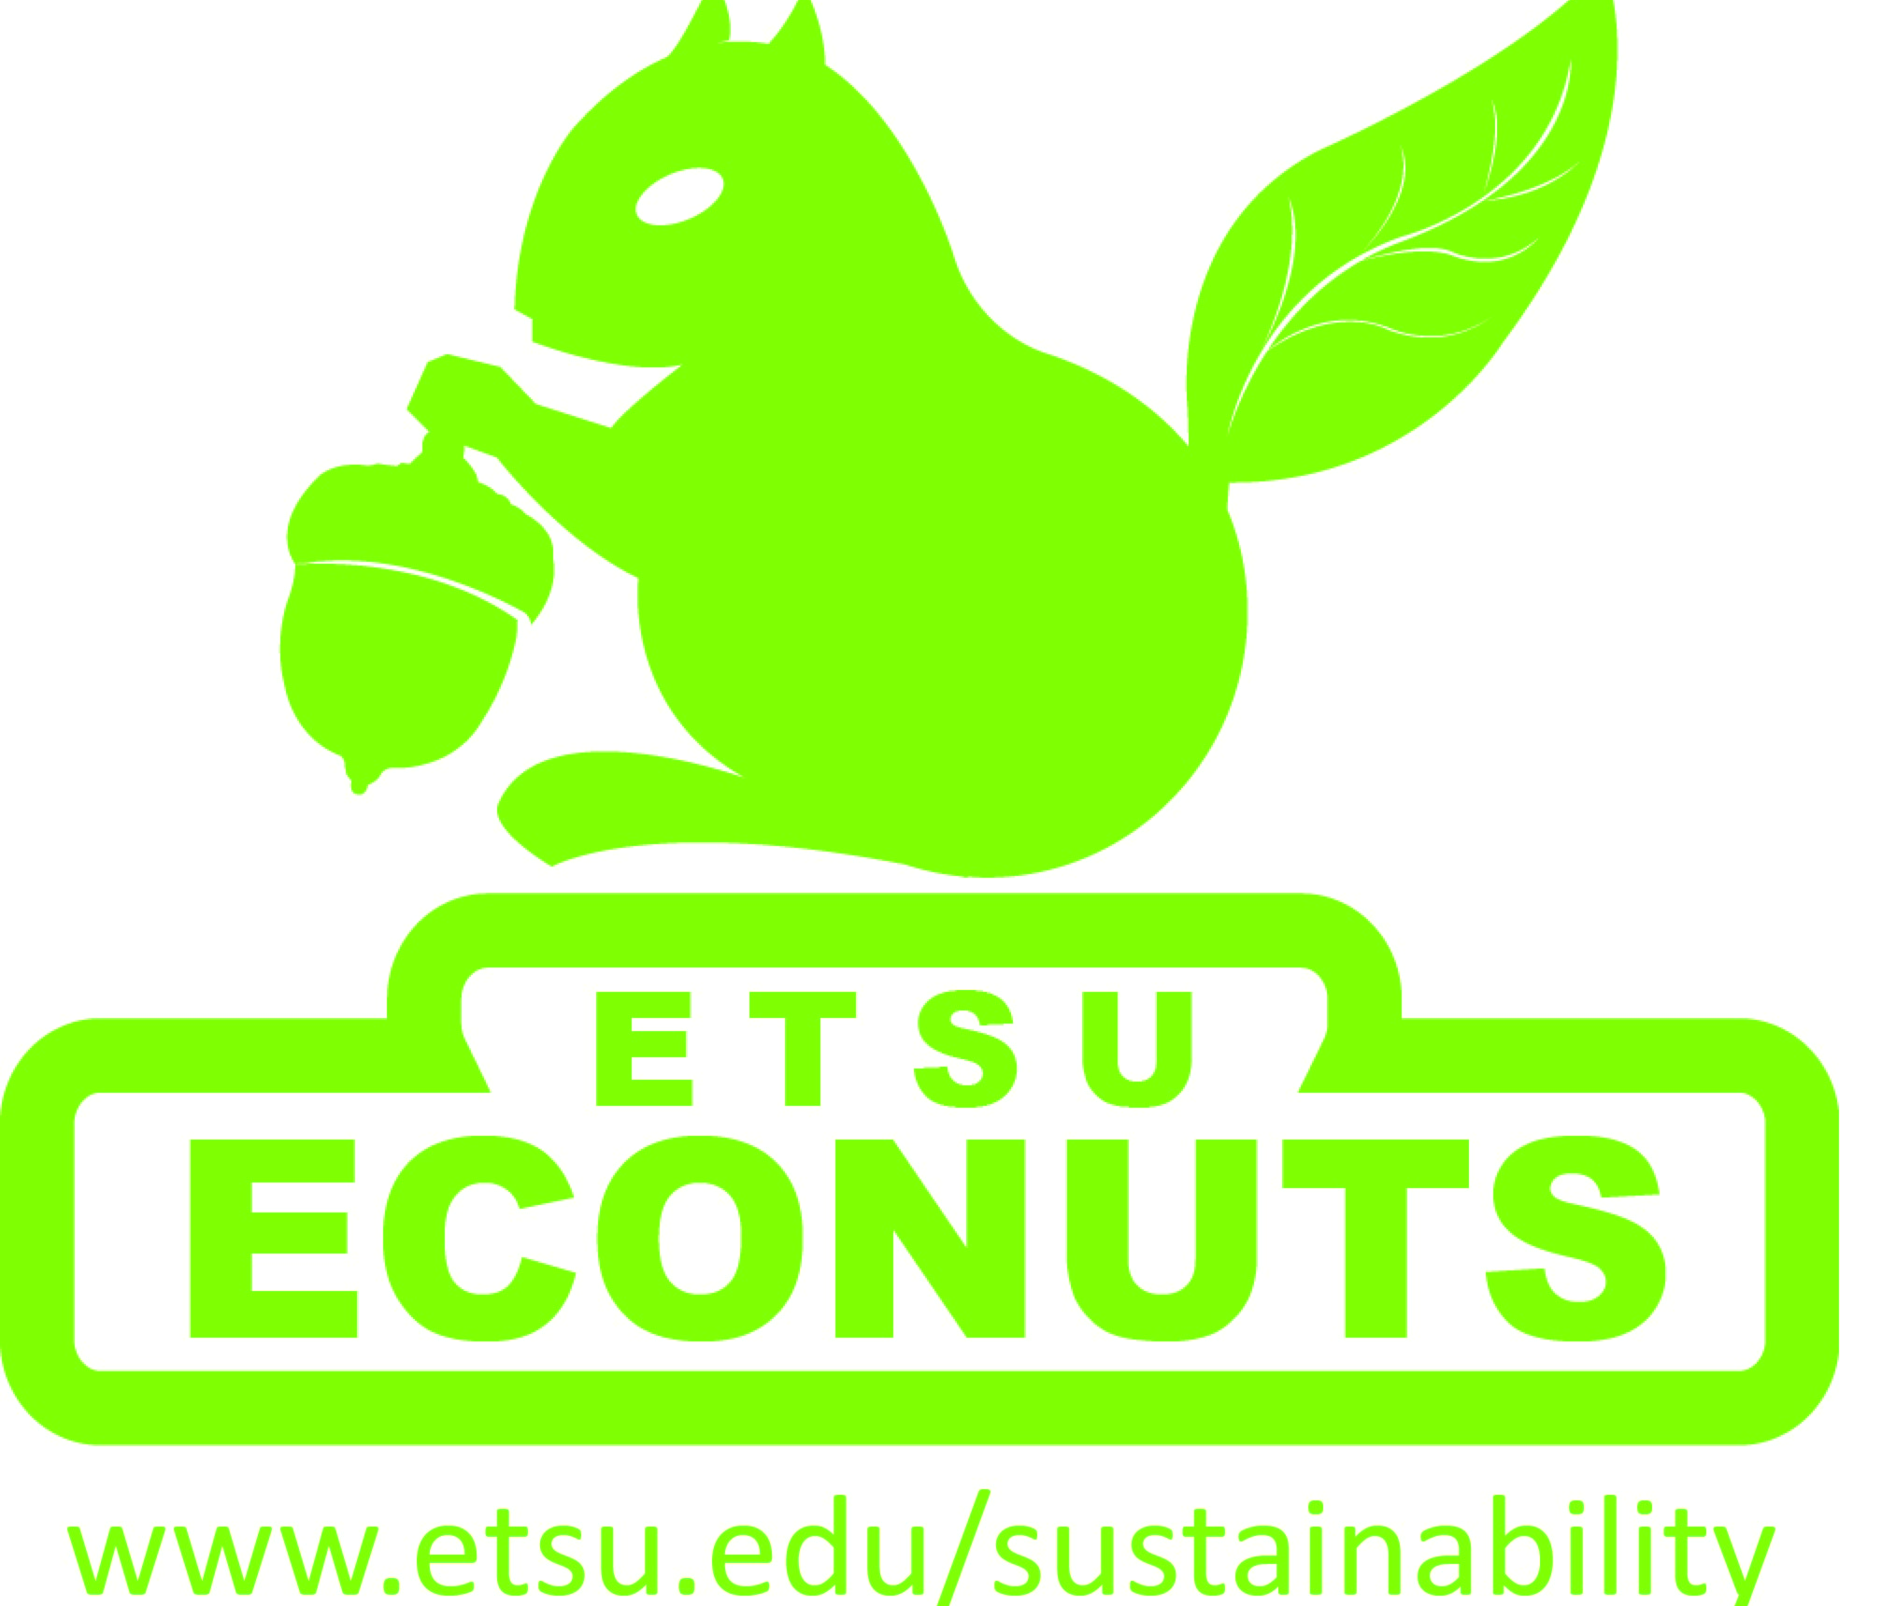
Application Form

Instructions: Please complete and email along with your resume, as attachments to hollidayj@etsu.edu by April 19th, 2019

Last Name: | First Name: |  | Middle Init:
Email Address: |  | Cell Phone #: ( ) -
Home/Permanent Address:
City, State, ZIP: |  | Home/Permanent Telephone: ( ) -
Fall 2018 Campus Address -- Residence Hall:
Room #:
School/College: |  | Anticipated Graduation Date: /
Major: |  | GPA:
Class Status for 2018-2019: First-Year Sophomore Junior Senior
E-Number:
Do you have Federal Work-Study job eligibility for 2018-2019?* Yes No Unsure
*Work Study is not required, but it only helps our budgetary planning to know who is or is not Work Study eligible. This information will not be used in the selection process.

EXPERIENCE
Please attach a copy of your most recent resume that outlines your involvement as a student and a history of your work and volunteer experience. Feel free to submit any additional materials that may help us know more about your skills and interests.

Application QUESTIONS
Submission Guidelines
Please respond to the following questions. Whenever possible, applicants should strive to illustrate a clear understanding of the concepts they choose to introduce in each response. A clear understanding can be shown when an applicant uses specific, often personal examples, or defines terms and concepts using their own words. Other methods of showing understanding are welcomed. Responses should be no more than 250 words.

Question #1
Why are you interested in being an EcoNut? What passions, skills*, and interests can you bring to this program to enhance its mission? *skills may include things like public speaking, desktop publishing, artistic, writing, acting, musical, organizing, web design, leadership, research, math, and office skills.

Question #2
The EcoNuts Program is dedicated to promoting ecological literacy and environmentally and/or socially responsible behaviors. What do these terms mean to you and how do you see yourself using these concepts in the work you do as an EcoNut?

Question #3
The EcoNuts Program seeks motivated individuals who can work both collaboratively and independently and see projects through to completion. Please describe a situation from your past that shows your ability to work in these ways.

Question #4
EcoNuts are educators and leaders on our campus. How do you define leadership in the context of an EcoNut? What opportunities have you taken advantage of to develop your leadership skills?

PLACEMENT
Our first choice is for students to be EcoNuts for the building in which they reside. In some cases, students are EcoNuts for a building in which they do not live.

REFERENCES
Please list the names, positions, phone numbers, and emails for two individuals (at least one from the ETSU community) who can serve as references. No written letters are required.

Name: | Phone#: ( ) - | Email Address:
Relationship to you:
Name: | Phone#: ( ) - | Email Address:
Relationship to you:

HOW DID YOU HEAR?
How did you hear about the EcoNuts position? Please check all that apply.

My RD/ARD | My RA | EcoNuts Facebook
Tabling Event | Brochure | Email
Class/Professor | Friend | Another EcoNut
Other:

ADDITIONAL COMMENTS/QUESTIONS
Is there anything else we should know about you? What questions do you have for us?

