East Tennessee State University
Department of Sustainability
FY2017-18 Annual Recycling Report

Mission Statement
The mission of the ETSU Department of Sustainability is to enhance the environmental, social, and economic health of the university community by developing sustainable practices, educating students, faculty, and staff, and reporting on key measures of success.

Vision Statement
For East Tennessee State University to be known as a place where sustainability is an integral part of the campus culture.

The East Tennessee State University Department of Sustainability continually monitors the amount of waste and recycled material produced by the main campus, seeking to reduce the environmental impact of ETSU through improving the recycling practices of students, staff, and faculty. Over the past eight years, ETSU has steadily increased the percentage of materials recycled as indicated by the following graph.

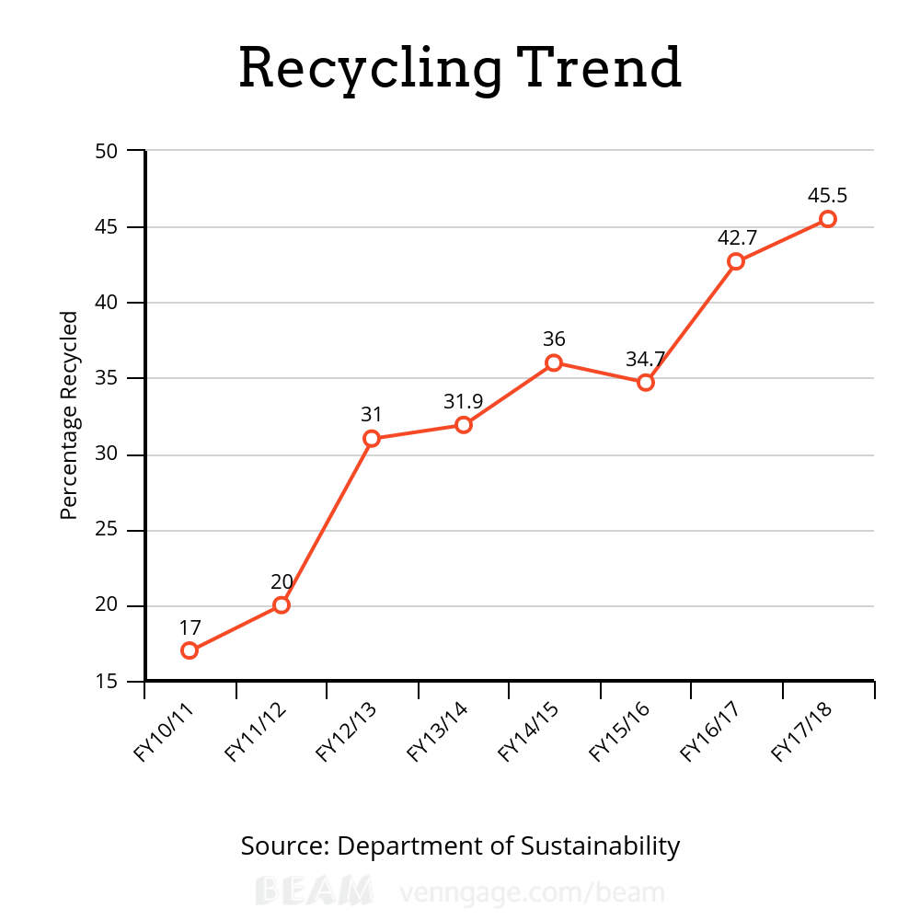
Figure 1

Additionally, the total amount of waste produced by ETSU has been reduced in the past eight years as indicated by the following graph.

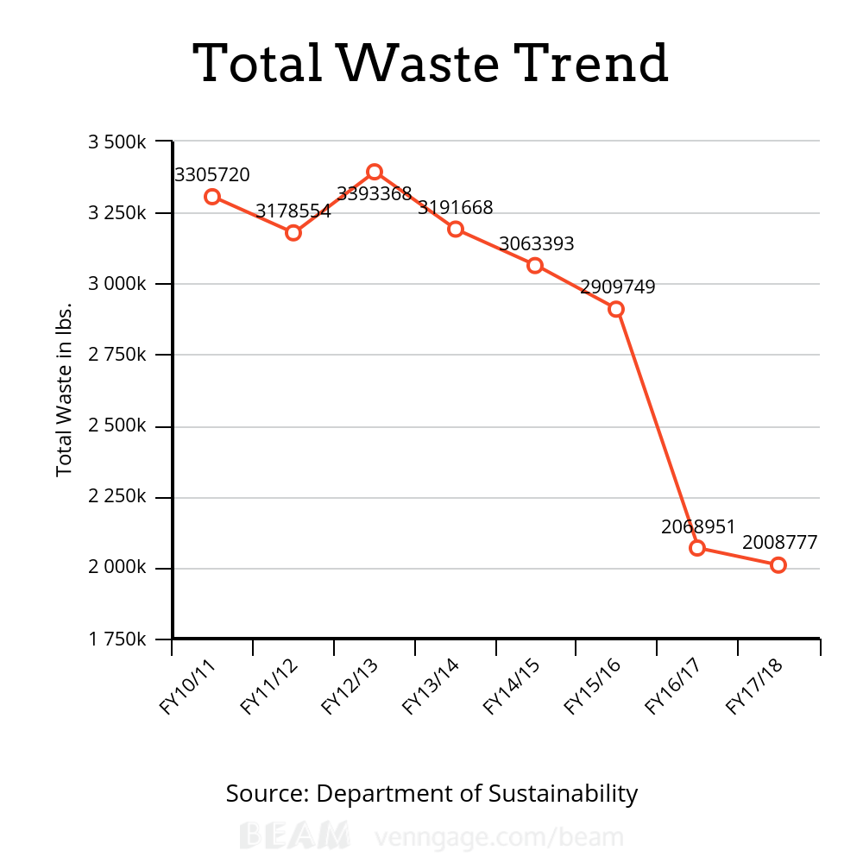

Figure 2

As shown by Figures 1 and 2, the percentage of materials recycled has increased in addition to the amount of total waste decreasing. The actions of the Department of Sustainability have greatly increased knowledge and awareness of issues regarding waste by informing students, faculty, and staff, providing methods of recycling, and promoting practices of reducing environmental impacts inside and outside of the classroom.
This year, East Tennessee State University recycled exactly 914,562 lbs. of material, which is 45.5% of the university’s total waste. The following chart shows the amount of each material in pounds that ETSU recycled during the 2017-18 fiscal year.
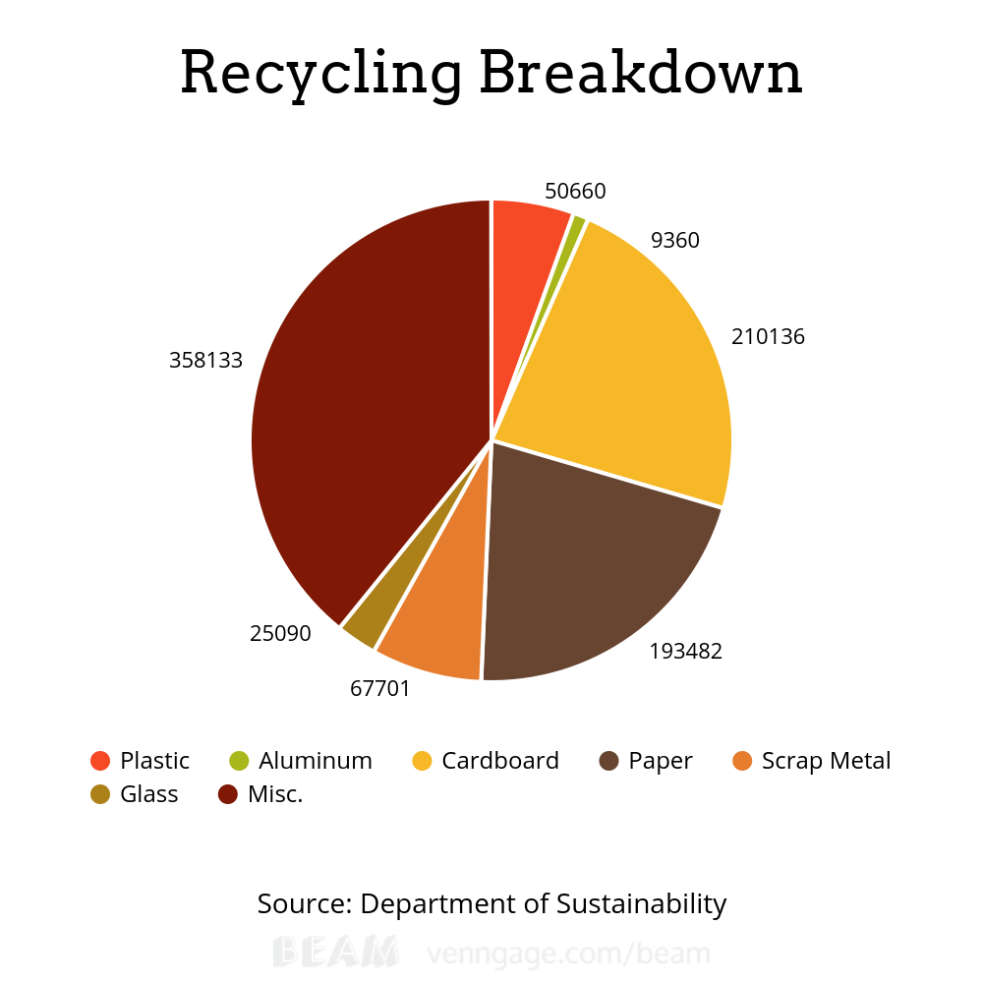
Figure 3
As is shown above, the miscellaneous category of recycling is the largest. This category is very broad to encompass items like electronics, ink cartridges, batteries, books, leaves, brush, lights, and compost.

