Visual Art

Instructor: Kristin Colson
Email: colsonk@etsu.edu
Phone: 439-4271

Course Description
Art is a hands-on class incorporating an array of techniques and media. Visual art integrates the elements of art and principles of design through a survey of art history. With deepened understanding and appreciation of art history, students will develop observation and technical skills in drawing, painting, printmaking, mixed-media and sculpture.

Tennessee State Curriculum Standards
https://www.tn.gov/education/districts/academic-standards/arts-education.html

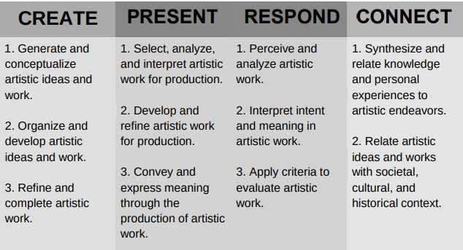

Units of Study
- Drawing contour drawing, lines, perspective, landscapes, still life, abstracts
- Painting color wheel, color theory, value charts, portraits, still life, techniques
- Mixed-Media a combination of various drawing techniques, painting, collage, etc.
- Sculpture wire, found object, etc.
- Printmaking various prints and techniques
- Art appreciation and critique as well as studio and sketchbook time.

Course Textbook
None required

Course Materials/Supply List
Provided in class

Classroom Expectations
The expectation is that all phones, earbuds, (and any other personal communications device) are silenced and will be kept in the student's backpack. Electronics may be used ONLY with permission and ONLY for educational purposes. Failure to follow these instructions may result in the phone being confiscated and possibly a written referral.

Canvas LMS Expectations
Students are expected to complete and submit all assignments as specified in one of the following: in class tray or online Canvas.
Grading
• Effort Doing your personal best every class all of class.
• Craftsmanship Taking your time, being careful with an eye for detail.
• Creativity/Originality Developing your own idea and style.
• Meet Assignment Objectives Listening and following guidelines for each project.
Remember to check PowerSchool regularly for updated grades should also be included.

University School Grading Scale
Total Points | Grade
100 – 90 | A
89 - 80 | B
79 - 70 | C
69 - 60 | D
59 - Below | F

Missing/Late Work Policy
This should reflect information included in the student handbook.

Testing Days
Quarterly exams may be givein.

Academic Integrity
Plagiarism/Cheating

University School is responsible for maintaining academic integrity for all of its students. It is the responsibility of the students to refrain from infractions of academic integrity, from conduct that may lead to suspicion of such infractions, and from conduct that aids others in such infractions. Infractions of academic integrity include but are not limited to:

- Cheating (using or attempting to use any information that the student knows is unauthorized)
- Fabrication (unauthorized falsification or invention of information in an academic assignment)
- Plagiarism (representing the words or ideas of another as one's own ideas, including copying from another person's paper and using Artificial Intelligence sites (AI) without proper citations
- Facilitating infractions of academic integrity (Helping or attempting to help another commit an infraction of academic integrity)

The above policy includes copying homework, lab papers, workbooks, and tests materials. It also includes using the on-line translators in world languages. Students who facilitate cheating will receive the same consequences as those who copy the work.

Students caught plagiarizing/cheating will be addressed by teacher and/or school administration. Incidents of cheating or plagiarism could result in a disciplinary referral and loss of credit for the given assignment. Repeat offenses may result in additional disciplinary action at the discretion of the administration.

Optional Items – The following items are optional. Teachers may add additional items if they choose to if they do not contradict items contained in the student handbook.
- Parent/Guardian and Student Signature Section
- Field Trips
- Other information

