The U.S. Constitution:
“I Smelt a Rat”
Becoming a Detective:
The painting, “Signing of the Constitution,” hangs in the House wing of the east stairway at the United States Capitol. Most likely, this image is in your civics textbook. Indeed, it is this rendering that seems to define the creation of our country’s Constitution.
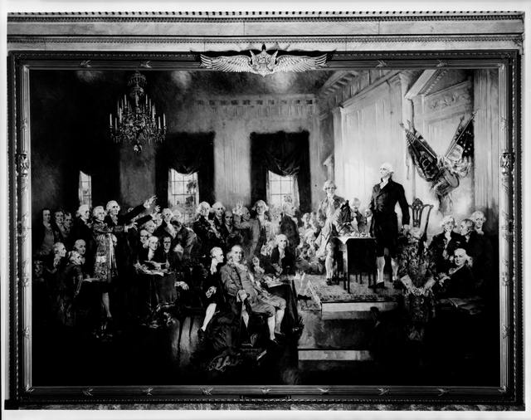
Commissioned in 1939, Howard Chandler Christy was paid $30,000 to render an “accurate” depiction of Independence Hall in Philadelphia on September 17, 1787. Using techniques of light and shadow as well as centering prominent figures like George Washington and Benjamin Franklin, this painting presents a picture of a unified vision from the delegates.
However, it is important to note that Howard Christy took some artistic liberties. For example, several delegates left the convention without signing, and three delegates (Edmund Randolph and George Mason from Virginia and Elbridge Gerry from Massachusetts) declined to sign the document. Others refused to attend the convention altogether, including one of the leading figures of the American Revolution: Patrick Henry from Virginia. When asked why he chose not to attend, he commented, “I smelt a rat.”
As a historical detective, your job will be to explore the following documents to determine why so many influential patriots like Patrick Henry and George Mason did not support the Constitution initially. In other words, your task is to find out what did Patrick Henry mean by “I smelt a rat”?
Investigating the Evidence:
Document A: | Speech by Dickinson at the Constitutional Convention - June 15, 1787
Document B: | Objections to the Constitution, George Mason
Document C: | Letters between George Washington, Patrick Henry, and Benjamin Harrison: Sept./Oct., 1787
Document D: | Patrick Henry’s speech at Virginia Ratification Convention: June 4, 1788
Document E: | Patrick Henry’s Speech at Virginia Ratification Convention, June 24, 1788
Document F: | Letter from Madison to Jefferson, Oct. 17, 1788
Document G: | Madison’s speech before 1st Congress concerning the need for amendments, June 8, 1789
Searching for Clues:
Please answer the following questions in the formatted case log about each primary source documents to help you understand their meaning.
Descriptive Questions:
For each document, please answer the following questions:
- Who wrote the document? Who was the intended audience?
- When was the document written?
- What objections to the Constitution are either stated and/or implied?
Analytical Questions:
Please answer the following questions referring back to your analysis of the documents.
- As a whole, what are the key objections to the Constitution?
- How would you assess the merits of these objections?
- Why do you think that the objections to the Constitution by such notable patriots are not emphasized more in your history textbook?
Cracking the Case: Based on your analysis of the documents and citing evidence to support your answer, please write a paragraph or two answering the following question: What did Patrick Henry mean when he said: “I smelt a rat”? To this end, why did so many influential patriots like Patrick Henry and George Mason not support the Constitution at the time of the signing on September 17, 1787? Within your analysis, please indicate whether you were satisfied with the evidence and list any additional questions that have been left unanswered through your investigation.

